Assignment #9: Collection Classes and Generic Classes

Rowan Pilon

041049454

For CST8284

Due November 21, 2023

**Task 1:** wrote a java code to illustrate the concept of Set, List, and deque,. Generate the correct output.

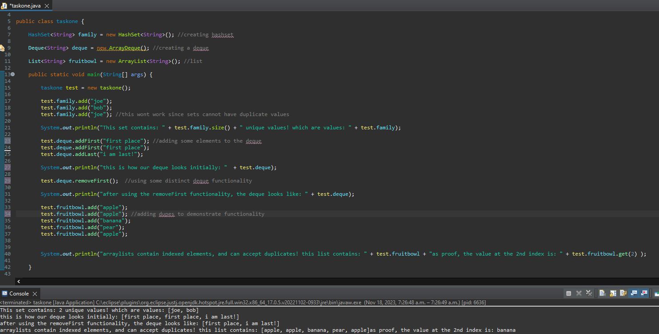

For my task one, I created the code above. I started by creating an instance of each required class, I then proceeded to make edits to demonstrate a few of the unique qualities these different interfaces/classes possess, such as the deques’ ability to undergo operations from both ends of the queue, Arrays’ ability to contain duplicates and search by index, and Hash Sets’ ability to hold unordered, unique elements.

**Task #2:** give a suitable example of generic classes and generate correct output

For this task I created the above code. I started by defining a generic class called tasktwo<T>. I then created a variable of the type T, meaning it would be of whatever type the generic class is defined as, which in this case is one string object and one integer object. I then set their unique variables using the methods to the respective data type, and then print them as seen in the output. I feel this is a solid example of the utility of generic classes and the ability to define variable types at object creation.

**Task #3:** Write a java code to implement the concept of vector and stack. Generate the correct output.

This is the program I created for task three. I created a class and main method and then defined both a vector and a stack. I then proceeded to add elements to the vector making sure to demonstrate its similarities to an arraylist by adding duplicates and varying data types. I then proceeded to use the push functionality on my stack to add elements to the stack, and then after that I used another piece of unique utility, the pop function, to remove the final element on the stack.