UPYOG
Aggregation Service
Architecture & Developer Reference

A Backend-for-Frontend (BFF) microservice in Go — field guide for Java engineers
Platform | UPYOG 2.0 — National Urban Digital Mission (NUDM)
Organisation | National Institute of Urban Affairs (NIUA), MoHUA
Component | upyog-aggregation-service (Go BFF)
Consumers | Citizen Dashboard UI (React / Flutter)
Document type | Architecture reference, developer onboarding guide, and design review
Status | Draft for review — refactored from engineering working notes

Contents
Contents 2
1 Executive Summary 4
1.1 What this document is 4
1.2 At a glance 4
2 High-Level Architecture 4
3 Project Structure — Package Map 6
4 Domain & Component Design 7
4.1 Core Domain Model 7
4.2 Aggregation Pipeline 7
4.3 HTTP Client & Resilience 8
4.4 Infrastructure Layer 8
4.5 Error Model 9
5 Request Flow — Step by Step 10
6 Component Reference 11
6.1 main.go — The Entry Point 11
6.2 api/ — HTTP Handlers 11
6.3 internal/aggregation/ — The Core Pipeline 13
6.4 internal/providers/ — Data Providers 13
6.4.1 Provider implementations 14
6.5 internal/clients/ — Resilient HTTP Client 15
6.6 internal/cache/ — Redis Cache 15
6.7 internal/middleware/ — 13 HTTP Middlewares 16
6.8 internal/config/ — Configuration Management 16
6.9 internal/errors/ — Error Types 17
6.10 pkg/logger/ — Structured Logging 17
7 Go for Java Developers 18
7.1 Goroutines & errgroup (≈ Virtual Threads / CompletableFuture) 18
7.2 context.Context (≈ ThreadLocal + CancellationToken) 18
7.3 Interfaces (≈ Java interfaces, but duck-typed) 18
7.4 Struct Embedding (≈ Composition / extends) 19
7.5 Multiple Return Values (≈ Tuple / Either) 19
7.6 defer (≈ try-finally / AutoCloseable) 21
7.7 sync.Map (≈ ConcurrentHashMap) 21
7.8 sync.Pool (≈ Object Pool Pattern) 21
7.9 Struct Tags (≈ Annotations) 21
7.10 Error Wrapping (≈ Exception Chaining) 21
7.11 Generics (Go 1.18+) 22
7.12 The internal/ Directory Convention 22
7.13 init() Functions (≈ Static Initializer Blocks) 22
8 Go Idioms Quick Reference 23
8.1 No constructors — factory functions instead 23
8.2 Pointers — * and & 23
8.3 No exceptions — error values instead 23
8.4 No this — the receiver is explicit 23
9 Dependency Summary 24
10 Go vs Java Cheat Sheet 25
11 Architecture Review & Recommendations 26
11.1 Resilience & Fault Isolation 26
11.2 Security & Multi-Tenancy 26
11.3 Observability & Operations 27
11.4 Code Quality & Maintainability 27
11.5 Testing 27
12 Summary of Recommended Actions 29

Right-click the table above and choose “Update Field” (or press F9) after opening this document in Word to populate page numbers.

1 Executive Summary
The UPYOG Aggregation Service is a Backend-for-Frontend (BFF) microservice written in Go. It exists to solve a single, focused problem: the new UPYOG citizen dashboard needs data from five backend services — inbox, billing, trade licence, user events, and draft — but a mobile or web client should not have to make five separate round trips to assemble one screen.
The service receives a single request, fans it out concurrently to the relevant downstream UPYOG services, tolerates partial failures so one slow or broken backend doesn't take down the whole dashboard, and merges everything into one JSON payload — with Redis caching and JWT passthrough along the way.
For a Java engineer, the closest mental model is a Spring Boot @RestController that uses CompletableFuture.allOf() to call several downstream microservices in parallel via RestTemplate / WebClient, then combines the results into a single response DTO. Every section below carries that comparison forward.

1.1 What this document is
- A refactored, structured version of the original engineering working notes — reorganised for reading top-to-bottom rather than as a scratchpad.
- An architecture and component reference for anyone joining the project.
- A Go-for-Java-developers primer, since the team's depth is in Java/Spring.
- A design review (Section 11) with concrete, prioritised recommendations based on the architecture as described in the source notes.

1.2 At a glance
Attribute | Value
Language / runtime | Go 1.21+
HTTP framework | Gin
Concurrency model | Goroutines + errgroup fan-out, per-provider timeouts
Caching | Redis, tenant-scoped keys, per-provider TTL
AuthN | JWT Bearer validation + passthrough to downstream services
AuthZ | RBAC authorizer defined; not yet wired into the request path — see §11.2
Resilience | Circuit breaker + exponential backoff retry per HTTP client
Observability | Zap structured logs, 20+ Prometheus metrics, OpenTelemetry tracing
Downstream services | Inbox, Billing, Trade Licence, User Events, Draft
Providers implemented | 7 (Quick Summary, Recent Applications, Notifications, Drafts, Due Renewals, Upcoming Events, Ad Banners)

2 High-Level Architecture
One request from the dashboard fans out to five backend UPYOG services concurrently. Everything inside the dashed boundary below is this project.
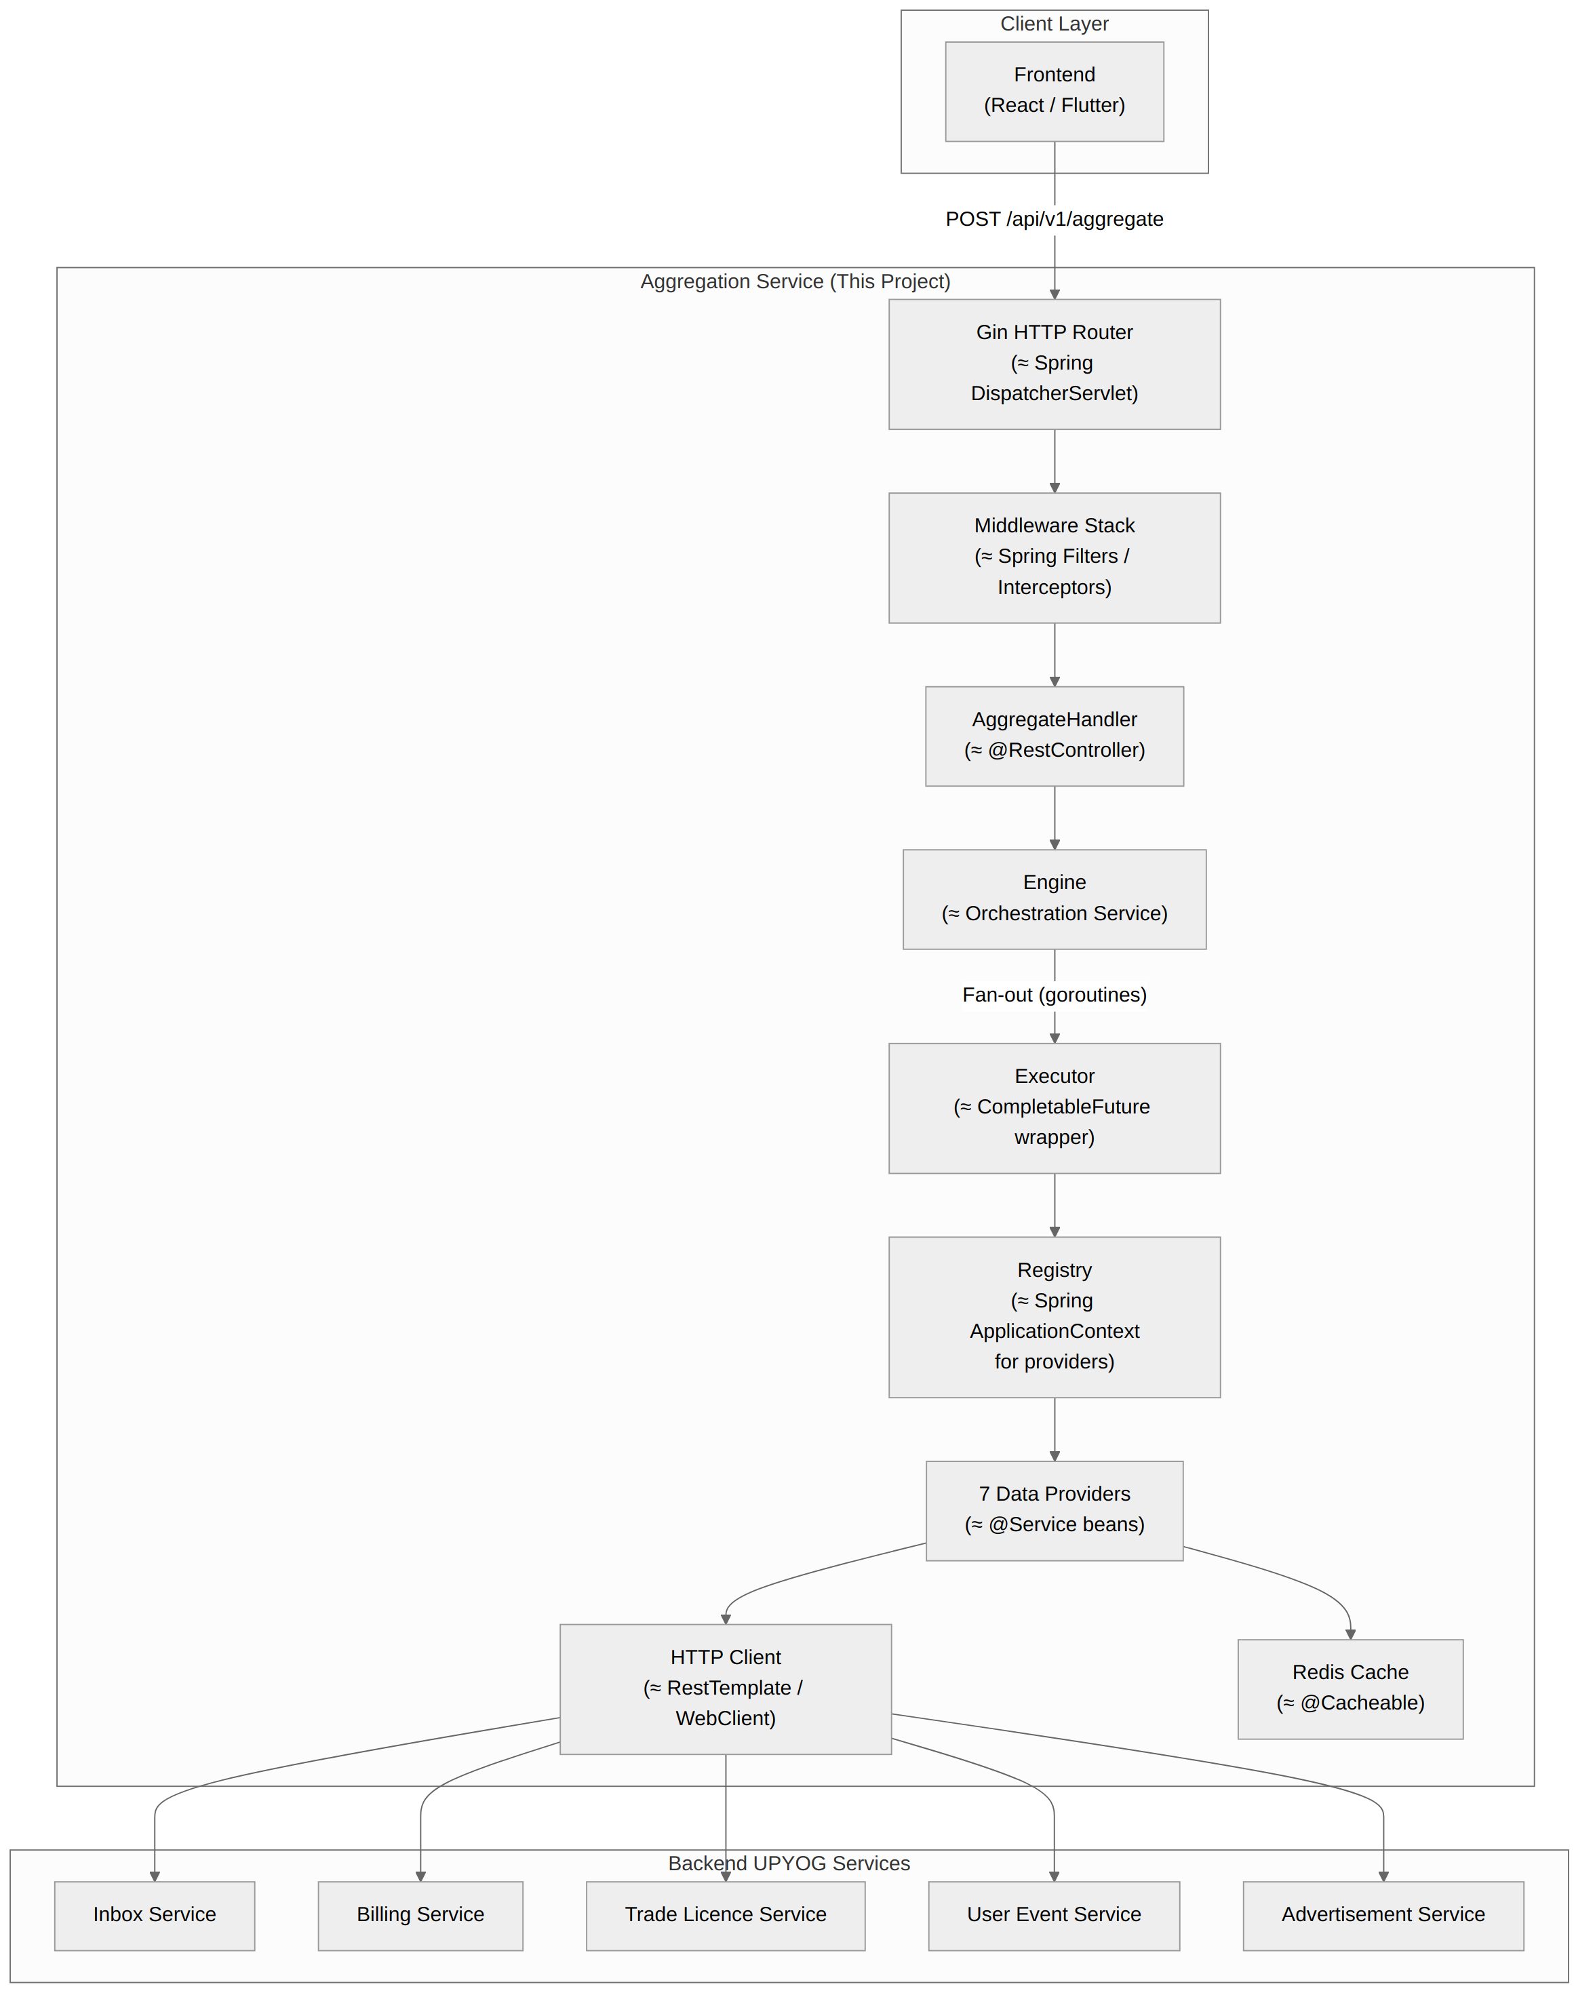
Figure 2.1 — Request path from the client, through the aggregation service, to backend UPYOG services

NOTE Every arrow crossing the service boundary in both directions carries the same JWT bearer token, request ID, and correlation ID — downstream services see the same identity and tracing context as the original request.

3 Project Structure — Package Map
In Go, the directory structure is the package structure. There is no pom.xml or build.gradle — only go.mod. Each directory is exactly one package, and no two files in the same directory may declare different package names.

TIP internal/ is a Go-enforced visibility boundary: packages under it cannot be imported by any module outside this repository. It's the closest thing Go has to Java's package-private access, but enforced project-wide rather than per-package.

upyog-aggregation-service/
├─ main.go ← Entry point (≈ SpringApplication.run())
├─ go.mod / go.sum ← Dependencies (≈ pom.xml + lockfile)
│
├─ api/ ← HTTP handlers (≈ @RestController layer)
│ ├─ router.go ← Route registration
│ ├─ aggregate_handler.go ← POST /api/v1/aggregate
│ └─ health_handler.go ← /health, /readiness, /liveness
│
└─ internal/ ← Private packages (not importable externally)
├─ aggregation/
│ ├─ engine/engine.go ← Orchestrator (fans out to providers)
│ ├─ executor/executor.go ← Single-provider executor with timeout
│ └─ registry/registry.go ← Provider lookup map
├─ auth/ jwt.go, authorizer.go
├─ cache/ redis.go
├─ clients/ client.go, circuit_breaker.go, retry.go
├─ common/ constants.go, context.go
├─ config/ config.go, loader.go
├─ dto/ request.go, response.go
├─ errors/ errors.go
├─ mapper/ mapper.go
├─ metrics/ metrics.go
├─ middleware/ 13 HTTP middlewares (≈ Servlet Filters)
├─ providers/ 7 data providers (the business logic)
├─ tracing/ tracing.go
└─ validator/ validator.go

pkg/logger/logger.go ← Zap structured logger
configs/ deployments/ scripts/ test/

4 Domain & Component Design
Go has no classes, inheritance, or constructors. This project uses structs (data) + methods (behaviour) + interfaces (contracts) + embedding (composition instead of inheritance). The diagrams below map each shape to its closest Java equivalent.

4.1 Core Domain Model
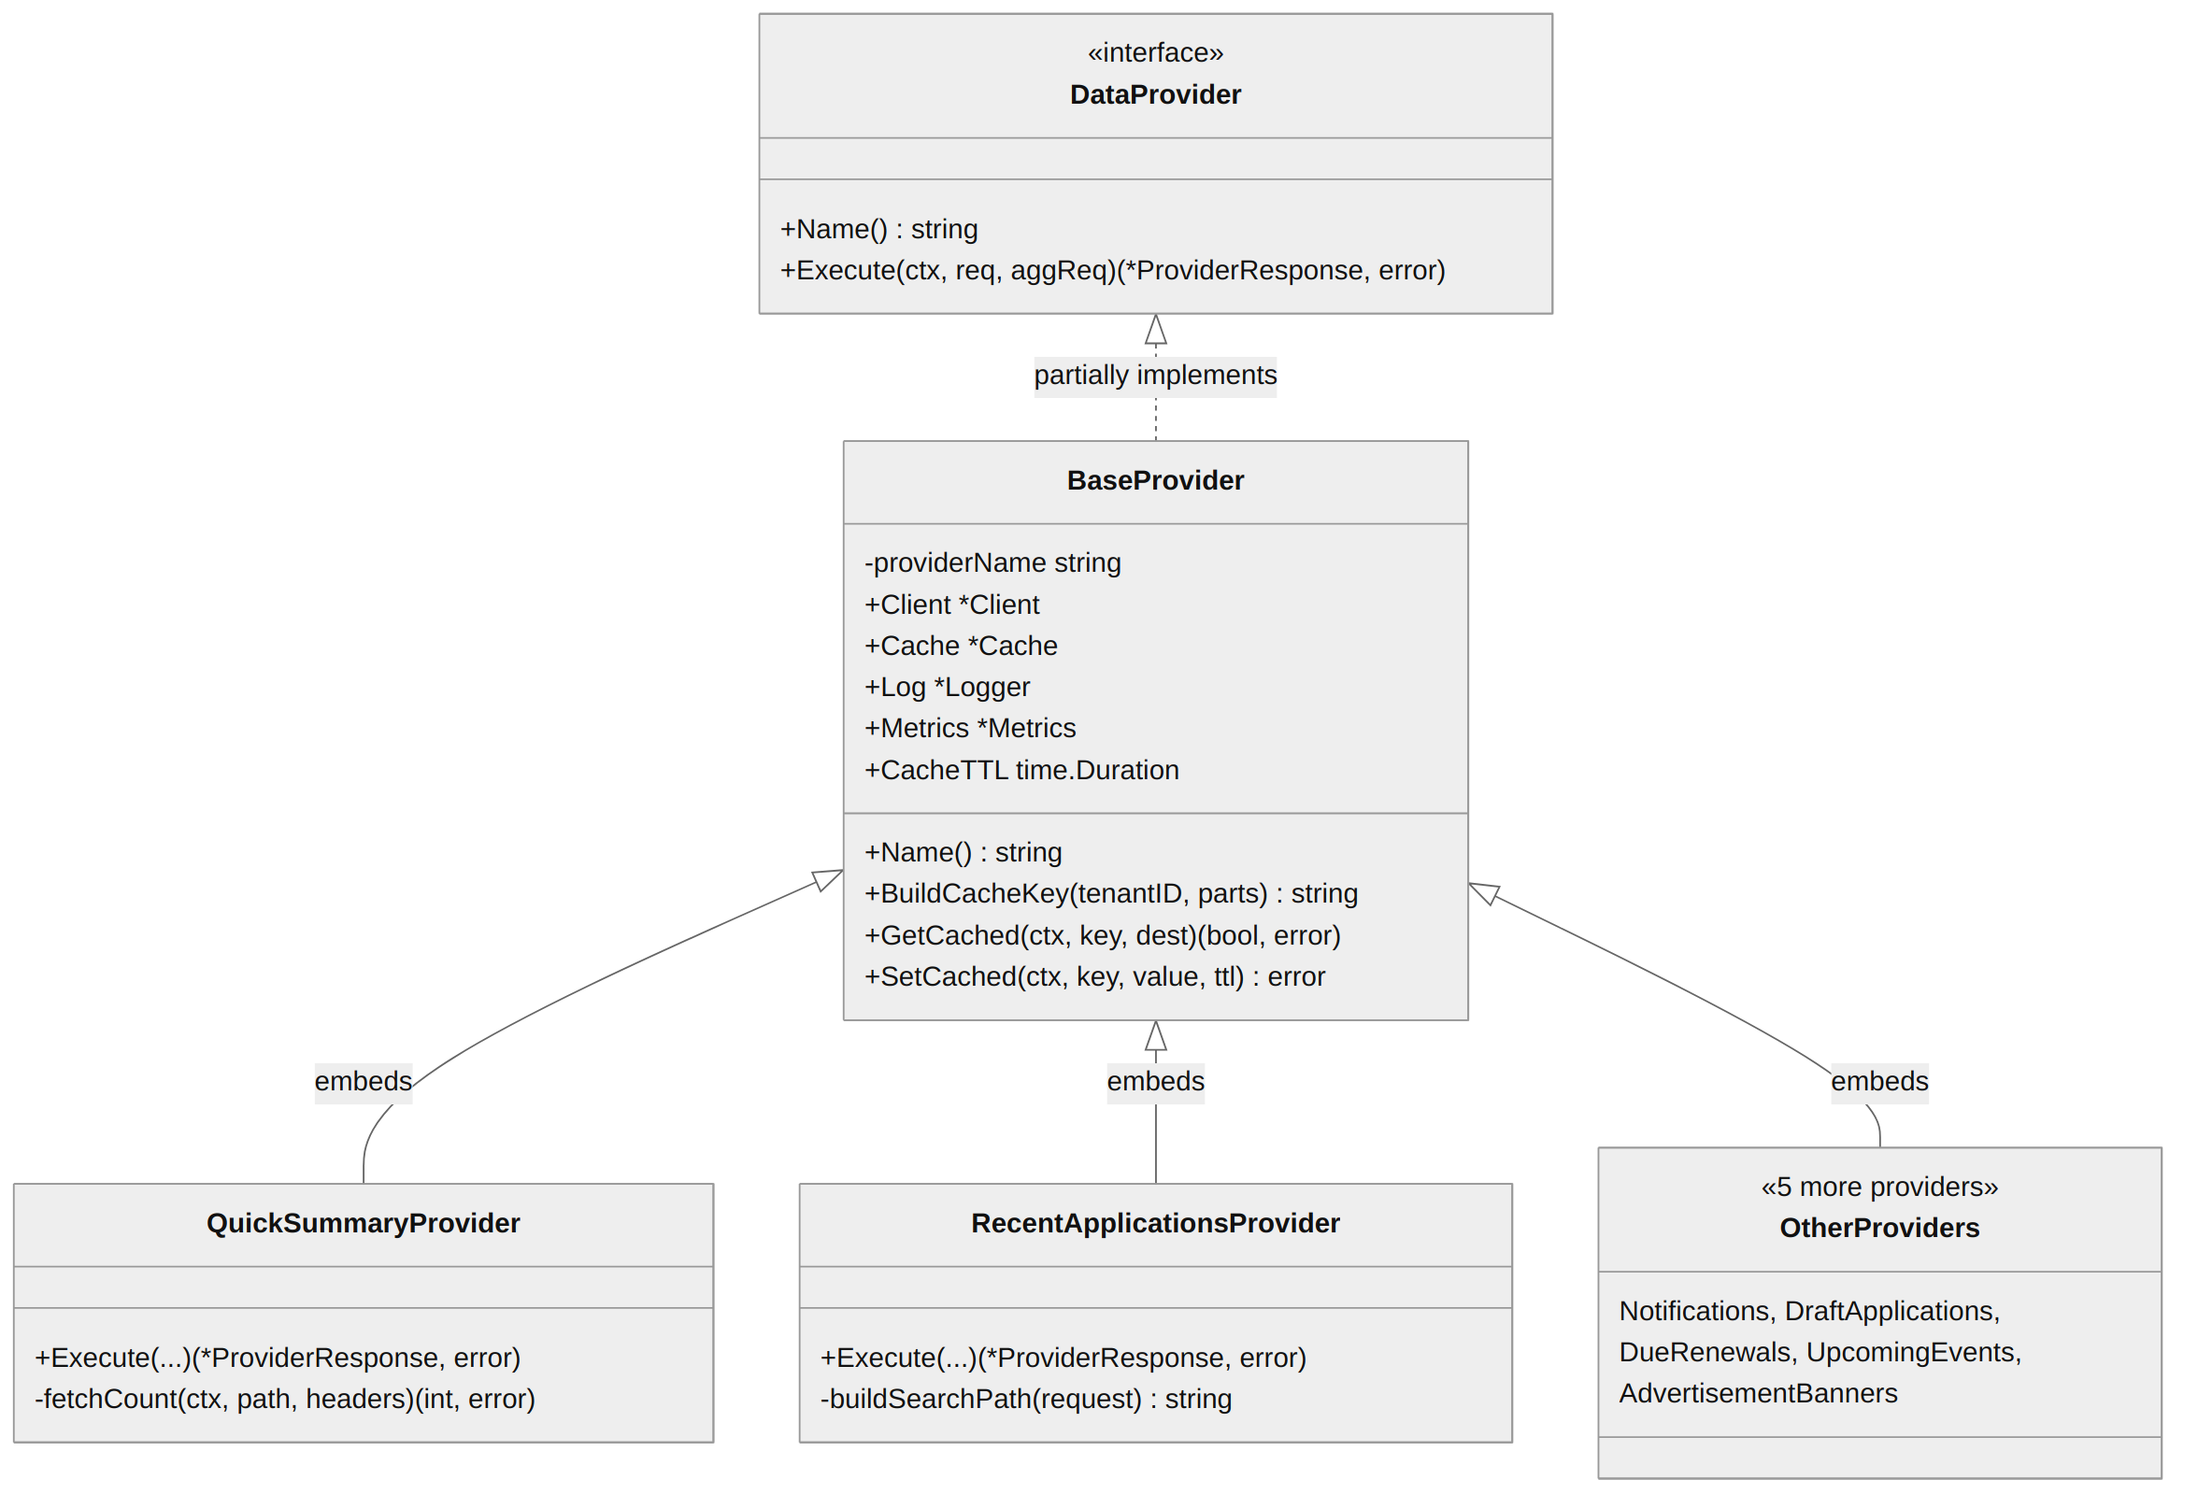
Figure 4.1 — DataProvider interface, BaseProvider, and the seven concrete providers

NOTE In Java: public interface DataProvider, implemented by an abstract BaseProvider that concrete providers extend. In Go: DataProvider is satisfied implicitly — any struct with a matching Name() and Execute() method automatically qualifies, with no “implements” keyword. BaseProvider is embedded (composed), not extended.

4.2 Aggregation Pipeline
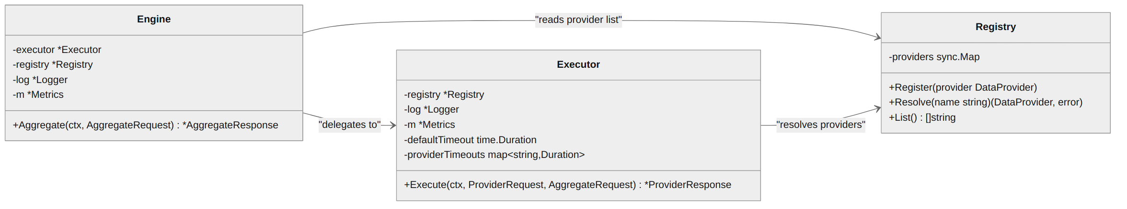
Figure 4.2 — Engine delegates to Executor, which resolves providers via Registry

NOTE Engine ≈ an orchestration @Service using errgroup for fan-out (the Go equivalent of CompletableFuture.allOf()). Registry ≈ a Map<String, DataProvider>, similar in spirit to Spring's ApplicationContext.getBean(name).

4.3 HTTP Client & Resilience
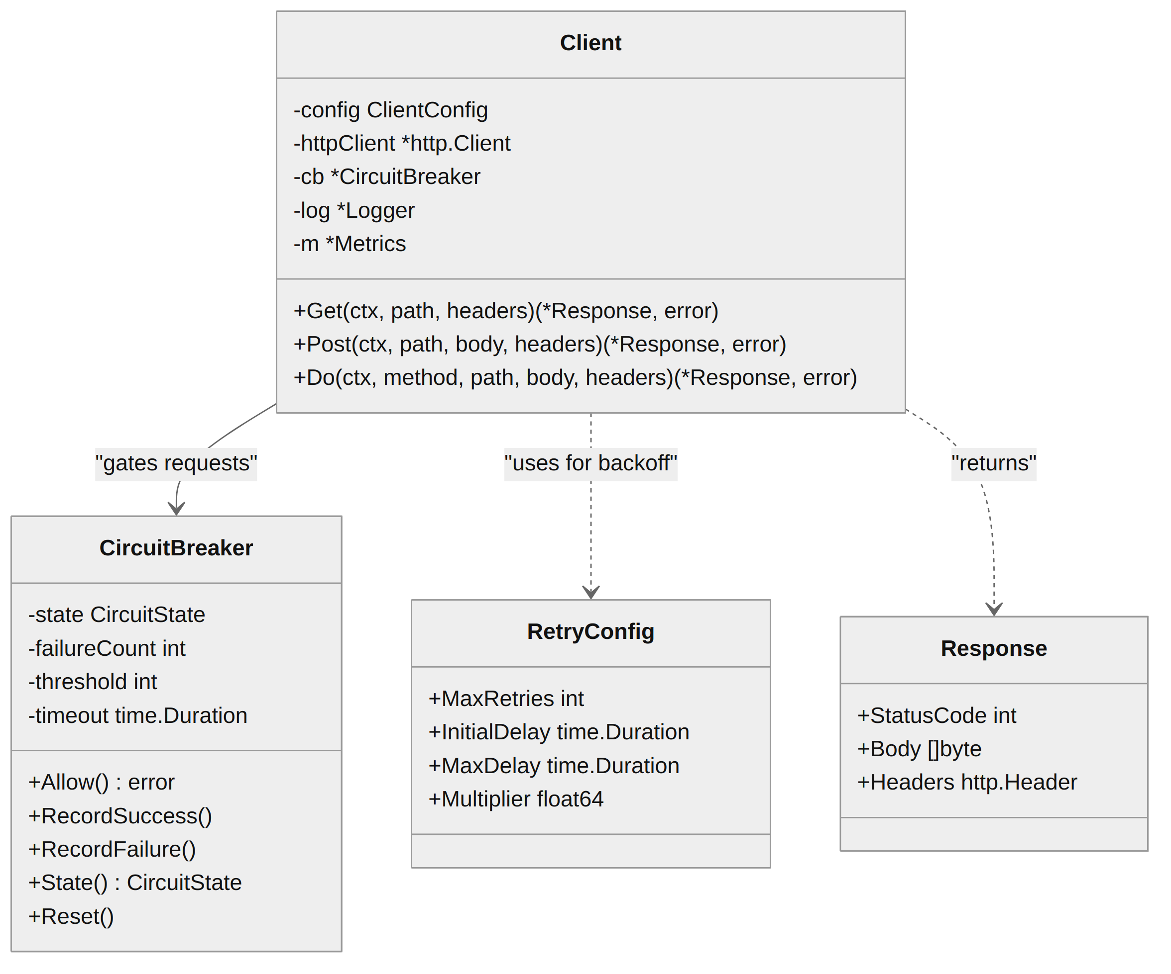
Figure 4.3 — Client, gated by a CircuitBreaker, using RetryConfig for backoff

NOTE Client ≈ RestTemplate / WebClient wired with Resilience4j's CircuitBreaker + Retry + a pooled connection manager, all in one place instead of separate annotations.

4.4 Infrastructure Layer
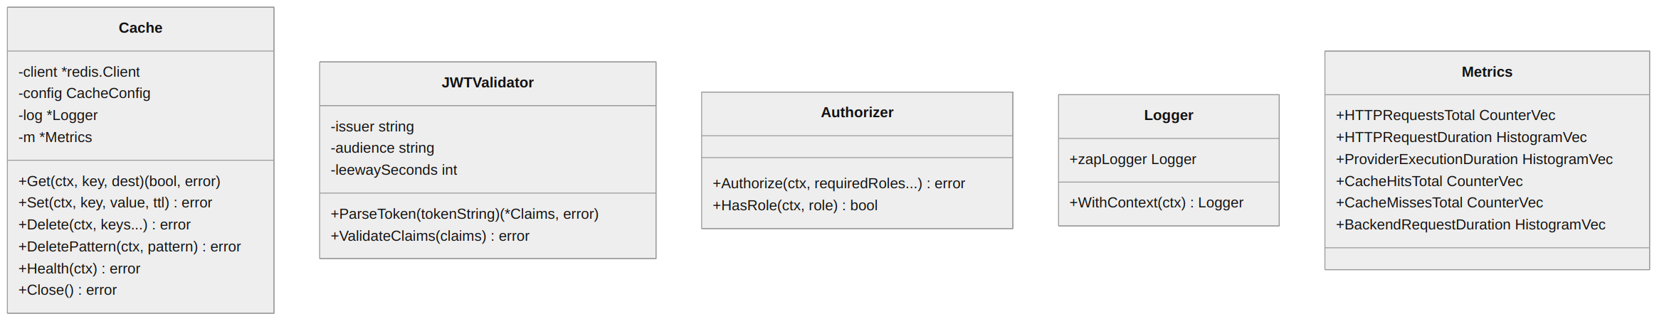
Figure 4.4 — Cache, JWTValidator, Authorizer, Logger, and Metrics
Component | Java equivalent
Cache | @Cacheable + RedisTemplate
JWTValidator | JwtDecoder (Spring Security)
Authorizer | @PreAuthorize / AccessDecisionManager
Logger | SLF4J + Logback with MDC
Metrics | Micrometer MeterRegistry

4.5 Error Model
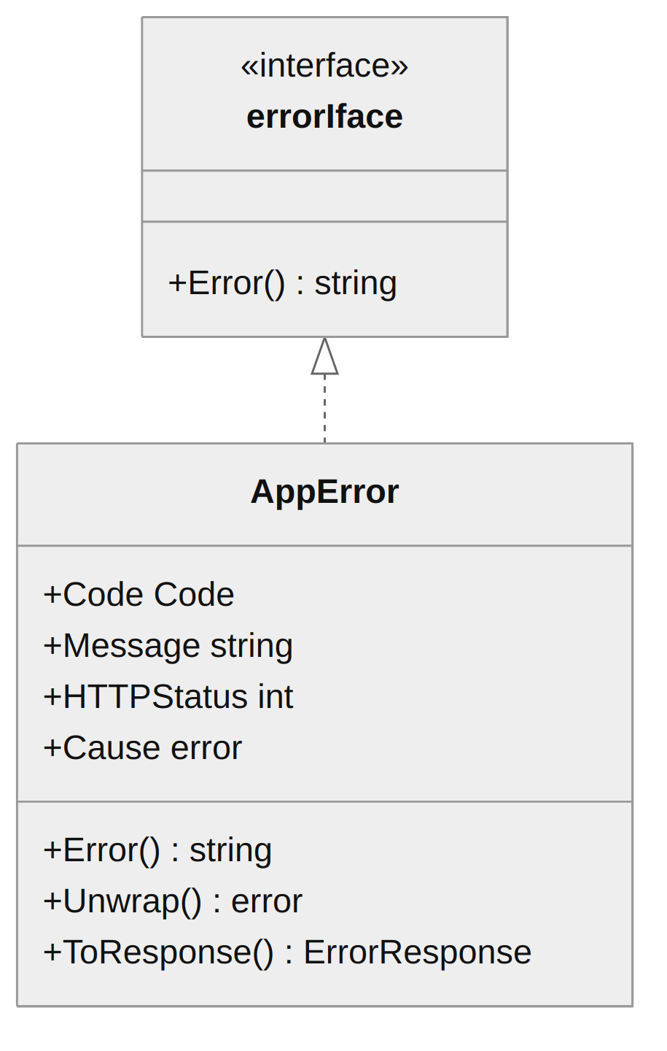
Figure 4.5 — AppError implements Go's built-in error interface

IMPORTANT Go has no exceptions and no try/catch. Errors are returned as ordinary values — every function that can fail returns (result, error), and callers check if err != nil instead of catching. AppError is the equivalent of a custom RuntimeException hierarchy, but it's a value your function returns, not something it throws.

Factory functions build the right error for the situation: NewInternal (500), NewValidation (400), NewAuthentication (401), NewAuthorization (403), NewProviderFailed / NewProviderTimeout (200, partial), NewBackendUnavailable (503), NewRateLimited (429).

5 Request Flow — Step by Step
A single POST /api/v1/aggregate travels through twelve middlewares, then the engine launches one goroutine per requested provider. Two are shown below — quick-summary (cache miss, four concurrent backend calls) and notifications (a plain pass-through call) — running in parallel.
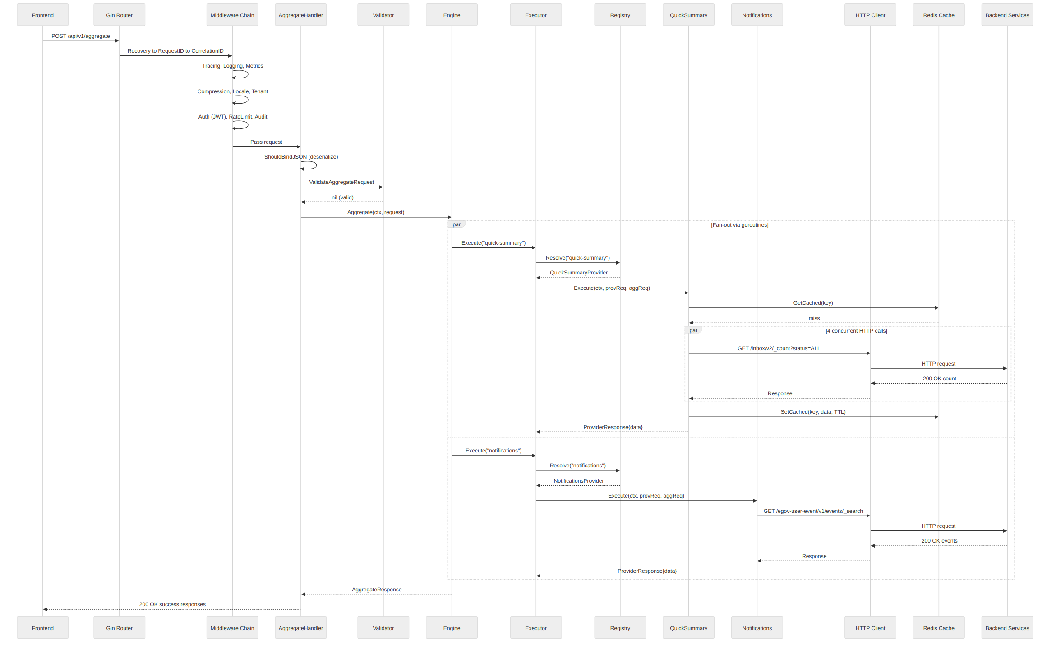
Figure 5.1 — Request lifecycle from client to backend and back

NOTE Every provider runs inside its own goroutine, resolves independently from the registry, and reports its own success, timeout, or failure — one slow provider does not block or fail the others.

6 Component Reference
What each package does, and its nearest Spring Boot equivalent.

6.1 main.go — The Entry Point
Java equivalent: public static void main() + SpringApplication.run().
On startup, main.go, in order:
- Creates the logger (≈ configuring Logback)
- Loads config from YAML via Viper (≈ @Value / @ConfigurationProperties)
- Initialises OpenTelemetry tracing (≈ Spring Cloud Sleuth)
- Creates the Prometheus metrics registry (≈ Micrometer)
- Connects to Redis (≈ @EnableCaching + RedisConnectionFactory)
- Registers custom validators (≈ @InitBinder)
- Creates the provider registry and registers all 7 providers (≈ @ComponentScan)
- Builds the executor and engine (≈ @Bean factory methods)
- Creates the JWT validator and authorizer (≈ Spring Security config)
- Sets up the Gin router with middleware (≈ SecurityFilterChain + FilterRegistrationBean)
- Starts the HTTP server with graceful shutdown (≈ embedded Tomcat)

IMPORTANT There is no dependency injection container in Go. Everything is constructed and wired by hand in main() — this is called “manual DI” or “poor man's DI,” and it is idiomatic Go, not a shortcut.

6.2 api/ — HTTP Handlers
router.go — Route Registration (≈ WebMvcConfigurer + SecurityFilterChain)
Registers every middleware in a fixed order, then mounts health endpoints and API routes. Order matters exactly as it does with FilterOrderRegistration in Spring:
1. Recovery – catches panics (≈ @ExceptionHandler, uncaught)
2. RequestID – assigns/propagates X-Request-Id
3. CorrelationID – assigns/propagates X-Correlation-Id
4. Tracing – creates OpenTelemetry span
5. Logging – logs method, path, status, latency
6. HTTPMetrics – records Prometheus counters
7. Compression – gzip (conditional)
8. LocaleResolver – extracts Accept-Language
9. TenantResolver – extracts X-Tenant-Id
10. Authentication – JWT validation (conditional)
11. RateLimiter – token-bucket (conditional)
12. Audit – logs POST / PUT / PATCH / DELETE
↓
AggregateHandler

aggregate_handler.go — The Main Endpoint (≈ @PostMapping("/api/v1/aggregate"))
- Binds the JSON body to AggregateRequest (≈ @RequestBody)
- Validates with a custom validator (≈ @Valid + a custom ConstraintValidator)
- Delegates to Engine.Aggregate() (≈ calling a @Service)
- Returns JSON (≈ ResponseEntity.ok())
health_handler.go — Health Probes (≈ Spring Boot Actuator /actuator/health)
- /health — always UP
- /readiness — checks Redis connectivity
- /liveness — always UP, lightweight

6.3 internal/aggregation/ — The Core Pipeline
registry.go (≈ Map<String, DataProvider> / ApplicationContext.getBean())
A sync.Map (thread-safe map) stores providers by name, registered once at startup and resolved per request:
Go | Java equivalent
reg.Register(provider) | context.registerBean("name", provider)
provider, err := reg.Resolve("name") | context.getBean("name", DataProvider.class)

executor.go (≈ CompletableFuture wrapper with timeout + metrics)
For each provider request, the executor:
- Resolves the provider from the registry
- Creates a per-provider timeout via context.WithTimeout (≈ orTimeout())
- Creates a tracing span
- Executes the provider
- Records duration, status, and error metrics
- Translates errors into the right ProviderResponse status
engine.go — Fan-Out Orchestrator (≈ CompletableFuture.allOf())
Uses errgroup.WithContext to launch one goroutine per provider request; results collect into a sync.Map and merge into a single AggregateResponse.
Go (this project) | Java equivalent
g, gCtx := errgroup.WithContext(ctx) | List<CompletableFuture<Void>> futures = new ArrayList<>();
for _, pr := range req.Requests { | for (ProviderRequest pr : req.getRequests()) {
g.Go(func() error { | futures.add(CompletableFuture.runAsync(() -> {
resp := e.executor.Execute(gCtx, pr) | Result result = executor.execute(pr);
results.Store(pr.Provider, resp) | results.put(pr.getProvider(), result);
return nil | }));
}) | }
}
_ = g.Wait() | CompletableFuture.allOf(futures.toArray(...)).join();

6.4 internal/providers/ — Data Providers
Java equivalent: interface DataProvider + abstract class BaseProvider.
Go | Java
type DataProvider interface { | public interface DataProvider {
Name() string | String getName();
Execute(ctx, req, aggReq) | ProviderResponse execute(
(*ProviderResponse, error) | ctx, req, aggReq);
} | }

6.4.1 Provider implementations
Provider | What it fetches | Backend API called
QuickSummaryProvider | 4 aggregate counts (apps, payments, completed, drafts) | /inbox/v2/_count, /billing-service/bill/v2/_count
RecentApplicationsProvider | Paginated recent applications | /inbox/v2/_search
NotificationsProvider | User notifications, optional unread filter | /egov-user-event/v1/events/_search
DraftApplicationsProvider | Draft (unsubmitted) applications | /inbox/v2/_search?status=DRAFT
DueRenewalsProvider | Licences / registrations nearing expiry | /tl-services/v1/BPAREG/_search
UpcomingEventsProvider | Future public events | /egov-user-event/v1/events/_search?eventType=EVENTSONGROUND
AdvertisementBannersProvider | Ad banners, optional placement filter | /advertisement-service/v1/advertisements/_search

NOTE QuickSummaryProvider is the most complex: it launches 4 nested goroutines within its own Execute() to fetch all 4 counts concurrently, and is the primary consumer of the cache layer.

6.5 internal/clients/ — Resilient HTTP Client
Java equivalent: WebClient + Resilience4j (@Retry + @CircuitBreaker).
client.go
- Connection pooling via http.Transport (≈ Apache PoolingHttpClientConnectionManager)
- Keep-alive with configurable idle timeout
- JWT propagation — forwards the bearer token from context
- Request / Correlation ID propagation — forwards tracing headers
- Retry with backoff, delegated to retry.go
- Circuit breaker — every call wrapped in cb.Allow() / cb.RecordSuccess() / RecordFailure()
- A child tracing span per HTTP call
- Prometheus metrics for duration, count, retries
circuit_breaker.go (≈ Resilience4j CircuitBreaker)
Three states: Closed → Open → Half-Open → Closed. Opens after N consecutive failures, auto-transitions to half-open after a timeout, and a single successful probe in half-open closes the circuit again.
retry.go (≈ Resilience4j Retry / Spring Retry @Retryable)
- Exponential backoff with jitter (random 0–50% of delay)
- Retries only on network errors and 5xx backend errors
- Respects context.Done() cancellation between attempts

6.6 internal/cache/ — Redis Cache
Java equivalent: @Cacheable + RedisTemplate<String, String>.
- JSON serialisation / deserialisation for cache values
- Tenant-scoped cache keys: agg:{tenantID}:{provider}:{extra}
- Pattern-based invalidation via SCAN (avoids blocking KEYS *)
- Health check via PING
- Hit / miss / error counters per provider

6.7 internal/middleware/ — 13 HTTP Middlewares
Java equivalent: javax.servlet.Filter / Spring HandlerInterceptor.
Middleware | What it does | Java equivalent
Recovery | Catches panics, returns 500 | @ExceptionHandler for uncaught
RequestID | Generates/propagates X-Request-Id | MDC.put("requestId")
CorrelationID | Generates/propagates X-Correlation-Id | MDC.put("correlationId")
Tracing | Creates OpenTelemetry span | Spring Cloud Sleuth TracingFilter
Logging | Logs method, path, status, latency | CommonsRequestLoggingFilter
HTTPMetrics | Records request count/duration/size | Micrometer WebMvcMetricsFilter
Compression | Gzip response if client accepts | GzipFilter
LocaleResolver | Extracts Accept-Language | LocaleResolver
TenantResolver | Extracts X-Tenant-Id header | Custom TenantFilter
Authentication | Validates JWT Bearer token | BearerTokenAuthenticationFilter
RateLimiter | Token-bucket rate limiting | Spring Cloud Gateway RequestRateLimiter
Audit | Logs POST/PUT/PATCH/DELETE ops | Custom AuditFilter
Authorization | RBAC role check — defined, unused | @PreAuthorize("hasRole(...)")

WARNING The Authorization middleware is implemented but not wired into the chain in §6.2's router order — authentication confirms who the caller is, but no role check currently gates what they can call. See §11.2 for the recommendation.

6.8 internal/config/ — Configuration Management
Java equivalent: @ConfigurationProperties + application.yml. Built on Viper — reads configs/application-{env}.yaml based on APP_ENV, supports UPYOG_-prefixed env var overrides, and maps nested structs via mapstructure tags.
Config
├─ ServerConfig (port, timeouts, compression)
├─ RedisConfig (host, port, pool, timeouts)
├─ AuthConfig (issuer, audience, public paths)
├─ ObservabilityConfig
│ ├─ MetricsConfig (namespace, subsystem)
│ └─ TracingConfig (endpoint, sampling rate)
├─ ProvidersConfig (default timeout, cache TTL, per-provider overrides)
├─ BackendConfig (per-service base URLs)
└─ RateLimitConfig (requests/sec, burst)

6.9 internal/errors/ — Error Types
Java equivalent: a custom exception hierarchy (extends RuntimeException). See Figure 4.5 for the full type.

6.10 pkg/logger/ — Structured Logging
Java equivalent: SLF4J + Logback + MDC. Built on Zap; WithContext(ctx) automatically enriches every log line with requestId, traceId, correlationId, tenantId, and provider.
Go usage | Java equivalent
log.WithContext(ctx).Info("message", zap.String("key","value")) | log.info("message requestId={} tenantId={}", MDC.get("requestId"), MDC.get("tenantId"));

7 Go for Java Developers
The thirteen Go features that matter most in this codebase, each mapped to the closest Java/Spring idiom.

7.1 Goroutines & errgroup (≈ Virtual Threads / CompletableFuture)
go func() launches a lightweight concurrent function. A goroutine costs roughly 2 KB of stack, against roughly 1 MB for a Java platform thread — millions can run at once.
Go: launch concurrent work | Java: CompletableFuture
g, ctx := errgroup.WithContext(ctx) | List<CompletableFuture<Void>> futures = new ArrayList<>();
for _, req := range requests { | for (Request req : requests) {
g.Go(func() error { | futures.add(CompletableFuture.runAsync(() -> {
result := doWork(ctx, req) | Result result = doWork(req);
results.Store(req.Name, result) | results.put(req.getName(), result);
return nil | }));
}) | }
}
_ = g.Wait() | CompletableFuture.allOf(futures...).join();
Used in: engine.go (fan-out), quick_summary.go (4 concurrent counts).

7.2 context.Context (≈ ThreadLocal + CancellationToken)
Passed through every function call, context.Context carries deadlines/timeouts, cancellation signals, and request-scoped values.
Go | Java
ctx, cancel := context.WithTimeout(ctx, 10*time.Second) | ExecutorService.submit(...).get(10, SECONDS)
defer cancel() | // auto-cleanup
value := ctx.Value(key) | ThreadLocal.get() / RequestContextHolder

WARNING Unlike Java's ThreadLocal, context.Context is explicitly passed as a function argument — it is never global or implicit. Every function in this codebase takes ctx context.Context as its first parameter.

7.3 Interfaces (≈ Java interfaces, but duck-typed)
Interfaces are satisfied implicitly. There is no “implements” keyword — if a struct has the right methods, it automatically satisfies the interface.
Go | Java
type DataProvider interface { | public interface DataProvider {
Name() string | String getName();
Execute(ctx,req,agg) (*Resp, error) | Response execute(ctx, req, agg);
} | }
type QuickSummaryProvider struct{ BaseProvider } | class QuickSummaryProvider extends BaseProvider
func (p *QuickSummaryProvider) Execute(...) {} | implements DataProvider { ... }
Used in: DataProvider, the built-in error interface, http.Flusher.

7.4 Struct Embedding (≈ Composition / extends)
Go has no inheritance. Instead, one struct is embedded inside another, and its methods are “promoted” to the outer struct.
Go: embedding | Java: inheritance
type BaseProvider struct { | public abstract class BaseProvider {
Client *clients.Client | protected RestTemplate client;
Cache *cache.Cache | protected RedisTemplate cache;
} | }
type QuickSummaryProvider struct { | public class QuickSummaryProvider
BaseProvider // embedded field | extends BaseProvider { }
}
provider.Name() // promoted method
provider.Client.Get() // promoted field
Used in: all 7 providers embed BaseProvider; gzipResponseWriter embeds gin.ResponseWriter.

7.5 Multiple Return Values (≈ Tuple / Either)
The (result, error) return pattern is the single most common idiom in Go — it appears in nearly every function in this codebase.
Go | Java
func ParseToken(s string) (*Claims, error) { | Either<AuthError, Claims> parseToken(String s) {
if err != nil { | if (error) {
return nil, errors.New("bad token") | return Either.left(new AuthError("bad token"));
} | }
return &claims, nil | return Either.right(claims);
} | }

7.6 defer (≈ try-finally / AutoCloseable)
defer schedules a call to run when the current function returns, regardless of how it returns.
Used in: main.go (logger sync, tracer shutdown, cache close), executor.go (span.End(), cancel()), client.go (response body close).

7.7 sync.Map (≈ ConcurrentHashMap)
Go | Java
var m sync.Map | ConcurrentHashMap<String,Object> m = new ConcurrentHashMap<>();
m.Store("key", value) | m.put("key", value);
v, ok := m.Load("key") | Object v = m.get("key"); // check null
m.Range(func(k, v any) bool { ... }) | m.forEach((k, v) -> { ... });
Used in: registry.go (provider storage), engine.go (result collection).

7.8 sync.Pool (≈ Object Pool Pattern)
A reusable object pool that reduces GC pressure. Used in compression.go to reuse gzip writers across requests instead of allocating one per response.

7.9 Struct Tags (≈ Annotations)
Metadata attached to struct fields via backtick strings, read by reflection at runtime.
Go tag | Java equivalent | Purpose
`json:"fieldName"` | @JsonProperty("fieldName") | JSON serialisation name
`json:",omitempty"` | @JsonInclude(NON_NULL) | Skip if zero value
`binding:"required"` | @NotNull | Gin validation
`binding:"min=1,max=128"` | @Size(min=1, max=128) | Gin validation
`binding:"uuid"` | @UUID (custom) | Gin validation
`mapstructure:"key"` | @Value("${key}") | Viper config binding

7.10 Error Wrapping (≈ Exception Chaining)
Go | Java
return fmt.Errorf("GET %s: %w", path, err) | throw new ServiceException("GET " + path, cause);
if errors.Is(err, context.DeadlineExceeded) { | if (ex.getCause() instanceof TimeoutException) {
var appErr *AppError | if (ex instanceof AppError appErr) {
if errors.As(err, &appErr) { ... } | // use appErr }
Used in: client.go, all providers, cache/redis.go.

7.11 Generics (Go 1.18+)
Go | Java
func MapSlice[T any, R any]( | <T, R> List<R> mapSlice(
source []T, fn func(T) R, | List<T> source, Function<T,R> fn
) []R { | ) {
result := make([]R, len(source)) | return source.stream()
for i, v := range source { | .map(fn)
result[i] = fn(v) | .collect(toList());
} | }
return result
}
Used in: mapper.go's generic MapSlice function.

7.12 The internal/ Directory Convention
Packages under internal/ cannot be imported by any module outside this repository — enforced by the Go compiler itself, not just convention. The nearest Java equivalent is package-private visibility, or Java 9 module exports directives, but Go's rule applies project-wide rather than package-by-package.

7.13 init() Functions (≈ Static Initializer Blocks)
Go supports func init() functions that run automatically before main() — the equivalent of a Java static { } block. Not heavily used in this project, since most wiring happens explicitly in main.go.

8 Go Idioms Quick Reference

8.1 No constructors — factory functions instead
// Go: NewXxx() is the naming convention // Java: constructor
func NewCache(cfg RedisConfig, ...) (*Cache, error) {
// ...
return &Cache{client: c, config: cfg}, nil
}

8.2 Pointers — * and &
// Go // Java
cfg := &Config{Port: 8080} // Config cfg = new Config(); cfg.setPort(8080);
// & = "address of" (creates a pointer) // all objects are already references
// * = "value at" (dereferences) // no equivalent needed

TIP Use *T (pointer) when you want to modify the value or avoid copying a large struct. Use T (value) for small, immutable data. In Java this decision doesn't exist — objects are always references.

8.3 No exceptions — error values instead
// Go: ALWAYS check errors // Java: try/catch
result, err := doSomething() try {
if err != nil { var result = doSomething();
return fmt.Errorf("context: %w", err) } catch (Exception e) {
} throw new WrappedException("context", e);
// use result }

8.4 No this — the receiver is explicit
// Go: receiver is explicit // Java: `this` is implicit
func (p *QuickSummaryProvider) Execute( public ProviderResponse execute(
ctx context.Context, // `this` is implicit
request dto.ProviderRequest, ProviderRequest request,
) (*dto.ProviderResponse, error) { ) {
p.Log.Info("...") // p is like `this` this.log.info("...");
} }

9 Dependency Summary
Go package | Java equivalent | Purpose
gin-gonic/gin | Spring MVC / Jersey | HTTP framework
spf13/viper | Spring Environment / @Value | Configuration management
uber-go/zap | SLF4J + Logback | Structured logging
redis/go-redis | Jedis / Lettuce | Redis client
prometheus/client_golang | Micrometer | Metrics (Prometheus)
opentelemetry.io/otel | Spring Cloud Sleuth / OTel Java | Distributed tracing
go-playground/validator | Hibernate Validator | Request validation
golang.org/x/sync/errgroup | CompletableFuture.allOf() | Concurrent error group
golang.org/x/time/rate | Guava RateLimiter | Token-bucket rate limiting
google/uuid | java.util.UUID | UUID generation
swaggo/swag | SpringDoc / Springfox | Swagger/OpenAPI generation

10 Go vs Java Cheat Sheet
Concept | Java | Go (this project)
Entry point | public static void main(String[]) | func main() in main.go
Dependency mgmt | Maven / Gradle | go.mod
Class | class Foo { } | type Foo struct { }
Interface | interface Foo { } (explicit impl) | type Foo interface { } (implicit)
Inheritance | extends BaseClass | Struct embedding
Constructor | new Foo() | NewFoo() factory function
Getter/Setter | getFoo() / setFoo() | Direct field access (capitalised = public)
Visibility | public / private / protected | Capitalised = public, lowercase = private
Null | null | nil
Exception | throw new Exception() | return nil, errors.New("msg")
Try/catch | try { } catch { } | if err != nil { }
Thread | new Thread() / ExecutorService | go func() { } (goroutine)
Synchronized | synchronized / Lock | sync.Mutex / sync.RWMutex
ConcurrentMap | ConcurrentHashMap | sync.Map
ThreadLocal | ThreadLocal<T> | context.Context values
Finally | finally { } | defer func() { }
Annotations | @RestController | Struct tags `json:"name"`
Generics | <T> (since Java 5) | [T any] (since Go 1.18)
Lambda | (x) -> x + 1 | func(x int) int { return x + 1 }
Stream.map | list.stream().map(fn) | MapSlice(list, fn) (custom)
Optional | Optional<T> | Multiple returns (T, bool)
Package | com.upyog.service | Directory path = package name
Build | mvn package / gradle build | go build ./...
Test | JUnit 5 | go test ./... (built-in)
Format | Checkstyle | gofmt (built-in, non-negotiable)
Lint | SonarQube | golangci-lint

11 Architecture Review & Recommendations
The design already covers the fundamentals well: concurrent fan-out with per-provider isolation, a circuit breaker and retry on the HTTP client, tenant-scoped Redis caching, structured logging, and broad Prometheus/OpenTelemetry coverage. The points below are what would come up in a design review of this specific architecture — gaps and edge cases worth closing before this carries production dashboard traffic, not criticisms of the overall approach.

11.1 Resilience & Fault Isolation
Observation | Recommendation | Priority
Client wraps every downstream call in one *CircuitBreaker — the diagram in §4.3 shows a single breaker per Client instance. | Key circuit breakers per downstream service (inbox, billing, trade-licence, events, ads). Otherwise one flaky service (e.g. advertisements) can trip the breaker and starve calls to an unrelated, healthy service (e.g. billing). | High
Concurrent dashboard users hitting the same tenant's Quick Summary on a cold cache can each trigger the same 4 backend calls simultaneously. | Add golang.org/x/sync/singleflight in front of cache-miss provider calls, so concurrent identical requests collapse into one backend call and share the result. | Medium
retry.go retries on network errors and 5xx responses. | Confirm retries are scoped to idempotent (GET) calls, or gated behind an idempotency key for any POST — retrying a non-idempotent write against an already-struggling backend risks duplicate side effects. | High
Redis is a dependency of every cache-aware provider. | Confirm Cache.Get()/Set() errors are treated as a cache miss (fail open to the backend call) rather than failing the whole provider — a Redis outage shouldn't take the dashboard down. | Medium

11.2 Security & Multi-Tenancy
Observation | Recommendation | Priority
The middleware table (§6.7) lists Authorization as “defined, unused.” JWT authentication confirms identity, but no role check currently gates access in the request path. | Wire the existing Authorizer into the middleware chain (or into AggregateHandler) before this reaches production, or explicitly document that role enforcement is intentionally deferred to each downstream DIGIT service — either is defensible, but it should be a decision, not an oversight. | High
RateLimitConfig (§6.8) describes requests/sec and burst, without an explicit tenant or user dimension. | Key the token-bucket limiter by tenant ID (and ideally by user) so one ULB's traffic spike — a common pattern around renewal deadlines — can't degrade the dashboard for every other tenant on the platform. | Medium
AuthConfig and RedisConfig imply secrets (JWT signing/verification material, Redis credentials) live in Viper-managed YAML. | Confirm these are sourced from Kubernetes Secrets or a secrets manager at deploy time, not committed as plaintext values in configs/application-{env}.yaml. | High

11.3 Observability & Operations
Observation | Recommendation | Priority
NewProviderFailed and NewProviderTimeout both map to HTTP 200 (partial success) so the dashboard still renders — by design, per the error model in §4.5. | Emit a distinct partial_failure metric per provider (separate from the overall HTTP success counter) so a rising rate of degraded-but-200 responses is visible on a dashboard, instead of hiding inside a healthy-looking success rate. | Medium
Graceful shutdown is handled in main.go, but the fan-out pattern means many goroutines can be mid-flight to backends at any moment. | Verify SIGTERM handling drains in-flight goroutines within the Kubernetes terminationGracePeriodSeconds, and that context cancellation propagates cleanly to every open backend call and Redis operation. | Medium

11.4 Code Quality & Maintainability
Observation | Recommendation | Priority
DueRenewalsProvider calls /tl-services/v1/BPAREG/_search specifically — renewals are hardcoded to Trade Licence. | Given UPYOG's broader module footprint (Water & Sewerage, FSM, PT, and others), consider making “renewal-capable modules” config-driven, so the same provider pattern extends to new modules without a Go code change each time. | Low
7 providers currently share one BaseProvider and one DataProvider contract, which has scaled cleanly so far. | As more providers are added, keep an explicit boundary in mind: providers should stay thin translators over backend calls, not accrete business logic — that keeps the fan-out model's failure isolation intact. | Low

11.5 Testing
Observation | Recommendation | Priority
7 providers each depend on a different DIGIT backend's response shape. | Add contract tests that assert each backend's response schema independently of this service — they catch upstream API drift (a DIGIT service renaming or dropping a field) before it silently breaks a provider's JSON parsing in production. | Medium
Circuit breaker and retry logic are core to this service's resilience story. | Add chaos-style tests (simulated timeouts, 5xx bursts, connection resets) against a mock backend to verify the breaker actually opens, half-opens, and recovers as designed — this logic is easy to get subtly wrong and hard to validate by reading code alone. | Medium

12 Summary of Recommended Actions
The five High-priority items, in the order they'd typically be tackled:
# | Action | Section
1 | Wire the Authorizer into the request path, or explicitly document why it's deferred to downstream services. | §11.2
2 | Move JWT signing material and Redis credentials out of YAML and into K8s Secrets / a secrets manager. | §11.2
3 | Split the shared circuit breaker into one per downstream service. | §11.1
4 | Audit retry.go for idempotency — confirm POST calls aren't retried without an idempotency key. | §11.1
5 | Confirm Redis failures fail open to a direct backend call rather than failing the provider. | §11.1

NOTE: On the refactor itself This document reorganises the original working notes into a single top-to-bottom reference: architecture before implementation detail, one consistent diagram style throughout, Go/Java comparisons pulled into scannable tables instead of inline comments, and the redundant flow-chart image for the middleware chain replaced with the numbered sequence already carried by the table in §6.7. Section 11 is new — a design-review pass over the architecture as described, not a rewrite of the original content.

