Create curl-
curl --location 'http://localhost:8087/asset-services/v1/assets/_create' \
--header 'Accept: application/json, text/plain, */*' \
--header 'Accept-Language: en-US,en;q=0.9,hi;q=0.8' \
--header 'Connection: keep-alive' \
--header 'Content-Type: application/json;charset=UTF-8' \
--header 'Origin: http://localhost:3000' \
--header 'Referer: http://localhost:3000/digit-ui/employee/asset/assetservice/new-assets/acknowledgement' \
--header 'Sec-Fetch-Dest: empty' \
--header 'Sec-Fetch-Mode: cors' \
--header 'Sec-Fetch-Site: same-origin' \
--header 'User-Agent: Mozilla/5.0 (Windows NT 10.0; Win64; x64) AppleWebKit/537.36 (KHTML, like Gecko) Chrome/131.0.0.0 Safari/537.36' \
--header 'sec-ch-ua: "Google Chrome";v="131", "Chromium";v="131", "Not_A Brand";v="24"' \
--header 'sec-ch-ua-mobile: ?0' \
--header 'sec-ch-ua-platform: "Windows"' \
--data '{
"Asset": {
"accountId": "",
"tenantId": "pg.citya",
"assetBookRefNo": "Refence/2024",
"assetName": "Chair for NIUA",
"description": "Description Lorem Ipsum data is coming from Lorem ipsum offical site",
"assetClassification": "MOVABLE",
"assetParentCategory": "IT",
"assetCategory": "STORAGE_DEVICES",
"assetSubCategory": "HARD_DRIVES_HDDS",
"department": "DEPT_5",
"assetType": "INFRASTRUCTURE_ASSET",
"assetUsage": "DISPOSED",
"financialYear": "2024-25",
"sourceOfFinance": "MUNICIPAL_FUNDS",
"applicationNo": "",
"approvalDate": "",
"applicationDate": "",
"status": "",
"modeOfPossessionOrAcquisition": "AST_LEASED",
"invoiceDate": 1730419200,
"invoiceNumber": "Invoice _nuuuuu33333",
"purchaseDate": 1730419200,
"purchaseOrderNumber": "2331232213",
"warranty": "15_YEAR",
"assetAge": "1 MONTH",
"location": "28.590213, 77.2257146",
"purchaseCost": 222222,
"acquisitionCost": 33333,
"bookValue": 255555,
"action": "",
"businessService": "asset-create",
"addressDetails": {
"city": "City A",
"locality": {
"code": "JLC414",
"area": "Area1"
}
},
"documents": [
{
"documentType": "OWNER.RECIEPTPHOTO",
"fileStoreId": "bd4932e3-d199-48a0-b1a7-db4c5a804551",
"documentUid": "bd4932e3-d199-48a0-b1a7-db4c5a804551",
"latitude": null,
"longitude": null
},
{
"documentType": "OWNER.ASSETPHOTO",
"fileStoreId": "2a776858-784a-4673-b32c-bdf20e5d3bc6",
"documentUid": "2a776858-784a-4673-b32c-bdf20e5d3bc6",
"latitude": null,
"longitude": null
}
],
"workflow": {
"action": "INITIATE",
"businessService": "asset-create",
"moduleName": "asset-services"
},
"additionalDetails": {
"assetParentCategory": "IT",
"warranty": {
"i18nKey": "15_YEAR",
"code": "15_YEAR",
"name": "warranty"
},
"modeOfPossessionOrAcquisition": {
"i18nKey": "AST_LEASED",
"code": "AST_LEASED",
"name": "modeOfPossessionOrAcquisition"
},
"brand": "Brand ",
"manufacturer": "Manufacturer "
}
},
"RequestInfo": {
"apiId": "Rainmaker",
"authToken": "98902e75-6108-4ca5-b6ac-c2fc42c7816f",
"userInfo": {
"id": 194,
"uuid": "ab5db0ed-b3ae-4fb8-bd93-f9913a0fa5da",
"userName": "ASSET_INITIATOR",
"name": "Asset Initiator",
"mobileNumber": "9999075991",
"emailId": null,
"locale": null,
"type": "EMPLOYEE",
"roles": [
{
"name": "Asset Initiator Employee",
"code": "ASSET_INITIATOR",
"tenantId": "pg.citya"
},
{
"name": "Asset Approver",
"code": "ASSET_APPROVER",
"tenantId": "pg.citya"
}

],
"active": true,
"tenantId": "pg.citya",
"permanentCity": null
},
"msgId": "1734002475778|en_IN",
"plainAccessRequest": {}
}
}'
Response-
{
"ResponseInfo": {
"apiId": "Rainmaker",
"ver": null,
"ts": null,
"resMsgId": "uief87324",
"msgId": "1734002475778|en_IN",
"status": "successful"
},
"Assets": [
{
"auditDetails": {
"createdBy": "ab5db0ed-b3ae-4fb8-bd93-f9913a0fa5da",
"lastModifiedBy": "ab5db0ed-b3ae-4fb8-bd93-f9913a0fa5da",
"createdTime": 1758184301435,
"lastModifiedTime": 1758184301435
},
"accumulatedDepreciartion": null,
"assetAssignable": false,
"id": "0d9cc51e-86c2-4520-88fe-cbf493dcc4b4",
"tenantId": "pg.citya",
"assetBookRefNo": "Refence/2024",
"assetName": "Chair for NIUA",
"description": "Description Lorem Ipsum data is coming from Lorem ipsum offical site",
"assetClassification": "MOVABLE",
"assetParentCategory": "IT",
"assetCategory": "STORAGE_DEVICES",
"assetSubCategory": "HARD_DRIVES_HDDS",
"department": "DEPT_5",
"applicationNo": "PG-1013-2025-I-001290",
"approvalNo": null,
"approvalDate": null,
"applicationDate": null,
"status": "INITIATED",
"addressDetails": {
"tenantId": null,
"doorNo": null,
"latitude": null,
"longitude": null,
"addressId": "0690953e-bae9-4395-94e9-b5c4f27159cb",
"addressNumber": null,
"type": null,
"addressLine1": null,
"addressLine2": null,
"landmark": null,
"city": "City A",
"pincode": null,
"detail": null,
"buildingName": null,
"street": null,
"locality": {
"code": "JLC414",
"name": null,
"label": null,
"latitude": null,
"longitude": null,
"children": null,
"materializedPath": null
}
},
"documents": [
{
"documentId": "b6b4a2c7-3be4-4601-92a4-6cbd66017403",
"documentType": "OWNER.RECIEPTPHOTO",
"fileStoreId": "bd4932e3-d199-48a0-b1a7-db4c5a804551",
"documentUid": "8c2f1d36-02db-419a-bfba-5f7811302d44",
"docDetails": null
},
{
"documentId": "25bfb330-9136-4a8e-85ae-be1893d78f0a",
"documentType": "OWNER.ASSETPHOTO",
"fileStoreId": "2a776858-784a-4673-b32c-bdf20e5d3bc6",
"documentUid": "a2b82b89-58f5-49e9-a0c0-39f0800a52a1",
"docDetails": null
}
],
"assetAssignment": null,
"additionalDetails": {
"assetParentCategory": "IT",
"warranty": {
"i18nKey": "15_YEAR",
"code": "15_YEAR",
"name": "warranty"
},
"modeOfPossessionOrAcquisition": {
"i18nKey": "AST_LEASED",
"code": "AST_LEASED",
"name": "modeOfPossessionOrAcquisition"
},
"brand": "Brand ",
"manufacturer": "Manufacturer "
},
"accountId": "ab5db0ed-b3ae-4fb8-bd93-f9913a0fa5da",
"remarks": null,
"financialYear": "2024-25",
"sourceOfFinance": "MUNICIPAL_FUNDS",
"workflow": {
"id": null,
"tenantId": null,
"businessService": "asset-create",
"businessId": null,
"action": "INITIATE",
"moduleName": "asset-services",
"state": null,
"comment": null,
"documents": null,
"assigner": null,
"assignee": null,
"nextActions": null,
"stateSla": null,
"businesssServiceSla": null,
"previousStatus": null,
"entity": null,
"auditDetails": null,
"assignes": null
},
"scheme": null,
"subScheme": null,
"purchaseCost": 222222.0,
"acquisitionCost": 33333.0,
"bookValue": 255555.0,
"invoiceDate": 1730419200,
"invoiceNumber": "Invoice _nuuuuu33333",
"purchaseDate": 1730419200,
"purchaseOrderNumber": "2331232213",
"location": "28.590213, 77.2257146",
"oldCode": null,
"modeOfPossessionOrAcquisition": "AST_LEASED",
"unitOfMeasurement": null,
"lifeOfAsset": null,
"assetUsage": "DISPOSED",
"assetType": "INFRASTRUCTURE_ASSET",
"assetStatus": null,
"originalBookValue": 0.0,
"minimumValue": null,
"islegacyData": null
}
]
}
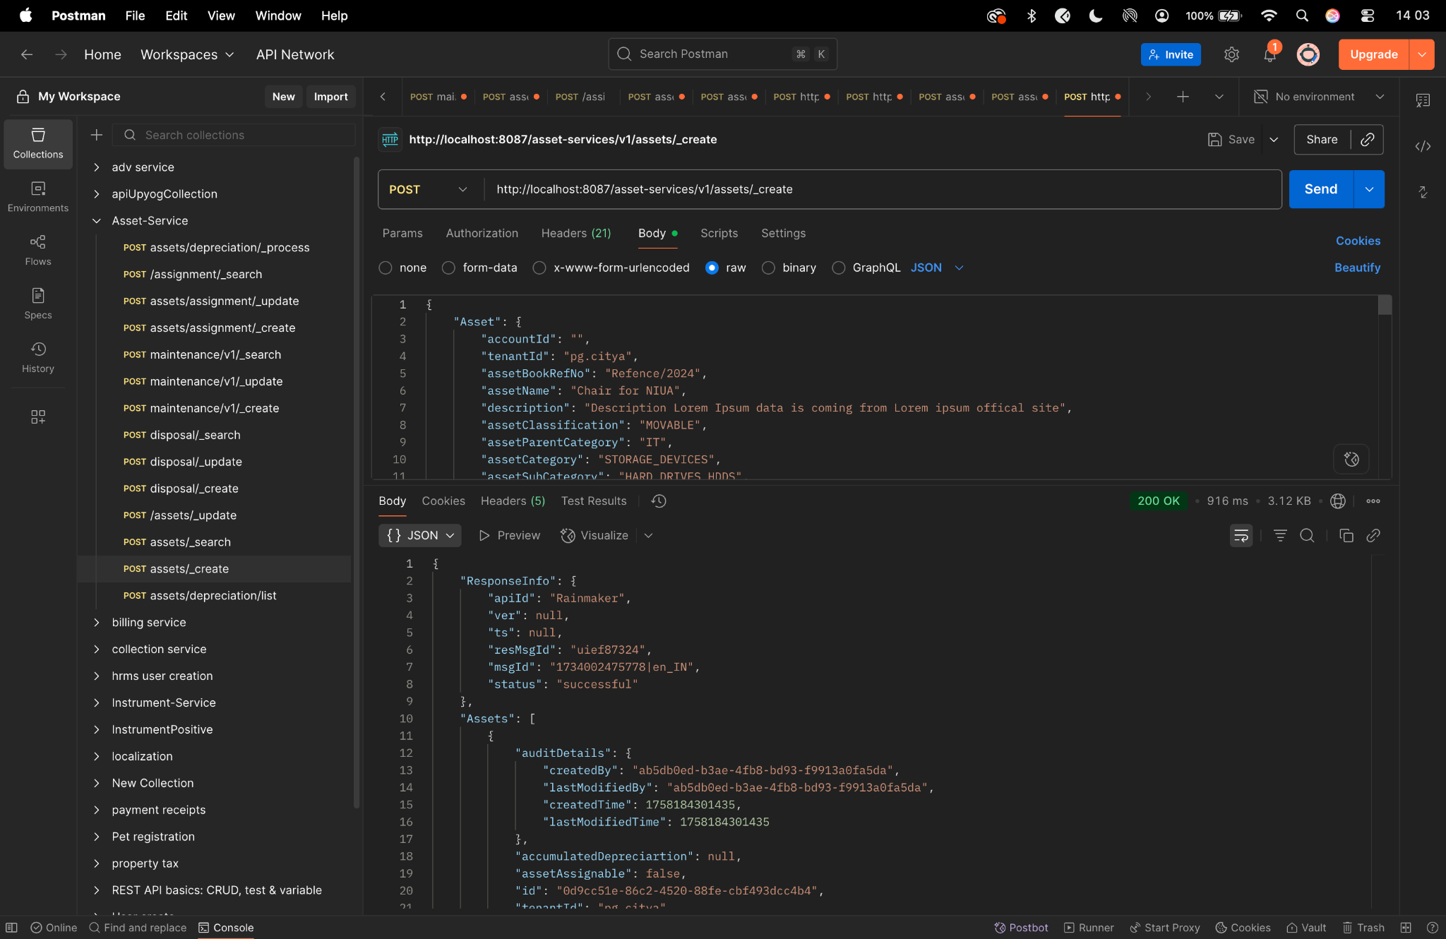

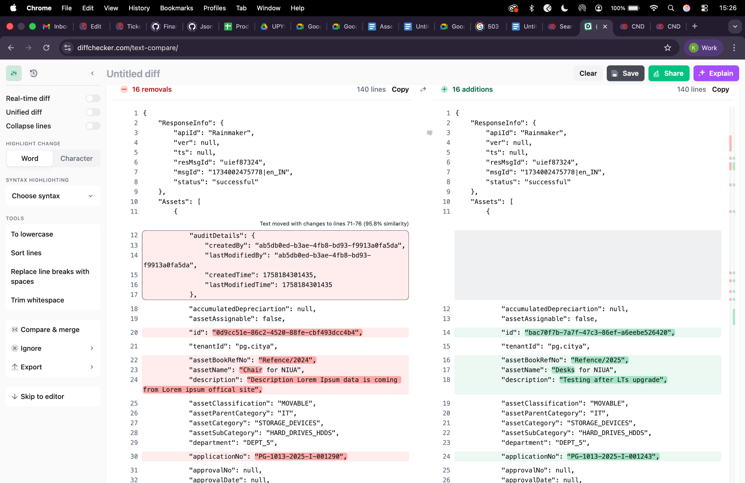

Update curl -
curl --location 'http://localhost:8087/asset-services/v1/assets/_update' \
--header 'Accept: application/json, text/plain, */*' \
--header 'Accept-Language: en-US,en;q=0.9,hi;q=0.8' \
--header 'Connection: keep-alive' \
--header 'Content-Type: application/json;charset=UTF-8' \
--header 'Origin: http://localhost:3000' \
--header 'Referer: http://localhost:3000/digit-ui/employee/asset/assetservice/edit-response' \
--header 'Sec-Fetch-Dest: empty' \
--header 'Sec-Fetch-Mode: cors' \
--header 'Sec-Fetch-Site: same-origin' \
--header 'User-Agent: Mozilla/5.0 (Windows NT 10.0; Win64; x64) AppleWebKit/537.36 (KHTML, like Gecko) Chrome/131.0.0.0 Safari/537.36' \
--header 'sec-ch-ua: "Google Chrome";v="131", "Chromium";v="131", "Not_A Brand";v="24"' \
--header 'sec-ch-ua-mobile: ?0' \
--header 'sec-ch-ua-platform: "Windows"' \
--data '{
"Asset": {
"accountId": "ab5db0ed-b3ae-4fb8-bd93-f9913a0fa5da",
"tenantId": "pg.citya",
"assetBookRefNo": "HP/20022/Ref_No/2222",
"assetName": "Chair for NIUA - UPDATED",
"description": "Lorem Ipsum is simply dummy text of the printing and typesetting industry. Lorem Ipsum has been the industry'\''s standard dummy text ever since UPdate - UPDATED",
"assetClassification": "MOVABLE",
"assetParentCategory": "FURNITURE",
"assetCategory": "HOME_EQUIPMENT",
"assetSubCategory": "SITTER",
"department": "DEPT_2",
"financialYear": "2024-25",
"sourceOfFinance": "AMRUT",
"applicationNo": "PG-1013-2025-I-001290",
"approvalDate": "",
"id": "0d9cc51e-86c2-4520-88fe-cbf493dcc4b4",
"applicationDate": "",
"status": "Employee Action Pending",
"action": "",
"businessService": "asset-create",
"addressDetails": {
"addressLine1": null,
"addressLine2": null,
"buildingName": null,
"doorNo": null,
"street": null,
"pincode": null,
"city": "City A",
"locality": {
"code": "JLC254",
"latitude": 0,
"longitude": 0
}
},
"documents": [
{
"documentId": "bd2d05d5-5462-4dde-a096-fed7df2c7b02",
"documentType": "OWNER.RECIEPTPHOTO",
"fileStoreId": "f0d569d7-8c71-4d6d-81a1-1ec93eb91981",
"documentUid": "6c5e4398-8a2f-4489-8459-611fa5ecc42c",
"docDetails": null
},
{
"documentId": "e82c5649-0591-44fe-b5f3-363e88e54505",
"documentType": "OWNER.ANYSUPPORTINGDOCUMENT",
"fileStoreId": "bee8e2cc-5d72-4abc-bc98-18b2e1223c64",
"documentUid": "77235dfb-3758-400c-8b00-10a8d711387b",
"docDetails": null
},
{
"documentId": "25f96703-2005-4b90-b696-b14601c4407a",
"documentType": "OWNER.ASSETPHOTO",
"fileStoreId": "769d03cd-4f95-4b86-ab3d-ceec1b741f88",
"documentUid": "845e0cc3-0aa2-4d03-b1a0-290726e7da60",
"docDetails": null
}
],
"workflow": {
"action": "VERIFY",
"businessService": "asset-create",
"moduleName": "asset-services"
},
"additionalDetails": {
"key": 1733743796659,
"brand": "LG Brand UPdate",
"manufacturer": "LG Manufacturer UPdate",
"warranty": {
"code": "1_YEAR",
"name": "warranty",
"value": "1 Year",
"i18nKey": "1 Year"
},
"acquisitionProcessionDetails": {}
}
},
"RequestInfo": {
"apiId": "Rainmaker",
"authToken": "2f302a1f-161a-4d9e-8c02-7fbad9b98f0f",
"userInfo": {
"id": 194,
"uuid": "ab5db0ed-b3ae-4fb8-bd93-f9913a0fa5da",
"userName": "ASSET_INITIATOR",
"name": "Asset Initiator",
"mobileNumber": "9999075991",
"emailId": null,
"locale": null,
"type": "EMPLOYEE",
"roles": [
{
"name": "Asset Initiator Employee",
"code": "ASSET_INITIATOR",
"tenantId": "pg.citya"
},
{
"name": "Asset Approver",
"code": "ASSET_APPROVER",
"tenantId": "pg.citya"
},
{
"name": "Asset Document Verifier",
"code": "ASSET_VERIFIER",
"tenantId": "pg.citya"
}

],
"active": true,
"tenantId": "pg.citya",
"permanentCity": null
},
"msgId": "1733743900982|en_IN",
"plainAccessRequest": {}
}
}'
Response -

{
"ResponseInfo": {
"apiId": "Rainmaker",
"ver": null,
"ts": null,
"resMsgId": "uief87324",
"msgId": "1733743900982|en_IN",
"status": "successful"
},
"Assets": [
{
"auditDetails": {
"createdBy": "ab5db0ed-b3ae-4fb8-bd93-f9913a0fa5da",
"lastModifiedBy": "ab5db0ed-b3ae-4fb8-bd93-f9913a0fa5da",
"createdTime": 1758184586533,
"lastModifiedTime": 1758184586533
},
"accumulatedDepreciartion": null,
"assetAssignable": false,
"id": "0d9cc51e-86c2-4520-88fe-cbf493dcc4b4",
"tenantId": "pg.citya",
"assetBookRefNo": "HP/20022/Ref_No/2222",
"assetName": "Chair for NIUA - UPDATED",
"description": "Lorem Ipsum is simply dummy text of the printing and typesetting industry. Lorem Ipsum has been the industry's standard dummy text ever since UPdate - UPDATED",
"assetClassification": "MOVABLE",
"assetParentCategory": "FURNITURE",
"assetCategory": "HOME_EQUIPMENT",
"assetSubCategory": "SITTER",
"department": "DEPT_2",
"applicationNo": "PG-1013-2025-I-001290",
"approvalNo": null,
"approvalDate": null,
"applicationDate": null,
"status": "VERIFIED",
"addressDetails": {
"tenantId": null,
"doorNo": null,
"latitude": null,
"longitude": null,
"addressId": null,
"addressNumber": null,
"type": null,
"addressLine1": null,
"addressLine2": null,
"landmark": null,
"city": "City A",
"pincode": null,
"detail": null,
"buildingName": null,
"street": null,
"locality": {
"code": "JLC254",
"name": null,
"label": null,
"latitude": "0",
"longitude": "0",
"children": null,
"materializedPath": null
}
},
"documents": [
{
"documentId": "bd2d05d5-5462-4dde-a096-fed7df2c7b02",
"documentType": "OWNER.RECIEPTPHOTO",
"fileStoreId": "f0d569d7-8c71-4d6d-81a1-1ec93eb91981",
"documentUid": "6c5e4398-8a2f-4489-8459-611fa5ecc42c",
"docDetails": null
},
{
"documentId": "e82c5649-0591-44fe-b5f3-363e88e54505",
"documentType": "OWNER.ANYSUPPORTINGDOCUMENT",
"fileStoreId": "bee8e2cc-5d72-4abc-bc98-18b2e1223c64",
"documentUid": "77235dfb-3758-400c-8b00-10a8d711387b",
"docDetails": null
},
{
"documentId": "25f96703-2005-4b90-b696-b14601c4407a",
"documentType": "OWNER.ASSETPHOTO",
"fileStoreId": "769d03cd-4f95-4b86-ab3d-ceec1b741f88",
"documentUid": "845e0cc3-0aa2-4d03-b1a0-290726e7da60",
"docDetails": null
}
],
"assetAssignment": null,
"additionalDetails": {
"key": 1733743796659,
"brand": "LG Brand UPdate",
"manufacturer": "LG Manufacturer UPdate",
"warranty": {
"code": "1_YEAR",
"name": "warranty",
"value": "1 Year",
"i18nKey": "1 Year"
},
"acquisitionProcessionDetails": {}
},
"accountId": "ab5db0ed-b3ae-4fb8-bd93-f9913a0fa5da",
"remarks": null,
"financialYear": "2024-25",
"sourceOfFinance": "AMRUT",
"workflow": {
"id": null,
"tenantId": null,
"businessService": "asset-create",
"businessId": null,
"action": "VERIFY",
"moduleName": "asset-services",
"state": null,
"comment": null,
"documents": null,
"assigner": null,
"assignee": null,
"nextActions": null,
"stateSla": null,
"businesssServiceSla": null,
"previousStatus": null,
"entity": null,
"auditDetails": null,
"assignes": null
},
"scheme": null,
"subScheme": null,
"purchaseCost": 0.0,
"acquisitionCost": 0.0,
"bookValue": 0.0,
"invoiceDate": null,
"invoiceNumber": null,
"purchaseDate": null,
"purchaseOrderNumber": null,
"location": null,
"oldCode": null,
"modeOfPossessionOrAcquisition": null,
"unitOfMeasurement": null,
"lifeOfAsset": null,
"assetUsage": null,
"assetType": null,
"assetStatus": null,
"originalBookValue": 0.0,
"minimumValue": null,
"islegacyData": null
}
]
}
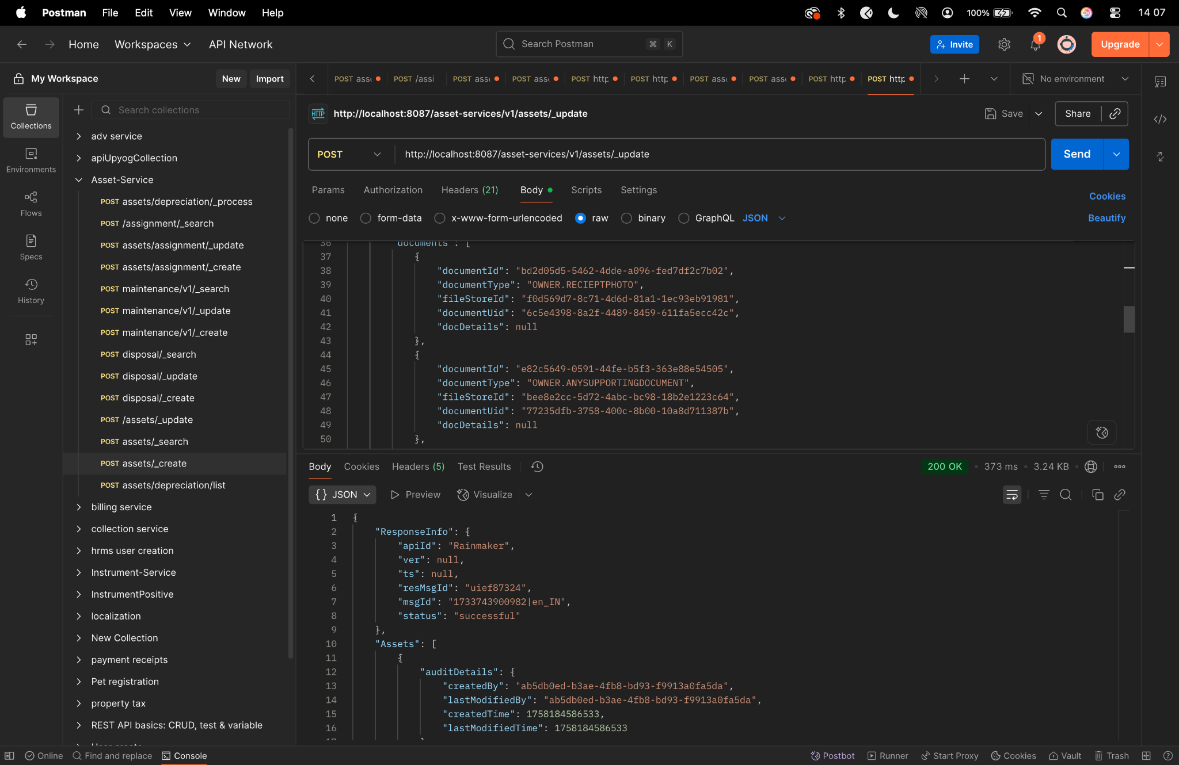

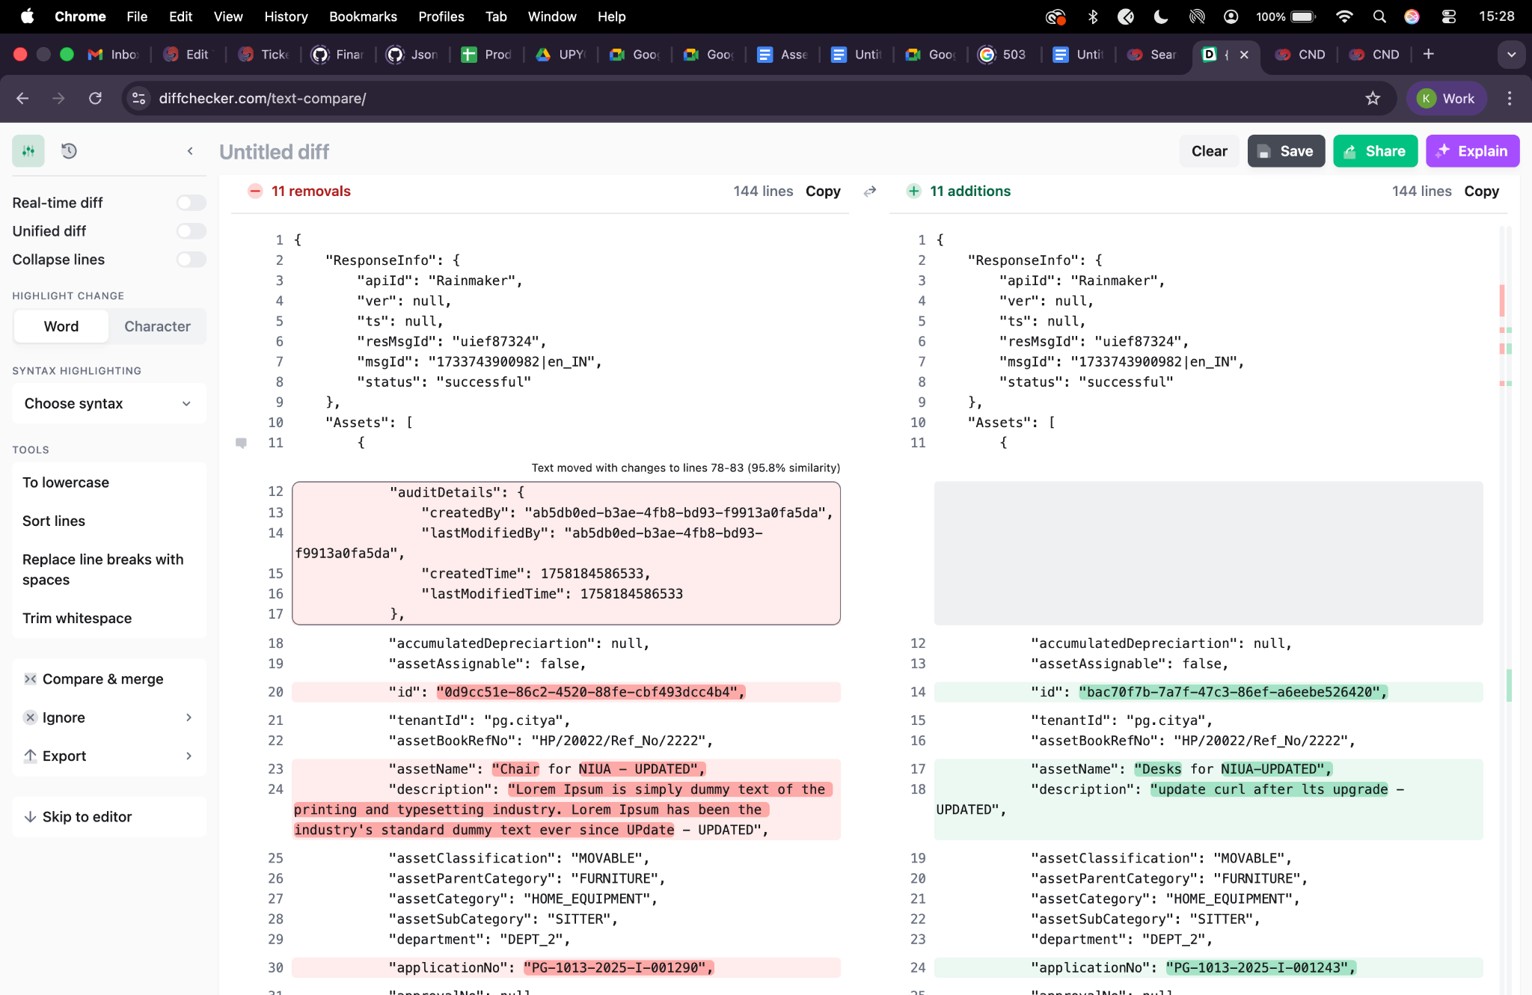

Search curl -
curl --location 'http://localhost:8087/asset-services/v1/assets/_search?tenantId=pg.citya&fromDate=1717180200000&toDate=1732645799000&limit=10&sortBy=commencementDate&sortOrder=DESC&_=1732600268762' \
--header 'Accept: application/json, text/plain, */*' \
--header 'Accept-Language: en-US,en;q=0.9,hi;q=0.8' \
--header 'Connection: keep-alive' \
--header 'Content-Type: application/json;charset=UTF-8' \
--header 'Origin: http://localhost:3000' \
--header 'Referer: http://localhost:3000/digit-ui/employee/asset/assetservice/my-asset' \
--header 'Sec-Fetch-Dest: empty' \
--header 'Sec-Fetch-Mode: cors' \
--header 'Sec-Fetch-Site: same-origin' \
--header 'User-Agent: Mozilla/5.0 (Windows NT 10.0; Win64; x64) AppleWebKit/537.36 (KHTML, like Gecko) Chrome/131.0.0.0 Safari/537.36' \
--header 'sec-ch-ua: "Google Chrome";v="131", "Chromium";v="131", "Not_A Brand";v="24"' \
--header 'sec-ch-ua-mobile: ?0' \
--header 'sec-ch-ua-platform: "Windows"' \
--data-raw '{
"RequestInfo": {
"apiId": "Rainmaker",
"authToken": "eceb5456-e376-4fe0-9598-b710bfb741d6",
"userInfo": {
"id": 194,
"uuid": "a9c4c021-f97b-49d2-8339-969ca2c376f8",
"userName": "BimalAAI2",
"name": "BimalAAITow",
"mobileNumber": "9912722222",
"emailId": "BimalAAITow^@gmail.com",
"locale": null,
"type": "EMPLOYEE",
"roles": [
{
"name": "Asset Initiator Employee",
"code": "ASSET_INITIATOR",
"tenantId": "pg.citya"
}
],
"active": true,
"tenantId": "pg.citya",
"permanentCity": null
},
"msgId": "1732600268762|en_IN",
"plainAccessRequest": {}
}
}'
Response -
{
"ResponseInfo": {
"apiId": "Rainmaker",
"ver": null,
"ts": null,
"resMsgId": "uief87324",
"msgId": "1732600268762|en_IN",
"status": "successful"
},
"Assets": [
{
"id": "a77740f5-2d9a-4b0c-aa6d-707782711cfd",
"tenantId": "pg.citya",
"assetBookRefNo": "Ref_no_12222",
"assetName": "Asset Name / Title ",
"description": null,
"assetClassification": "MOVABLE",
"assetParentCategory": "VEHICLE",
"assetCategory": "MCWG",
"assetSubCategory": "NA",
"department": "DEPT_1",
"applicationNo": "PG-1013-2024-V-000689",
"applicationDate": 1732181902353,
"status": "INITIATED",
"assetStatus": "1",
"location": "25.958179, 92.506975",
"assetAssignment": {
"assignmentId": null,
"assignedUserName": null,
"employeeCode": null,
"designation": null,
"department": "DEPT_1",
"assignedDate": 0,
"isAssigned": false,
"returnDate": 0
}
},
{
"id": "fb42a630-5882-4df2-ae4b-722411f24dc2",
"tenantId": "pg.citya",
"assetBookRefNo": "32424",
"assetName": "324",
"description": null,
"assetClassification": "MOVABLE",
"assetParentCategory": "VEHICLE",
"assetCategory": "COMPUTERS_AND_LAPTOPS",
"assetSubCategory": "DESKTOP_COMPUTERS",
"department": "DEPT_1",
"applicationNo": "PG-1013-2024-V-000676",
"applicationDate": 1730894407972,
"status": "INITIATED",
"assetStatus": "1",
"location": "21.420445, 80.933966",
"assetAssignment": {
"assignmentId": null,
"assignedUserName": null,
"employeeCode": null,
"designation": null,
"department": "DEPT_1",
"assignedDate": 0,
"isAssigned": false,
"returnDate": 0
}
},
{
"id": "05e34c42-440a-4bd6-bf58-2d9ba2243742",
"tenantId": "pg.citya",
"assetBookRefNo": "56456456456",
"assetName": "DP01",
"description": null,
"assetClassification": "IMMOVABLE",
"assetParentCategory": "SERVICE",
"assetCategory": "PUBLIC_LIGHTING_SYSTEM",
"assetSubCategory": "NA",
"department": "DEPT_1",
"applicationNo": "PG-1013-2024-S-000684",
"applicationDate": 1731477742188,
"status": "INITIATED",
"assetStatus": "1",
"location": "19.204042, 87.878343",
"assetAssignment": {
"assignmentId": null,
"assignedUserName": null,
"employeeCode": null,
"designation": null,
"department": "DEPT_1",
"assignedDate": 0,
"isAssigned": false,
"returnDate": 0
}
},
{
"id": "46e1472c-e443-45c8-9e75-d28ebf885a23",
"tenantId": "pg.citya",
"assetBookRefNo": "RefN_00",
"assetName": "HP Laptops",
"description": null,
"assetClassification": "MOVABLE",
"assetParentCategory": "IT",
"assetCategory": "COMPUTERS_AND_LAPTOPS",
"assetSubCategory": "OFFICE_DESK",
"department": "DEPT_1",
"applicationNo": "PG-1013-2024-I-000697",
"applicationDate": 1732601104279,
"status": "INITIATED",
"assetStatus": "1",
"location": "10.359482, 71.894475",
"assetAssignment": {
"assignmentId": null,
"assignedUserName": null,
"employeeCode": null,
"designation": null,
"department": "DEPT_1",
"assignedDate": 0,
"isAssigned": false,
"returnDate": 0
}
},
{
"id": "bc8b2bc2-7889-4044-ae78-c381b4e52c6e",
"tenantId": "pg.citya",
"assetBookRefNo": "Ref_NO_12345",
"assetName": "Laptop Asset name",
"description": null,
"assetClassification": "MOVABLE",
"assetParentCategory": "IT",
"assetCategory": "COMPUTERS_AND_LAPTOPS",
"assetSubCategory": "LAPTOP_COMPUTERS",
"department": "DEPT_1",
"applicationNo": "PG-1013-2024-I-000688",
"applicationDate": 1732165138248,
"status": "INITIATED",
"assetStatus": "1",
"location": "22.897679, 72.842408",
"assetAssignment": {
"assignmentId": null,
"assignedUserName": null,
"employeeCode": null,
"designation": null,
"department": "DEPT_1",
"assignedDate": 0,
"isAssigned": false,
"returnDate": 0
}
},
{
"id": "a6dc0220-37be-401c-bb0e-1db4002ed2dc",
"tenantId": "pg.citya",
"assetBookRefNo": "Keyboard_Ref_number",
"assetName": "Key board",
"description": null,
"assetClassification": "MOVABLE",
"assetParentCategory": "IT",
"assetCategory": "PERIPHERALS",
"assetSubCategory": "KEYBOARDS",
"department": "DEPT_1",
"applicationNo": "PG-1013-2024-I-000686",
"applicationDate": 1732084382373,
"status": "INITIATED",
"assetStatus": "1",
"location": "21.740109, 96.418964",
"assetAssignment": {
"assignmentId": null,
"assignedUserName": null,
"employeeCode": null,
"designation": null,
"department": "DEPT_1",
"assignedDate": 0,
"isAssigned": false,
"returnDate": 0
}
},
{
"id": "fa1d3b8e-40e4-4403-b3a3-36e1078e797f",
"tenantId": "pg.citya",
"assetBookRefNo": "Reference 124",
"assetName": "Asset Name ",
"description": null,
"assetClassification": "MOVABLE",
"assetParentCategory": "IT",
"assetCategory": "COMPUTERS_AND_LAPTOPS",
"assetSubCategory": "DESKTOP_COMPUTERS",
"department": "DEPT_1",
"applicationNo": "PG-1013-2024-I-000606",
"applicationDate": 1729245645271,
"status": "APPROVED",
"assetStatus": "1",
"location": "26.566658, 87.330774",
"assetAssignment": {
"assignmentId": null,
"assignedUserName": null,
"employeeCode": null,
"designation": null,
"department": "DEPT_1",
"assignedDate": 0,
"isAssigned": false,
"returnDate": 0
}
},
{
"id": "1d54061d-5326-4fba-8102-4d405a071351",
"tenantId": "pg.citya",
"assetBookRefNo": "34524352345",
"assetName": "PC",
"description": null,
"assetClassification": "MOVABLE",
"assetParentCategory": "IT",
"assetCategory": "COMPUTERS_AND_LAPTOPS",
"assetSubCategory": "DESKTOP_COMPUTERS",
"department": "DEPT_1",
"applicationNo": "PG-1013-2024-I-000588",
"applicationDate": 1729002883768,
"status": "INITIATED",
"assetStatus": "1",
"location": "10.288927, 70.593843",
"assetAssignment": {
"assignmentId": null,
"assignedUserName": null,
"employeeCode": null,
"designation": null,
"department": "DEPT_1",
"assignedDate": 0,
"isAssigned": false,
"returnDate": 0
}
},
{
"id": "ce4ff3ae-6ebc-4445-b542-7a3f454c1d91",
"tenantId": "pg.citya",
"assetBookRefNo": "23456",
"assetName": "dfadf",
"description": null,
"assetClassification": "MOVABLE",
"assetParentCategory": "IT",
"assetCategory": "COMPUTERS_AND_LAPTOPS",
"assetSubCategory": "DESKTOP_COMPUTERS",
"department": "AGENDA_BRANCH",
"applicationNo": "PG-1013-2024-I-000584",
"applicationDate": 1728452044995,
"status": "INITIATED",
"assetStatus": "1",
"location": "19.098518, 95.519855",
"assetAssignment": {
"assignmentId": null,
"assignedUserName": null,
"employeeCode": null,
"designation": null,
"department": "AGENDA_BRANCH",
"assignedDate": 0,
"isAssigned": false,
"returnDate": 0
}
},
{
"id": "193e9808-2876-4279-b189-96855ac7894d",
"tenantId": "pg.citya",
"assetBookRefNo": "54321",
"assetName": "HP Laptop i5",
"description": null,
"assetClassification": "MOVABLE",
"assetParentCategory": "IT",
"assetCategory": "COMPUTERS_AND_LAPTOPS",
"assetSubCategory": "LAPTOP_COMPUTERS",
"department": "DEPT_4",
"applicationNo": "PG-1013-2024-I-000582",
"applicationDate": 1728279333991,
"status": "APPROVED",
"assetStatus": "1",
"location": "29.172340, 82.294005",
"assetAssignment": {
"assignmentId": null,
"assignedUserName": null,
"employeeCode": null,
"designation": null,
"department": "DEPT_4",
"assignedDate": 0,
"isAssigned": false,
"returnDate": 0
}
}
]
}
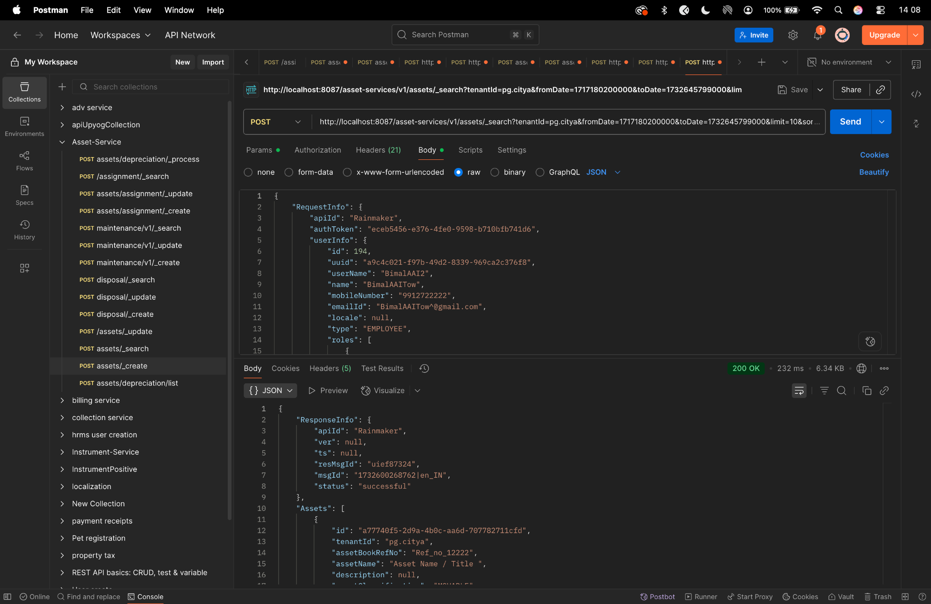

Assignment create-

curl --location 'http://localhost:8087/asset-services/v1/assets/assignment/_create' \
--header 'accept: application/json, text/plain, */*' \
--header 'accept-language: en-GB,en-US;q=0.9,en;q=0.8,hi;q=0.7' \
--header 'content-type: application/json;charset=UTF-8' \
--header 'origin: https://niuatt.niua.in' \
--header 'priority: u=1, i' \
--header 'referer: https://niuatt.niua.in/digit-ui/employee/asset/assetservice/assign-response' \
--header 'sec-ch-ua: "Not;A=Brand";v="99", "Google Chrome";v="139", "Chromium";v="139"' \
--header 'sec-ch-ua-mobile: ?0' \
--header 'sec-ch-ua-platform: "macOS"' \
--header 'sec-fetch-dest: empty' \
--header 'sec-fetch-mode: cors' \
--header 'sec-fetch-site: same-origin' \
--header 'user-agent: Mozilla/5.0 (Macintosh; Intel Mac OS X 10_15_7) AppleWebKit/537.36 (KHTML, like Gecko) Chrome/139.0.0.0 Safari/537.36' \
--header 'Cookie: locale=en_IN; _ga=GA1.1.559242739.1756447705; _clck=19weqns%5E2%5Efyv%5E0%5E2067; _ga_VZ9TNBTB3X=GS2.1.s1756447704$o1$g1$t1756447780$j59$l0$h0; _ga_E39TFV5YXM=GS2.1.s1756447709$o1$g1$t1756448684$j60$l0$h0' \
--data '{
"Asset": {
"id": "292c3bd8-4060-4efa-9f0d-d1fc81926625",
"tenantId": "pg.citya",
"applicationNo": "PG-1013-2025-I-001236",
"assetAssignment": {
"assignmentId": "",
"assetApplicaltionNo": "",
"assetId": "",
"assignedUserName": "Kunal Gaurav",
"designation": "DESIG_01",
"department": "DEPT_1",
"assignedDate": 1756924200000,
"isAssigned": true,
"allocatedDepartment": "DEPT_1",
"employeeCode": "EMP-001",
"auditDetails": {
"createdBy": "",
"lastModifiedBy": "",
"createdTime": "",
"lastModifiedTime": ""
}
}
},
"RequestInfo": {
"apiId": "Rainmaker",
"authToken": "54552937-0eb8-4cec-910a-182918416f7f",
"userInfo": {
"id": 909,
"uuid": "491381fb-858c-4582-a8cd-24ea08394bb8",
"userName": "ASSET_APPROVER",
"name": "Asset Approver",
"mobileNumber": "8448489439",
"emailId": null,
"locale": null,
"type": "EMPLOYEE",
"roles": [
{
"name": "Asset Approver",
"code": "ASSET_APPROVER",
"tenantId": "pg.citya"
},
{
"name": "Asset Allocator",
"code": "ASSET_ALLOCATOR",
"tenantId": "pg.citya"
}
],
"active": true,
"tenantId": "pg.citya",
"permanentCity": null
},
"msgId": "1757667814971|en_IN",
"plainAccessRequest": {}
}
}'
Response -
{
"ResponseInfo": {
"apiId": "Rainmaker",
"ver": null,
"ts": null,
"resMsgId": "uief87324",
"msgId": "1757667814971|en_IN",
"status": "successful"
},
"Assets": [
{
"auditDetails": null,
"accumulatedDepreciartion": null,
"assetAssignable": false,
"id": "292c3bd8-4060-4efa-9f0d-d1fc81926625",
"tenantId": "pg.citya",
"assetBookRefNo": null,
"assetName": null,
"description": null,
"assetClassification": null,
"assetParentCategory": null,
"assetCategory": null,
"assetSubCategory": null,
"department": null,
"applicationNo": "PG-1013-2025-I-001236",
"approvalNo": null,
"approvalDate": null,
"applicationDate": null,
"status": null,
"addressDetails": null,
"documents": null,
"assetAssignment": {
"auditDetails": {
"createdBy": "491381fb-858c-4582-a8cd-24ea08394bb8",
"lastModifiedBy": "491381fb-858c-4582-a8cd-24ea08394bb8",
"createdTime": 1758185392536,
"lastModifiedTime": 1758185392536
},
"assignmentId": "2c611b09-fb89-4e9c-8630-d5916b628cc7",
"assetApplicaltionNo": "",
"tenantId": null,
"assignedUserName": "Kunal Gaurav",
"employeeCode": "EMP-001",
"designation": "DESIG_01",
"department": "DEPT_1",
"assignedDate": 1756924200000,
"isAssigned": true,
"returnDate": null
},
"additionalDetails": null,
"accountId": null,
"remarks": null,
"financialYear": null,
"sourceOfFinance": null,
"workflow": null,
"scheme": null,
"subScheme": null,
"purchaseCost": 0.0,
"acquisitionCost": 0.0,
"bookValue": 0.0,
"invoiceDate": null,
"invoiceNumber": null,
"purchaseDate": null,
"purchaseOrderNumber": null,
"location": null,
"oldCode": null,
"modeOfPossessionOrAcquisition": null,
"unitOfMeasurement": null,
"lifeOfAsset": null,
"assetUsage": null,
"assetType": null,
"assetStatus": null,
"originalBookValue": 0.0,
"minimumValue": null,
"islegacyData": null
}
]
}

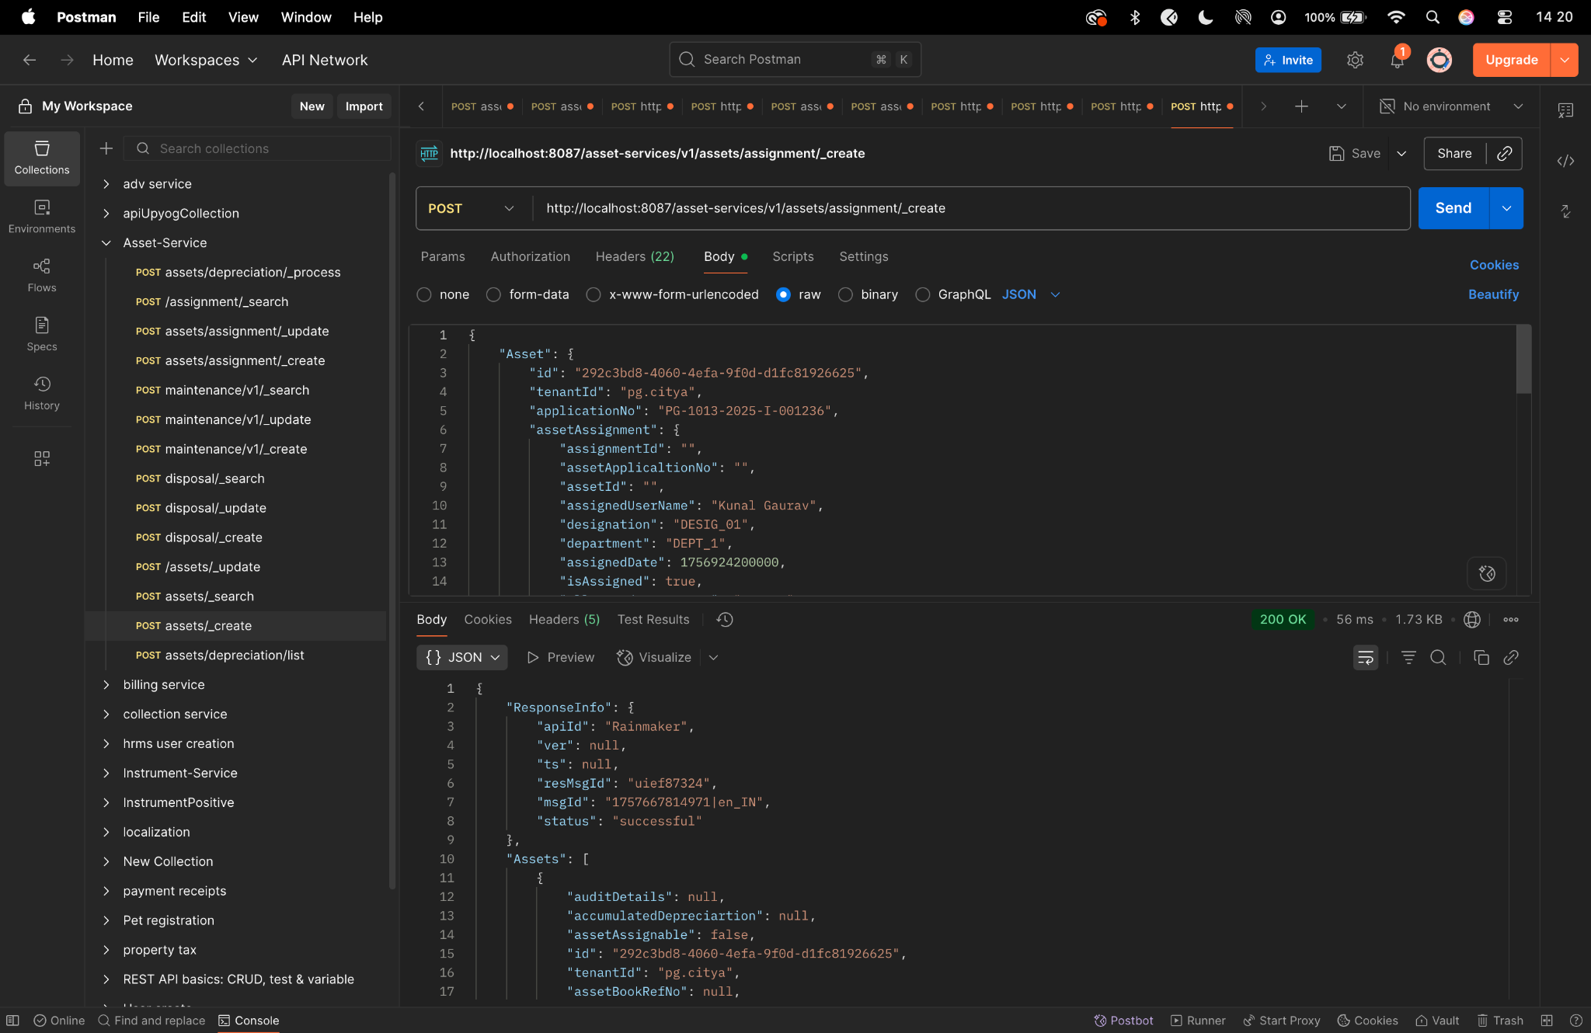

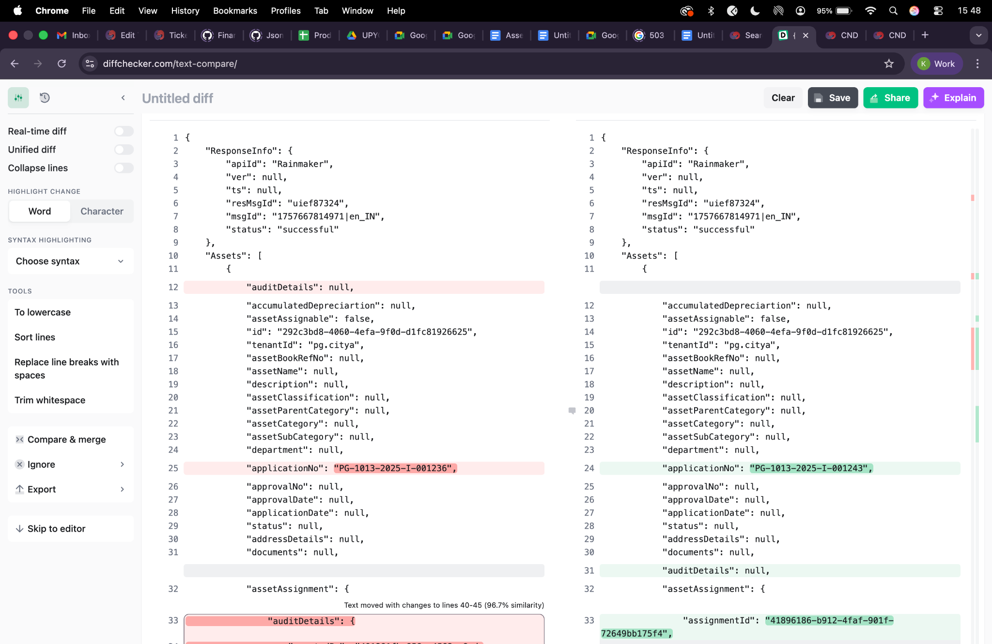

Assignment update -
curl --location 'http://localhost:8087/asset-services/v1/assets/assignment/_update' \
--header 'accept: application/json, text/plain, */*' \
--header 'accept-language: en-GB,en-US;q=0.9,en;q=0.8,hi;q=0.7' \
--header 'content-type: application/json;charset=UTF-8' \
--header 'origin: https://niuatt.niua.in' \
--header 'priority: u=1, i' \
--header 'referer: https://niuatt.niua.in/digit-ui/employee/asset/assetservice/assign-response' \
--header 'sec-ch-ua: "Not;A=Brand";v="99", "Google Chrome";v="139", "Chromium";v="139"' \
--header 'sec-ch-ua-mobile: ?0' \
--header 'sec-ch-ua-platform: "macOS"' \
--header 'sec-fetch-dest: empty' \
--header 'sec-fetch-mode: cors' \
--header 'sec-fetch-site: same-origin' \
--header 'user-agent: Mozilla/5.0 (Macintosh; Intel Mac OS X 10_15_7) AppleWebKit/537.36 (KHTML, like Gecko) Chrome/139.0.0.0 Safari/537.36' \
--header 'Cookie: locale=en_IN; _ga=GA1.1.559242739.1756447705; _clck=19weqns%5E2%5Efyv%5E0%5E2067; _ga_VZ9TNBTB3X=GS2.1.s1756447704$o1$g1$t1756447780$j59$l0$h0; _ga_E39TFV5YXM=GS2.1.s1756447709$o1$g1$t1756448684$j60$l0$h0' \
--data '{
"Asset": {
"id": "292c3bd8-4060-4efa-9f0d-d1fc81926625",
"tenantId": "pg.citya",
"applicationNo": "PG-1013-2025-I-001236",
"assetAssignment": {
"assignmentId": "2c611b09-fb89-4e9c-8630-d5916b628cc7",
"assetApplicaltionNo": "PG-1013-2025-I-001236",
"assetId": "292c3bd8-4060-4efa-9f0d-d1fc81926625",
"assignedUserName": "Kunal Gaurav - Updated",
"designation": "DESIG_02",
"department": "DEPT_2",
"assignedDate": 1756924200000,
"returnDate": 1757529000000,
"isAssigned": false,
"allocatedDepartment": "DEPT_2",
"employeeCode": "EMP-002",
"auditDetails": {
"createdBy": "admin",
"lastModifiedBy": "admin",
"createdTime": 1672531200000,
"lastModifiedTime": 1672534800000
}
}
},
"RequestInfo": {
"apiId": "Rainmaker",
"authToken": "54552937-0eb8-4cec-910a-182918416f7f",
"userInfo": {
"id": 909,
"uuid": "491381fb-858c-4582-a8cd-24ea08394bb8",
"userName": "ASSET_APPROVER",
"name": "Asset Approver",
"mobileNumber": "8448489439",
"emailId": null,
"locale": null,
"type": "EMPLOYEE",
"roles": [
{
"name": "Asset Approver",
"code": "ASSET_APPROVER",
"tenantId": "pg.citya"
},
{
"name": "Asset Allocator",
"code": "ASSET_ALLOCATOR",
"tenantId": "pg.citya"
}
],
"active": true,
"tenantId": "pg.citya",
"permanentCity": null
},
"msgId": "1757667814971|en_IN",
"plainAccessRequest": {}
}
}'
Response -
{
"ResponseInfo": {
"apiId": "Rainmaker",
"ver": null,
"ts": null,
"resMsgId": "uief87324",
"msgId": "1757667814971|en_IN",
"status": "successful"
},
"Assets": [
{
"auditDetails": null,
"accumulatedDepreciartion": null,
"assetAssignable": false,
"id": "292c3bd8-4060-4efa-9f0d-d1fc81926625",
"tenantId": "pg.citya",
"assetBookRefNo": null,
"assetName": null,
"description": null,
"assetClassification": null,
"assetParentCategory": null,
"assetCategory": null,
"assetSubCategory": null,
"department": null,
"applicationNo": "PG-1013-2025-I-001236",
"approvalNo": null,
"approvalDate": null,
"applicationDate": null,
"status": null,
"addressDetails": null,
"documents": null,
"assetAssignment": {
"auditDetails": {
"createdBy": "491381fb-858c-4582-a8cd-24ea08394bb8",
"lastModifiedBy": "491381fb-858c-4582-a8cd-24ea08394bb8",
"createdTime": 1758185523626,
"lastModifiedTime": 1758185523626
},
"assignmentId": "2c611b09-fb89-4e9c-8630-d5916b628cc7",
"assetApplicaltionNo": "PG-1013-2025-I-001236",
"tenantId": null,
"assignedUserName": "Kunal Gaurav - Updated",
"employeeCode": "EMP-002",
"designation": "DESIG_02",
"department": "DEPT_2",
"assignedDate": 1756924200000,
"isAssigned": false,
"returnDate": 1757529000000
},
"additionalDetails": null,
"accountId": null,
"remarks": null,
"financialYear": null,
"sourceOfFinance": null,
"workflow": null,
"scheme": null,
"subScheme": null,
"purchaseCost": 0.0,
"acquisitionCost": 0.0,
"bookValue": 0.0,
"invoiceDate": null,
"invoiceNumber": null,
"purchaseDate": null,
"purchaseOrderNumber": null,
"location": null,
"oldCode": null,
"modeOfPossessionOrAcquisition": null,
"unitOfMeasurement": null,
"lifeOfAsset": null,
"assetUsage": null,
"assetType": null,
"assetStatus": null,
"originalBookValue": 0.0,
"minimumValue": null,
"islegacyData": null
}
]
}
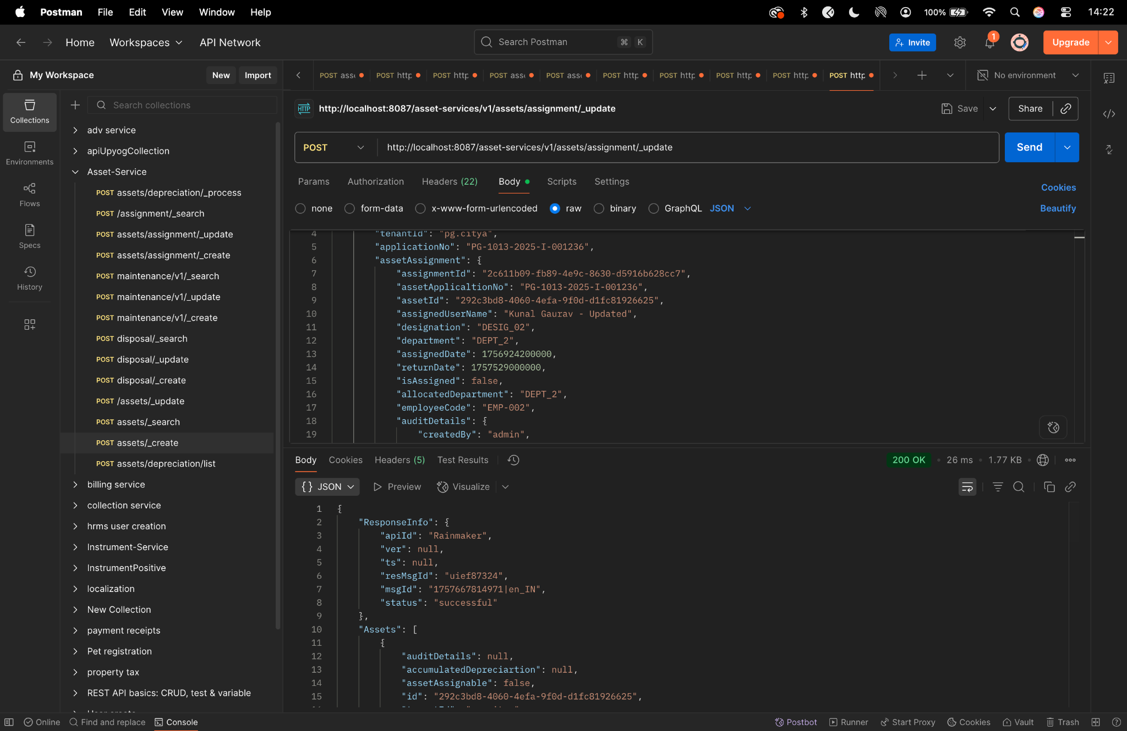

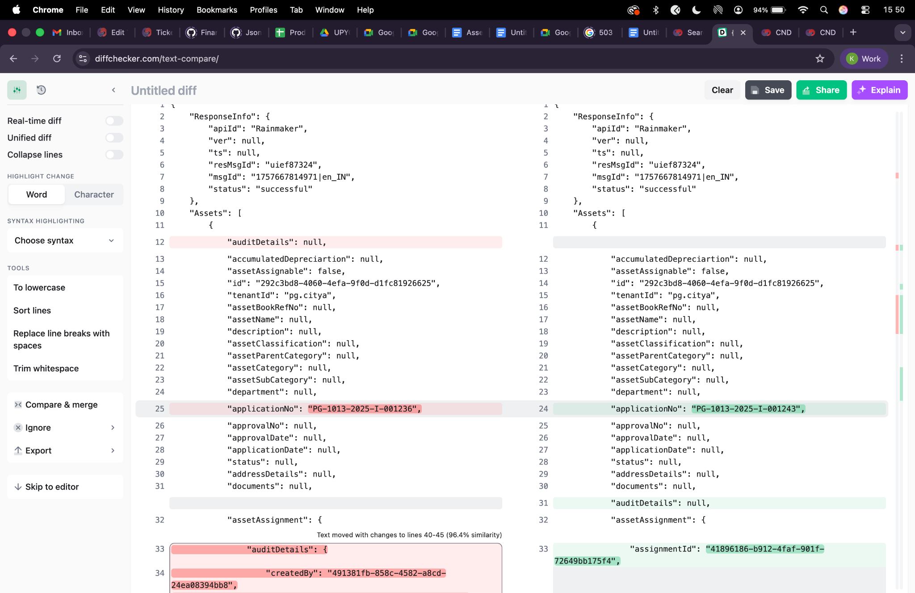

Assignment search -
curl --location 'http://localhost:8087/asset-services/v1/assets/assignment/_search' \
--header 'accept: application/json, text/plain, */*' \
--header 'accept-language: en-GB,en-US;q=0.9,en;q=0.8,hi;q=0.7' \
--header 'content-type: application/json;charset=UTF-8' \
--header 'origin: https://niuatt.niua.in' \
--header 'priority: u=1, i' \
--header 'referer: https://niuatt.niua.in/digit-ui/employee/asset/assetservice/assign-response' \
--header 'sec-ch-ua: "Not;A=Brand";v="99", "Google Chrome";v="139", "Chromium";v="139"' \
--header 'sec-ch-ua-mobile: ?0' \
--header 'sec-ch-ua-platform: "macOS"' \
--header 'sec-fetch-dest: empty' \
--header 'sec-fetch-mode: cors' \
--header 'sec-fetch-site: same-origin' \
--header 'user-agent: Mozilla/5.0 (Macintosh; Intel Mac OS X 10_15_7) AppleWebKit/537.36 (KHTML, like Gecko) Chrome/139.0.0.0 Safari/537.36' \
--header 'Cookie: locale=en_IN; _ga=GA1.1.559242739.1756447705; _clck=19weqns%5E2%5Efyv%5E0%5E2067; _ga_VZ9TNBTB3X=GS2.1.s1756447704$o1$g1$t1756447780$j59$l0$h0; _ga_E39TFV5YXM=GS2.1.s1756447709$o1$g1$t1756448684$j60$l0$h0' \
--data '{
"Asset": {
"id": "292c3bd8-4060-4efa-9f0d-d1fc81926625",
"tenantId": "pg.citya"
},
"RequestInfo": {
"apiId": "Rainmaker",
"authToken": "54552937-0eb8-4cec-910a-182918416f7f",
"userInfo": {
"id": 909,
"uuid": "491381fb-858c-4582-a8cd-24ea08394bb8",
"userName": "ASSET_APPROVER",
"name": "Asset Approver",
"mobileNumber": "8448489439",
"emailId": null,
"locale": null,
"type": "EMPLOYEE",
"roles": [
{
"name": "Asset Approver",
"code": "ASSET_APPROVER",
"tenantId": "pg.citya"
},
{
"name": "Asset Allocator",
"code": "ASSET_ALLOCATOR",
"tenantId": "pg.citya"
}
],
"active": true,
"tenantId": "pg.citya",
"permanentCity": null
},
"msgId": "1757667814971|en_IN",
"plainAccessRequest": {}
}
}'
Response -
{
"assetAssignments": [
{
"auditDetails": null,
"assignmentId": "2c611b09-fb89-4e9c-8630-d5916b628cc7",
"assetApplicaltionNo": "PG-1013-2025-I-001236",
"tenantId": "pg.citya",
"assignedUserName": "Kunal Gaurav - Updated",
"employeeCode": "EMP-002",
"designation": "DESIG_02",
"department": "DEPT_2",
"assignedDate": 1756924200000,
"isAssigned": false,
"returnDate": 1757529000000
},
{
"auditDetails": null,
"assignmentId": "2c611b09-fb89-4e9c-8630-d5916b628cc7",
"assetApplicaltionNo": "PG-1013-2025-I-001236",
"tenantId": "pg.citya",
"assignedUserName": "Kunal Gaurav - Updated",
"employeeCode": "EMP-002",
"designation": "DESIG_02",
"department": "DEPT_2",
"assignedDate": 1756924200000,
"isAssigned": false,
"returnDate": 1757529000000
},
{
"auditDetails": null,
"assignmentId": "2c611b09-fb89-4e9c-8630-d5916b628cc7",
"assetApplicaltionNo": "PG-1013-2025-I-001236",
"tenantId": "pg.citya",
"assignedUserName": "Kunal Gaurav - Updated",
"employeeCode": "EMP-002",
"designation": "DESIG_02",
"department": "DEPT_2",
"assignedDate": 1756924200000,
"isAssigned": false,
"returnDate": 1757529000000
}
],
"ResponseInfo": {
"apiId": "",
"ver": "",
"ts": null,
"resMsgId": "uief87324",
"msgId": "",
"status": "successful"
}
}

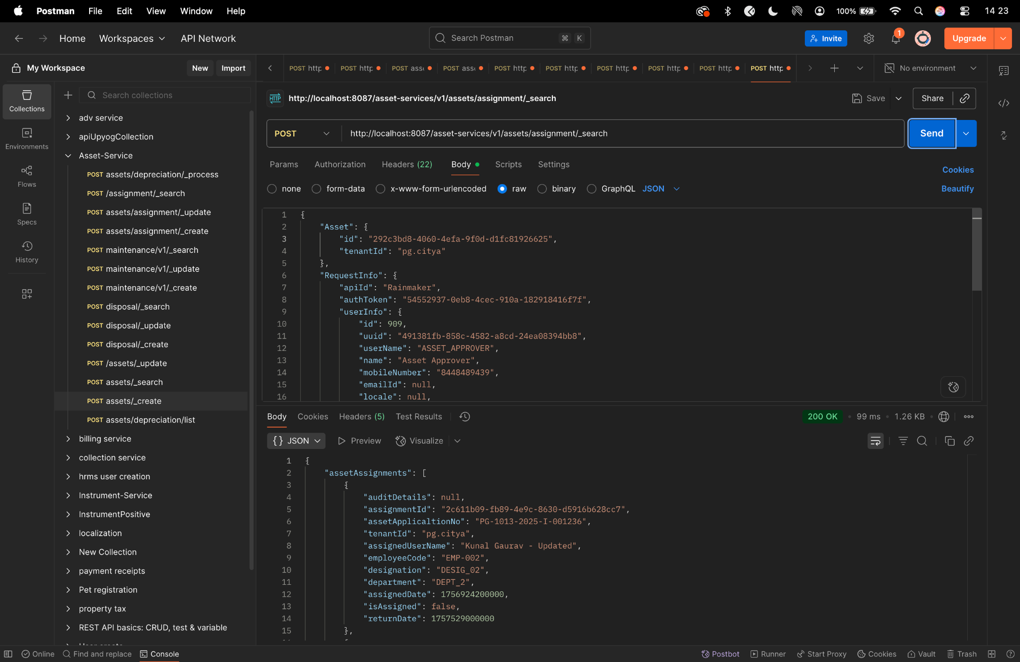

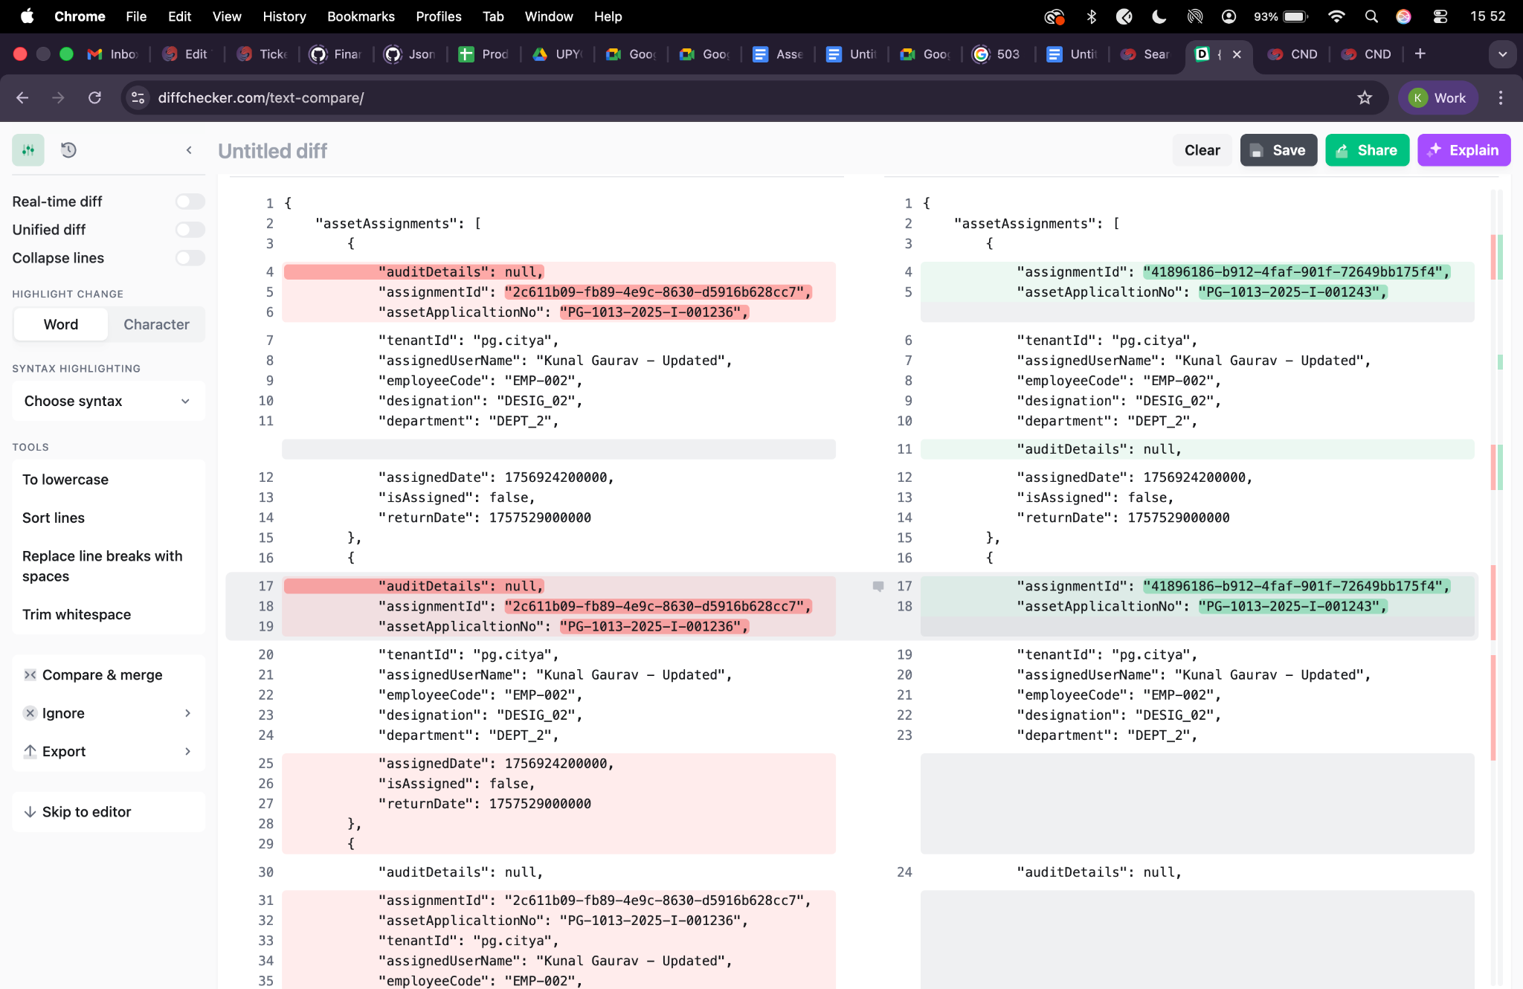

Maintenance create-
curl --location 'http://localhost:8087/asset-services/maintenance/v1/_create' \
--header 'sec-ch-ua-platform: "macOS"' \
--header 'Referer: https://niuatt.niua.in/digit-ui/employee/asset/assetservice/maintenance' \
--header 'User-Agent: Mozilla/5.0 (Macintosh; Intel Mac OS X 10_15_7) AppleWebKit/537.36 (KHTML, like Gecko) Chrome/133.0.0.0 Safari/537.36' \
--header 'Accept: application/json, text/plain, */*' \
--header 'sec-ch-ua: "Not(A:Brand";v="99", "Google Chrome";v="133", "Chromium";v="133"' \
--header 'Content-Type: application/json;charset=UTF-8' \
--header 'sec-ch-ua-mobile: ?0' \
--data '{
"AssetMaintenance": {
"maintenanceId": "",
"assetId": "0d9cc51e-86c2-4520-88fe-cbf493dcc4b4",
"tenantId": "pg.citya",
"warrantyStatus": "IN_AMC",
"assetWarrantyDescription": "sdfdsf",
"amcDetails": "sdfsd",
"assetMaintenanceDate": 1756771200,
"assetNextMaintenanceDate": null,
"maintenanceType": "CORRECTIVE",
"paymentType": "BANK_TRANSFER",
"costOfMaintenance": "",
"description": "warranty",
"vendor": "dsfs",
"maintenanceCycle": "QUARTERLY",
"partsAddedOrReplaced": "sdfsdf",
"preConditionRemarks": "dfsdf",
"postConditionRemarks": "dsfsdf",
"isAMCExpired": true,
"isWarrantyExpired": false,
"isLifeOfAssetAffected": "TRUE",
"assetMaintenanceIncreasedYear": "2",
"documents": [
{
"documentType": "ASSET.MAINTENANCE.DOC3",
"fileStoreId": "16ce3c83-a416-4e60-b6ff-1eaa1a47c278",
"documentUid": "16ce3c83-a416-4e60-b6ff-1eaa1a47c278"
},
{
"documentType": "ASSET.MAINTENANCE.DOC1",
"fileStoreId": "ba1ca218-ca65-438c-9a2e-519acf799f3e",
"documentUid": "ba1ca218-ca65-438c-9a2e-519acf799f3e"
},
{
"documentType": "ASSET.MAINTENANCE.DOC2",
"fileStoreId": "48e2932e-432b-4f83-8b0a-09229f107fbc",
"documentUid": "48e2932e-432b-4f83-8b0a-09229f107fbc"
}
],
"auditDetails": {
"createdBy": "",
"createdTime": "",
"lastModifiedBy": "",
"lastModifiedTime": ""
}
},
"RequestInfo": {
"apiId": "Rainmaker",
"authToken": "54552937-0eb8-4cec-910a-182918416f7f",
"userInfo": {
"id": 909,
"uuid": "491381fb-858c-4582-a8cd-24ea08394bb8",
"userName": "ASSET_APPROVER",
"name": "Asset Approver",
"mobileNumber": "8448489439",
"emailId": null,
"locale": null,
"type": "EMPLOYEE",
"roles": [
{
"name": "Asset Approver",
"code": "ASSET_APPROVER",
"tenantId": "pg.citya"
},
{
"name": "Asset Allocator",
"code": "ASSET_ALLOCATOR",
"tenantId": "pg.citya"
}
],
"active": true,
"tenantId": "pg.citya",
"permanentCity": null
},
"msgId": "1757659710772|en_IN",
"plainAccessRequest": {}
}
}'

Response -
{
"ResponseInfo": {
"apiId": "Rainmaker",
"ver": null,
"ts": null,
"resMsgId": "uief87324",
"msgId": "1757659710772|en_IN",
"status": "successful"
},
"AssetMaintenance": [
{
"auditDetails": {
"createdBy": "491381fb-858c-4582-a8cd-24ea08394bb8",
"lastModifiedBy": "491381fb-858c-4582-a8cd-24ea08394bb8",
"createdTime": 1758185766277,
"lastModifiedTime": 1758185766277
},
"maintenanceId": "87f076a2-347f-4a0e-84a5-965a1bb82717",
"assetId": "0d9cc51e-86c2-4520-88fe-cbf493dcc4b4",
"tenantId": "pg.citya",
"currentLifeOfAsset": null,
"isWarrantyExpired": false,
"isAMCExpired": true,
"warrantyStatus": "IN_AMC",
"amcDetails": "sdfsd",
"maintenanceType": "CORRECTIVE",
"paymentType": "BANK_TRANSFER",
"costOfMaintenance": null,
"vendor": "dsfs",
"maintenanceCycle": "QUARTERLY",
"partsAddedOrReplaced": "sdfsdf",
"additionalDetails": null,
"postConditionRemarks": "dsfsdf",
"preConditionRemarks": "dfsdf",
"assetMaintenanceStatus": null,
"documents": [
{
"documentId": "0b0f03ef-050d-43a7-8fa7-18aae7e1db7e",
"documentType": "ASSET.MAINTENANCE.DOC3",
"fileStoreId": "16ce3c83-a416-4e60-b6ff-1eaa1a47c278",
"documentUid": "fec3f032-dafa-4a82-9056-11df338c07e9",
"docDetails": null
},
{
"documentId": "923b2d99-923c-4d37-9888-3361aa21c6a8",
"documentType": "ASSET.MAINTENANCE.DOC1",
"fileStoreId": "ba1ca218-ca65-438c-9a2e-519acf799f3e",
"documentUid": "3974fdbd-d719-4703-baa6-37440ec371d4",
"docDetails": null
},
{
"documentId": "523b6ab6-7d1f-425a-9443-b4dc203a19af",
"documentType": "ASSET.MAINTENANCE.DOC2",
"fileStoreId": "48e2932e-432b-4f83-8b0a-09229f107fbc",
"documentUid": "a2325374-e43e-4b48-bf13-f1bea26653e7",
"docDetails": null
}
],
"description": "warranty",
"assetMaintenanceDate": 1756771200,
"assetNextMaintenanceDate": null
}
]
}
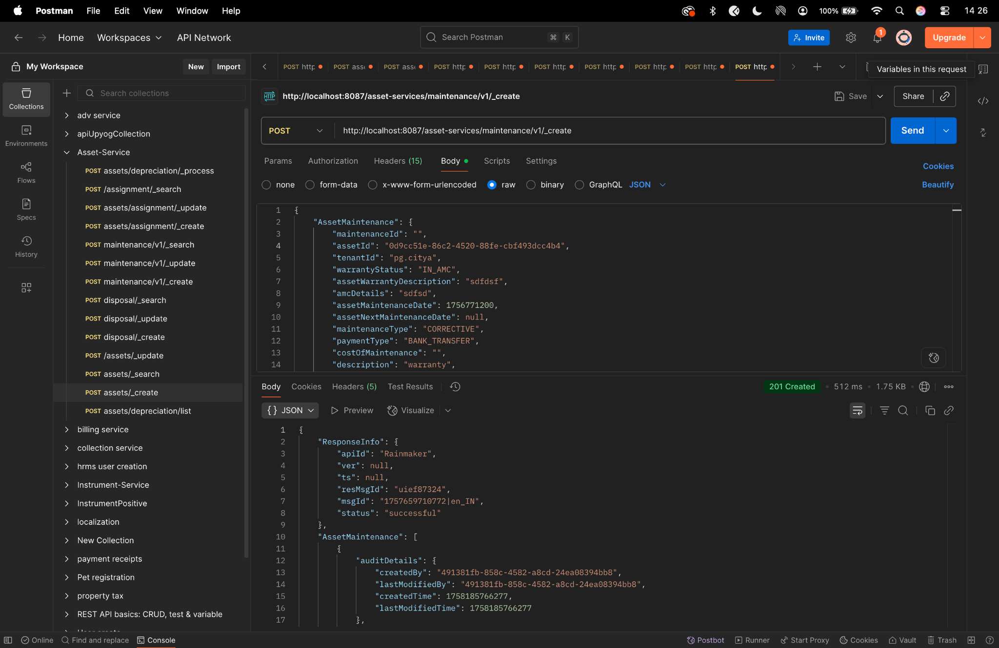

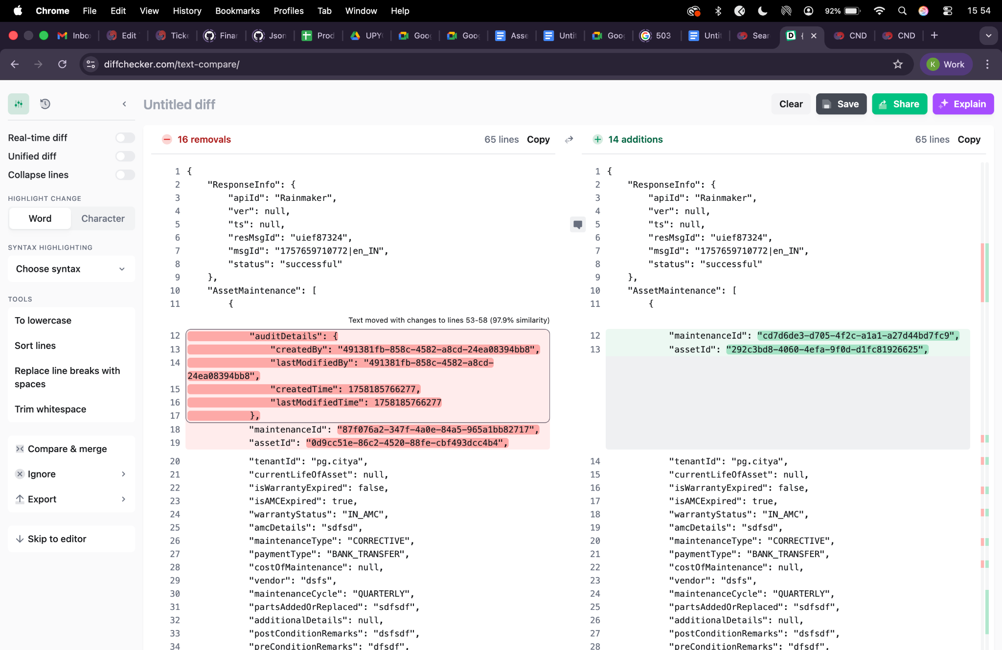

Maintenance update -
curl --location 'http://localhost:8087/asset-services/maintenance/v1/_update' \
--header 'sec-ch-ua-platform: "macOS"' \
--header 'Referer: https://niuatt.niua.in/digit-ui/employee/asset/assetservice/maintenance' \
--header 'User-Agent: Mozilla/5.0 (Macintosh; Intel Mac OS X 10_15_7) AppleWebKit/537.36 (KHTML, like Gecko) Chrome/133.0.0.0 Safari/537.36' \
--header 'Accept: application/json, text/plain, */*' \
--header 'sec-ch-ua: "Not(A:Brand";v="99", "Google Chrome";v="133", "Chromium";v="133"' \
--header 'Content-Type: application/json;charset=UTF-8' \
--header 'sec-ch-ua-mobile: ?0' \
--data '{
"AssetMaintenance": {
"maintenanceId": "487f076a2-347f-4a0e-84a5-965a1bb82717",
"assetId": "0d9cc51e-86c2-4520-88fe-cbf493dcc4b4",
"tenantId": "pg.citya",
"warrantyStatus": "IN_AMC",
"assetWarrantyDescription": "sdfdsf",
"amcDetails": "sdfsd",
"assetMaintenanceDate": 1756771200,
"assetNextMaintenanceDate": null,
"maintenanceType": "CORRECTIVE",
"paymentType": "BANK_TRANSFER",
"costOfMaintenance": "",
"description": "warranty",
"vendor": "Kunal Gaurav",
"maintenanceCycle": "QUARTERLY",
"partsAddedOrReplaced": "sdfsdf",
"preConditionRemarks": "dfsdf",
"postConditionRemarks": "dsfsdf",
"isAMCExpired": true,
"isWarrantyExpired": false,
"isLifeOfAssetAffected": "TRUE",
"assetMaintenanceIncreasedYear": "2",
"documents": [
{
"documentType": "ASSET.MAINTENANCE.DOC3",
"fileStoreId": "16ce3c83-a416-4e60-b6ff-1eaa1a47c278",
"documentUid": "16ce3c83-a416-4e60-b6ff-1eaa1a47c278",
"documentId": "1"
},
{
"documentType": "ASSET.MAINTENANCE.DOC1",
"fileStoreId": "ba1ca218-ca65-438c-9a2e-519acf799f3e",
"documentUid": "ba1ca218-ca65-438c-9a2e-519acf799f3e",
"documentId": "1"
},
{
"documentType": "ASSET.MAINTENANCE.DOC2",
"fileStoreId": "48e2932e-432b-4f83-8b0a-09229f107fbc",
"documentUid": "48e2932e-432b-4f83-8b0a-09229f107fbc",
"documentId": "1"
}
],
"auditDetails": {
"createdBy": "",
"createdTime": "",
"lastModifiedBy": "",
"lastModifiedTime": ""
}
},
"RequestInfo": {
"apiId": "Rainmaker",
"authToken": "54552937-0eb8-4cec-910a-182918416f7f",
"userInfo": {
"id": 909,
"uuid": "491381fb-858c-4582-a8cd-24ea08394bb8",
"userName": "ASSET_APPROVER",
"name": "Asset Approver",
"mobileNumber": "8448489439",
"emailId": null,
"locale": null,
"type": "EMPLOYEE",
"roles": [
{
"name": "Asset Approver",
"code": "ASSET_APPROVER",
"tenantId": "pg.citya"
},
{
"name": "Asset Allocator",
"code": "ASSET_ALLOCATOR",
"tenantId": "pg.citya"
}
],
"active": true,
"tenantId": "pg.citya",
"permanentCity": null
},
"msgId": "1757659710772|en_IN",
"plainAccessRequest": {}
}
}'
Response -

{
"ResponseInfo": {
"apiId": "Rainmaker",
"ver": null,
"ts": null,
"resMsgId": "uief87324",
"msgId": "1757659710772|en_IN",
"status": "successful"
},
"AssetMaintenance": [
{
"auditDetails": {
"createdBy": null,
"lastModifiedBy": "491381fb-858c-4582-a8cd-24ea08394bb8",
"createdTime": null,
"lastModifiedTime": 1758185878304
},
"maintenanceId": "487f076a2-347f-4a0e-84a5-965a1bb82717",
"assetId": "0d9cc51e-86c2-4520-88fe-cbf493dcc4b4",
"tenantId": "pg.citya",
"currentLifeOfAsset": null,
"isWarrantyExpired": false,
"isAMCExpired": true,
"warrantyStatus": "IN_AMC",
"amcDetails": "sdfsd",
"maintenanceType": "CORRECTIVE",
"paymentType": "BANK_TRANSFER",
"costOfMaintenance": null,
"vendor": "Kunal Gaurav",
"maintenanceCycle": "QUARTERLY",
"partsAddedOrReplaced": "sdfsdf",
"additionalDetails": null,
"postConditionRemarks": "dsfsdf",
"preConditionRemarks": "dfsdf",
"assetMaintenanceStatus": null,
"documents": [
{
"documentId": "1",
"documentType": "ASSET.MAINTENANCE.DOC3",
"fileStoreId": "16ce3c83-a416-4e60-b6ff-1eaa1a47c278",
"documentUid": "16ce3c83-a416-4e60-b6ff-1eaa1a47c278",
"docDetails": null
},
{
"documentId": "1",
"documentType": "ASSET.MAINTENANCE.DOC1",
"fileStoreId": "ba1ca218-ca65-438c-9a2e-519acf799f3e",
"documentUid": "ba1ca218-ca65-438c-9a2e-519acf799f3e",
"docDetails": null
},
{
"documentId": "1",
"documentType": "ASSET.MAINTENANCE.DOC2",
"fileStoreId": "48e2932e-432b-4f83-8b0a-09229f107fbc",
"documentUid": "48e2932e-432b-4f83-8b0a-09229f107fbc",
"docDetails": null
}
],
"description": "warranty",
"assetMaintenanceDate": 1756771200,
"assetNextMaintenanceDate": null
}
]
}
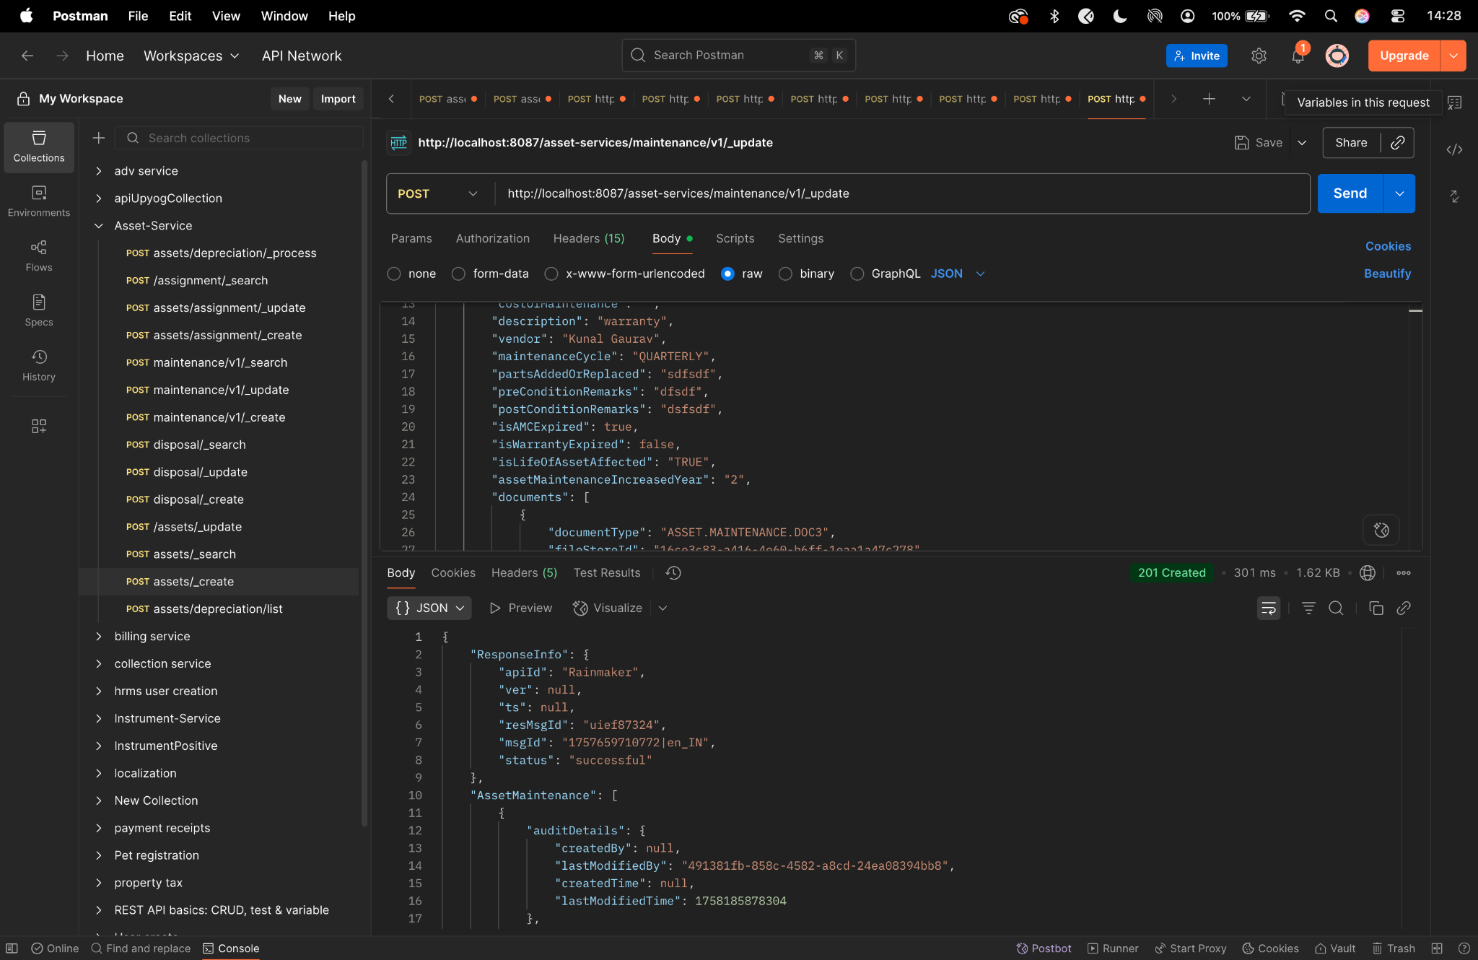

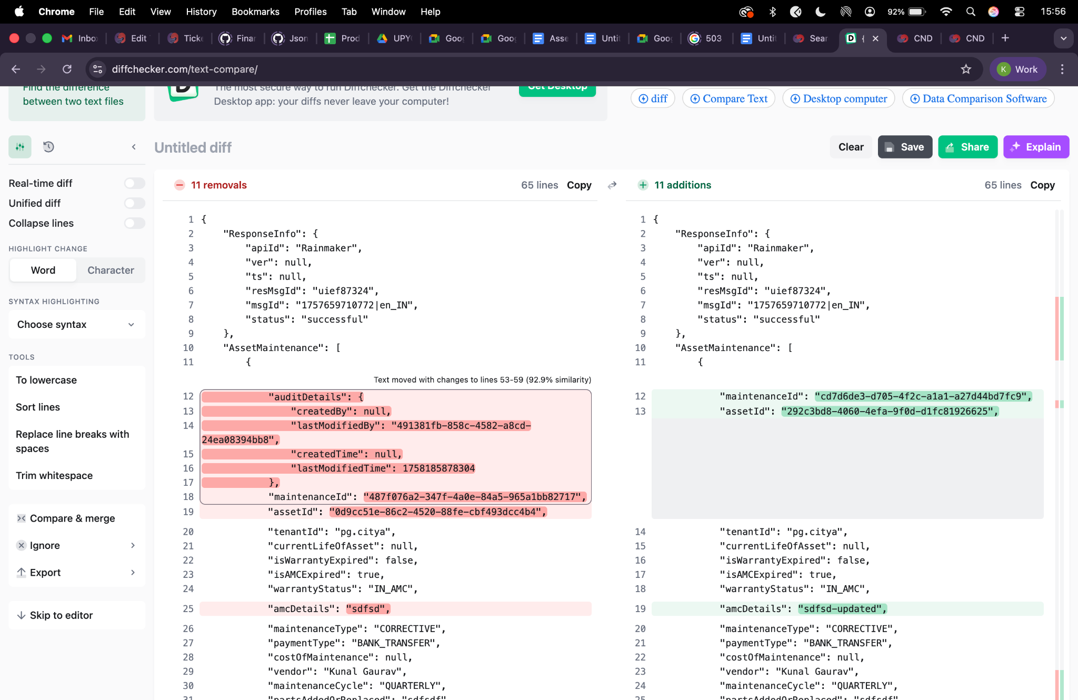

Maintenance search -
curl --location 'http://localhost:8087/asset-services/maintenance/v1/_search' \
--header 'sec-ch-ua-platform: "macOS"' \
--header 'Referer: https://niuatt.niua.in/digit-ui/employee/asset/assetservice/maintenance' \
--header 'User-Agent: Mozilla/5.0 (Macintosh; Intel Mac OS X 10_15_7) AppleWebKit/537.36 (KHTML, like Gecko) Chrome/133.0.0.0 Safari/537.36' \
--header 'Accept: application/json, text/plain, */*' \
--header 'sec-ch-ua: "Not(A:Brand";v="99", "Google Chrome";v="133", "Chromium";v="133"' \
--header 'Content-Type: application/json;charset=UTF-8' \
--header 'sec-ch-ua-mobile: ?0' \
--data '{
"AssetMaintenanceSearchCriteria": {
"tenantId": "pg.citya",
"assetId": "0d9cc51e-86c2-4520-88fe-cbf493dcc4b4",
"maintenanceId": "487f076a2-347f-4a0e-84a5-965a1bb82717",
"maintenanceType": "CORRECTIVE",
"offset": 0,
"limit": 10
},
"RequestInfo": {
"apiId": "Rainmaker",
"authToken": "54552937-0eb8-4cec-910a-182918416f7f",
"userInfo": {
"id": 909,
"uuid": "491381fb-858c-4582-a8cd-24ea08394bb8",
"userName": "ASSET_APPROVER",
"name": "Asset Approver",
"mobileNumber": "8448489439",
"emailId": null,
"locale": null,
"type": "EMPLOYEE",
"roles": [
{
"name": "Asset Approver",
"code": "ASSET_APPROVER",
"tenantId": "pg.citya"
},
{
"name": "Asset Allocator",
"code": "ASSET_ALLOCATOR",
"tenantId": "pg.citya"
}
],
"active": true,
"tenantId": "pg.citya",
"permanentCity": null
},
"msgId": "1757659710772|en_IN",
"plainAccessRequest": {}
}
}'
Response -
{
"ResponseInfo": {
"apiId": "",
"ver": "",
"ts": null,
"resMsgId": "uief87324",
"msgId": "",
"status": "successful"
},
"AssetMaintenance": [
{
"auditDetails": {
"createdBy": "491381fb-858c-4582-a8cd-24ea08394bb8",
"lastModifiedBy": "491381fb-858c-4582-a8cd-24ea08394bb8",
"createdTime": 1758185766277,
"lastModifiedTime": 1758185766277
},
"maintenanceId": "87f076a2-347f-4a0e-84a5-965a1bb82717",
"assetId": "0d9cc51e-86c2-4520-88fe-cbf493dcc4b4",
"tenantId": null,
"currentLifeOfAsset": null,
"isWarrantyExpired": false,
"isAMCExpired": true,
"warrantyStatus": "IN_AMC",
"amcDetails": "sdfsd",
"maintenanceType": "CORRECTIVE",
"paymentType": "BANK_TRANSFER",
"costOfMaintenance": 0.0,
"vendor": "dsfs",
"maintenanceCycle": "QUARTERLY",
"partsAddedOrReplaced": "sdfsdf",
"additionalDetails": null,
"postConditionRemarks": "dsfsdf",
"preConditionRemarks": "dfsdf",
"assetMaintenanceStatus": null,
"documents": [
{
"documentId": "523b6ab6-7d1f-425a-9443-b4dc203a19af",
"documentType": "ASSET.MAINTENANCE.DOC2",
"fileStoreId": "48e2932e-432b-4f83-8b0a-09229f107fbc",
"documentUid": "a2325374-e43e-4b48-bf13-f1bea26653e7",
"docDetails": null
},
{
"documentId": "0b0f03ef-050d-43a7-8fa7-18aae7e1db7e",
"documentType": "ASSET.MAINTENANCE.DOC3",
"fileStoreId": "16ce3c83-a416-4e60-b6ff-1eaa1a47c278",
"documentUid": "fec3f032-dafa-4a82-9056-11df338c07e9",
"docDetails": null
},
{
"documentId": "923b2d99-923c-4d37-9888-3361aa21c6a8",
"documentType": "ASSET.MAINTENANCE.DOC1",
"fileStoreId": "ba1ca218-ca65-438c-9a2e-519acf799f3e",
"documentUid": "3974fdbd-d719-4703-baa6-37440ec371d4",
"docDetails": null
}
],
"description": "warranty",
"assetMaintenanceDate": 1756771200,
"assetNextMaintenanceDate": 0
},
{
"auditDetails": {
"createdBy": "491381fb-858c-4582-a8cd-24ea08394bb8",
"lastModifiedBy": "491381fb-858c-4582-a8cd-24ea08394bb8",
"createdTime": 1758107236775,
"lastModifiedTime": 1758107236775
},
"maintenanceId": "8e6bb054-0d47-4ea5-9f6f-7f2f4ea5096e",
"assetId": "7ac33616-78d8-4a72-a310-a6fa5df7c9a9",
"tenantId": null,
"currentLifeOfAsset": null,
"isWarrantyExpired": false,
"isAMCExpired": true,
"warrantyStatus": "IN_AMC-maintenance",
"amcDetails": "sdfsd",
"maintenanceType": "CORRECTIVE",
"paymentType": "BANK_TRANSFER",
"costOfMaintenance": 0.0,
"vendor": "dsfs",
"maintenanceCycle": "QUARTERLY",
"partsAddedOrReplaced": "sdfsdf",
"additionalDetails": null,
"postConditionRemarks": "dsfsdf",
"preConditionRemarks": "dfsdf",
"assetMaintenanceStatus": null,
"documents": [
{
"documentId": "fcc4cf4d-2aba-4091-95a8-4bf8141ae34c",
"documentType": "ASSET.MAINTENANCE.DOC3",
"fileStoreId": "16ce3c83-a416-4e60-b6ff-1eaa1a47c278",
"documentUid": "9da64740-9f8f-4bc8-a924-ca9b59ccdf17",
"docDetails": null
},
{
"documentId": "8f767f85-5073-4049-9914-3e07e32f43f8",
"documentType": "ASSET.MAINTENANCE.DOC2",
"fileStoreId": "48e2932e-432b-4f83-8b0a-09229f107fbc",
"documentUid": "f48cf0a3-1ab3-455b-9d84-04763881a712",
"docDetails": null
},
{
"documentId": "838db1ab-0b15-48cd-b7e8-c140a1ddd582",
"documentType": "ASSET.MAINTENANCE.DOC1",
"fileStoreId": "ba1ca218-ca65-438c-9a2e-519acf799f3e",
"documentUid": "f5e1f838-83f8-4b1b-bc03-ee09349c825b",
"docDetails": null
}
],
"description": "warranty",
"assetMaintenanceDate": 1756771200,
"assetNextMaintenanceDate": 0
},
{
"auditDetails": {
"createdBy": "491381fb-858c-4582-a8cd-24ea08394bb8",
"lastModifiedBy": "491381fb-858c-4582-a8cd-24ea08394bb8",
"createdTime": 1757771228926,
"lastModifiedTime": 1757772477342
},
"maintenanceId": "cd7d6de3-d705-4f2c-a1a1-a27d44bd7fc9",
"assetId": "292c3bd8-4060-4efa-9f0d-d1fc81926625",
"tenantId": null,
"currentLifeOfAsset": null,
"isWarrantyExpired": false,
"isAMCExpired": true,
"warrantyStatus": "IN_AMC",
"amcDetails": "sdfsd-updated",
"maintenanceType": "CORRECTIVE",
"paymentType": "BANK_TRANSFER",
"costOfMaintenance": 0.0,
"vendor": "Kunal Gaurav",
"maintenanceCycle": "QUARTERLY",
"partsAddedOrReplaced": "sdfsdf",
"additionalDetails": null,
"postConditionRemarks": "dsfsdf",
"preConditionRemarks": "dfsdf",
"assetMaintenanceStatus": null,
"documents": [
{
"documentId": "8a02c38b-fc6e-42d9-b9e3-54f6ad102714",
"documentType": "ASSET.MAINTENANCE.DOC2",
"fileStoreId": "48e2932e-432b-4f83-8b0a-09229f107fbc",
"documentUid": "7277e8eb-d740-4ed0-aad5-57e66b1b8dc3",
"docDetails": null
},
{
"documentId": "d54474db-d5a1-4376-a759-3d6cc9252e61",
"documentType": "ASSET.MAINTENANCE.DOC3",
"fileStoreId": "16ce3c83-a416-4e60-b6ff-1eaa1a47c278",
"documentUid": "5de089ce-6114-4c19-b0e5-41790a65708a",
"docDetails": null
},
{
"documentId": "6c9de3cd-4294-4699-9260-1c2e1c9f6207",
"documentType": "ASSET.MAINTENANCE.DOC1",
"fileStoreId": "ba1ca218-ca65-438c-9a2e-519acf799f3e",
"documentUid": "351aab1f-61d1-41ae-ba52-fba2ab29e6b9",
"docDetails": null
}
],
"description": "warranty - UPDATED",
"assetMaintenanceDate": 1756771200,
"assetNextMaintenanceDate": 0
},
{
"auditDetails": {
"createdBy": "491381fb-858c-4582-a8cd-24ea08394bb8",
"lastModifiedBy": "491381fb-858c-4582-a8cd-24ea08394bb8",
"createdTime": 1757661737186,
"lastModifiedTime": 1757661737186
},
"maintenanceId": "03646cec-498d-4757-a411-b458a7478845",
"assetId": "292c3bd8-4060-4efa-9f0d-d1fc81926625",
"tenantId": null,
"currentLifeOfAsset": null,
"isWarrantyExpired": false,
"isAMCExpired": true,
"warrantyStatus": "IN_AMC",
"amcDetails": "sdfsd",
"maintenanceType": "CORRECTIVE",
"paymentType": "BANK_TRANSFER",
"costOfMaintenance": 0.0,
"vendor": "dsfs",
"maintenanceCycle": "QUARTERLY",
"partsAddedOrReplaced": "sdfsdf",
"additionalDetails": null,
"postConditionRemarks": "dsfsdf",
"preConditionRemarks": "dfsdf",
"assetMaintenanceStatus": null,
"documents": [
{
"documentId": "68467009-aad1-425f-b377-0de95d762c29",
"documentType": "ASSET.MAINTENANCE.DOC2",
"fileStoreId": "48e2932e-432b-4f83-8b0a-09229f107fbc",
"documentUid": "cf91ad54-b1bf-4583-859a-3b233e61e53f",
"docDetails": null
},
{
"documentId": "44544ae4-9548-4a52-8f2e-3ee8cd1fe368",
"documentType": "ASSET.MAINTENANCE.DOC3",
"fileStoreId": "16ce3c83-a416-4e60-b6ff-1eaa1a47c278",
"documentUid": "84d2cce6-178d-4e86-a12b-b9b00cf1ba12",
"docDetails": null
},
{
"documentId": "772a45df-4a70-479b-96be-69290eef2183",
"documentType": "ASSET.MAINTENANCE.DOC1",
"fileStoreId": "ba1ca218-ca65-438c-9a2e-519acf799f3e",
"documentUid": "8a237d7e-7a5a-4f98-9cfd-8744d9fdb5a5",
"docDetails": null
}
],
"description": "warranty",
"assetMaintenanceDate": 1756771200,
"assetNextMaintenanceDate": 0
},
{
"auditDetails": {
"createdBy": "491381fb-858c-4582-a8cd-24ea08394bb8",
"lastModifiedBy": "491381fb-858c-4582-a8cd-24ea08394bb8",
"createdTime": 1757660688539,
"lastModifiedTime": 1757660688539
},
"maintenanceId": "f8c41d3d-b308-4c64-b801-a960ea8f9396",
"assetId": "292c3bd8-4060-4efa-9f0d-d1fc81926625",
"tenantId": null,
"currentLifeOfAsset": null,
"isWarrantyExpired": false,
"isAMCExpired": true,
"warrantyStatus": "IN_AMC",
"amcDetails": "sdfsd",
"maintenanceType": "CORRECTIVE",
"paymentType": "BANK_TRANSFER",
"costOfMaintenance": 0.0,
"vendor": "dsfs",
"maintenanceCycle": "QUARTERLY",
"partsAddedOrReplaced": "sdfsdf",
"additionalDetails": null,
"postConditionRemarks": "dsfsdf",
"preConditionRemarks": "dfsdf",
"assetMaintenanceStatus": null,
"documents": [
{
"documentId": null,
"documentType": null,
"fileStoreId": null,
"documentUid": null,
"docDetails": null
}
],
"description": "warranty",
"assetMaintenanceDate": 1756771200,
"assetNextMaintenanceDate": 0
},
{
"auditDetails": {
"createdBy": "491381fb-858c-4582-a8cd-24ea08394bb8",
"lastModifiedBy": "491381fb-858c-4582-a8cd-24ea08394bb8",
"createdTime": 1757660534192,
"lastModifiedTime": 1757660534192
},
"maintenanceId": "3a036056-e533-4794-bedb-7893d152bcec",
"assetId": "292c3bd8-4060-4efa-9f0d-d1fc81926625",
"tenantId": null,
"currentLifeOfAsset": null,
"isWarrantyExpired": false,
"isAMCExpired": true,
"warrantyStatus": "IN_AMC",
"amcDetails": "sdfsd",
"maintenanceType": "CORRECTIVE",
"paymentType": "BANK_TRANSFER",
"costOfMaintenance": 0.0,
"vendor": "dsfs",
"maintenanceCycle": "QUARTERLY",
"partsAddedOrReplaced": "sdfsdf",
"additionalDetails": null,
"postConditionRemarks": "dsfsdf",
"preConditionRemarks": "dfsdf",
"assetMaintenanceStatus": null,
"documents": [
{
"documentId": "e3f4b94c-28d0-44a2-964d-ac778b32f191",
"documentType": "ASSET.MAINTENANCE.DOC2",
"fileStoreId": "48e2932e-432b-4f83-8b0a-09229f107fbc",
"documentUid": "dca099f3-1be6-47bf-9cb7-1c0420223837",
"docDetails": null
},
{
"documentId": "fdff5c18-4a05-4387-a38a-936c0ee79c4a",
"documentType": "ASSET.MAINTENANCE.DOC3",
"fileStoreId": "16ce3c83-a416-4e60-b6ff-1eaa1a47c278",
"documentUid": "fa4edde5-15dd-48ec-abf7-fbbdf305e1ca",
"docDetails": null
},
{
"documentId": "821e3411-bb64-4842-b7d7-6a4089df5d75",
"documentType": "ASSET.MAINTENANCE.DOC1",
"fileStoreId": "ba1ca218-ca65-438c-9a2e-519acf799f3e",
"documentUid": "53185eaf-6fc1-4c1e-9471-3296c78044bd",
"docDetails": null
}
],
"description": "warranty",
"assetMaintenanceDate": 1756771200,
"assetNextMaintenanceDate": 0
},
{
"auditDetails": {
"createdBy": "491381fb-858c-4582-a8cd-24ea08394bb8",
"lastModifiedBy": "491381fb-858c-4582-a8cd-24ea08394bb8",
"createdTime": 1757660055007,
"lastModifiedTime": 1757666300505
},
"maintenanceId": "45d9c743-54c5-41c7-8211-53bb329df78e",
"assetId": "292c3bd8-4060-4efa-9f0d-d1fc81926625",
"tenantId": null,
"currentLifeOfAsset": null,
"isWarrantyExpired": false,
"isAMCExpired": true,
"warrantyStatus": "IN_AMC",
"amcDetails": "sdfsd",
"maintenanceType": "CORRECTIVE",
"paymentType": "BANK_TRANSFER",
"costOfMaintenance": 0.0,
"vendor": "Kunal Gaurav",
"maintenanceCycle": "QUARTERLY",
"partsAddedOrReplaced": "sdfsdf",
"additionalDetails": null,
"postConditionRemarks": "dsfsdf",
"preConditionRemarks": "dfsdf",
"assetMaintenanceStatus": null,
"documents": [
{
"documentId": "b3659e8b-fe32-4353-96c8-5fcb03dbe95c",
"documentType": "ASSET.MAINTENANCE.DOC1",
"fileStoreId": "ba1ca218-ca65-438c-9a2e-519acf799f3e",
"documentUid": "4edea342-d4a9-49ce-b570-50ac303252d7",
"docDetails": null
},
{
"documentId": "1",
"documentType": "ASSET.MAINTENANCE.DOC2",
"fileStoreId": "48e2932e-432b-4f83-8b0a-09229f107fbc",
"documentUid": "48e2932e-432b-4f83-8b0a-09229f107fbc",
"docDetails": null
},
{
"documentId": "21020b2b-d921-4744-95f6-e0add0a8e67f",
"documentType": "ASSET.MAINTENANCE.DOC2",
"fileStoreId": "48e2932e-432b-4f83-8b0a-09229f107fbc",
"documentUid": "bc1f1b0a-e187-4884-9f1b-79d0e3ad39b7",
"docDetails": null
},
{
"documentId": "c996c42e-184d-4e12-8ce5-22c08f0ff8e4",
"documentType": "ASSET.MAINTENANCE.DOC3",
"fileStoreId": "16ce3c83-a416-4e60-b6ff-1eaa1a47c278",
"documentUid": "b9791a91-b5c7-4d5c-9592-f5055121afc0",
"docDetails": null
}
],
"description": "warranty",
"assetMaintenanceDate": 1756771200,
"assetNextMaintenanceDate": 0
},
{
"auditDetails": {
"createdBy": "491381fb-858c-4582-a8cd-24ea08394bb8",
"lastModifiedBy": "491381fb-858c-4582-a8cd-24ea08394bb8",
"createdTime": 1757659711964,
"lastModifiedTime": 1757659711964
},
"maintenanceId": "1c30ac12-6f52-446a-89ab-227c4a8d2744",
"assetId": "292c3bd8-4060-4efa-9f0d-d1fc81926625",
"tenantId": null,
"currentLifeOfAsset": null,
"isWarrantyExpired": false,
"isAMCExpired": true,
"warrantyStatus": "IN_AMC",
"amcDetails": "sdfsd",
"maintenanceType": "CORRECTIVE",
"paymentType": "BANK_TRANSFER",
"costOfMaintenance": 0.0,
"vendor": "dsfs",
"maintenanceCycle": "QUARTERLY",
"partsAddedOrReplaced": "sdfsdf",
"additionalDetails": null,
"postConditionRemarks": "dsfsdf",
"preConditionRemarks": "dfsdf",
"assetMaintenanceStatus": null,
"documents": [
{
"documentId": "32790ea6-fcfa-405d-a6e7-ed5007d1b047",
"documentType": "ASSET.MAINTENANCE.DOC1",
"fileStoreId": "ba1ca218-ca65-438c-9a2e-519acf799f3e",
"documentUid": "1d9a6c45-77fe-428b-96ce-e20e85359db6",
"docDetails": null
},
{
"documentId": "911e086a-224b-4ead-abe0-17e03dac30d5",
"documentType": "ASSET.MAINTENANCE.DOC2",
"fileStoreId": "48e2932e-432b-4f83-8b0a-09229f107fbc",
"documentUid": "a7a2aa11-3d0d-4222-be92-ca550531c3eb",
"docDetails": null
},
{
"documentId": "868adea6-9071-4a9c-b944-776d3a1bc64b",
"documentType": "ASSET.MAINTENANCE.DOC3",
"fileStoreId": "16ce3c83-a416-4e60-b6ff-1eaa1a47c278",
"documentUid": "bd448679-fc5e-4cd8-a135-eb9484b66a4c",
"docDetails": null
}
],
"description": "sdfsdf",
"assetMaintenanceDate": 1756771200,
"assetNextMaintenanceDate": 0
},
{
"auditDetails": {
"createdBy": "491381fb-858c-4582-a8cd-24ea08394bb8",
"lastModifiedBy": "491381fb-858c-4582-a8cd-24ea08394bb8",
"createdTime": 1756118965461,
"lastModifiedTime": 1756118965461
},
"maintenanceId": "c18721c6-bfa4-4e8e-bf8f-0dc35d1fb52a",
"assetId": "f9c7697d-16e9-480e-98ea-778f75281efc",
"tenantId": null,
"currentLifeOfAsset": null,
"isWarrantyExpired": true,
"isAMCExpired": false,
"warrantyStatus": "IN_WARRANTY",
"amcDetails": "",
"maintenanceType": "PREVENTIVE",
"paymentType": "BANK_TRANSFER",
"costOfMaintenance": 0.0,
"vendor": "Pradeep",
"maintenanceCycle": "MONTHLY",
"partsAddedOrReplaced": "Parts to be added",
"additionalDetails": null,
"postConditionRemarks": "Post Condition Description",
"preConditionRemarks": "Pre Condition Description",
"assetMaintenanceStatus": null,
"documents": [
{
"documentId": "d38bc4ed-a504-4f9b-a052-030018a81634",
"documentType": "ASSET.MAINTENANCE.DOC2",
"fileStoreId": "1e5cc808-b548-448f-849a-af66f052af7f",
"documentUid": "0c66a9e4-9127-49d5-8d85-d803b3285ec7",
"docDetails": null
},
{
"documentId": "d872343a-e3a3-4a9f-9c11-3120c82c9685",
"documentType": "ASSET.MAINTENANCE.DOC1",
"fileStoreId": "0d5ef23f-aaef-462d-85c7-8dac467ad182",
"documentUid": "6205c868-d834-4059-b401-6878532b8ae9",
"docDetails": null
},
{
"documentId": "cab920cb-ff54-42c5-a8c4-3ec474f2d6d0",
"documentType": "ASSET.MAINTENANCE.DOC3",
"fileStoreId": "fdf9743e-4f67-4243-809f-c108e7d289a3",
"documentUid": "cb1ecbac-434a-4d7d-a8cc-4de3ec42df28",
"docDetails": null
}
],
"description": "Maintenance Description",
"assetMaintenanceDate": 1641340800,
"assetNextMaintenanceDate": 1644019200
},
{
"auditDetails": {
"createdBy": "491381fb-858c-4582-a8cd-24ea08394bb8",
"lastModifiedBy": "491381fb-858c-4582-a8cd-24ea08394bb8",
"createdTime": 1756118401276,
"lastModifiedTime": 1756118401276
},
"maintenanceId": "c7bf6092-ce1c-4c0a-9a16-6069795539f5",
"assetId": "7c9fdf54-0569-4f0d-ab84-2443848bf3cc",
"tenantId": null,
"currentLifeOfAsset": null,
"isWarrantyExpired": false,
"isAMCExpired": true,
"warrantyStatus": "IN_AMC",
"amcDetails": "DSFSDF",
"maintenanceType": "PREVENTIVE",
"paymentType": "BANK_TRANSFER",
"costOfMaintenance": 0.0,
"vendor": "SDFD",
"maintenanceCycle": "QUARTERLY",
"partsAddedOrReplaced": "SDF",
"additionalDetails": null,
"postConditionRemarks": "SDFDS",
"preConditionRemarks": "DFSDFSF",
"assetMaintenanceStatus": null,
"documents": [
{
"documentId": "d15e8d04-92f6-4aad-a45d-1288e0392051",
"documentType": "ASSET.MAINTENANCE.DOC3",
"fileStoreId": "772fb1c3-c148-4c70-b739-f64bba970a40",
"documentUid": "9032eff2-4464-4f79-94f1-34ad6bc07f5a",
"docDetails": null
},
{
"documentId": "704ee6ab-5c15-44f5-a1d3-999803ab23c5",
"documentType": "ASSET.MAINTENANCE.DOC2",
"fileStoreId": "a0a48e97-8435-478f-8d5e-7858ecc20978",
"documentUid": "ae895faf-0733-4143-8634-756e0dcd3c70",
"docDetails": null
},
{
"documentId": "70c9d37a-d3de-49c2-bd0e-daadcd1562c6",
"documentType": "ASSET.MAINTENANCE.DOC1",
"fileStoreId": "5b13e544-bc40-43a4-9a54-6e112d9359ce",
"documentUid": "fe468ecf-bcd6-4068-a08d-8b1c8275d76b",
"docDetails": null
}
],
"description": "SDFS",
"assetMaintenanceDate": 1754870400,
"assetNextMaintenanceDate": 1762819200
}
]
}
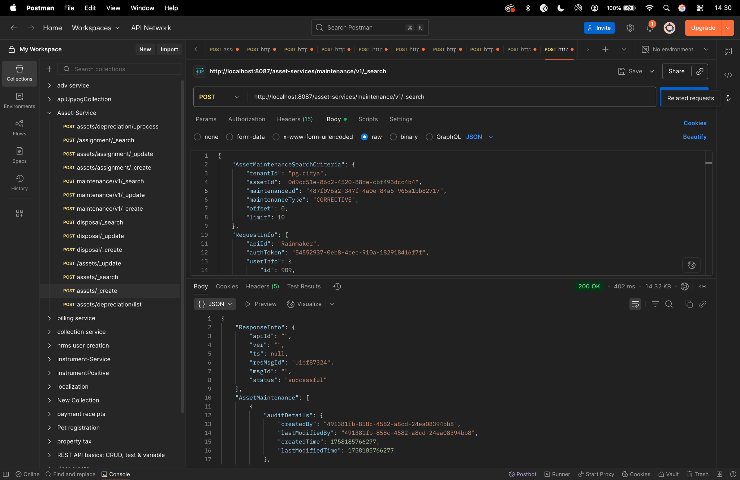

Disposal create -
curl --location 'http://localhost:8087/asset-services/v1/disposal/_create' \
--header 'accept: application/json, text/plain, */*' \
--header 'accept-language: en-GB,en-US;q=0.9,en;q=0.8,hi;q=0.7' \
--header 'content-type: application/json;charset=UTF-8' \
--header 'origin: https://niuatt.niua.in' \
--header 'priority: u=1, i' \
--header 'referer: https://niuatt.niua.in/upyog-ui/employee/asset/assetservice/dispose-assets/PG-1013-2025-I-001236' \
--header 'sec-ch-ua: "Not;A=Brand";v="99", "Google Chrome";v="139", "Chromium";v="139"' \
--header 'sec-ch-ua-mobile: ?0' \
--header 'sec-ch-ua-platform: "macOS"' \
--header 'sec-fetch-dest: empty' \
--header 'sec-fetch-mode: cors' \
--header 'sec-fetch-site: same-origin' \
--header 'user-agent: Mozilla/5.0 (Macintosh; Intel Mac OS X 10_15_7) AppleWebKit/537.36 (KHTML, like Gecko) Chrome/139.0.0.0 Safari/537.36' \
--header 'Cookie: locale=en_IN; _ga=GA1.1.559242739.1756447705; _clck=19weqns%5E2%5Efyv%5E0%5E2067; _ga_VZ9TNBTB3X=GS2.1.s1756447704$o1$g1$t1756447780$j59$l0$h0; _ga_E39TFV5YXM=GS2.1.s1756447709$o1$g1$t1756448684$j60$l0$h0' \
--data '{
"AssetDisposal": {
"disposalId": "",
"assetId": "0d9cc51e-86c2-4520-88fe-cbf493dcc4b4",
"tenantId": "pg.citya",
"lifeOfAsset": "5",
"isAssetDisposedInFacility": true,
"currentAgeOfAsset": 2,
"disposalDate": 1756924200000,
"reasonForDisposal": "Others",
"amountReceived": 500,
"purchaserName": "",
"paymentMode": "",
"comments": "for assest",
"glCode": "111111",
"assetDisposalStatus": "DISPOSED",
"additionalDetails": {
"approvalNumber": "APPROVAL-2020",
"disposedBy": "Kunal Gaurav"
},
"auditDetail": {
"createdBy": "admin",
"createdTime": 1672531200000,
"lastModifiedBy": "admin",
"lastModifiedTime": 1672534800000
},
"documents": [
{
"documentType": "OWNER.RECIEPTPHOTO",
"fileStoreId": "ba740edc-006d-4a34-98d7-96dd2947c795",
"documentUid": "ba740edc-006d-4a34-98d7-96dd2947c795",
"latitude": null,
"longitude": null
}
]
},
"RequestInfo": {
"apiId": "Rainmaker",
"authToken": "54552937-0eb8-4cec-910a-182918416f7f",
"userInfo": {
"id": 909,
"uuid": "491381fb-858c-4582-a8cd-24ea08394bb8",
"userName": "ASSET_APPROVER",
"name": "Asset Approver",
"mobileNumber": "8448489439",
"emailId": null,
"locale": null,
"type": "EMPLOYEE",
"roles": [
{
"name": "Asset Approver",
"code": "ASSET_APPROVER",
"tenantId": "pg.citya"
},
{
"name": "Asset Allocator",
"code": "ASSET_ALLOCATOR",
"tenantId": "pg.citya"
}
],
"active": true,
"tenantId": "pg.citya",
"permanentCity": null
},
"msgId": "1757656020981|en_IN",
"plainAccessRequest": {}
}
}'
Response -
{
"ResponseInfo": {
"apiId": "Rainmaker",
"ver": null,
"ts": null,
"resMsgId": "uief87324",
"msgId": "1757656020981|en_IN",
"status": "successful"
},
"AssetDisposals": [
{
"auditDetails": {
"createdBy": "491381fb-858c-4582-a8cd-24ea08394bb8",
"lastModifiedBy": "491381fb-858c-4582-a8cd-24ea08394bb8",
"createdTime": 1758186094876,
"lastModifiedTime": 1758186094876
},
"disposalId": "554955a9-2e56-42d1-8986-3a415d0088e2",
"assetId": "0d9cc51e-86c2-4520-88fe-cbf493dcc4b4",
"tenantId": "pg.citya",
"lifeOfAsset": 5,
"currentAgeOfAsset": 2,
"isAssetDisposedInFacility": true,
"disposalDate": 1756924200000,
"reasonForDisposal": "Others",
"amountReceived": 500.0,
"purchaserName": "",
"paymentMode": "",
"receiptNumber": null,
"comments": "for assest",
"glCode": "111111",
"assetDisposalStatus": "DISPOSED",
"additionalDetails": {
"approvalNumber": "APPROVAL-2020",
"disposedBy": "Kunal Gaurav"
},
"documents": [
{
"documentId": "4934ba28-f642-4872-a926-bb590fb81ee1",
"documentType": "OWNER.RECIEPTPHOTO",
"fileStoreId": "ba740edc-006d-4a34-98d7-96dd2947c795",
"documentUid": "942f64b2-804a-41cd-9300-1ccf13d078b7",
"docDetails": null
}
]
}
]
}
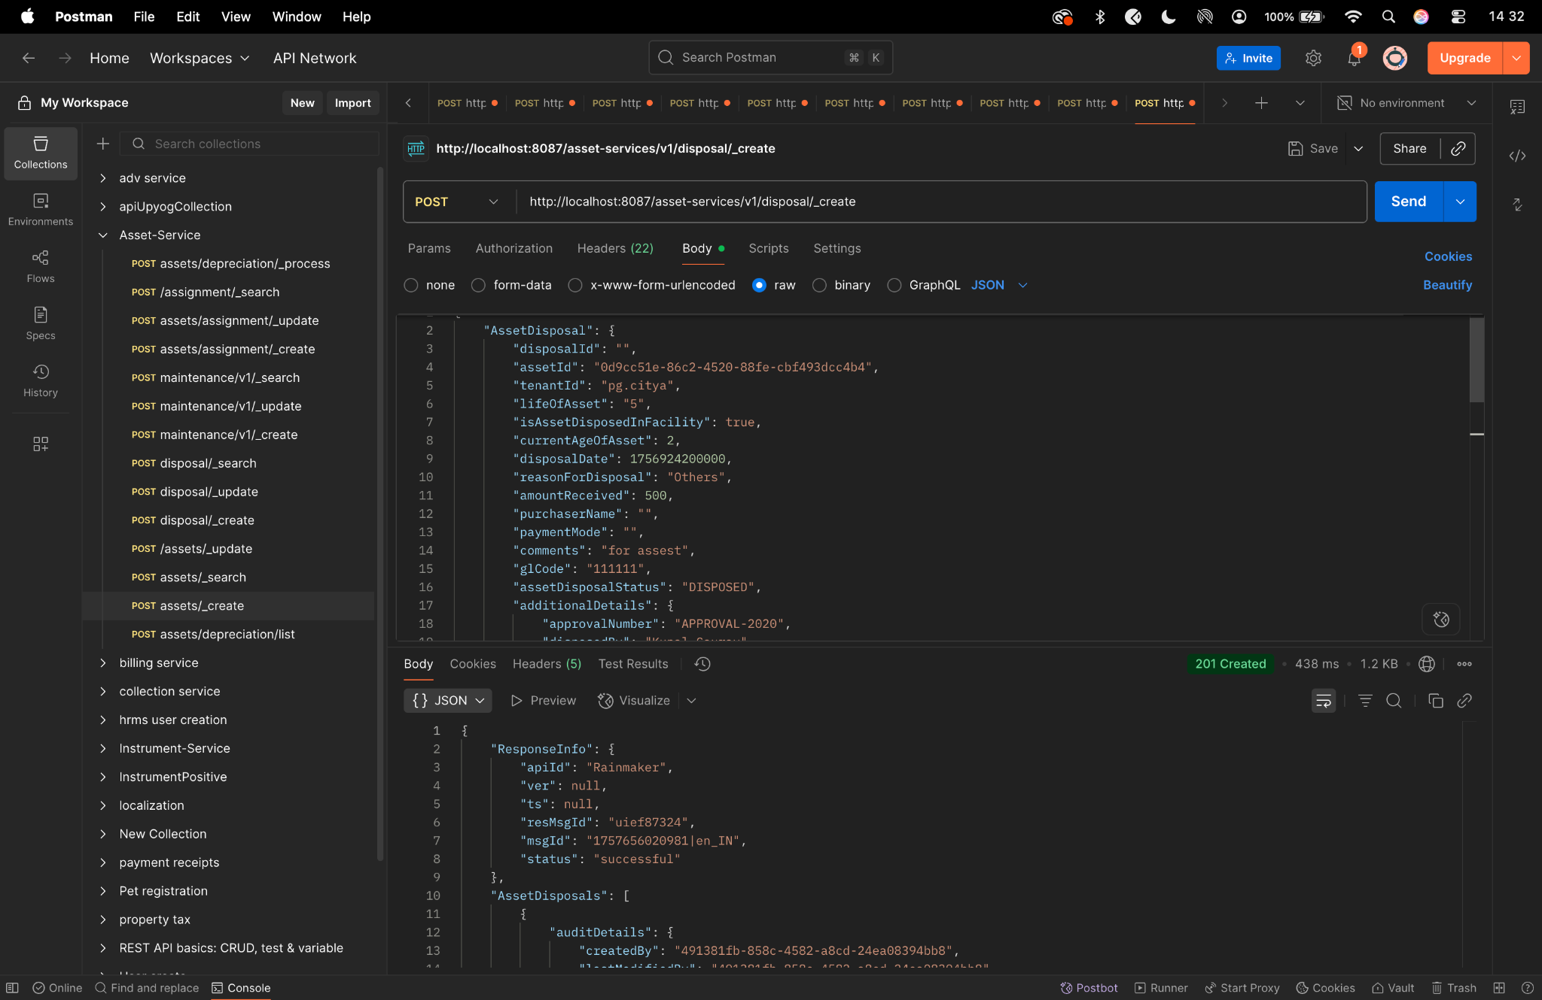

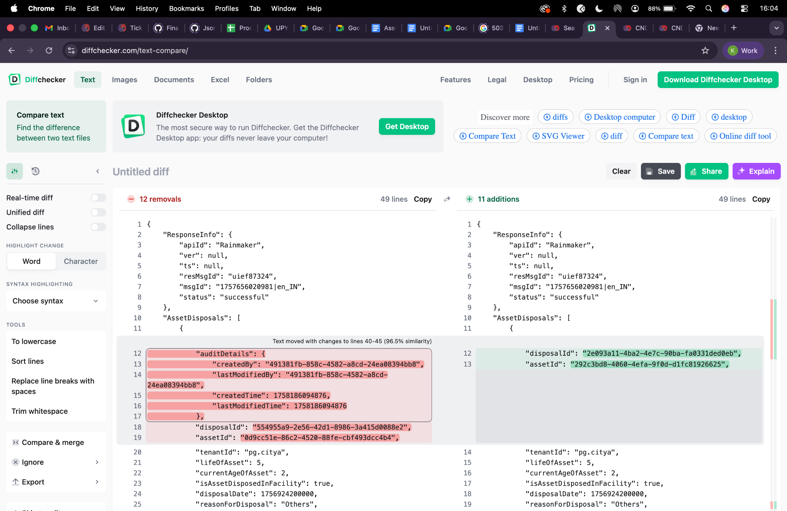

Disposal update -
curl --location 'http://localhost:8087/asset-services/v1/disposal/_update' \
--header 'accept: application/json, text/plain, */*' \
--header 'accept-language: en-GB,en-US;q=0.9,en;q=0.8,hi;q=0.7' \
--header 'content-type: application/json;charset=UTF-8' \
--header 'origin: https://niuatt.niua.in' \
--header 'priority: u=1, i' \
--header 'referer: https://niuatt.niua.in/upyog-ui/employee/asset/assetservice/dispose-assets/PG-1013-2025-I-001236' \
--header 'sec-ch-ua: "Not;A=Brand";v="99", "Google Chrome";v="139", "Chromium";v="139"' \
--header 'sec-ch-ua-mobile: ?0' \
--header 'sec-ch-ua-platform: "macOS"' \
--header 'sec-fetch-dest: empty' \
--header 'sec-fetch-mode: cors' \
--header 'sec-fetch-site: same-origin' \
--header 'user-agent: Mozilla/5.0 (Macintosh; Intel Mac OS X 10_15_7) AppleWebKit/537.36 (KHTML, like Gecko) Chrome/139.0.0.0 Safari/537.36' \
--header 'Cookie: locale=en_IN; _ga=GA1.1.559242739.1756447705; _clck=19weqns%5E2%5Efyv%5E0%5E2067; _ga_VZ9TNBTB3X=GS2.1.s1756447704$o1$g1$t1756447780$j59$l0$h0; _ga_E39TFV5YXM=GS2.1.s1756447709$o1$g1$t1756448684$j60$l0$h0' \
--data '{
"AssetDisposal": {
"disposalId": "554955a9-2e56-42d1-8986-3a415d0088e2",
"assetId": "0d9cc51e-86c2-4520-88fe-cbf493dcc4b4",
"tenantId": "pg.citya",
"lifeOfAsset": "6",
"isAssetDisposedInFacility": true,
"currentAgeOfAsset": 2,
"disposalDate": 1756924200000,
"reasonForDisposal": "Others",
"amountReceived": 500,
"purchaserName": "",
"paymentMode": "",
"comments": "ertwrtwe-UPDATED",
"glCode": "111111",
"assetDisposalStatus": "DISPOSED",
"additionalDetails": {
"approvalNumber": "APPROVAL202501",
"disposedBy": "Jane Smith"
},
"auditDetail": {
"createdBy": "admin",
"createdTime": 1672531200000,
"lastModifiedBy": "admin",
"lastModifiedTime": 1672534800000
},
"documents": [
{
"documentType": "OWNER.RECIEPTPHOTO",
"fileStoreId": "ba740edc-006d-4a34-98d7-96dd2947c795",
"documentUid": "ba740edc-006d-4a34-98d7-96dd2947c795",
"latitude": null,
"longitude": null
}
]
},
"RequestInfo": {
"apiId": "Rainmaker",
"authToken": "54552937-0eb8-4cec-910a-182918416f7f",
"userInfo": {
"id": 909,
"uuid": "491381fb-858c-4582-a8cd-24ea08394bb8",
"userName": "ASSET_APPROVER",
"name": "Asset Approver",
"mobileNumber": "8448489439",
"emailId": null,
"locale": null,
"type": "EMPLOYEE",
"roles": [
{
"name": "Asset Approver",
"code": "ASSET_APPROVER",
"tenantId": "pg.citya"
},
{
"name": "Asset Allocator",
"code": "ASSET_ALLOCATOR",
"tenantId": "pg.citya"
}
],
"active": true,
"tenantId": "pg.citya",
"permanentCity": null
},
"msgId": "1757656020981|en_IN",
"plainAccessRequest": {}
}
}'
Response -
{
"ResponseInfo": {
"apiId": "Rainmaker",
"ver": null,
"ts": null,
"resMsgId": "uief87324",
"msgId": "1757656020981|en_IN",
"status": "successful"
},
"AssetDisposals": [
{
"auditDetails": {
"createdBy": null,
"lastModifiedBy": "491381fb-858c-4582-a8cd-24ea08394bb8",
"createdTime": null,
"lastModifiedTime": 1758186179486
},
"disposalId": "554955a9-2e56-42d1-8986-3a415d0088e2",
"assetId": "0d9cc51e-86c2-4520-88fe-cbf493dcc4b4",
"tenantId": "pg.citya",
"lifeOfAsset": 6,
"currentAgeOfAsset": 2,
"isAssetDisposedInFacility": true,
"disposalDate": 1756924200000,
"reasonForDisposal": "Others",
"amountReceived": 500.0,
"purchaserName": "",
"paymentMode": "",
"receiptNumber": null,
"comments": "ertwrtwe-UPDATED",
"glCode": "111111",
"assetDisposalStatus": "DISPOSED",
"additionalDetails": {
"approvalNumber": "APPROVAL202501",
"disposedBy": "Jane Smith"
},
"documents": [
{
"documentId": "80ba5e24-4b5e-463a-b364-0ee5dc8f14a8",
"documentType": "OWNER.RECIEPTPHOTO",
"fileStoreId": "ba740edc-006d-4a34-98d7-96dd2947c795",
"documentUid": "d2686bd6-4ae7-4c62-9689-5e2b91ec727e",
"docDetails": null
}
]
}
]
}
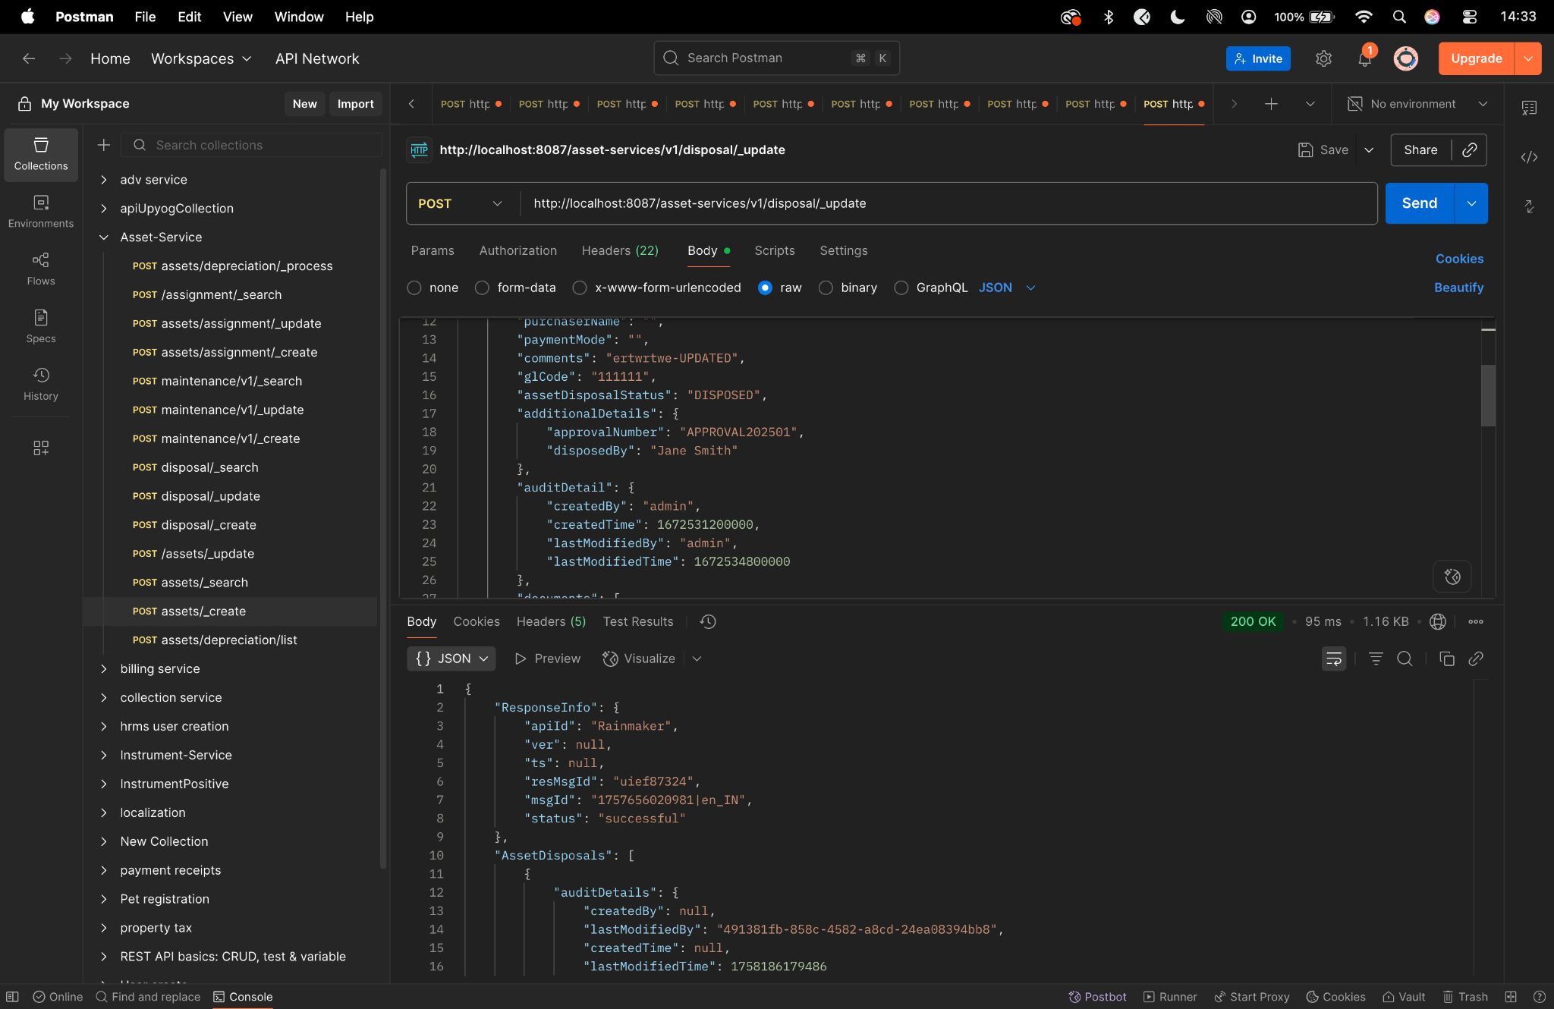

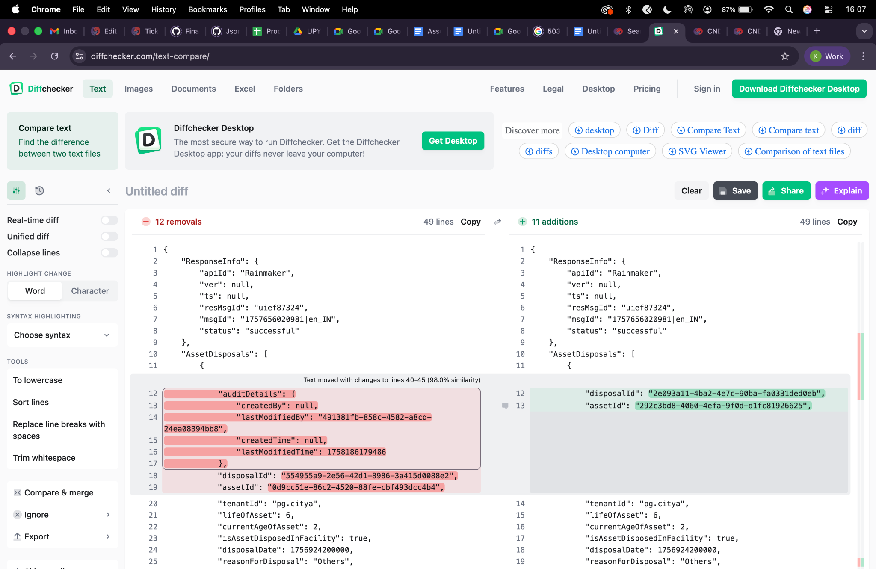

Disposal search -
curl --location 'http://localhost:8087/asset-services/v1/disposal/_search' \
--header 'accept: application/json, text/plain, */*' \
--header 'accept-language: en-GB,en-US;q=0.9,en;q=0.8,hi;q=0.7' \
--header 'content-type: application/json;charset=UTF-8' \
--header 'origin: https://niuatt.niua.in' \
--header 'priority: u=1, i' \
--header 'referer: https://niuatt.niua.in/upyog-ui/employee/asset/assetservice/dispose-assets/' \
--header 'sec-ch-ua: "Not;A=Brand";v="99", "Google Chrome";v="139", "Chromium";v="139"' \
--header 'sec-ch-ua-mobile: ?0' \
--header 'sec-ch-ua-platform: "macOS"' \
--header 'sec-fetch-dest: empty' \
--header 'sec-fetch-mode: cors' \
--header 'sec-fetch-site: same-origin' \
--header 'user-agent: Mozilla/5.0 (Macintosh; Intel Mac OS X 10_15_7) AppleWebKit/537.36 (KHTML, like Gecko) Chrome/139.0.0.0 Safari/537.36' \
--header 'Cookie: locale=en_IN; _ga=GA1.1.559242739.1756447705; _clck=19weqns%5E2%5Efyv%5E0%5E2067; _ga_VZ9TNBTB3X=GS2.1.s1756447704$o1$g1$t1756447780$j59$l0$h0; _ga_E39TFV5YXM=GS2.1.s1756447709$o1$g1$t1756448684$j60$l0$h0' \
--data '{
"searchCriteria": {
"tenantId": "pg.citya",
"assetId": "0d9cc51e-86c2-4520-88fe-cbf493dcc4b4",
"assetDisposalStatus": "DISPOSED",
"offset": 0,
"limit": 10
},
"RequestInfo": {
"apiId": "Rainmaker",
"authToken": "54552937-0eb8-4cec-910a-182918416f7f",
"userInfo": {
"id": 909,
"uuid": "491381fb-858c-4582-a8cd-24ea08394bb8",
"userName": "ASSET_APPROVER",
"name": "Asset Approver",
"mobileNumber": "8448489439",
"emailId": null,
"locale": null,
"type": "EMPLOYEE",
"roles": [
{
"name": "Asset Approver",
"code": "ASSET_APPROVER",
"tenantId": "pg.citya"
},
{
"name": "Asset Allocator",
"code": "ASSET_ALLOCATOR",
"tenantId": "pg.citya"
}
],
"active": true,
"tenantId": "pg.citya",
"permanentCity": null
},
"msgId": "1757656020981|en_IN",
"plainAccessRequest": {}
}
}'
Response -
{
"ResponseInfo": {
"apiId": "",
"ver": "",
"ts": null,
"resMsgId": "uief87324",
"msgId": "",
"status": "successful"
},
"AssetDisposals": [
{
"auditDetails": {
"createdBy": "491381fb-858c-4582-a8cd-24ea08394bb8",
"lastModifiedBy": "491381fb-858c-4582-a8cd-24ea08394bb8",
"createdTime": 1757909565458,
"lastModifiedTime": 1757909815407
},
"disposalId": "2e093a11-4ba2-4e7c-90ba-fa0331ded0eb",
"assetId": "292c3bd8-4060-4efa-9f0d-d1fc81926625",
"tenantId": "pg.citya",
"lifeOfAsset": 6,
"currentAgeOfAsset": 2,
"isAssetDisposedInFacility": true,
"disposalDate": 1756924200000,
"reasonForDisposal": "Others",
"amountReceived": 500.0,
"purchaserName": "",
"paymentMode": "",
"receiptNumber": null,
"comments": "ertwrtwe-UPDATED",
"glCode": "111111",
"assetDisposalStatus": "DISPOSED",
"additionalDetails": {
"disposedBy": "Jane Smith",
"approvalNumber": "APPROVAL202501"
},
"documents": [
{
"documentId": "450356eb-e775-49e1-9fe3-1b0b24718452",
"documentType": "OWNER.RECIEPTPHOTO",
"fileStoreId": "ba740edc-006d-4a34-98d7-96dd2947c795",
"documentUid": "01f47b2b-834f-4439-9d52-cb9fe2124022",
"docDetails": null
},
{
"documentId": "ea772419-7e00-436a-b757-4d38c2098f5d",
"documentType": "OWNER.RECIEPTPHOTO",
"fileStoreId": "ba740edc-006d-4a34-98d7-96dd2947c795",
"documentUid": "f9b78727-b042-4782-b528-a62afcecfb64",
"docDetails": null
}
]
},
{
"auditDetails": {
"createdBy": "491381fb-858c-4582-a8cd-24ea08394bb8",
"lastModifiedBy": "491381fb-858c-4582-a8cd-24ea08394bb8",
"createdTime": 1757657906528,
"lastModifiedTime": 1757657906528
},
"disposalId": "c0896a34-a2df-4723-b3c2-6f676174c2ce",
"assetId": "1163afaf-b0a1-4929-b5f1-aaaa20e2070d",
"tenantId": "pg.citya",
"lifeOfAsset": 5,
"currentAgeOfAsset": 2,
"isAssetDisposedInFacility": true,
"disposalDate": 1756924200000,
"reasonForDisposal": "Others",
"amountReceived": 500.0,
"purchaserName": "",
"paymentMode": "",
"receiptNumber": null,
"comments": "for assest",
"glCode": "111111",
"assetDisposalStatus": "DISPOSED",
"additionalDetails": {
"disposedBy": "Kunal Gaurav",
"approvalNumber": "APPROVAL-2020"
},
"documents": [
{
"documentId": "b2aee7e4-0223-433f-9f72-b5da9ffb9b7f",
"documentType": "OWNER.RECIEPTPHOTO",
"fileStoreId": "ba740edc-006d-4a34-98d7-96dd2947c795",
"documentUid": "e74db517-601e-4cba-919a-a23049977972",
"docDetails": null
}
]
},
{
"auditDetails": {
"createdBy": "491381fb-858c-4582-a8cd-24ea08394bb8",
"lastModifiedBy": "491381fb-858c-4582-a8cd-24ea08394bb8",
"createdTime": 1756119041208,
"lastModifiedTime": 1756119041208
},
"disposalId": "a29c1018-f2b2-4cf5-9714-671b581aaf07",
"assetId": "f9c7697d-16e9-480e-98ea-778f75281efc",
"tenantId": "pg.citya",
"lifeOfAsset": 6,
"currentAgeOfAsset": 1695,
"isAssetDisposedInFacility": true,
"disposalDate": 1754332200000,
"reasonForDisposal": "DISPOSED_AND_SOLD",
"amountReceived": 20001.0,
"purchaserName": "Dinesh ",
"paymentMode": "Offline",
"receiptNumber": "yes",
"comments": "dhjhdsalfjsd",
"glCode": "111111",
"assetDisposalStatus": "DISPOSED",
"additionalDetails": {
"disposedBy": "Jane Smith",
"approvalNumber": "APPROVAL202501"
},
"documents": [
{
"documentId": "c2df6db1-1835-44fc-b981-0d3c656958f4",
"documentType": "ASSET.DISPOSE.DOC1",
"fileStoreId": null,
"documentUid": "6d388690-2a15-4924-b8c3-87f9ae4ea2d7",
"docDetails": null
}
]
},
{
"auditDetails": {
"createdBy": "491381fb-858c-4582-a8cd-24ea08394bb8",
"lastModifiedBy": "491381fb-858c-4582-a8cd-24ea08394bb8",
"createdTime": 1756118697660,
"lastModifiedTime": 1756118697660
},
"disposalId": "bd60611d-0e83-4d69-a6f4-726de10c7ae2",
"assetId": "7c9fdf54-0569-4f0d-ab84-2443848bf3cc",
"tenantId": "pg.citya",
"lifeOfAsset": 4,
"currentAgeOfAsset": 1697,
"isAssetDisposedInFacility": true,
"disposalDate": 1612204200000,
"reasonForDisposal": "DISPOSED",
"amountReceived": 2340.0,
"purchaserName": "PARVESH",
"paymentMode": "ONLINE",
"receiptNumber": "YES RECIPT",
"comments": "DFGHJKL",
"glCode": "111111",
"assetDisposalStatus": "DISPOSED",
"additionalDetails": {
"disposedBy": "Jane Smith",
"approvalNumber": "APPROVAL202501"
},
"documents": [
{
"documentId": "93c36bf2-43f8-407e-acac-190312cbe981",
"documentType": "ASSET.DISPOSE.DOC1",
"fileStoreId": "7e700a97-6c89-4d44-8122-16171e5ada04",
"documentUid": "fb7423db-cd32-4a13-a214-5b47c4a4c884",
"docDetails": null
}
]
},
{
"auditDetails": {
"createdBy": "491381fb-858c-4582-a8cd-24ea08394bb8",
"lastModifiedBy": "491381fb-858c-4582-a8cd-24ea08394bb8",
"createdTime": 1755425097891,
"lastModifiedTime": 1755425097891
},
"disposalId": "41a076dc-13b2-4897-a1af-d6393db0de7c",
"assetId": "9086cc20-67b8-4248-af35-8064694262d6",
"tenantId": "pg.citya",
"lifeOfAsset": 1,
"currentAgeOfAsset": 16,
"isAssetDisposedInFacility": true,
"disposalDate": 1754332200000,
"reasonForDisposal": "DISPOSED_AND_SOLD",
"amountReceived": 2345.0,
"purchaserName": "gfjhgkh",
"paymentMode": "hgj",
"receiptNumber": "g",
"comments": "ygtgk",
"glCode": "111111",
"assetDisposalStatus": "DISPOSED",
"additionalDetails": {
"disposedBy": "Jane Smith",
"approvalNumber": "APPROVAL202501"
},
"documents": [
{
"documentId": "d5ad83c1-5af8-4d68-b048-0ffbcc20c0f8",
"documentType": "ASSET.DISPOSE.DOC1",
"fileStoreId": null,
"documentUid": "3fc354e9-2990-4896-9208-b5dc36dbcea3",
"docDetails": null
}
]
},
{
"auditDetails": {
"createdBy": "491381fb-858c-4582-a8cd-24ea08394bb8",
"lastModifiedBy": "491381fb-858c-4582-a8cd-24ea08394bb8",
"createdTime": 1748840312789,
"lastModifiedTime": 1748840312789
},
"disposalId": "7b1946f2-f3ec-4230-801f-4e67d242a4da",
"assetId": "60a8fc3a-f127-4ebd-a4d5-8e3573c18b87",
"tenantId": "pg.citya",
"lifeOfAsset": 21,
"currentAgeOfAsset": 31,
"isAssetDisposedInFacility": true,
"disposalDate": 1748802600000,
"reasonForDisposal": "DISPOSED_AND_SOLD",
"amountReceived": 2000.0,
"purchaserName": "",
"paymentMode": "",
"receiptNumber": null,
"comments": "ok ",
"glCode": "111111",
"assetDisposalStatus": "DISPOSED",
"additionalDetails": {
"disposedBy": "Jane Smith",
"approvalNumber": "APPROVAL202501"
},
"documents": [
{
"documentId": "9a7528ee-abcb-41d9-b292-f091e5f62ee4",
"documentType": "ASSET.DISPOSE.DOC1",
"fileStoreId": null,
"documentUid": "37e5bbe6-7396-4020-ad91-b3fb593d4b19",
"docDetails": null
}
]
},
{
"auditDetails": {
"createdBy": "491381fb-858c-4582-a8cd-24ea08394bb8",
"lastModifiedBy": "491381fb-858c-4582-a8cd-24ea08394bb8",
"createdTime": 1748492511326,
"lastModifiedTime": 1748492511326
},
"disposalId": "593be013-95b7-441a-91f0-2ff7e6e82444",
"assetId": "6afce2b0-4fa7-4ceb-8810-9bbf744bcbd9",
"tenantId": "pg.citya",
"lifeOfAsset": 10,
"currentAgeOfAsset": 477,
"isAssetDisposedInFacility": true,
"disposalDate": 1746988200000,
"reasonForDisposal": "DISPOSED",
"amountReceived": 6098.0,
"purchaserName": "",
"paymentMode": "",
"receiptNumber": null,
"comments": "Asset Disposed",
"glCode": "111111",
"assetDisposalStatus": "DISPOSED",
"additionalDetails": {
"disposedBy": "Jane Smith",
"approvalNumber": "APPROVAL202501"
},
"documents": [
{
"documentId": "483273af-59e0-4c73-8994-6958c67a5305",
"documentType": "ASSET.DISPOSE.DOC1",
"fileStoreId": null,
"documentUid": "93c0c3f0-f89d-44fa-a6cf-8bbcde0113f9",
"docDetails": null
}
]
},
{
"auditDetails": {
"createdBy": "6e6585c8-83d7-4170-850a-fec8316f81a2",
"lastModifiedBy": "6e6585c8-83d7-4170-850a-fec8316f81a2",
"createdTime": 1742368116292,
"lastModifiedTime": 1742368116292
},
"disposalId": "b16745f5-2f2f-428f-b3ff-813cee1146f5",
"assetId": "cce3ca2a-6b8a-4131-8658-cf38677cb83d",
"tenantId": "pg.citya",
"lifeOfAsset": 5,
"currentAgeOfAsset": 1538,
"isAssetDisposedInFacility": true,
"disposalDate": 1738348200000,
"reasonForDisposal": "DISPOSED",
"amountReceived": 5000.0,
"purchaserName": "Mohin",
"paymentMode": "online",
"receiptNumber": "lorem",
"comments": "lorem",
"glCode": "111111",
"assetDisposalStatus": "DISPOSED",
"additionalDetails": {
"disposedBy": "Jane Smith",
"approvalNumber": "APPROVAL202501"
},
"documents": [
{
"documentId": "9fcc16c3-dfea-446e-ade2-758091e48a7d",
"documentType": "ASSET.DISPOSE.DOC1",
"fileStoreId": "3416ef31-e7c6-4e93-92c3-ea0d8e7e54c6",
"documentUid": "f77a73a2-7f41-44a9-8823-e06d62f1ecbe",
"docDetails": null
}
]
},
{
"auditDetails": {
"createdBy": "6e6585c8-83d7-4170-850a-fec8316f81a2",
"lastModifiedBy": "6e6585c8-83d7-4170-850a-fec8316f81a2",
"createdTime": 1742363096245,
"lastModifiedTime": 1742363096245
},
"disposalId": "85721148-8002-44bb-862e-5c2e0d6f3d32",
"assetId": "877e53fb-5ebc-4b11-8c02-2680986c1a62",
"tenantId": "pg.citya",
"lifeOfAsset": 5,
"currentAgeOfAsset": 1538,
"isAssetDisposedInFacility": true,
"disposalDate": 1740767400000,
"reasonForDisposal": "DISPOSED",
"amountReceived": 10000.0,
"purchaserName": "deepak",
"paymentMode": "cash",
"receiptNumber": "345678",
"comments": "dfsfd",
"glCode": "111111",
"assetDisposalStatus": "DISPOSED",
"additionalDetails": {
"disposedBy": "Jane Smith",
"approvalNumber": "APPROVAL202501"
},
"documents": [
{
"documentId": "c77662e8-274c-4d37-8d59-5d13467ab2a2",
"documentType": "ASSET.DISPOSE.DOC1",
"fileStoreId": null,
"documentUid": "77f9e52b-4fb6-4885-9055-ed974e359e9e",
"docDetails": null
}
]
},
{
"auditDetails": {
"createdBy": "16ac4a3c-115d-4ab7-8b7e-57d2396c1e38",
"lastModifiedBy": "16ac4a3c-115d-4ab7-8b7e-57d2396c1e38",
"createdTime": 1738942240366,
"lastModifiedTime": 1738942240366
},
"disposalId": "29d25169-a98c-4d2d-ba73-441786ee95ad",
"assetId": "e8d7df41-e6bc-404f-a4f1-ffa0b4269d92",
"tenantId": "pg.citya",
"lifeOfAsset": 5,
"currentAgeOfAsset": 1311,
"isAssetDisposedInFacility": true,
"disposalDate": 1733337000000,
"reasonForDisposal": "DISPOSED_AND_SOLD",
"amountReceived": 2332.0,
"purchaserName": "",
"paymentMode": "",
"receiptNumber": null,
"comments": "dsfasdf",
"glCode": "111111",
"assetDisposalStatus": "DISPOSED",
"additionalDetails": {
"disposedBy": "Jane Smith",
"approvalNumber": "APPROVAL202501"
},
"documents": [
{
"documentId": "e4048269-ec98-457a-af9b-44caed456514",
"documentType": "ASSET.DISPOSE.DOC1",
"fileStoreId": "ea4ba943-a933-4f7d-a745-b42be381235b",
"documentUid": "4f35e0c9-3186-49a5-bd2e-dd6258584903",
"docDetails": null
}
]
}
]
}
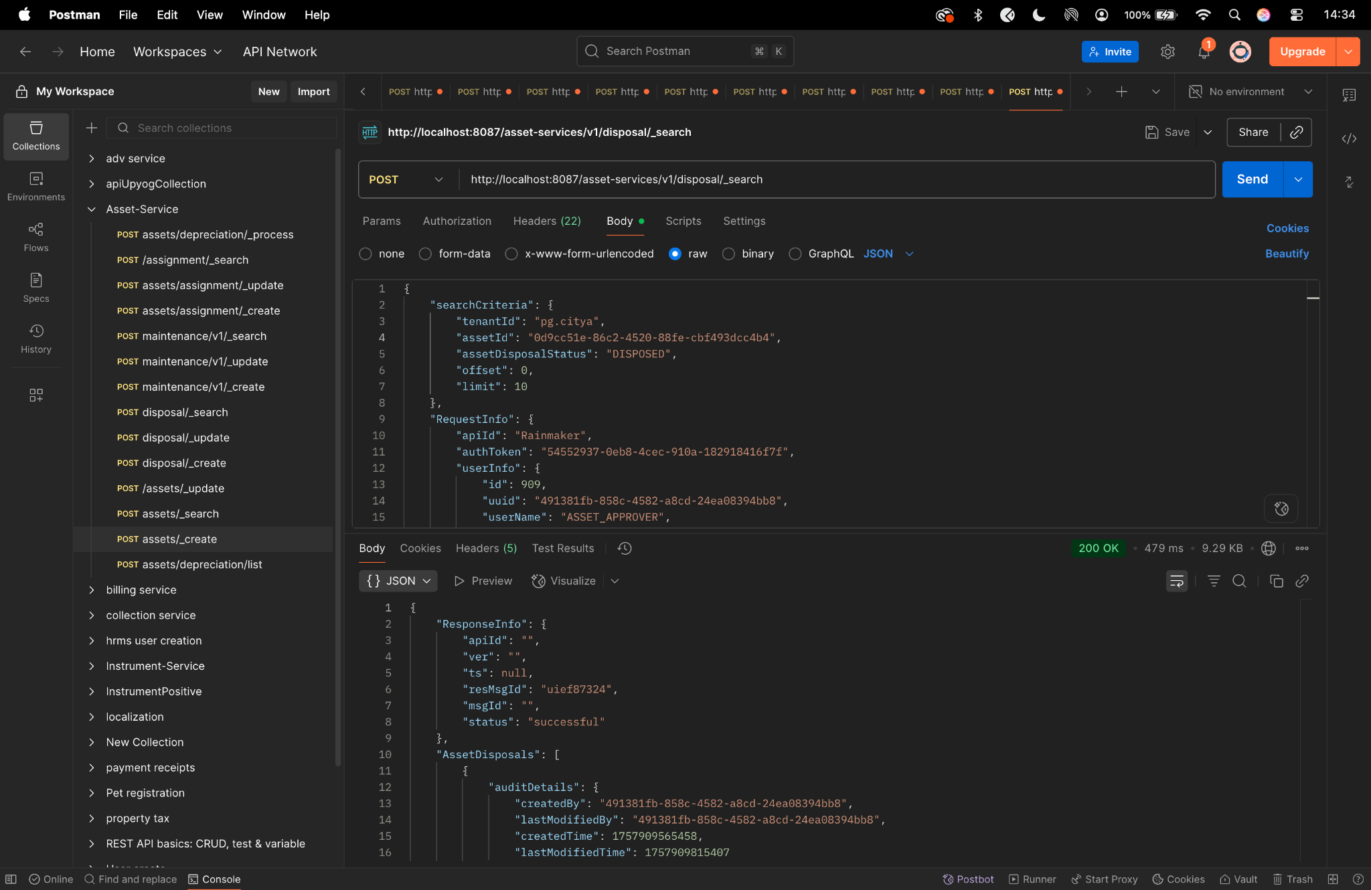

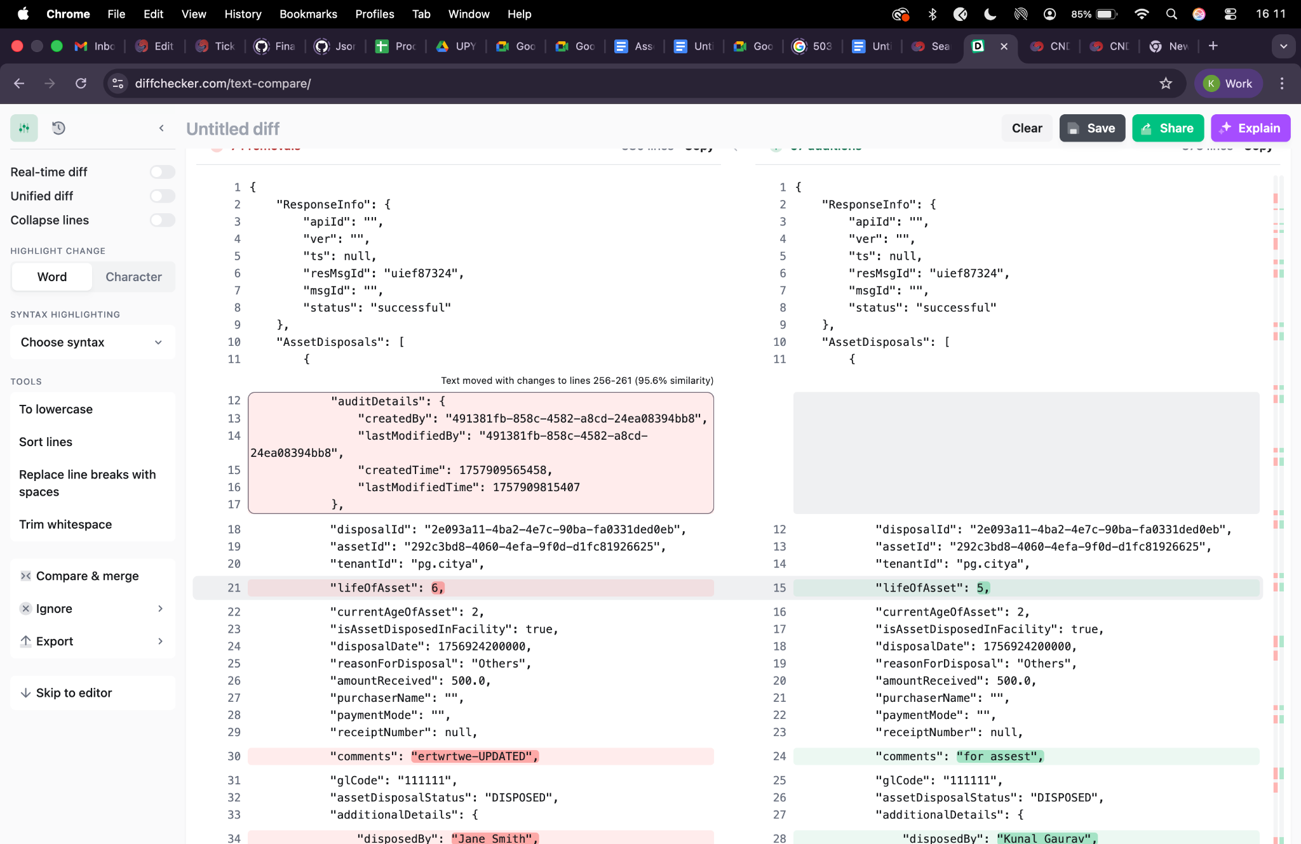

Depreciation/create-

curl --location 'http://localhost:8013/asset-services/v1/assets/depreciation/_process' \
--header 'accept: application/json, text/plain, */*' \
--header 'accept-language: en-GB,en-US;q=0.9,en;q=0.8,hi;q=0.7' \
--header 'content-type: application/json;charset=UTF-8' \
--header 'origin: https://niuatt.niua.in' \
--header 'priority: u=1, i' \
--header 'referer: https://niuatt.niua.in/digit-ui/employee/asset/assetservice/my-asset' \
--header 'sec-ch-ua: "Not;A=Brand";v="99", "Google Chrome";v="139", "Chromium";v="139"' \
--header 'sec-ch-ua-mobile: ?0' \
--header 'sec-ch-ua-platform: "macOS"' \
--header 'sec-fetch-dest: empty' \
--header 'sec-fetch-mode: cors' \
--header 'sec-fetch-site: same-origin' \
--header 'user-agent: Mozilla/5.0 (Macintosh; Intel Mac OS X 10_15_7) AppleWebKit/537.36 (KHTML, like Gecko) Chrome/139.0.0.0 Safari/537.36' \
--header 'Cookie: locale=en_IN; _ga=GA1.1.559242739.1756447705; _clck=19weqns%5E2%5Efyv%5E0%5E2067; _ga_VZ9TNBTB3X=GS2.1.s1756447704$o1$g1$t1756447780$j59$l0$h0; _ga_E39TFV5YXM=GS2.1.s1756447709$o1$g1$t1756448684$j60$l0$h0' \
--data '{
"Asset": {
"tenantId": "pg.citya",
"id": "a5aa6bd2-cd0e-4e9f-bfdb-083862e17e1b",
"accountId": ""
},
"RequestInfo": {
"apiId": "Rainmaker",
"authToken": "54552937-0eb8-4cec-910a-182918416f7f",
"userInfo": {
"id": 909,
"uuid": "491381fb-858c-4582-a8cd-24ea08394bb8",
"userName": "ASSET_APPROVER",
"name": "Asset Approver",
"mobileNumber": "8448489439",
"emailId": null,
"locale": null,
"type": "EMPLOYEE",
"roles": [
{
"name": "Asset Approver",
"code": "ASSET_APPROVER",
"tenantId": "pg.citya"
},
{
"name": "Asset Allocator",
"code": "ASSET_ALLOCATOR",
"tenantId": "pg.citya"
}
],
"active": true,
"tenantId": "pg.citya",
"permanentCity": null
},
"msgId": "1757669988361|en_IN",
"plainAccessRequest": {}
}
}'

Response -

{
"ResponseInfo": {
"apiId": "Rainmaker",
"ver": null,
"ts": null,
"resMsgId": "uief87324",
"msgId": "1757669988361|en_IN",
"status": "successful"
},
"Message": "Depreciation calculated successfully "
}
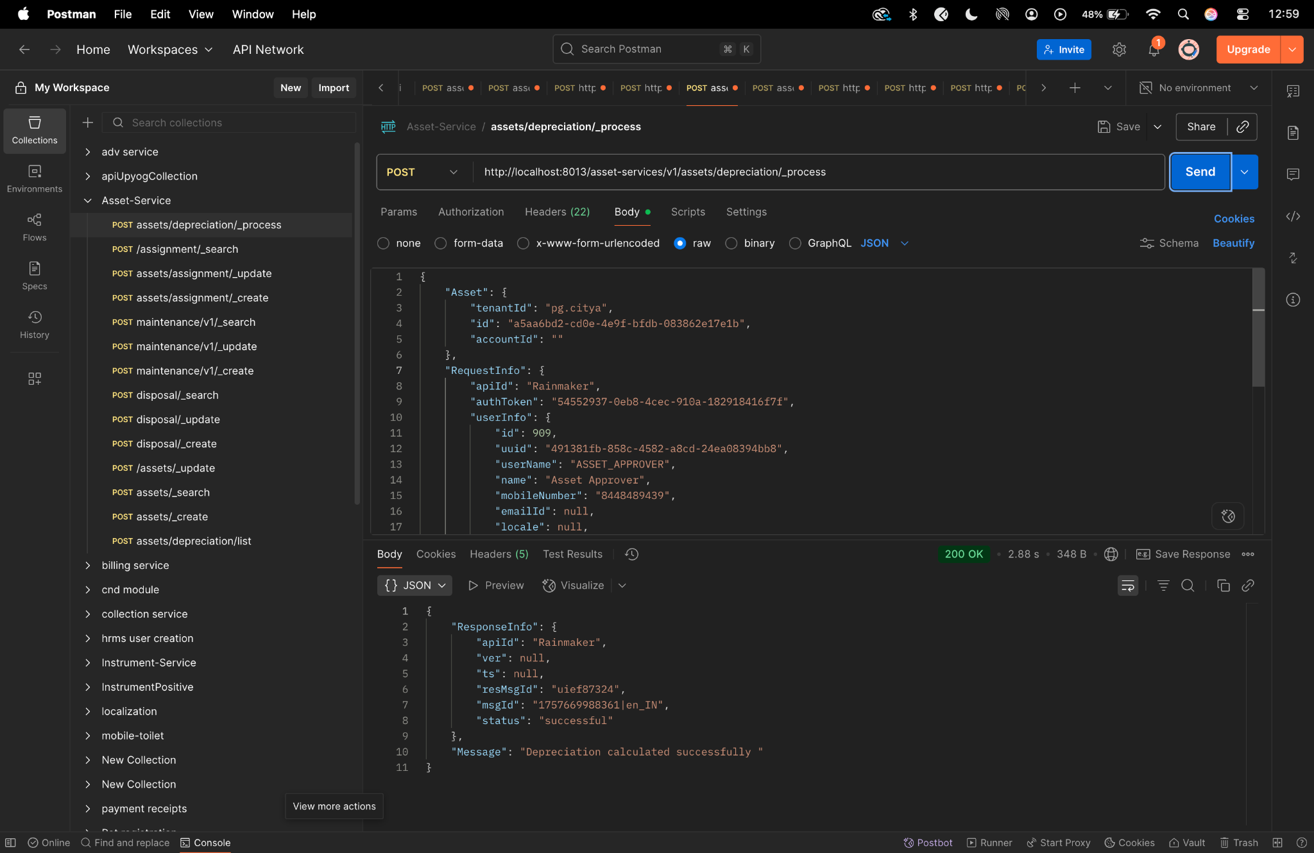

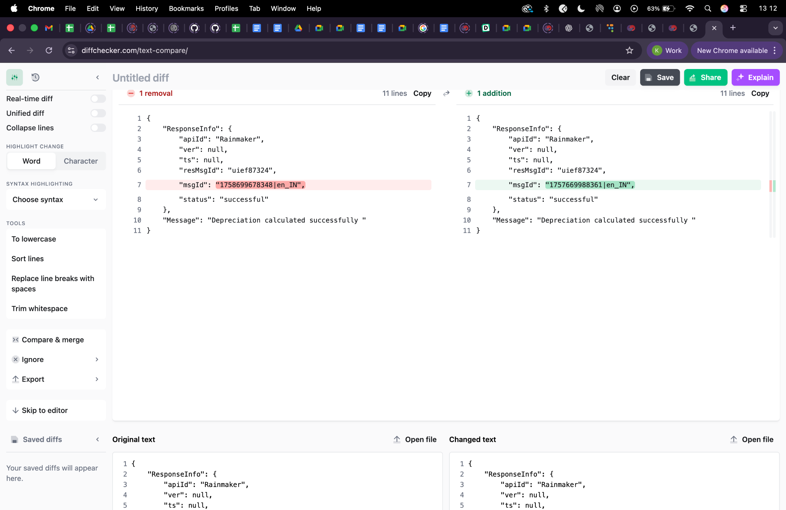

depreciation /list-
curl --location 'http://localhost:8013/asset-services/v1/assets/depreciation/list' \
--header 'accept: application/json, text/plain, */*' \
--header 'accept-language: en-GB,en-US;q=0.9,en;q=0.8,hi;q=0.7' \
--header 'content-type: application/json;charset=UTF-8' \
--header 'origin: https://niuatt.niua.in' \
--header 'priority: u=1, i' \
--header 'referer: https://niuatt.niua.in/digit-ui/employee/asset/assetservice/applicationsearch/application-details/PG-1013-2025-I-001237' \
--header 'sec-ch-ua: "Not;A=Brand";v="99", "Google Chrome";v="139", "Chromium";v="139"' \
--header 'sec-ch-ua-mobile: ?0' \
--header 'sec-ch-ua-platform: "macOS"' \
--header 'sec-fetch-dest: empty' \
--header 'sec-fetch-mode: cors' \
--header 'sec-fetch-site: same-origin' \
--header 'user-agent: Mozilla/5.0 (Macintosh; Intel Mac OS X 10_15_7) AppleWebKit/537.36 (KHTML, like Gecko) Chrome/139.0.0.0 Safari/537.36' \
--header 'Cookie: locale=en_IN; _ga=GA1.1.559242739.1756447705; _clck=19weqns%5E2%5Efyv%5E0%5E2067; _ga_VZ9TNBTB3X=GS2.1.s1756447704$o1$g1$t1756447780$j59$l0$h0; _ga_E39TFV5YXM=GS2.1.s1756447709$o1$g1$t1756448684$j60$l0$h0' \
--data '{
"Asset": {
"tenantId": "pg.citya",
"id": "a5aa6bd2-cd0e-4e9f-bfdb-083862e17e1b",
"accountId": ""
},
"RequestInfo": {
"apiId": "Rainmaker",
"authToken": "54552937-0eb8-4cec-910a-182918416f7f",
"userInfo": {
"id": 909,
"uuid": "491381fb-858c-4582-a8cd-24ea08394bb8",
"userName": "ASSET_APPROVER",
"name": "Asset Approver",
"mobileNumber": "8448489439",
"emailId": null,
"locale": null,
"type": "EMPLOYEE",
"roles": [
{
"name": "Asset Approver",
"code": "ASSET_APPROVER",
"tenantId": "pg.citya"
},
{
"name": "Asset Allocator",
"code": "ASSET_ALLOCATOR",
"tenantId": "pg.citya"
}
],
"active": true,
"tenantId": "pg.citya",
"permanentCity": null
},
"msgId": "1757670044190|en_IN",
"plainAccessRequest": {}
}
}'
Response -
{
"ResponseInfo": {
"apiId": "",
"ver": "",
"ts": null,
"resMsgId": "uief87324",
"msgId": "",
"status": "successful"
},
"DepreciationDetails": [
{
"id": 350,
"assetId": "a5aa6bd2-cd0e-4e9f-bfdb-083862e17e1b",
"fromDate": "2020-04-03",
"toDate": "2021-04-03",
"depreciationValue": 10893.75,
"bookValue": 32681.25,
"rate": 25.0,
"oldBookValue": 43575.0,
"createdAt": "2025-09-24 07:29:19",
"updatedAt": null,
"createdBy": "491381fb-858c-4582-a8cd-24ea08394bb8",
"updatedBy": null,
"depreciationMethod": "SLM"
},
{
"id": 351,
"assetId": "a5aa6bd2-cd0e-4e9f-bfdb-083862e17e1b",
"fromDate": "2021-04-03",
"toDate": "2022-04-03",
"depreciationValue": 10893.75,
"bookValue": 21787.5,
"rate": 25.0,
"oldBookValue": 32681.25,
"createdAt": "2025-09-24 07:29:21",
"updatedAt": null,
"createdBy": "491381fb-858c-4582-a8cd-24ea08394bb8",
"updatedBy": null,
"depreciationMethod": "SLM"
},
{
"id": 352,
"assetId": "a5aa6bd2-cd0e-4e9f-bfdb-083862e17e1b",
"fromDate": "2022-04-03",
"toDate": "2023-04-03",
"depreciationValue": 10893.75,
"bookValue": 10893.75,
"rate": 25.0,
"oldBookValue": 21787.5,
"createdAt": "2025-09-24 07:29:21",
"updatedAt": null,
"createdBy": "491381fb-858c-4582-a8cd-24ea08394bb8",
"updatedBy": null,
"depreciationMethod": "SLM"
},
{
"id": 353,
"assetId": "a5aa6bd2-cd0e-4e9f-bfdb-083862e17e1b",
"fromDate": "2023-04-03",
"toDate": "2024-04-03",
"depreciationValue": 10893.75,
"bookValue": 0.0,
"rate": 25.0,
"oldBookValue": 10893.75,
"createdAt": "2025-09-24 07:29:21",
"updatedAt": null,
"createdBy": "491381fb-858c-4582-a8cd-24ea08394bb8",
"updatedBy": null,
"depreciationMethod": "SLM"
},
{
"id": 354,
"assetId": "a5aa6bd2-cd0e-4e9f-bfdb-083862e17e1b",
"fromDate": "2024-04-03",
"toDate": "2025-04-03",
"depreciationValue": 0.0,
"bookValue": 0.0,
"rate": 25.0,
"oldBookValue": 0.0,
"createdAt": "2025-09-24 07:29:21",
"updatedAt": null,
"createdBy": "491381fb-858c-4582-a8cd-24ea08394bb8",
"updatedBy": null,
"depreciationMethod": "SLM"
}
]
}
