EWASTE SERVICE
Create Api
Local
curl --location 'http://localhost:8081/ewaste-services/ewaste-request/_create' \
--header 'accept: application/json, text/plain, */*' \
--header 'accept-language: en-GB,en-US;q=0.9,en;q=0.8' \
--header 'content-type: application/json;charset=UTF-8' \
--header 'origin: https://niuatt.niua.in' \
--header 'priority: u=1, i' \
--header 'referer: https://niuatt.niua.in/digit-ui/citizen/ew/raiseRequest/acknowledgement' \
--header 'sec-ch-ua: "Google Chrome";v="137", "Chromium";v="137", "Not/A)Brand";v="24"' \
--header 'sec-ch-ua-mobile: ?0' \
--header 'sec-ch-ua-platform: "macOS"' \
--header 'sec-fetch-dest: empty' \
--header 'sec-fetch-mode: cors' \
--header 'sec-fetch-site: same-origin' \
--header 'user-agent: Mozilla/5.0 (Macintosh; Intel Mac OS X 10_15_7) AppleWebKit/537.36 (KHTML, like Gecko) Chrome/137.0.0.0 Safari/537.36' \
--header 'Cookie: _ga=GA1.1.1498208436.1748421576; _ga_VZ9TNBTB3X=GS2.1.s1748421575$o1$g0$t1748421575$j60$l0$h0; _clck=tkuuq4%7C2%7Cfwa%7C0%7C1974' \
--data-raw '{
"EwasteApplication": [
{
"tenantId": "pg.citya",
"requestId": "",
"transactionId": "",
"pickUpDate": "",
"vendorUuid": "345",
"requestStatus": "New Request",
"calculatedAmount": 1680,
"applicant": {
"applicantName": "Nikhil",
"mobileNumber": "7000000000",
"emailId": "nikhil@gmail.com",
"altMobileNumber": ""
},
"ewasteDetails": [
{
"productId": "",
"productName": "Water Cooler",
"quantity": "5",
"price": 1680
}
],
"address": {
"tenantId": "pg.citya",
"doorNo": "43534",
"latitude": null,
"longitude": null,
"addressNumber": "",
"type": "RESIDENTIAL",
"addressLine1": "sdfsdf",
"addressLine2": "sfsdf",
"landmark": "sdfsdf",
"city": "New Delhi",
"pincode": "143001",
"detail": "",
"buildingName": "sdfsdf",
"street": "india Habitat Centre",
"locality": {
"code": "JLC476",
"name": ""
}
},
"documents": [
{
"filestoreId": "3140a495-c0b7-4961-8dd9-1a836811e327",
"documentuuid": "3140a495-c0b7-4961-8dd9-1a836811e327",
"documentType": "Photo1"
}
],
"workflow": {
"businessService": "ewst",
"action": "CREATE",
"moduleName": "ewaste-services"
}
}
],
"RequestInfo": {
"apiId": "Rainmaker",
"authToken": "56b1475a-b56c-47af-b9a3-7c214508147a",
"userInfo": {
"id": 808,
"uuid": "38dd895e-95a0-4b72-946f-023a8a782c49",
"userName": "7000000000",
"name": "Nikhil",
"mobileNumber": "7000000000",
"emailId": "nikhil@gmail.com",
"locale": null,
"type": "CITIZEN",
"roles": [
{
"name": "Citizen",
"code": "CITIZEN",
"tenantId": "pg"
}
],
"active": true,
"tenantId": "pg",
"permanentCity": null
},
"msgId": "1751882010316|en_IN",
"plainAccessRequest": {}
}}'
Response:-
{
"ResponseInfo": {
"apiId": "Rainmaker",
"ver": null,
"ts": null,
"resMsgId": "uief87324",
"msgId": "1751882010316|en_IN",
"status": "successful"
},
"EwasteApplication": [
{
"id": "8d10209c-d685-4db2-a92c-499b7403c02a",
"tenantId": "pg.citya",
"requestId": "PG-EW-2025-07-07-000327",
"calculatedAmount": "1680",
"vendorUuid": "345",
"pickUpDate": "",
"transactionId": "",
"finalAmount": null,
"requestStatus": "REQUESTCREATED",
"ewasteDetails": [
{
"id": "8ec94363-8f96-450a-874a-5f05a99ef1ef",
"productId": "",
"productName": "Water Cooler",
"quantity": "5",
"price": "1680"
}
],
"applicant": {
"id": "345fe4c4-2ffb-419f-b2fa-a607b059acc8",
"applicantName": "Nikhil",
"gender": null,
"mobileNumber": "7000000000",
"emailId": "nikhil@gmail.com",
"altMobileNumber": "",
"tenantId": null,
"ewId": "8d10209c-d685-4db2-a92c-499b7403c02a"
},
"address": {
"id": "80297f66-a97c-45d2-a6fe-3d4f5ce77709",
"tenantId": "pg.citya",
"registrationId": "8d10209c-d685-4db2-a92c-499b7403c02a",
"doorNo": "43534",
"latitude": null,
"longitude": null,
"addressId": null,
"addressNumber": "",
"type": "RESIDENTIAL",
"addressLine1": "sdfsdf",
"addressLine2": "sfsdf",
"landmark": "sdfsdf",
"city": "New Delhi",
"pincode": "143001",
"detail": "",
"buildingName": "sdfsdf",
"street": "india Habitat Centre",
"locality": {
"code": "JLC476",
"name": "",
"label": null,
"latitude": null,
"longitude": null,
"children": null,
"materializedPath": null
},
"auditDetails": {
"createdBy": "38dd895e-95a0-4b72-946f-023a8a782c49",
"lastModifiedBy": null,
"createdTime": 1751883667710,
"lastModifiedTime": null
}
},
"auditDetails": {
"createdBy": "38dd895e-95a0-4b72-946f-023a8a782c49",
"lastModifiedBy": null,
"createdTime": 1751883667710,
"lastModifiedTime": null
},
"documents": [
{
"id": "75a5d5a4-4a0b-45c6-8088-ab9d8561a30c",
"active": true,
"tenantId": "pg.citya",
"documentType": "Photo1",
"filestoreId": "3140a495-c0b7-4961-8dd9-1a836811e327",
"documentUid": null,
"auditDetails": {
"createdBy": "38dd895e-95a0-4b72-946f-023a8a782c49",
"lastModifiedBy": null,
"createdTime": 1751883667710,
"lastModifiedTime": null
}
}
],
"workflow": {
"action": "CREATE",
"status": null,
"comments": null,
"assignes": null,
"documents": null
}
}
]
}
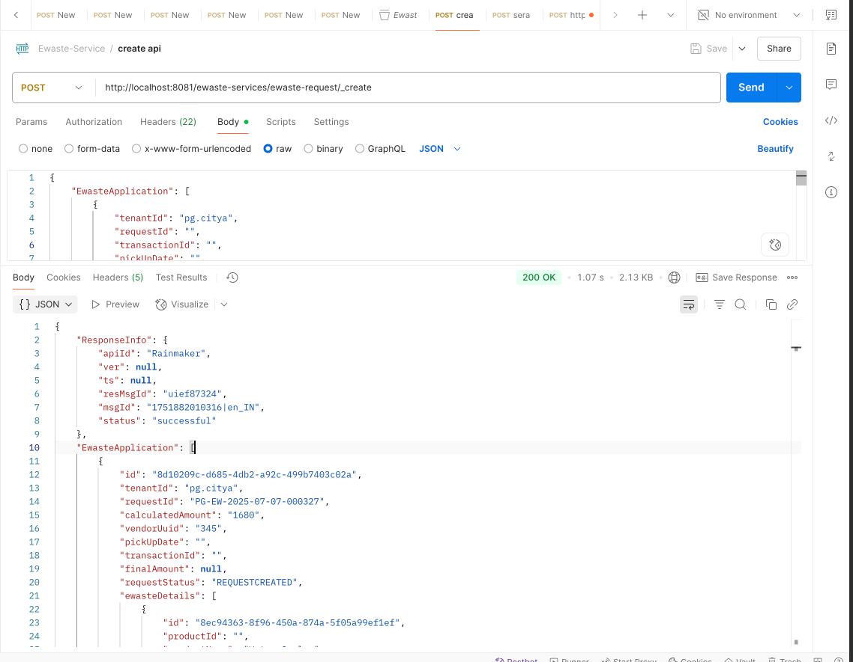
Niuatt
curl --location 'https://niuatt.niua.in/ewaste-services/ewaste-request/_create' \
--header 'accept: application/json, text/plain, */*' \
--header 'accept-language: en-GB,en-US;q=0.9,en;q=0.8' \
--header 'content-type: application/json;charset=UTF-8' \
--header 'origin: https://niuatt.niua.in' \
--header 'priority: u=1, i' \
--header 'referer: https://niuatt.niua.in/digit-ui/citizen/ew/raiseRequest/acknowledgement' \
--header 'sec-ch-ua: "Google Chrome";v="137", "Chromium";v="137", "Not/A)Brand";v="24"' \
--header 'sec-ch-ua-mobile: ?0' \
--header 'sec-ch-ua-platform: "macOS"' \
--header 'sec-fetch-dest: empty' \
--header 'sec-fetch-mode: cors' \
--header 'sec-fetch-site: same-origin' \
--header 'user-agent: Mozilla/5.0 (Macintosh; Intel Mac OS X 10_15_7) AppleWebKit/537.36 (KHTML, like Gecko) Chrome/137.0.0.0 Safari/537.36' \
--header 'Cookie: _ga=GA1.1.1498208436.1748421576; _ga_VZ9TNBTB3X=GS2.1.s1748421575$o1$g0$t1748421575$j60$l0$h0; _clck=tkuuq4%7C2%7Cfwa%7C0%7C1974' \
--data-raw '{
"EwasteApplication": [
{
"tenantId": "pg.citya",
"requestId": "",
"transactionId": "",
"pickUpDate": "",
"vendorUuid": "345",
"requestStatus": "New Request",
"calculatedAmount": 1680,
"applicant": {
"applicantName": "Nikhil",
"mobileNumber": "7000000000",
"emailId": "nikhil@gmail.com",
"altMobileNumber": ""
},
"ewasteDetails": [
{
"productId": "",
"productName": "Water Cooler",
"quantity": "5",
"price": 1680
}
],
"address": {
"tenantId": "pg.citya",
"doorNo": "43534",
"latitude": null,
"longitude": null,
"addressNumber": "",
"type": "RESIDENTIAL",
"addressLine1": "sdfsdf",
"addressLine2": "sfsdf",
"landmark": "sdfsdf",
"city": "New Delhi",
"pincode": "143001",
"detail": "",
"buildingName": "sdfsdf",
"street": "india Habitat Centre",
"locality": {
"code": "JLC476",
"name": ""
}
},
"documents": [
{
"filestoreId": "3140a495-c0b7-4961-8dd9-1a836811e327",
"documentuuid": "3140a495-c0b7-4961-8dd9-1a836811e327",
"documentType": "Photo1"
}
],
"workflow": {
"businessService": "ewst",
"action": "CREATE",
"moduleName": "ewaste-services"
}
}
],
"RequestInfo": {
"apiId": "Rainmaker",
"authToken": "56b1475a-b56c-47af-b9a3-7c214508147a",
"userInfo": {
"id": 808,
"uuid": "38dd895e-95a0-4b72-946f-023a8a782c49",
"userName": "7000000000",
"name": "Nikhil",
"mobileNumber": "7000000000",
"emailId": "nikhil@gmail.com",
"locale": null,
"type": "CITIZEN",
"roles": [
{
"name": "Citizen",
"code": "CITIZEN",
"tenantId": "pg"
}
],
"active": true,
"tenantId": "pg",
"permanentCity": null
},
"msgId": "1751882010316|en_IN",
"plainAccessRequest": {}
}
}'

Response:-
{
"ResponseInfo": {
"apiId": "Rainmaker",
"ver": null,
"ts": null,
"resMsgId": "uief87324",
"msgId": "1751882010316|en_IN",
"status": "successful"
},
"EwasteApplication": [
{
"id": "1cbffbf1-fe1e-4312-8b6f-49bec0e4b945",
"tenantId": "pg.citya",
"requestId": "PG-EW-2025-07-07-000328",
"calculatedAmount": "1680",
"vendorUuid": "345",
"pickUpDate": "",
"transactionId": "",
"finalAmount": null,
"requestStatus": "REQUESTCREATED",
"ewasteDetails": [
{
"id": "167eb52a-07f7-4313-b91e-20359e45bf47",
"productId": "",
"productName": "Water Cooler",
"quantity": "5",
"price": "1680"
}
],
"applicant": {
"id": "a06cba11-9757-40b1-b289-fb0a4e2eb69e",
"applicantName": "Nikhil",
"gender": null,
"mobileNumber": "7000000000",
"emailId": "nikhil@gmail.com",
"altMobileNumber": "",
"tenantId": null,
"ewId": "1cbffbf1-fe1e-4312-8b6f-49bec0e4b945"
},
"address": {
"id": "a1247b81-78c0-4513-b191-74b5d6ce64a5",
"tenantId": "pg.citya",
"registrationId": "1cbffbf1-fe1e-4312-8b6f-49bec0e4b945",
"doorNo": "43534",
"latitude": null,
"longitude": null,
"addressId": null,
"addressNumber": "",
"type": "RESIDENTIAL",
"addressLine1": "sdfsdf",
"addressLine2": "sfsdf",
"landmark": "sdfsdf",
"city": "New Delhi",
"pincode": "143001",
"detail": "",
"buildingName": "sdfsdf",
"street": "india Habitat Centre",
"locality": {
"code": "JLC476",
"name": "",
"label": null,
"latitude": null,
"longitude": null,
"children": null,
"materializedPath": null
},
"auditDetails": {
"createdBy": "38dd895e-95a0-4b72-946f-023a8a782c49",
"lastModifiedBy": null,
"createdTime": 1751884279683,
"lastModifiedTime": null
}
},
"auditDetails": {
"createdBy": "38dd895e-95a0-4b72-946f-023a8a782c49",
"lastModifiedBy": null,
"createdTime": 1751884279683,
"lastModifiedTime": null
},
"documents": [
{
"id": "641353cd-f857-47b2-9ef3-3f946278794f",
"active": true,
"tenantId": "pg.citya",
"documentType": "Photo1",
"filestoreId": "3140a495-c0b7-4961-8dd9-1a836811e327",
"documentUid": null,
"auditDetails": {
"createdBy": "38dd895e-95a0-4b72-946f-023a8a782c49",
"lastModifiedBy": null,
"createdTime": 1751884279683,
"lastModifiedTime": null
}
}
],
"workflow": {
"action": "CREATE",
"status": null,
"comments": null,
"assignes": null,
"documents": null
}
}
]
}
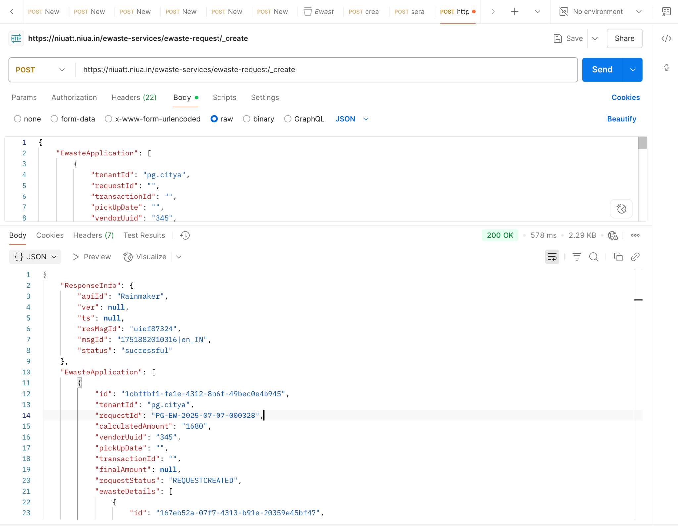

Curl local vs niuatt

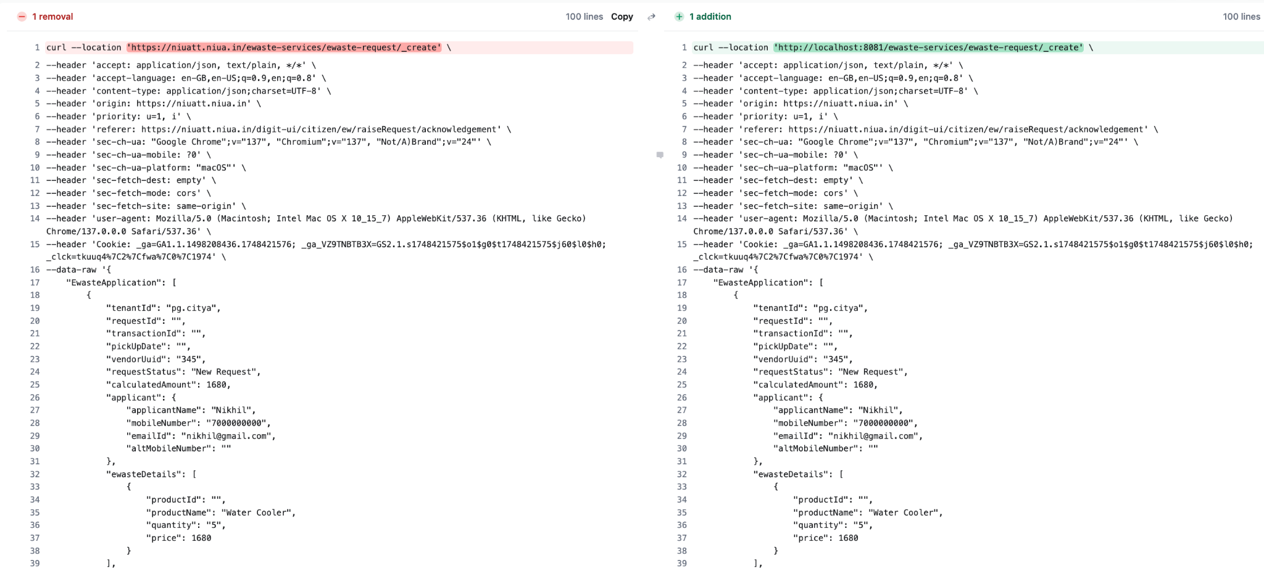
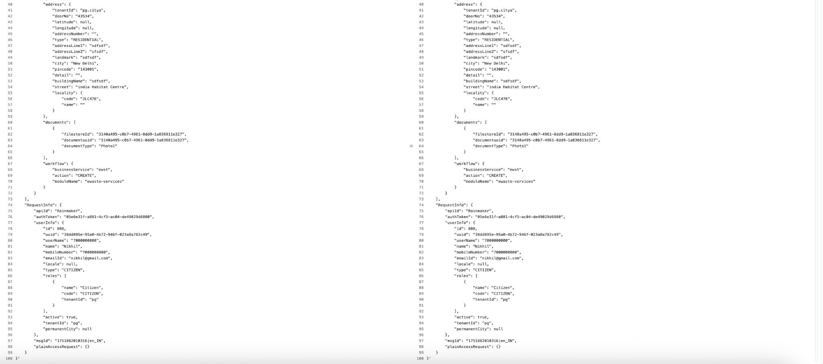

Response Local Vs Niuatt

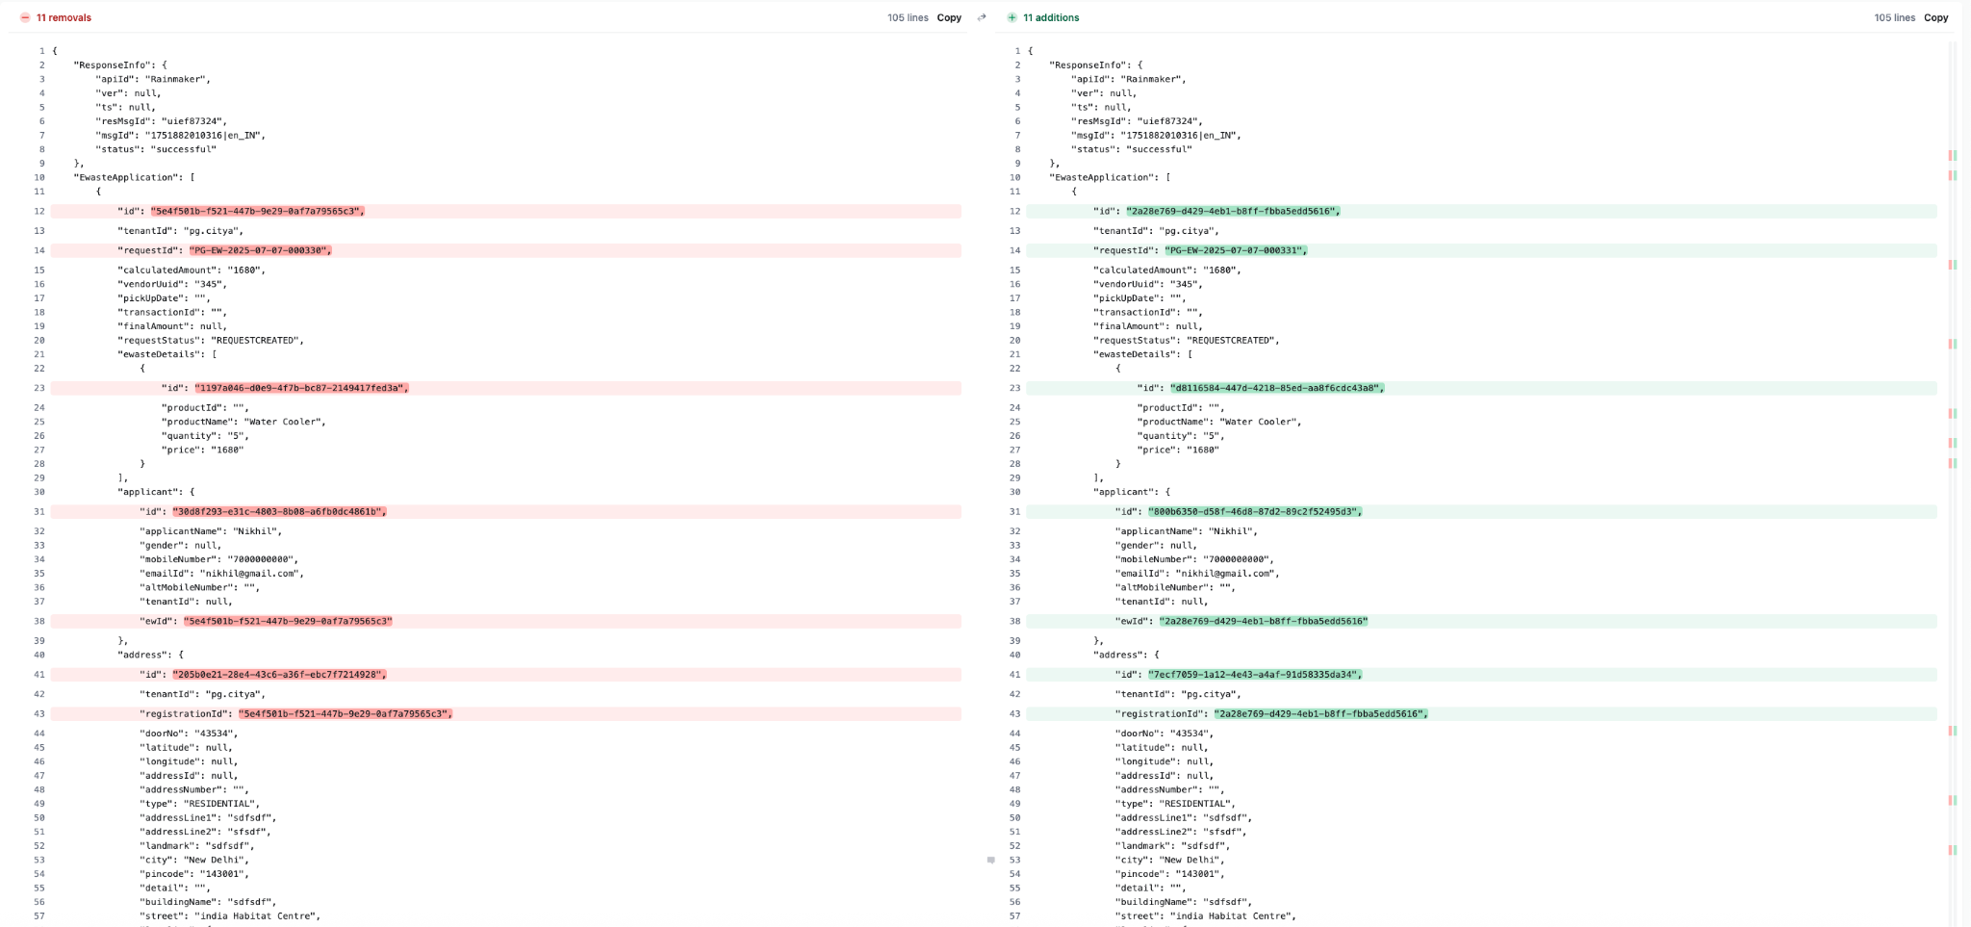
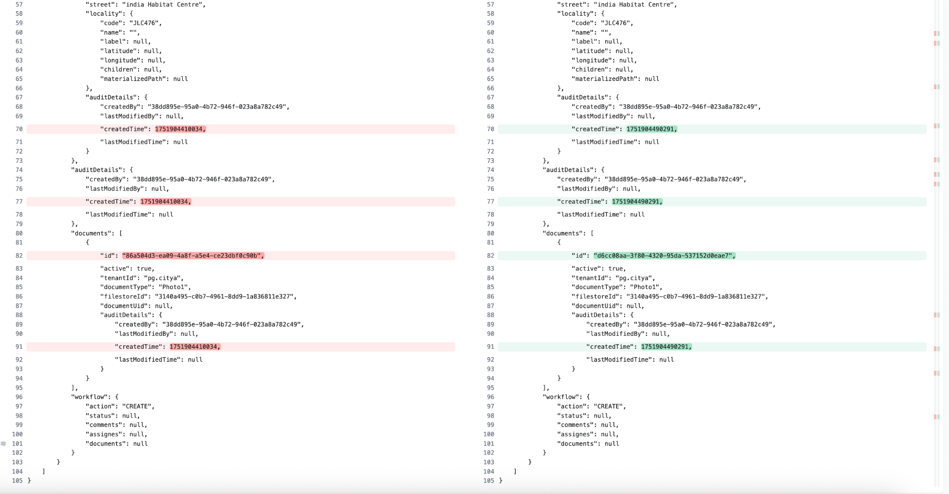

Search Api
Local
curl --location 'http://localhost:8081/ewaste-services/ewaste-request/_search?tenantId=pg.citya&limit=4&sortOrder=ASC&sortBy=createdTime&offset=0&mobileNumber=7000000000&_=1751882604065' \
--header 'accept: application/json, text/plain, */*' \
--header 'accept-language: en-GB,en-US;q=0.9,en;q=0.8' \
--header 'content-type: application/json;charset=UTF-8' \
--header 'origin: https://niuatt.niua.in' \
--header 'priority: u=1, i' \
--header 'referer: https://niuatt.niua.in/digit-ui/citizen/ew/myApplication' \
--header 'sec-ch-ua: "Google Chrome";v="137", "Chromium";v="137", "Not/A)Brand";v="24"' \
--header 'sec-ch-ua-mobile: ?0' \
--header 'sec-ch-ua-platform: "macOS"' \
--header 'sec-fetch-dest: empty' \
--header 'sec-fetch-mode: cors' \
--header 'sec-fetch-site: same-origin' \
--header 'user-agent: Mozilla/5.0 (Macintosh; Intel Mac OS X 10_15_7) AppleWebKit/537.36 (KHTML, like Gecko) Chrome/137.0.0.0 Safari/537.36' \
--header 'Cookie: _ga=GA1.1.1498208436.1748421576; _ga_VZ9TNBTB3X=GS2.1.s1748421575$o1$g0$t1748421575$j60$l0$h0; _clck=tkuuq4%7C2%7Cfwa%7C0%7C1974' \
--data-raw '{
"RequestInfo": {
"apiId": "Rainmaker",
"authToken": "56b1475a-b56c-47af-b9a3-7c214508147a",
"userInfo": {
"id": 808,
"uuid": "38dd895e-95a0-4b72-946f-023a8a782c49",
"userName": "7000000000",
"name": "Nikhil",
"mobileNumber": "7000000000",
"emailId": "nikhil@gmail.com",
"locale": null,
"type": "CITIZEN",
"roles": [
{
"name": "Citizen",
"code": "CITIZEN",
"tenantId": "pg"
}
],
"active": true,
"tenantId": "pg",
"permanentCity": null
},
"msgId": "1751882604065|en_IN",
"plainAccessRequest": {}
}
}'

Response:-

{
"ResponseInfo": {
"apiId": "Rainmaker",
"ver": null,
"ts": null,
"resMsgId": "uief87324",
"msgId": "1751882604065|en_IN",
"status": "successful"
},
"EwasteApplication": [
{
"id": "b613a5be-1ddd-4dfb-a640-3b2fe351ed1e",
"tenantId": "pg.citya",
"requestId": "PG-EW-2025-07-07-000323",
"calculatedAmount": "1680",
"vendorUuid": "345",
"pickUpDate": "",
"transactionId": "",
"finalAmount": null,
"requestStatus": "REQUESTCREATED",
"ewasteDetails": [
{
"id": null,
"productId": "",
"productName": "Water Cooler",
"quantity": "5",
"price": "1680"
}
],
"applicant": {
"id": "e514e3ef-6af7-4454-b4f8-6127360d9c92",
"applicantName": "Nikhil",
"gender": null,
"mobileNumber": "7000000000",
"emailId": "nikhil@gmail.com",
"altMobileNumber": "",
"tenantId": null,
"ewId": null
},
"address": {
"id": "c7a11a07-81e4-4cf5-a052-3941f9d5385d",
"tenantId": "pg.citya",
"registrationId": null,
"doorNo": "43534",
"latitude": 0.0,
"longitude": 0.0,
"addressId": null,
"addressNumber": "",
"type": "RESIDENTIAL",
"addressLine1": "sdfsdf",
"addressLine2": "sfsdf",
"landmark": "sdfsdf",
"city": "New Delhi",
"pincode": "143001",
"detail": "",
"buildingName": "sdfsdf",
"street": "india Habitat Centre",
"locality": null,
"auditDetails": null
},
"auditDetails": {
"createdBy": "38dd895e-95a0-4b72-946f-023a8a782c49",
"lastModifiedBy": null,
"createdTime": 1751882011756,
"lastModifiedTime": null
},
"documents": [
{
"id": "48a6ced9-a091-4933-b3fa-98f4595ff1d4",
"active": null,
"tenantId": null,
"documentType": "Photo1",
"filestoreId": "3140a495-c0b7-4961-8dd9-1a836811e327",
"documentUid": null,
"auditDetails": null
}
],
"workflow": null
}
]
}

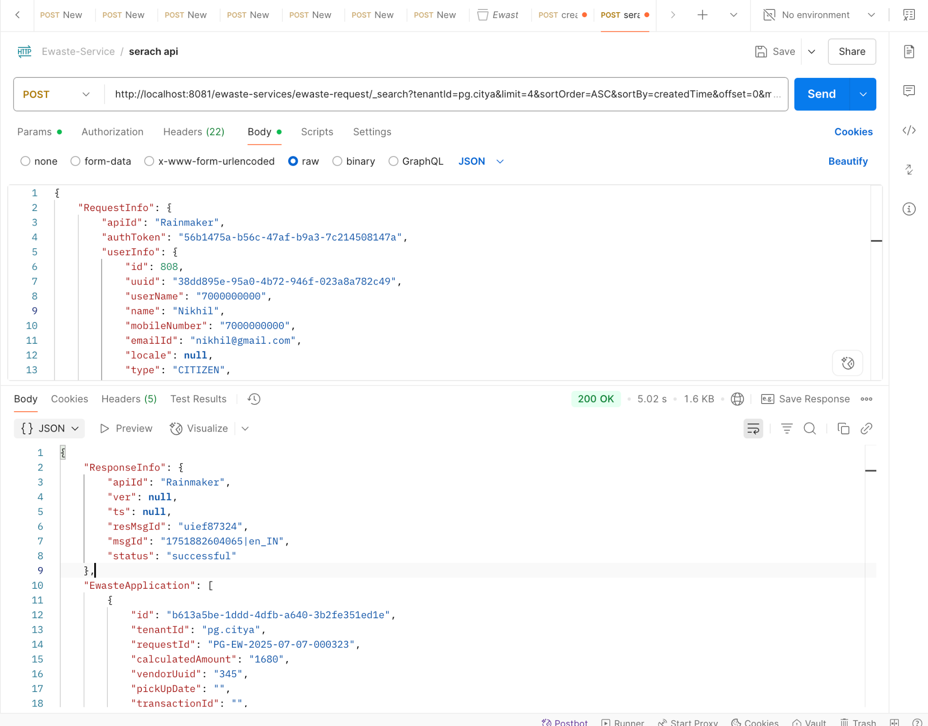

Niuatt
curl 'https://niuatt.niua.in/ewaste-services/ewaste-request/_search?tenantId=pg.citya&limit=4&sortOrder=ASC&sortBy=createdTime&offset=0&mobileNumber=7000000000&_=1751882604065' \
-H 'accept: application/json, text/plain, */*' \
-H 'accept-language: en-GB,en-US;q=0.9,en;q=0.8' \
-H 'content-type: application/json;charset=UTF-8' \
-b '_ga=GA1.1.1498208436.1748421576; _ga_VZ9TNBTB3X=GS2.1.s1748421575$o1$g0$t1748421575$j60$l0$h0; _clck=tkuuq4%7C2%7Cfwa%7C0%7C1974' \
-H 'origin: https://niuatt.niua.in' \
-H 'priority: u=1, i' \
-H 'referer: https://niuatt.niua.in/digit-ui/citizen/ew/myApplication' \
-H 'sec-ch-ua: "Google Chrome";v="137", "Chromium";v="137", "Not/A)Brand";v="24"' \
-H 'sec-ch-ua-mobile: ?0' \
-H 'sec-ch-ua-platform: "macOS"' \
-H 'sec-fetch-dest: empty' \
-H 'sec-fetch-mode: cors' \
-H 'sec-fetch-site: same-origin' \
-H 'user-agent: Mozilla/5.0 (Macintosh; Intel Mac OS X 10_15_7) AppleWebKit/537.36 (KHTML, like Gecko) Chrome/137.0.0.0 Safari/537.36' \
--data-raw '{"RequestInfo":{"apiId":"Rainmaker","authToken":"56b1475a-b56c-47af-b9a3-7c214508147a","userInfo":{"id":808,"uuid":"38dd895e-95a0-4b72-946f-023a8a782c49","userName":"7000000000","name":"Nikhil","mobileNumber":"7000000000","emailId":"nikhil@gmail.com","locale":null,"type":"CITIZEN","roles":[{"name":"Citizen","code":"CITIZEN","tenantId":"pg"}],"active":true,"tenantId":"pg","permanentCity":null},"msgId":"1751882604065|en_IN","plainAccessRequest":{}}}'

Response:-
{
"ResponseInfo": {
"apiId": "Rainmaker",
"ver": null,
"ts": null,
"resMsgId": "uief87324",
"msgId": "1751882604065|en_IN",
"status": "successful"
},
"EwasteApplication": [
{
"id": "b613a5be-1ddd-4dfb-a640-3b2fe351ed1e",
"tenantId": "pg.citya",
"requestId": "PG-EW-2025-07-07-000323",
"calculatedAmount": "1680",
"vendorUuid": "345",
"pickUpDate": "",
"transactionId": "",
"finalAmount": null,
"requestStatus": "REQUESTCREATED",
"ewasteDetails": [
{
"id": null,
"productId": "",
"productName": "Water Cooler",
"quantity": "5",
"price": "1680"
}
],
"applicant": {
"id": "e514e3ef-6af7-4454-b4f8-6127360d9c92",
"applicantName": "Nikhil",
"gender": null,
"mobileNumber": "7000000000",
"emailId": "nikhil@gmail.com",
"altMobileNumber": "",
"tenantId": null,
"ewId": null
},
"address": {
"id": "c7a11a07-81e4-4cf5-a052-3941f9d5385d",
"tenantId": "pg.citya",
"registrationId": null,
"doorNo": "43534",
"latitude": 0.0,
"longitude": 0.0,
"addressId": null,
"addressNumber": "",
"type": "RESIDENTIAL",
"addressLine1": "sdfsdf",
"addressLine2": "sfsdf",
"landmark": "sdfsdf",
"city": "New Delhi",
"pincode": "143001",
"detail": "",
"buildingName": "sdfsdf",
"street": "india Habitat Centre",
"locality": null,
"auditDetails": null
},
"auditDetails": {
"createdBy": "38dd895e-95a0-4b72-946f-023a8a782c49",
"lastModifiedBy": null,
"createdTime": 1751882011756,
"lastModifiedTime": null
},
"documents": [
{
"id": "48a6ced9-a091-4933-b3fa-98f4595ff1d4",
"active": null,
"tenantId": null,
"documentType": "Photo1",
"filestoreId": "3140a495-c0b7-4961-8dd9-1a836811e327",
"documentUid": null,
"auditDetails": null
}
],
"workflow": null
}
]
}

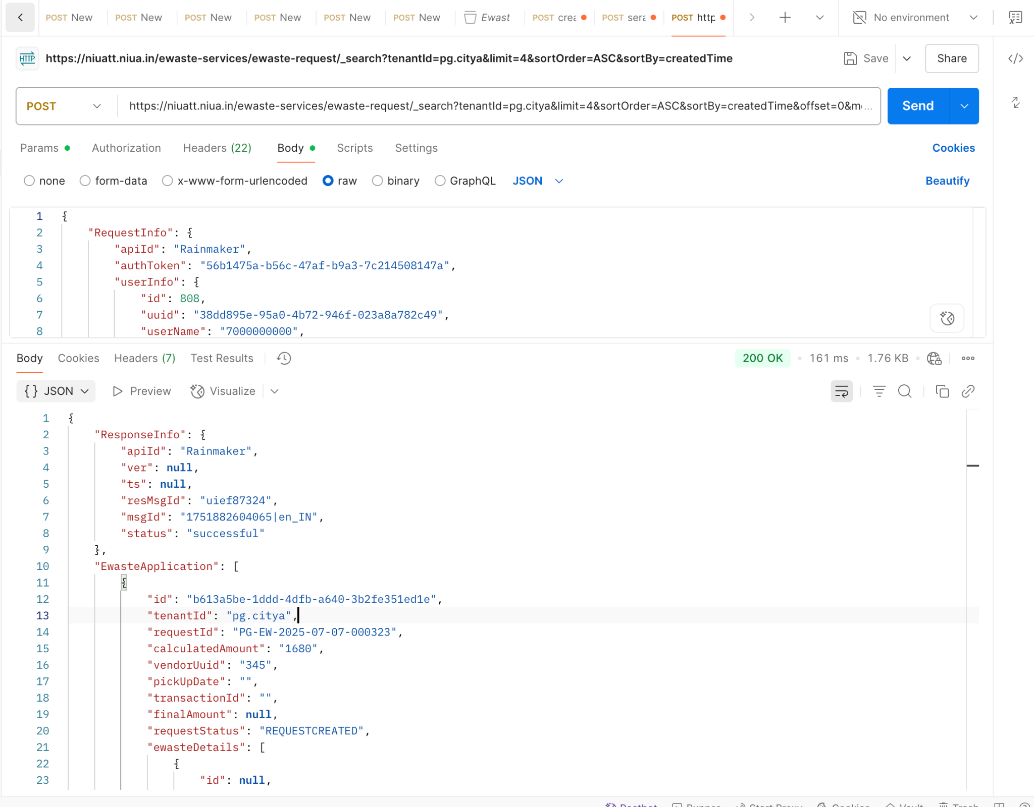

Curl local Vs Niuatt

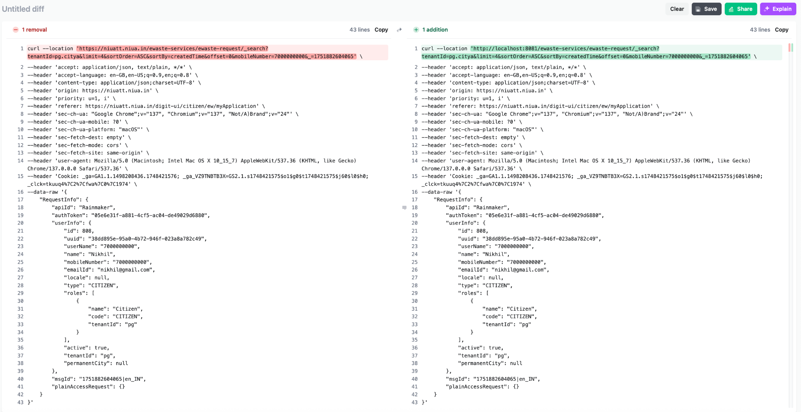

Response Local Vs Niuatt

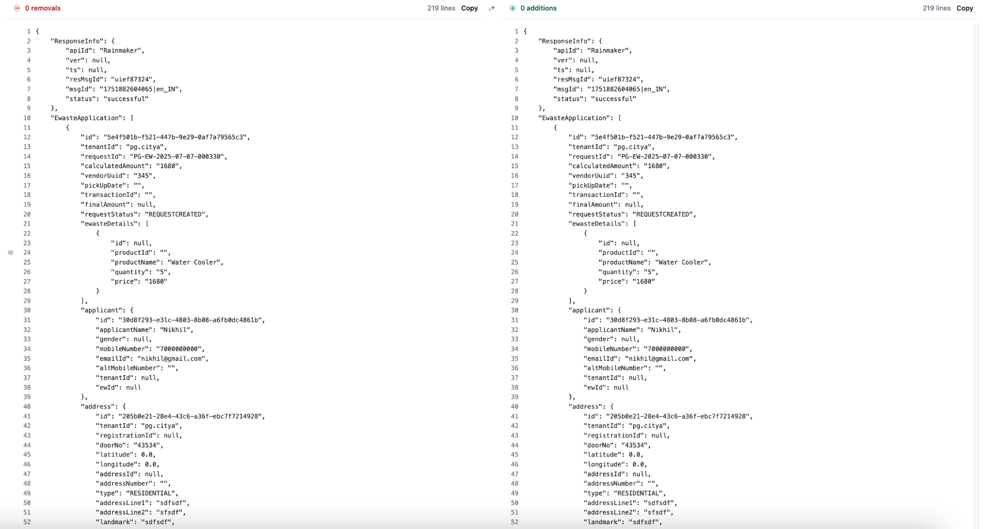

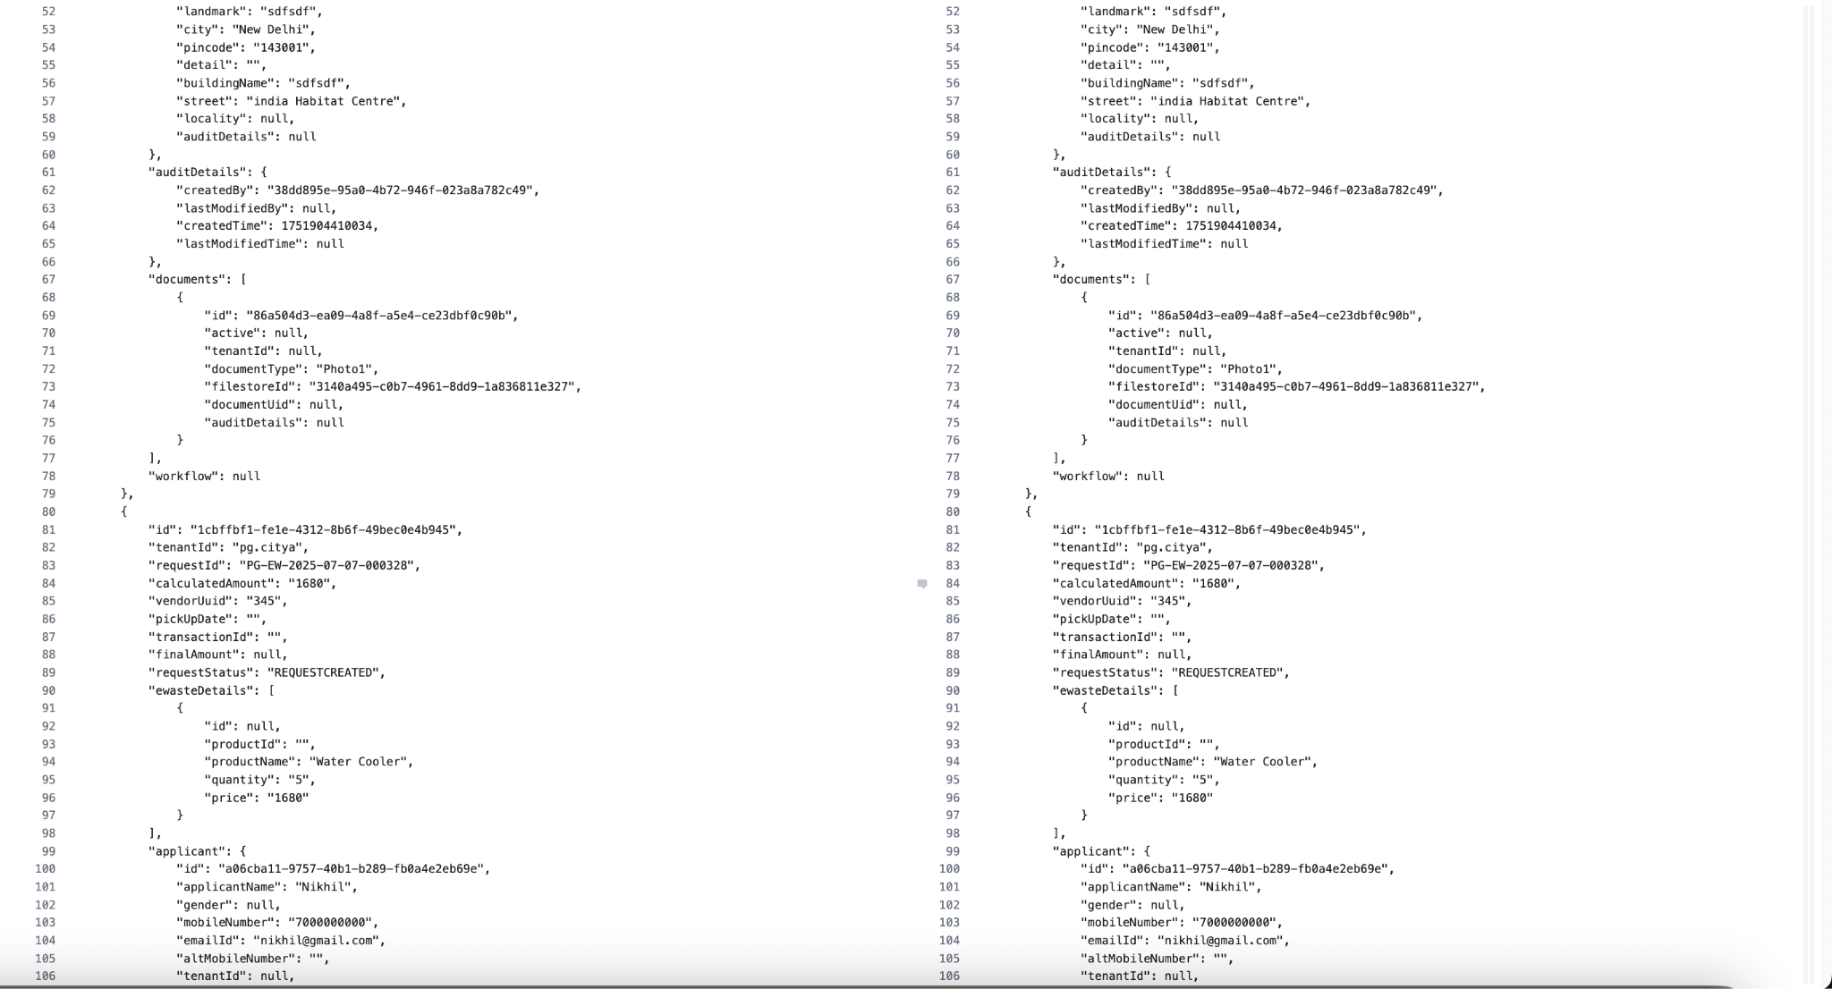

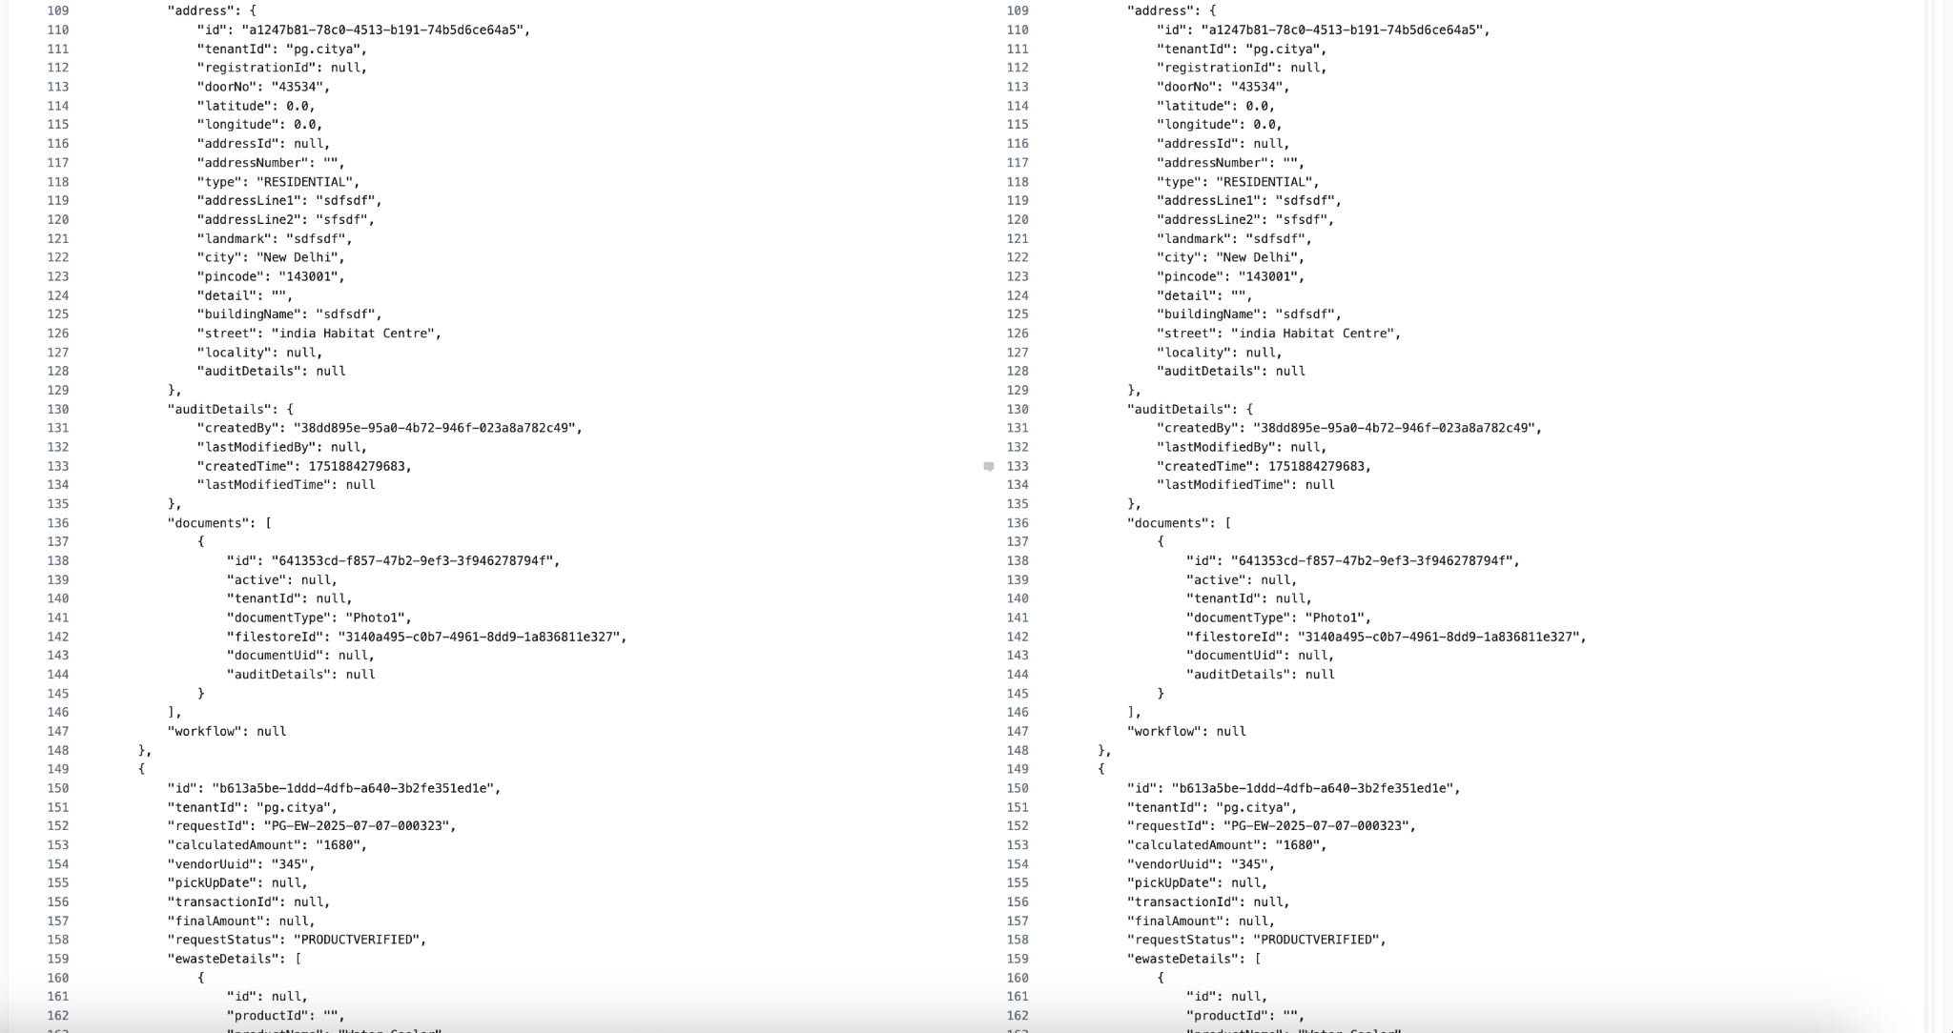

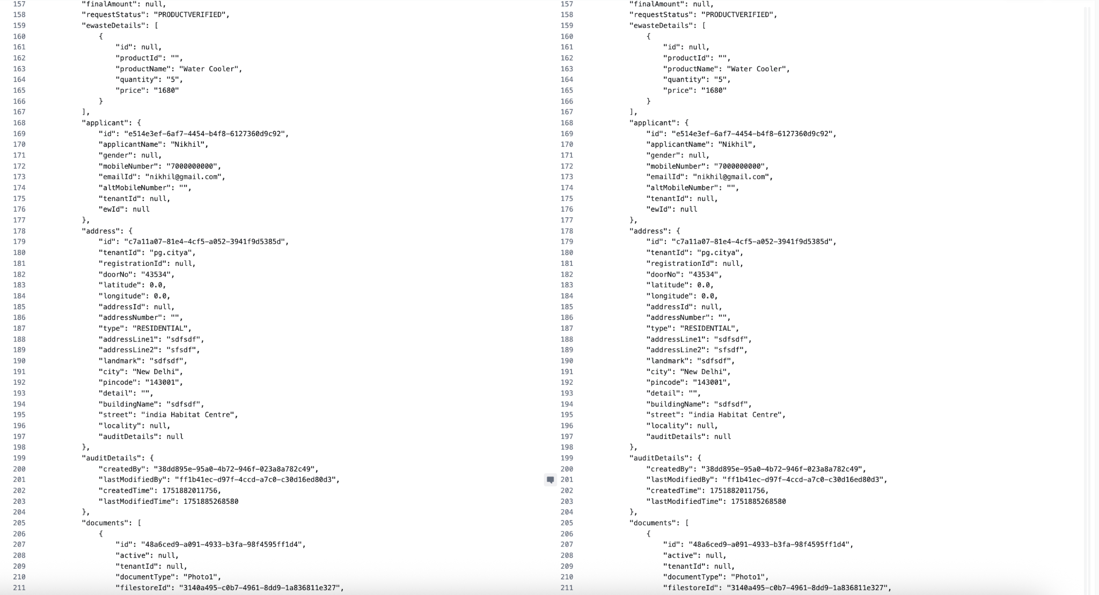
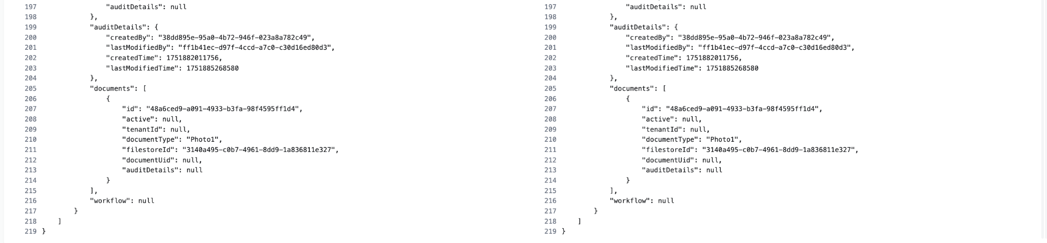

Update API
Local
curl --location 'http://localhost:8081/ewaste-services/ewaste-request/_update' \
--header 'sec-ch-ua-platform: "macOS"' \
--header 'Referer: https://niuatt.niua.in/digit-ui/employee/ew/application-details/PG-EW-2025-07-07-000323' \
--header 'User-Agent: Mozilla/5.0 (Macintosh; Intel Mac OS X 10_15_7) AppleWebKit/537.36 (KHTML, like Gecko) Chrome/137.0.0.0 Safari/537.36' \
--header 'Accept: application/json, text/plain, */*' \
--header 'sec-ch-ua: "Google Chrome";v="137", "Chromium";v="137", "Not/A)Brand";v="24"' \
--header 'Content-Type: application/json;charset=UTF-8' \
--header 'sec-ch-ua-mobile: ?0' \
--data-raw '{
"EwasteApplication": [
{
"id": "b613a5be-1ddd-4dfb-a640-3b2fe351ed1e",
"tenantId": "pg.citya",
"requestId": "PG-EW-2025-07-07-000323",
"calculatedAmount": "1680",
"vendorUuid": "345",
"requestStatus": "REQUESTCREATED",
"ewasteDetails": [
{
"id": null,
"productId": "",
"productName": "Water Cooler",
"quantity": "5",
"price": "1680"
}
],
"applicant": {
"id": "e514e3ef-6af7-4454-b4f8-6127360d9c92",
"applicantName": "Nikhil",
"gender": null,
"mobileNumber": "7000000000",
"emailId": "nikhil@gmail.com",
"altMobileNumber": "",
"tenantId": null,
"ewId": null
},
"address": {
"id": "c7a11a07-81e4-4cf5-a052-3941f9d5385d",
"tenantId": "pg.citya",
"registrationId": null,
"doorNo": "43534",
"latitude": 0,
"longitude": 0,
"addressId": null,
"addressNumber": "",
"type": "RESIDENTIAL",
"addressLine1": "sdfsdf",
"addressLine2": "sfsdf",
"landmark": "sdfsdf",
"city": "New Delhi",
"pincode": "143001",
"detail": "",
"buildingName": "sdfsdf",
"street": "india Habitat Centre",
"locality": null,
"auditDetails": null
},
"auditDetails": {
"createdBy": "38dd895e-95a0-4b72-946f-023a8a782c49",
"lastModifiedBy": null,
"createdTime": 1751882011756,
"lastModifiedTime": null
},
"documents": [
{
"id": "48a6ced9-a091-4933-b3fa-98f4595ff1d4",
"active": null,
"tenantId": null,
"documentType": "Photo1",
"filestoreId": "3140a495-c0b7-4961-8dd9-1a836811e327",
"documentUid": null,
"auditDetails": null
}
],
"workflow": {
"action": "VERIFYPRODUCT",
"comments": "erer",
"businessService": "ewst",
"moduleName": "ewaste-services"
}
}
],
"RequestInfo": {
"apiId": "Rainmaker",
"authToken": "5a179a33-5c3f-4c42-9795-81d1eb73a13b",
"userInfo": {
"id": 787,
"uuid": "ff1b41ec-d97f-4ccd-a7c0-c30d16ed80d3",
"userName": "EWASTE",
"name": "Ewaste",
"mobileNumber": "9810010159",
"emailId": null,
"locale": null,
"type": "EMPLOYEE",
"roles": [
{
"name": "Employee",
"code": "EMPLOYEE",
"tenantId": "pg.citya"
},
{
"name": "Vendor",
"code": "EW_VENDOR",
"tenantId": "pg.citya"
}
],
"active": true,
"tenantId": "pg.citya",
"permanentCity": null
},
"msgId": "1751884957778|en_IN",
"plainAccessRequest": {}
}
}'

Response:-
{
"ResponseInfo": {
"apiId": "Rainmaker",
"ver": null,
"ts": null,
"resMsgId": "uief87324",
"msgId": "1751884957778|en_IN",
"status": "successful"
},
"EwasteApplication": [
{
"id": "b613a5be-1ddd-4dfb-a640-3b2fe351ed1e",
"tenantId": "pg.citya",
"requestId": "PG-EW-2025-07-07-000323",
"calculatedAmount": "1680",
"vendorUuid": "345",
"pickUpDate": null,
"transactionId": null,
"finalAmount": null,
"requestStatus": "PRODUCTVERIFIED",
"ewasteDetails": [
{
"id": null,
"productId": "",
"productName": "Water Cooler",
"quantity": "5",
"price": "1680"
}
],
"applicant": {
"id": "e514e3ef-6af7-4454-b4f8-6127360d9c92",
"applicantName": "Nikhil",
"gender": null,
"mobileNumber": "7000000000",
"emailId": "nikhil@gmail.com",
"altMobileNumber": "",
"tenantId": null,
"ewId": null
},
"address": {
"id": "c7a11a07-81e4-4cf5-a052-3941f9d5385d",
"tenantId": "pg.citya",
"registrationId": null,
"doorNo": "43534",
"latitude": 0.0,
"longitude": 0.0,
"addressId": null,
"addressNumber": "",
"type": "RESIDENTIAL",
"addressLine1": "sdfsdf",
"addressLine2": "sfsdf",
"landmark": "sdfsdf",
"city": "New Delhi",
"pincode": "143001",
"detail": "",
"buildingName": "sdfsdf",
"street": "india Habitat Centre",
"locality": null,
"auditDetails": null
},
"auditDetails": {
"createdBy": "38dd895e-95a0-4b72-946f-023a8a782c49",
"lastModifiedBy": "ff1b41ec-d97f-4ccd-a7c0-c30d16ed80d3",
"createdTime": 1751882011756,
"lastModifiedTime": 1751885498581
},
"documents": [
{
"id": "48a6ced9-a091-4933-b3fa-98f4595ff1d4",
"active": null,
"tenantId": null,
"documentType": "Photo1",
"filestoreId": "3140a495-c0b7-4961-8dd9-1a836811e327",
"documentUid": null,
"auditDetails": null
}
],
"workflow": {
"action": "VERIFYPRODUCT",
"status": null,
"comments": "erer",
"assignes": null,
"documents": null
}
}
]
}
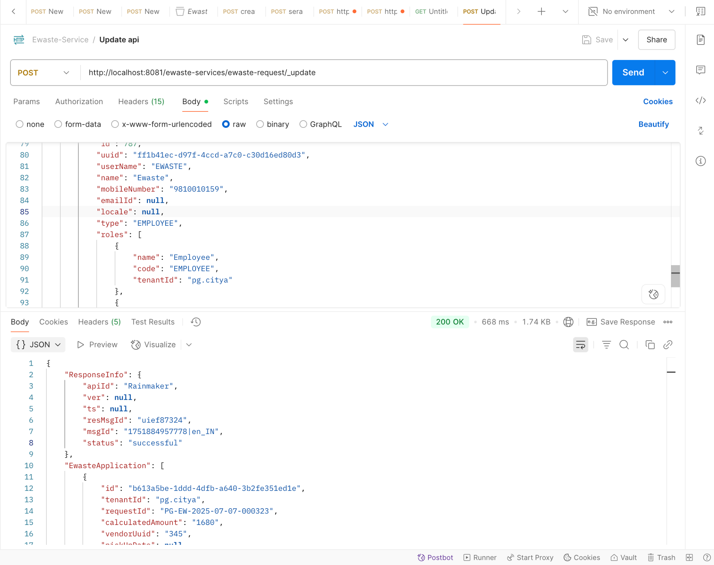

Niuatt
curl --location 'https://niuatt.niua.in/ewaste-services/ewaste-request/_update' \
--header 'sec-ch-ua-platform: "macOS"' \
--header 'Referer: https://niuatt.niua.in/digit-ui/employee/ew/application-details/PG-EW-2025-07-07-000323' \
--header 'User-Agent: Mozilla/5.0 (Macintosh; Intel Mac OS X 10_15_7) AppleWebKit/537.36 (KHTML, like Gecko) Chrome/137.0.0.0 Safari/537.36' \
--header 'Accept: application/json, text/plain, */*' \
--header 'sec-ch-ua: "Google Chrome";v="137", "Chromium";v="137", "Not/A)Brand";v="24"' \
--header 'Content-Type: application/json;charset=UTF-8' \
--header 'sec-ch-ua-mobile: ?0' \
--data-raw '{
"EwasteApplication": [
{
"id": "b613a5be-1ddd-4dfb-a640-3b2fe351ed1e",
"tenantId": "pg.citya",
"requestId": "PG-EW-2025-07-07-000323",
"calculatedAmount": "1680",
"vendorUuid": "345",
"requestStatus": "REQUESTCREATED",
"ewasteDetails": [
{
"id": null,
"productId": "",
"productName": "Water Cooler",
"quantity": "5",
"price": "1680"
}
],
"applicant": {
"id": "e514e3ef-6af7-4454-b4f8-6127360d9c92",
"applicantName": "Nikhil",
"gender": null,
"mobileNumber": "7000000000",
"emailId": "nikhil@gmail.com",
"altMobileNumber": "",
"tenantId": null,
"ewId": null
},
"address": {
"id": "c7a11a07-81e4-4cf5-a052-3941f9d5385d",
"tenantId": "pg.citya",
"registrationId": null,
"doorNo": "43534",
"latitude": 0,
"longitude": 0,
"addressId": null,
"addressNumber": "",
"type": "RESIDENTIAL",
"addressLine1": "sdfsdf",
"addressLine2": "sfsdf",
"landmark": "sdfsdf",
"city": "New Delhi",
"pincode": "143001",
"detail": "",
"buildingName": "sdfsdf",
"street": "india Habitat Centre",
"locality": null,
"auditDetails": null
},
"auditDetails": {
"createdBy": "38dd895e-95a0-4b72-946f-023a8a782c49",
"lastModifiedBy": null,
"createdTime": 1751882011756,
"lastModifiedTime": null
},
"documents": [
{
"id": "48a6ced9-a091-4933-b3fa-98f4595ff1d4",
"active": null,
"tenantId": null,
"documentType": "Photo1",
"filestoreId": "3140a495-c0b7-4961-8dd9-1a836811e327",
"documentUid": null,
"auditDetails": null
}
],
"workflow": {
"action": "VERIFYPRODUCT",
"comments": "erer",
"businessService": "ewst",
"moduleName": "ewaste-services"
}
}
],
"RequestInfo": {
"apiId": "Rainmaker",
"authToken": "5a179a33-5c3f-4c42-9795-81d1eb73a13b",
"userInfo": {
"id": 787,
"uuid": "ff1b41ec-d97f-4ccd-a7c0-c30d16ed80d3",
"userName": "EWASTE",
"name": "Ewaste",
"mobileNumber": "9810010159",
"emailId": null,
"locale": null,
"type": "EMPLOYEE",
"roles": [
{
"name": "Employee",
"code": "EMPLOYEE",
"tenantId": "pg.citya"
},
{
"name": "Vendor",
"code": "EW_VENDOR",
"tenantId": "pg.citya"
}
],
"active": true,
"tenantId": "pg.citya",
"permanentCity": null
},
"msgId": "1751884957778|en_IN",
"plainAccessRequest": {}
}
}'

Response:-

{
"ResponseInfo": {
"apiId": "Rainmaker",
"ver": null,
"ts": null,
"resMsgId": "uief87324",
"msgId": "1751884957778|en_IN",
"status": "successful"
},
"EwasteApplication": [
{
"id": "b613a5be-1ddd-4dfb-a640-3b2fe351ed1e",
"tenantId": "pg.citya",
"requestId": "PG-EW-2025-07-07-000323",
"calculatedAmount": "1680",
"vendorUuid": "345",
"pickUpDate": null,
"transactionId": null,
"finalAmount": null,
"requestStatus": "PRODUCTVERIFIED",
"ewasteDetails": [
{
"id": null,
"productId": "",
"productName": "Water Cooler",
"quantity": "5",
"price": "1680"
}
],
"applicant": {
"id": "e514e3ef-6af7-4454-b4f8-6127360d9c92",
"applicantName": "Nikhil",
"gender": null,
"mobileNumber": "7000000000",
"emailId": "nikhil@gmail.com",
"altMobileNumber": "",
"tenantId": null,
"ewId": null
},
"address": {
"id": "c7a11a07-81e4-4cf5-a052-3941f9d5385d",
"tenantId": "pg.citya",
"registrationId": null,
"doorNo": "43534",
"latitude": 0.0,
"longitude": 0.0,
"addressId": null,
"addressNumber": "",
"type": "RESIDENTIAL",
"addressLine1": "sdfsdf",
"addressLine2": "sfsdf",
"landmark": "sdfsdf",
"city": "New Delhi",
"pincode": "143001",
"detail": "",
"buildingName": "sdfsdf",
"street": "india Habitat Centre",
"locality": null,
"auditDetails": null
},
"auditDetails": {
"createdBy": "38dd895e-95a0-4b72-946f-023a8a782c49",
"lastModifiedBy": "ff1b41ec-d97f-4ccd-a7c0-c30d16ed80d3",
"createdTime": 1751882011756,
"lastModifiedTime": 1751885268580
},
"documents": [
{
"id": "48a6ced9-a091-4933-b3fa-98f4595ff1d4",
"active": null,
"tenantId": null,
"documentType": "Photo1",
"filestoreId": "3140a495-c0b7-4961-8dd9-1a836811e327",
"documentUid": null,
"auditDetails": null
}
],
"workflow": {
"action": "VERIFYPRODUCT",
"status": null,
"comments": "erer",
"assignes": null,
"documents": null
}
}
]
}

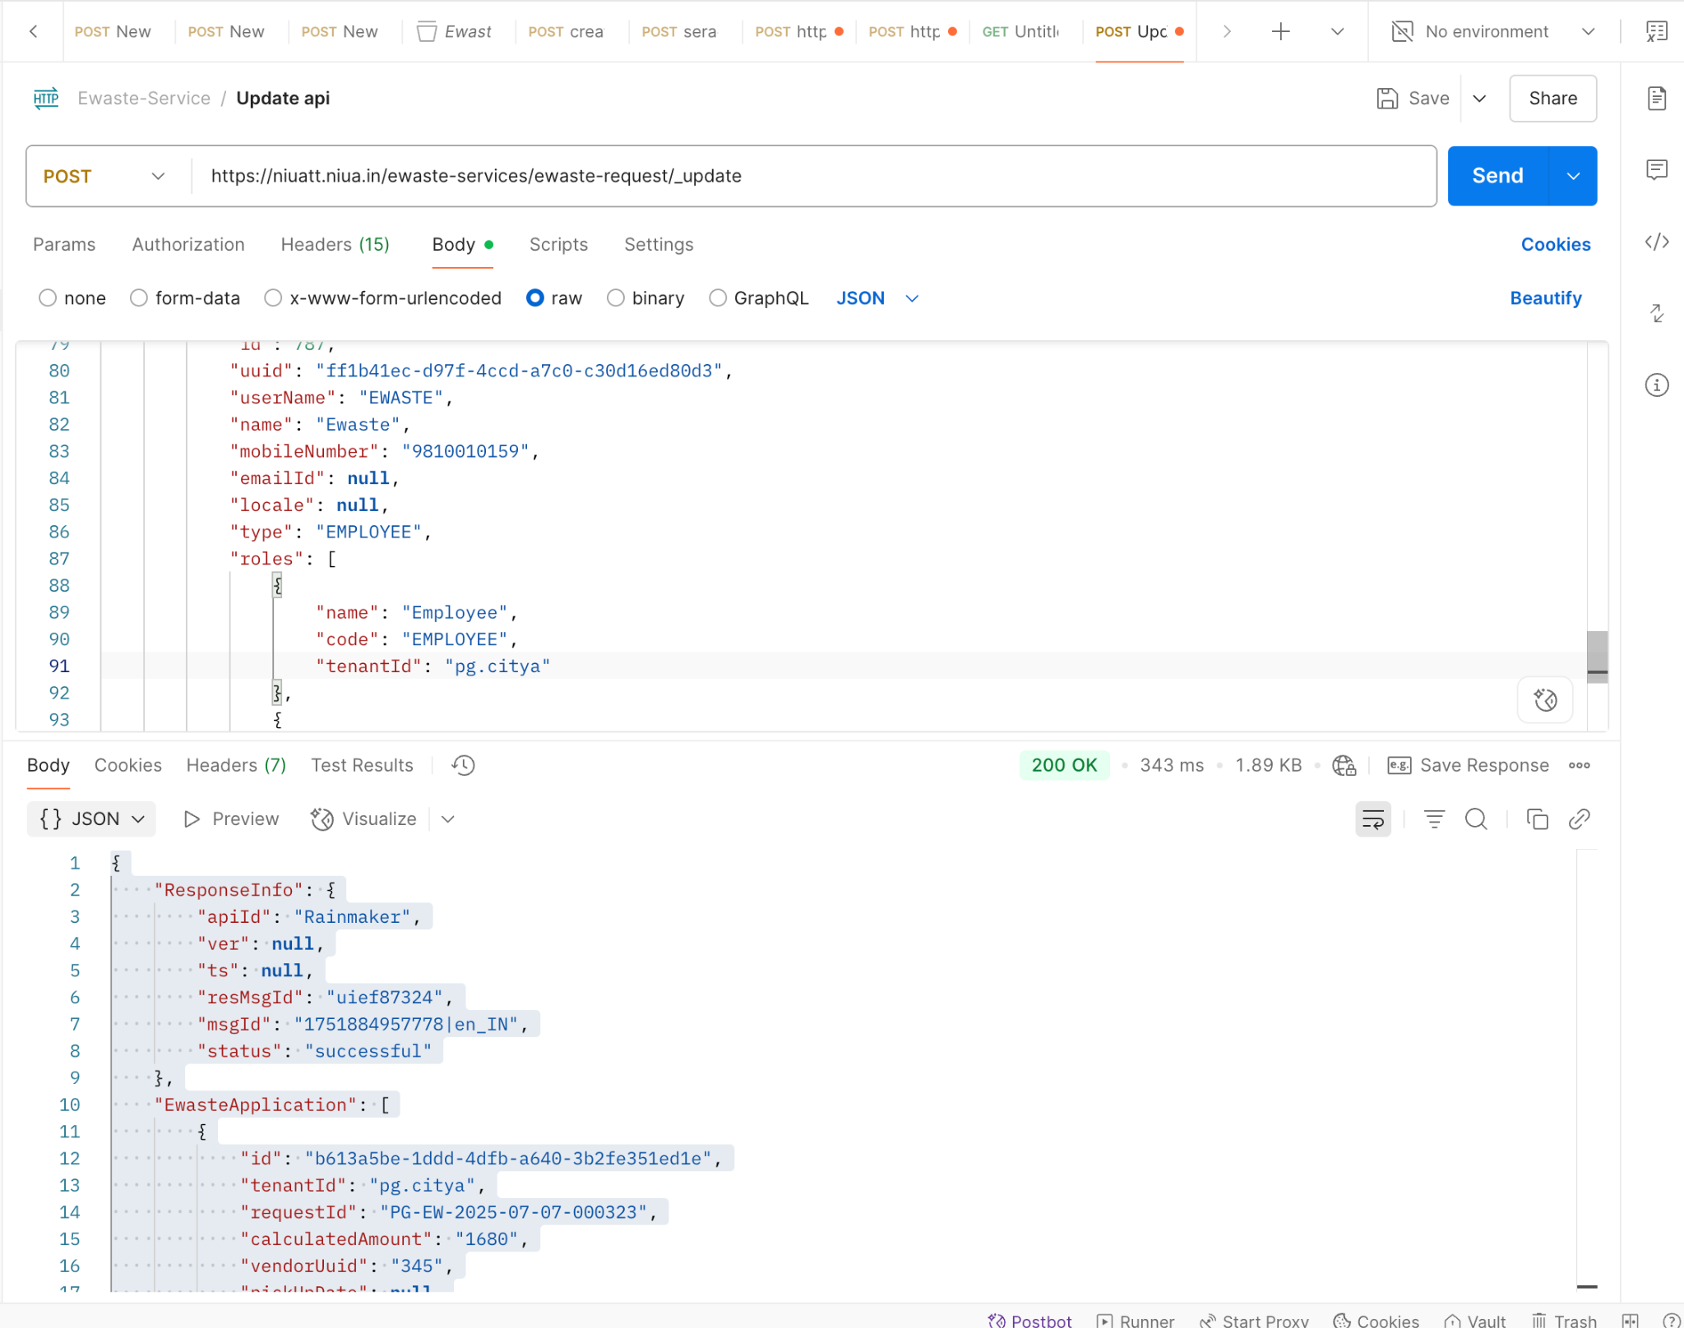

Curl Local Vs Niuatt
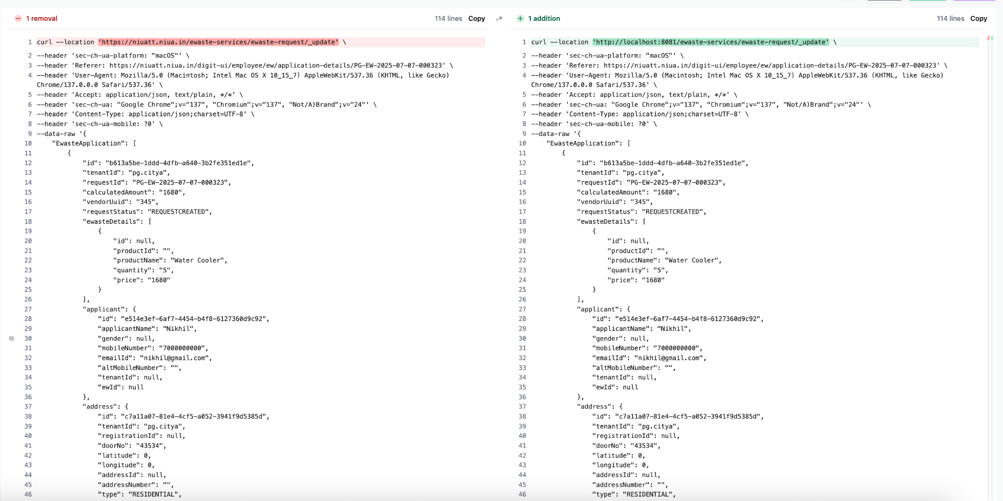
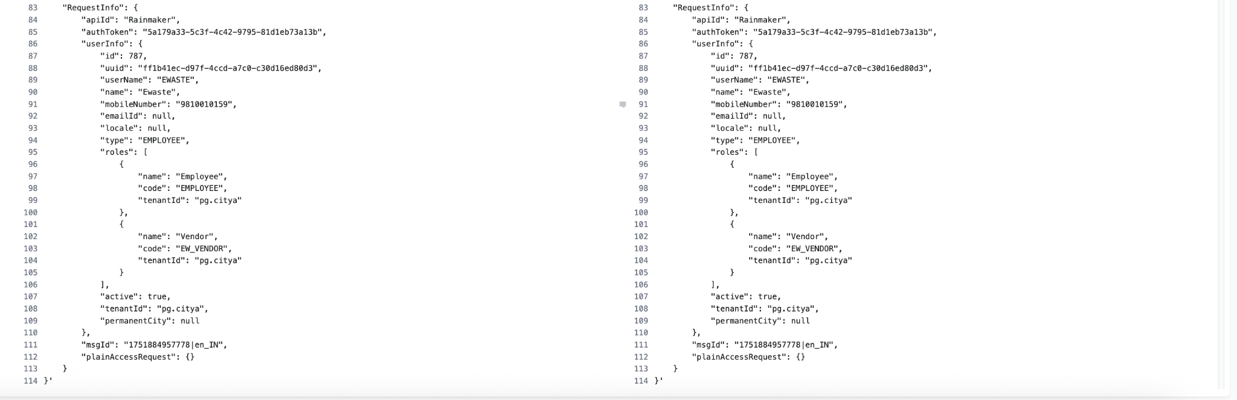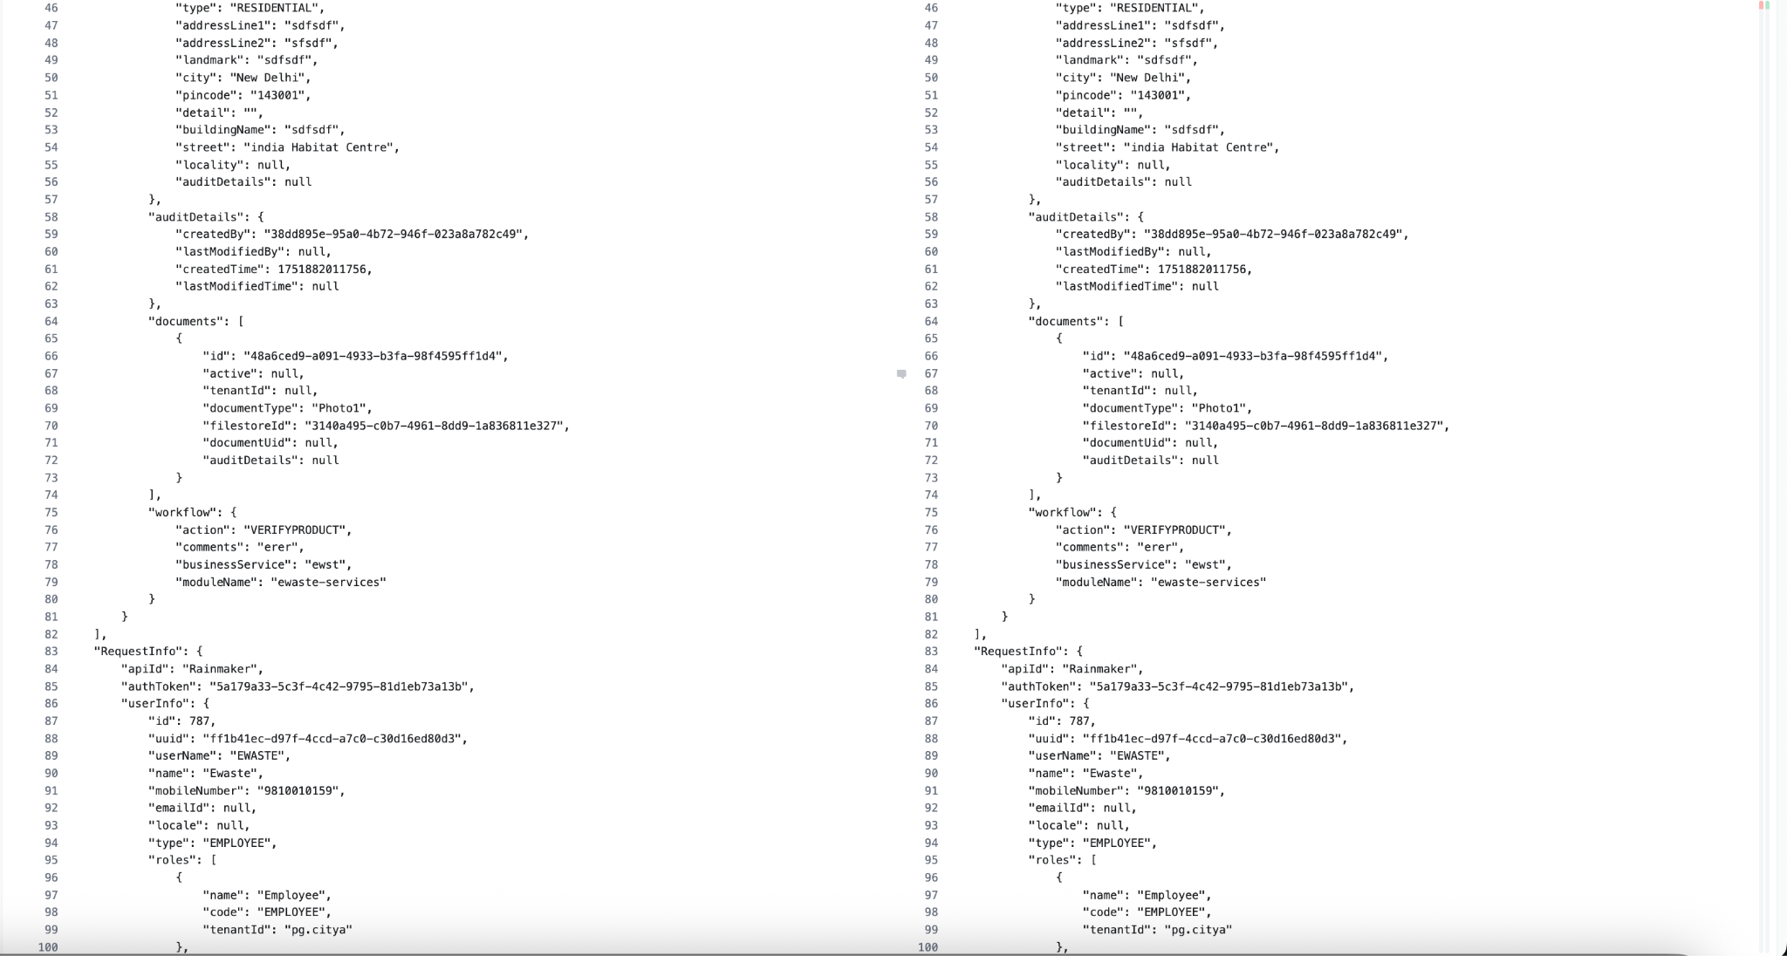

Response Local Vs Niuatt