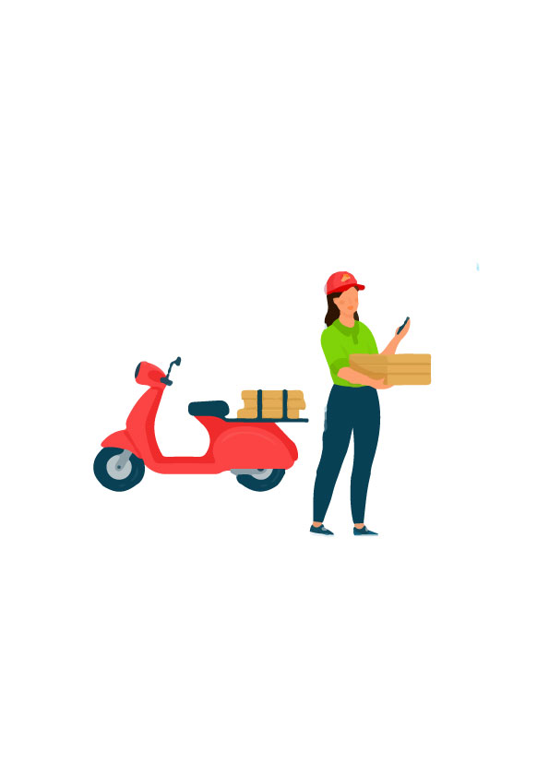

**ONLINE FOOD**

**DILIVERY &**

**PREFRENCES**

**ERD**

**SUBMITTED BY:**

HADIA ZAKIR (019)

UQBA GULZAR (067)

ZUNAIRA KHATOON (074)

ZUNAIRA NOOR (075)

**SUBMITTED TO:**

DR. IRUM MATLOOB

**Attributes of Customer**

Entity of customer contains the attributes of customerID, name, DOB, phone number and composite attributes like first name, middle name and last name.

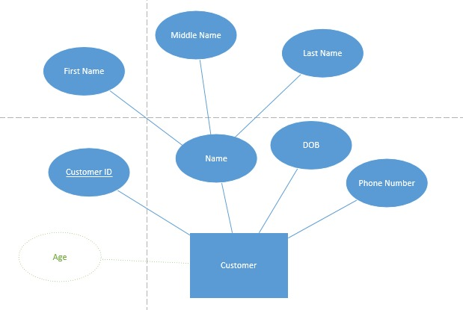

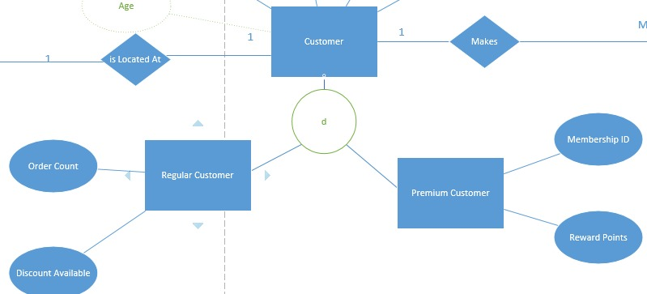

**Attributes of Location**

Entity of location contains the attributes of locationID, address, pincode and composite attributes area and street number.

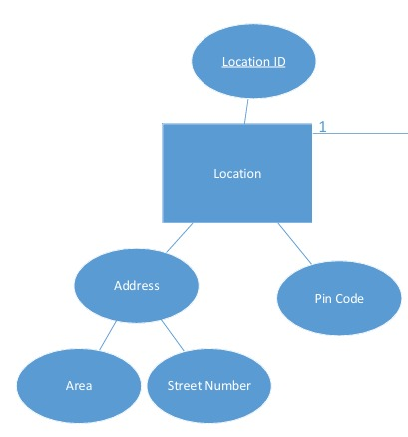

**Attributes of Restaurant**

Entity of restaurant contains the attributes of restaurantID, name, cuisinetype, feedback.

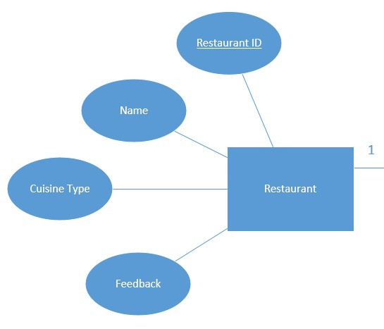

**Attributes of Order**

Entity of order contains the attributes of orderID ,prefrences, cuisine, mealtyoe, quantity.

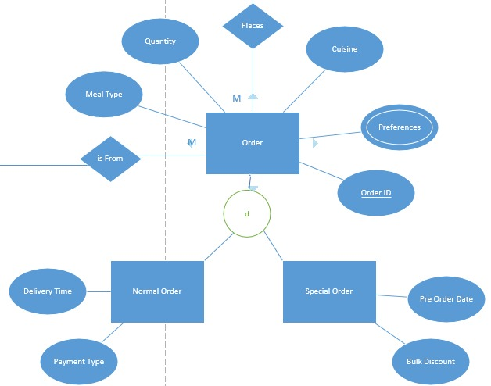

**Attributes of Order issues**

Entity of order issues contains the attributes of issueID,wrong order, poor hygiene, missing item.

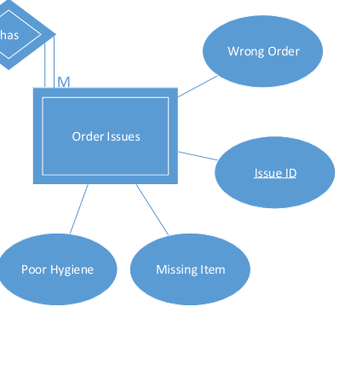

**Attributes of Payment**

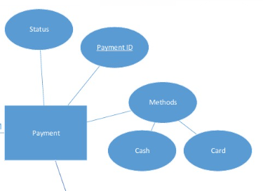

**Attributes of Delivery**

Entity of delivery contains the attributes of deliveryID, status, actual time, estimate time.

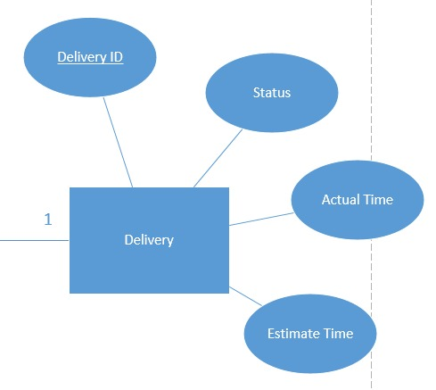

**Attributes of Food Quality**

Entity of food quality contains the attributes of foodID, freshness, temperature, packaging.

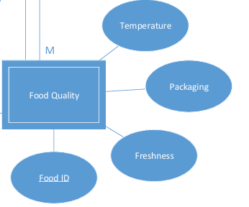

**Attributes of Delivery Conditions**

Entity of delivery conditions contains the attributes of road condition, wait time, conditionID.

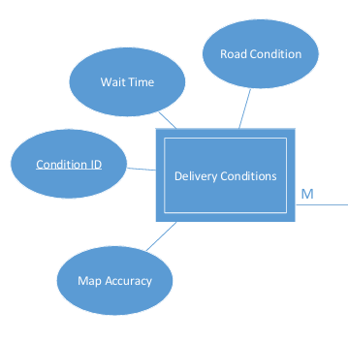

**Attributes of Final Outcome**

Entity of final outcome contains the attributes of outcomeID, customer satisfaction, delivery speed, food quality.

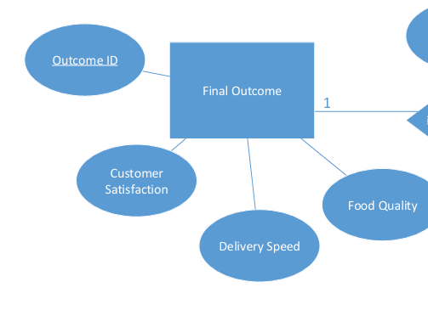

**Attributes Of Entities:**

|  |  |  |  |  |
| --- | --- | --- | --- | --- |
| Entity | Attributes | Special Attribute Types | Primary Key | Foreign Key |
| Customer | CustomerID (PK), Name, Contact, Email, Age, Gender | Derived: Age (from DOB) | CustomerID |  |
| Location | LocationID (PK), Street, City, Pin Code | Composite: Address (Street, City, Pin Code) | LocationID |  |
| Restaurant | RestaurantID (PK), Name, Cuisine Type, Rating |  | RestaurantID |  |
| Order | OrderID (PK), Preferences, Cuisine, Meal Type, Quantity | Multi-valued: Preferences (Veg, Non-Veg, Italian, Chinese) | OrderID |  |
| Order Issues | Issue id,Missing Item,Poor Hygiene,Wrong Order |  |  | OrderID |
| Payment | PaymentID (PK), Method (Card, UPI, Cash), Status | Multi-valued: Method (Can have multiple options) | PaymentID |  |
| Delivery | DeliveryID (PK), Status, Estimated Time, Actual Time |  | DeliveryID |  |
| Food Quality | Food_id,Freshness,Temperature,  Packaging |  |  | DeliveryID |
| Delivery Conditions | Condition id,Wait time,Road Condition,Maps Accuracy |  |  | DeliveryID |
| Final Outcome | OutcomeID , Customer Satisfaction, Delivery Speed, Food Quality |  |  | FoodID |

**Strong (independent) entities and weak (dependent) entities, ensuring weak entities have proper identifying relationships.**

|  |  |  |  |  |  |
| --- | --- | --- | --- | --- | --- |
| **Entity** | **Type** | |  | | --- | | **Reason** |  |  | | --- | |  | | **Identifying Relationship (for Weak Entities)** |
| Customer | Strong Entity | Can exist independently without relying on another entity. | NULL |
| Location | Strong Entity | Stores address details and exists independently. | NULL |
| |  | | --- | | **Payment** |  |  | | --- | |  | | Strong Entity | Exists independently with attributes like PaymentID and Amount. | NULL |
| Order | Strong Entity | Exists independently as a customer request. | NULL |
| Restaurant | Strong Entity | Exists independently with attributes like Name, Cuisine Type. | NULL |
| Delivery | Strong Entity | Exists as a separate entity managing deliveries. | NULL |
| Food Quality | Weak Entity | Exists only when an order is delivered; depends on Delivery. | Identified by **DeliveryID** |
| Final Outcome | Weak Entity | Depends on Food Quality to determine customer satisfaction. | Identified by **FoodID** |
| Delivery Conditions | Weak Entity | Exists only when a delivery happens; depends on **Delivery** for its existence. | Identified by **DeliveryID** |
| Order Issues | Weak Entity | Exists only if an **Order** has a problem; depends on **Order** for its existence. | Identified by **OrderID** |

**Super entity types and their subtypes, applying the disjoint (D) or overlap (O) rules as needed.**

**Customer**

A customer can either be a **Regular Customer** or a **Premium Customer** but never both at the same time. This means the relationship is **Disjoint (D)**.

* **Regular Customer**: They place normal orders and may have a discount available.
* **Premium Customer**: These customers have a **Membership ID** and earn **reward points** based on their orders.

**Payment**

Payments are classified into **Online Payment** and **Cash Payment**. A single payment can only belong to one of these types, making this classification **Disjoint (D)**.

* **Online Payment**: Includes details like **Transaction ID**, the **Payment Gateway** used, and the associated **Bank Name**.
* **Cash Payment**: Includes information about the person who **received the cash** and any **change** given to the customer.

**Order**

Orders are categorized into **Normal Orders** and **Special Orders** based on their nature. Since an order can’t be both at the same time, this follows the **Disjoint (D)** rule.

* **Normal Order**: A standard order with attributes like **delivery time** and **payment type**.
* **Special Order**: These orders are pre-scheduled or bulk orders and include attributes like **pre-order date**, **bulk discounts**, and any special **customization requests**.

**ENTITY RELATIONSHIP DIAGRAM**

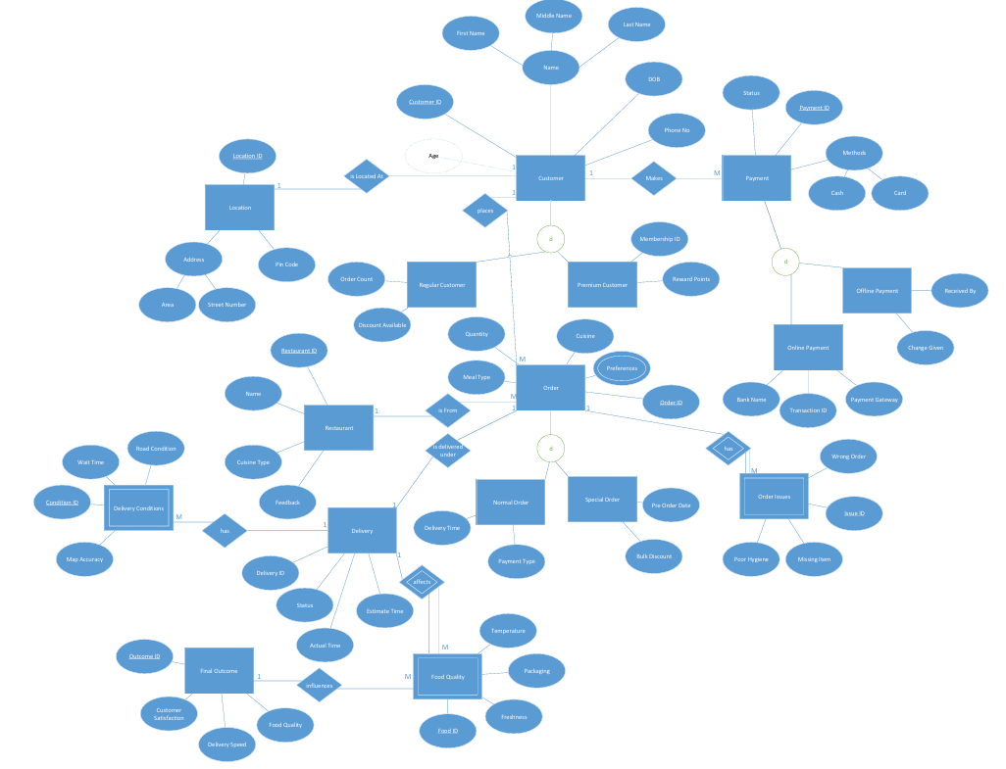

**Entity-Relationship Diagram (ERD)**

This ERD represents a structured food ordering and delivery system, ensuring clear relationships between customers, orders, payments, and deliveries. Each entity is designed with unique attributes, proper constraints, and logical classifications to maintain data integrity.

**Entities and Their Relationships**

The Customer entity stores personal details and is associated with multiple Orders and Payments. A customer can place multiple orders, but each order belongs to only one customer. Similarly, a customer can make multiple payments, but each payment is linked to a specific order.

Each Order contains details like preferences, cuisine type, meal type, and quantity. Orders are associated with Restaurants, meaning each order originates from a specific restaurant. Once an order is placed, it is assigned a Delivery, ensuring that each order is delivered individually.

Payment records include the method used (Card, UPI, or Cash) and payment status. Payments are linked to a customer and their respective orders.

The Delivery entity tracks the delivery status, estimated time, and actual time. Deliveries influence Food Quality, which considers factors like freshness, temperature, and packaging. The quality of food delivered affects the Final Outcome, which includes customer satisfaction and delivery speed.

**Super Entities and Subtypes**

Some entities have subtypes based on specific characteristics.

Customer is divided into Regular Customers and Premium Customers (Disjoint). A customer can belong to only one category at a time.

Payment has two subtypes: **Online Payment** and **Cash Payment**, where online payments require transaction details, while cash payments involve physical transactions.

Order can be a Normal Order or a Special Order (bulk or pre-ordered).

**Weak Entities**

Certain entities depend on strong entities for their existence.

Order Issues exist only when a problem arises with an order and are identified by OrderID.

Delivery Conditions depend on the DeliveryID, tracking delays or special conditions.

Food Quality relies on DeliveryID and determines the outcome of an order.

Final Outcome is a weak entity, depending on Food Quality to assess customer satisfaction and service effectiveness.