Assignment-1

**Task 1 – Gitea Repository**

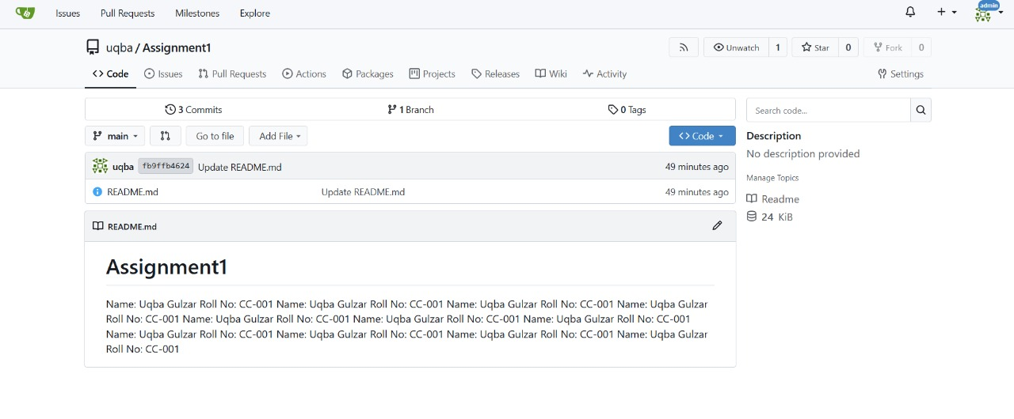

**Task 2 – GitHub Assignment Repo**

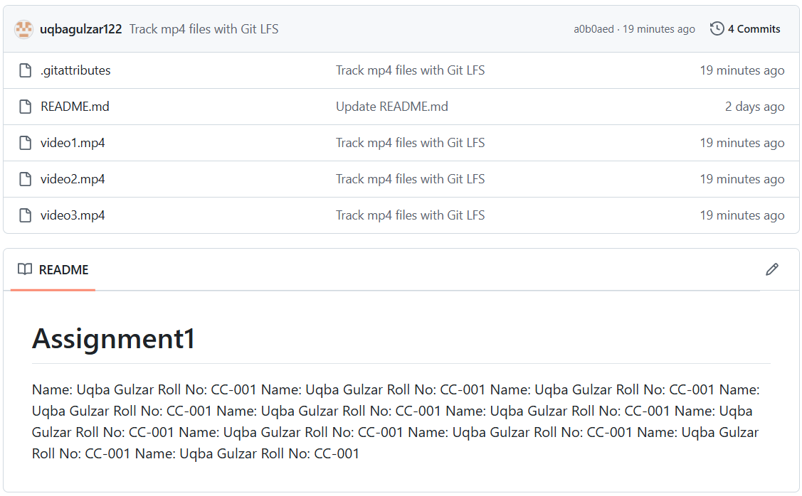

GitHub Link: <https://github.com/uqbagulzar122/assignment-1>

**Task 3 – Git Remotes**

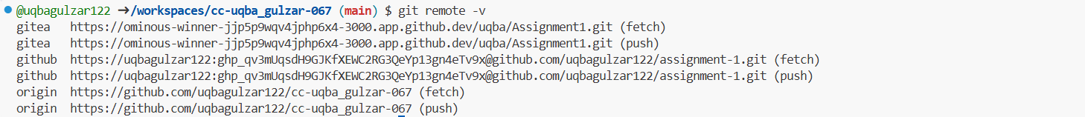

**Task 4 – GitHub Pages Portfolio**

<https://uqbagulzar122.github.io/>