

**Submitted By:**

**Uqba Gulzar**

**Submitted To:**

**Engr. Muhammad Shehzad**

**Reg No:**

**2023-BSE-067**

**Section:**

**BSE-IVB**

**Department:**

**Software Engineering**

**Course Title:**

**CCN**

**LAB 05:**

Understand the basic commands for switch port security on different VLAN environment

according to Figure 1.

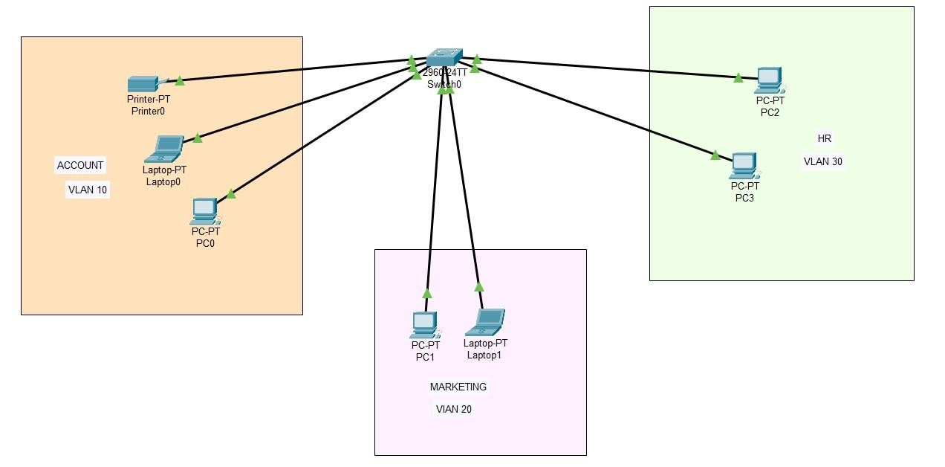

Switch1>enable

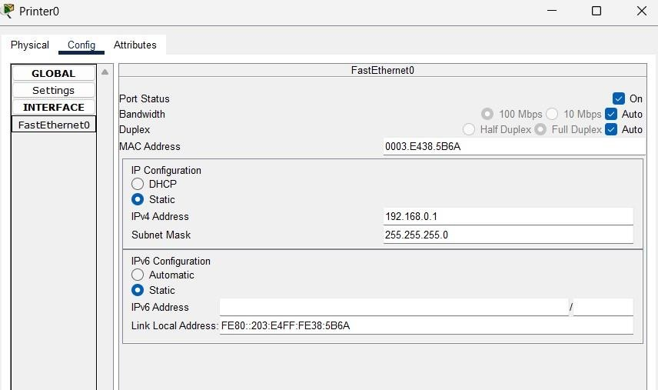

**Basic Switch Commands:**

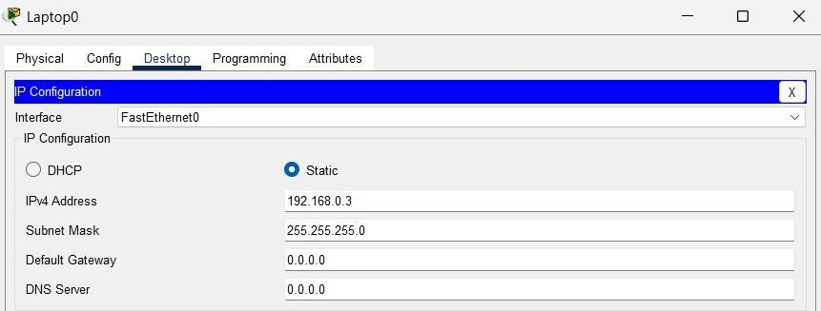

Switch1#Show vlan brief (showing interfaces of vlan briefly)

**Making VLANS**

Switch1#config terminal

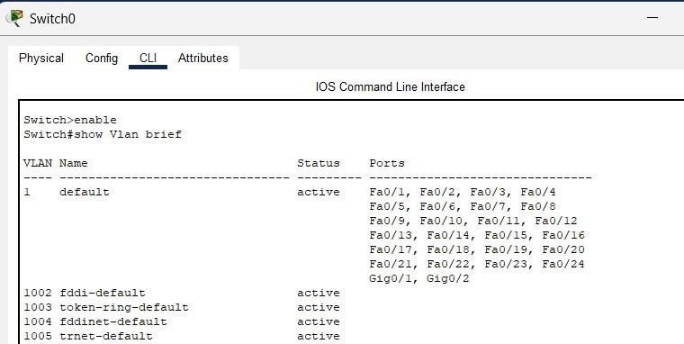

VlAN 10 name Actg exit vlan 20 name Mkt exit vlan 30 name Hr

exit

switch1#show vlan brief

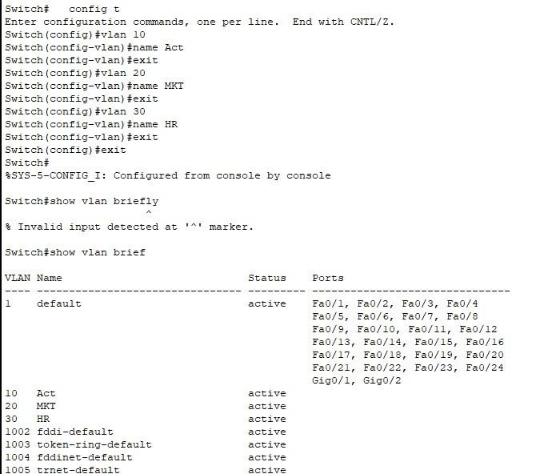

**Assigning Ethernet Ports to VLANs:**

Switch#config t

Switch(config)#interface range fa0/1-3

Switch(config-if)#

Switch(config-if)#switchport mode access

Switch(config-if)#switchport access vlan 10

Switch(config)#interface range fa0/4-5

Switch(config-if)#switchport mode access

Switch(config-if)#switchport access vlan 20

Switch(config)#interface range fa0/6-7

Switch(config-if-range)#switchport mode access

Switch(config-if-range)#switchport access vlan 50

