

**ASSIGNMENT**

**SUBMITTED BY:**

HADIA ZAKIR (019)

UQBA GULZAR (067)

ZUNAIRA KHATOON (074)

ZUNAIRA NOOR (075)

**SUBMITTED TO:**

MS. SUMAIRA SHAUKAT

**Q1- Develop a system that will help in planning large scale events and parties such as, weddings, graduation celebrations, birthday parties. Using an activity diagram, model the process context for such a system that shows the activities involved in planning a party (booking a venue, organizing invitations, etc.) and the system elements that may be used at each stage.**

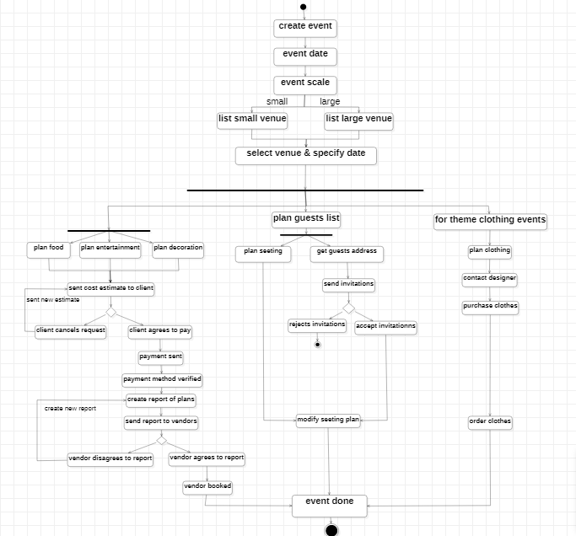

**ACTOR: EVENT MANAGER.**

This is an event management activity diagram which starts with creating an event then selecting date and then it will select the scale either, it is large scale or small scale event. Then select the venue according to you event scale and specify date to book the venue. Once these steps are done our system will proceed towards planning food, entertainment, and decoration and send the cost estimated for these plans if client disagrees to that cost our system will make new estimate and if client agrees to pay then payment methods will be done and verified and report on plans will be made which is then send to the vendors. If vendor agrees to the plan report vendor will be booked and if vendor dis agrees we will make new plan report.

Our system will plan guests list and then plan sitting according to the guests. On other hand our system will get guests address from client and send invitations to them if they reject the invitation guest will be removed and if they accept we will update our sitting plan accordingly.

If client wants themed event like one color, any costumes etc. system will plan clothing designs and then contact to designers purchase clothes from them and book orders.

**Q2- For the MHC-PMS, propose a set of use cases that illustrates the interactions between a doctor, who sees patients and prescribes medicines and treatments, and the MHC-PMS.**

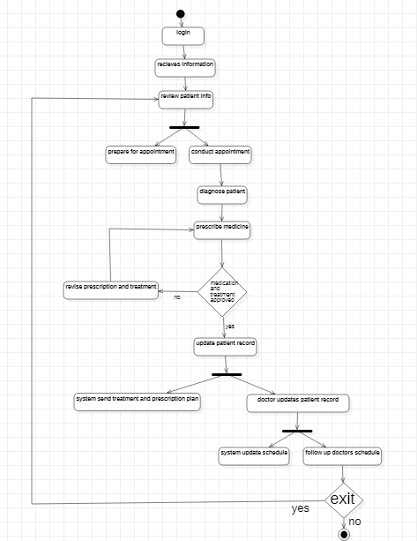

**ACTOR**: Doctor

1. "Doctor reviews patient information"

- This is the starting point of the diagram.

- The doctor reviews the patient's medical history, current symptoms, and other relevant information.

2. (Fork)

- This fork indicates that the doctor can perform multiple tasks simultaneously.

- The flow splits into two parallel paths.

3. "Doctor prepares for appointment"

- This task is performed simultaneously with "Doctor conducts appointment".

- The doctor prepares for the appointment by reviewing medical history, preparing equipment, and other tasks.

4. "Doctor conducts appointment"

- This task is performed simultaneously with "Doctor prepares for appointment".

- The doctor conducts the appointment by examining the patient, taking notes, and other tasks.

5. "Doctor diagnoses patient"

- This task is performed after "Doctor conducts appointment".

- The doctor diagnoses the patient based on the information gathered during the appointment.

6. "Doctor prescribes medication and treatment"

- This task is performed after "Doctor diagnoses patient".

- The doctor prescribes medication and treatment based on the diagnosis.

7. "Condition: Medication and treatment approved?"

- This is a decision point.

- If the medication and treatment are approved, the flow continues to "Doctor updates patient records".

- If not, the flow continues to "Doctor revises prescription and treatment".

8. (Fork)

- This fork indicates that the doctor can perform multiple tasks simultaneously.

- The flow splits into two parallel paths.

9. "Doctor updates patient records"

- This task is performed simultaneously with "System sends prescription and treatment plan to patient".

- The doctor updates the patient's records with the new diagnosis, medication, and treatment.

10. "System sends prescription and treatment plan to patient"

- This task is performed simultaneously with "Doctor updates patient records".

- The system sends the prescription and treatment plan to the patient.

11. "Doctor schedules follow-up appointment (if needed)"

- This task is performed after "Doctor updates patient records".

- The doctor schedules a follow-up appointment if necessary.

12. "System updates schedules and records"

- This task is performed after "Doctor schedules follow-up appointment (if needed)".

- The system updates the schedules and records with the new appointment information.

13. "Doctor receives patient feedback (if needed)"

- This task is performed after "System updates schedules and records".

- The doctor receives feedback from the patient (if necessary).

14. "Doctor updates patient records"

15. (Fork)

- This fork indicates that the doctor can perform multiple tasks simultaneously.

- The flow splits into two parallel paths.

16. "Doctor attends to next appointment"

- This task is performed simultaneously

- The doctor attends to the next appointment.

If yes than doctor go to the patient information. Else go to exit