Create Private Git Hub Repository:

Connect Repository Via ssh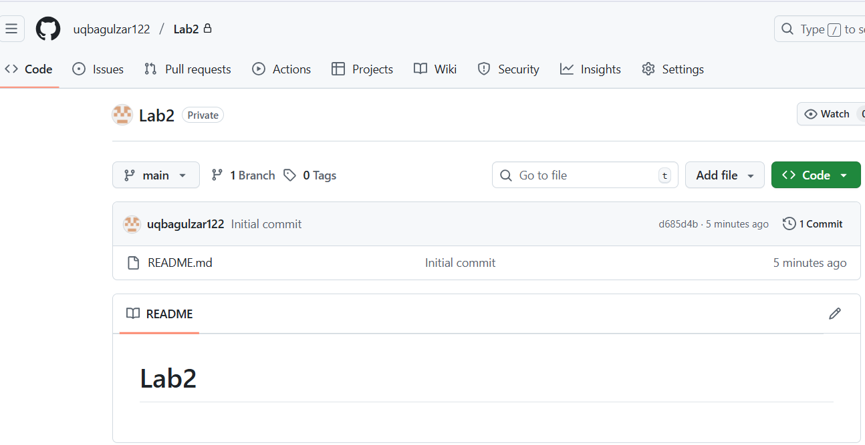

Connect Repository Via ssh

Generate New ssh Key Using Powershell:

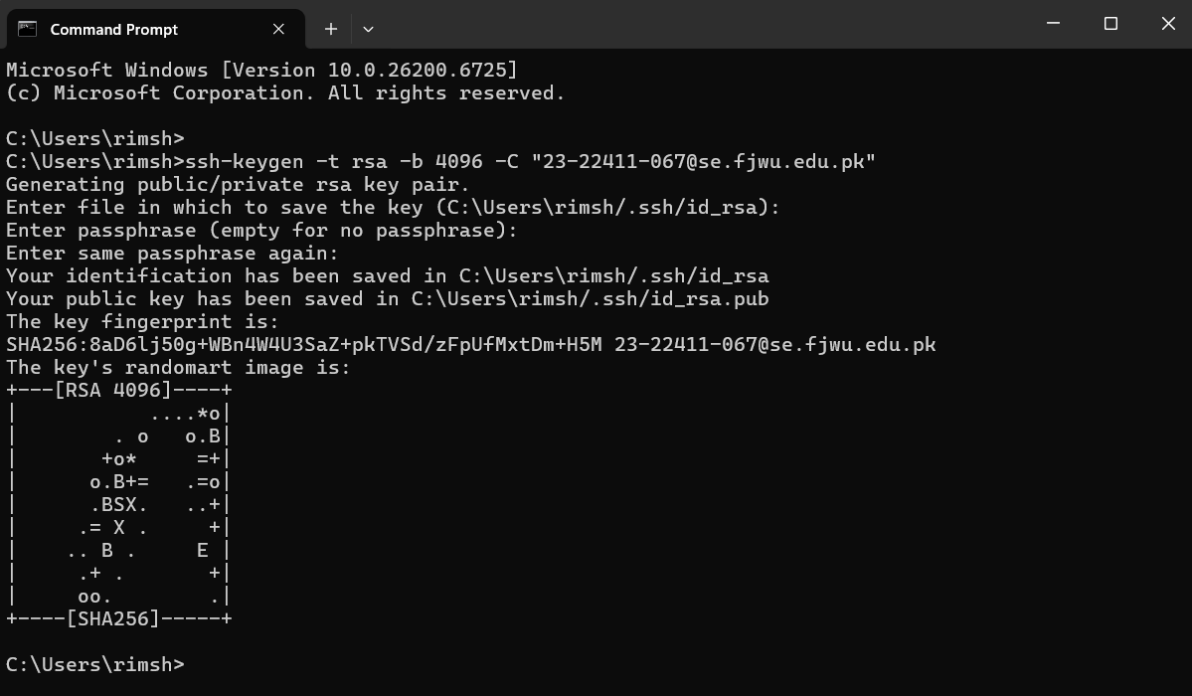

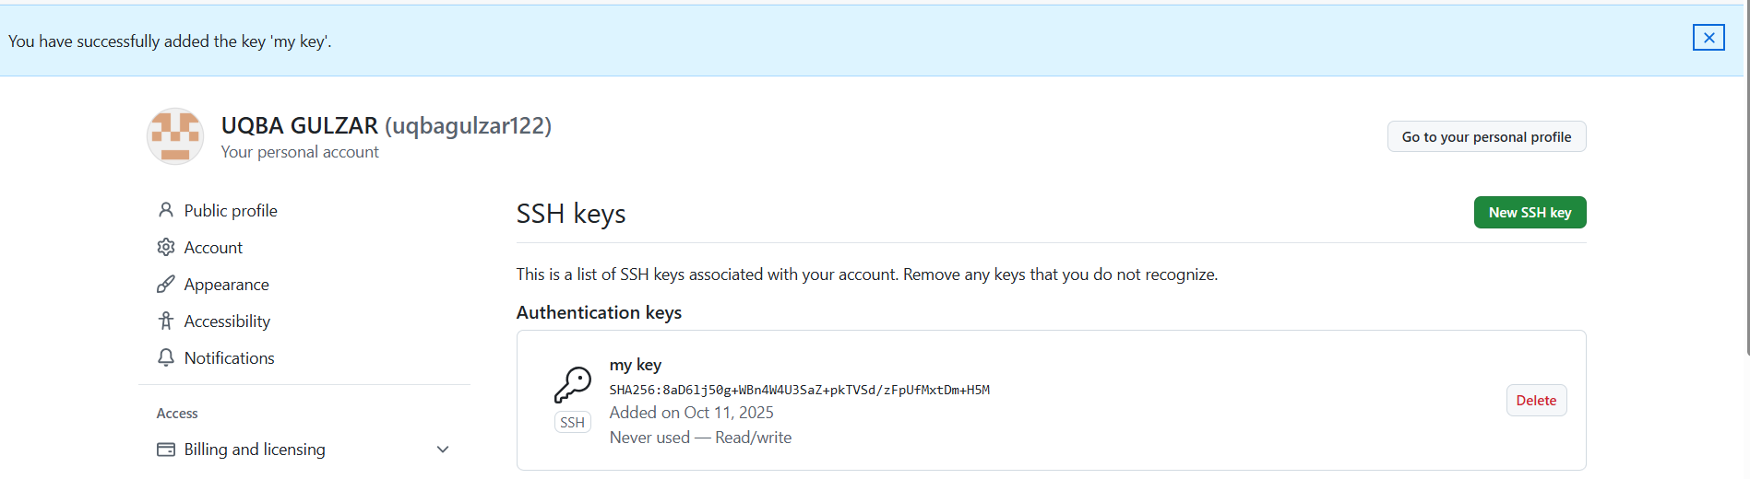

**Add your SSH public key to GitHub (Settings > SSH and GPG keys)**

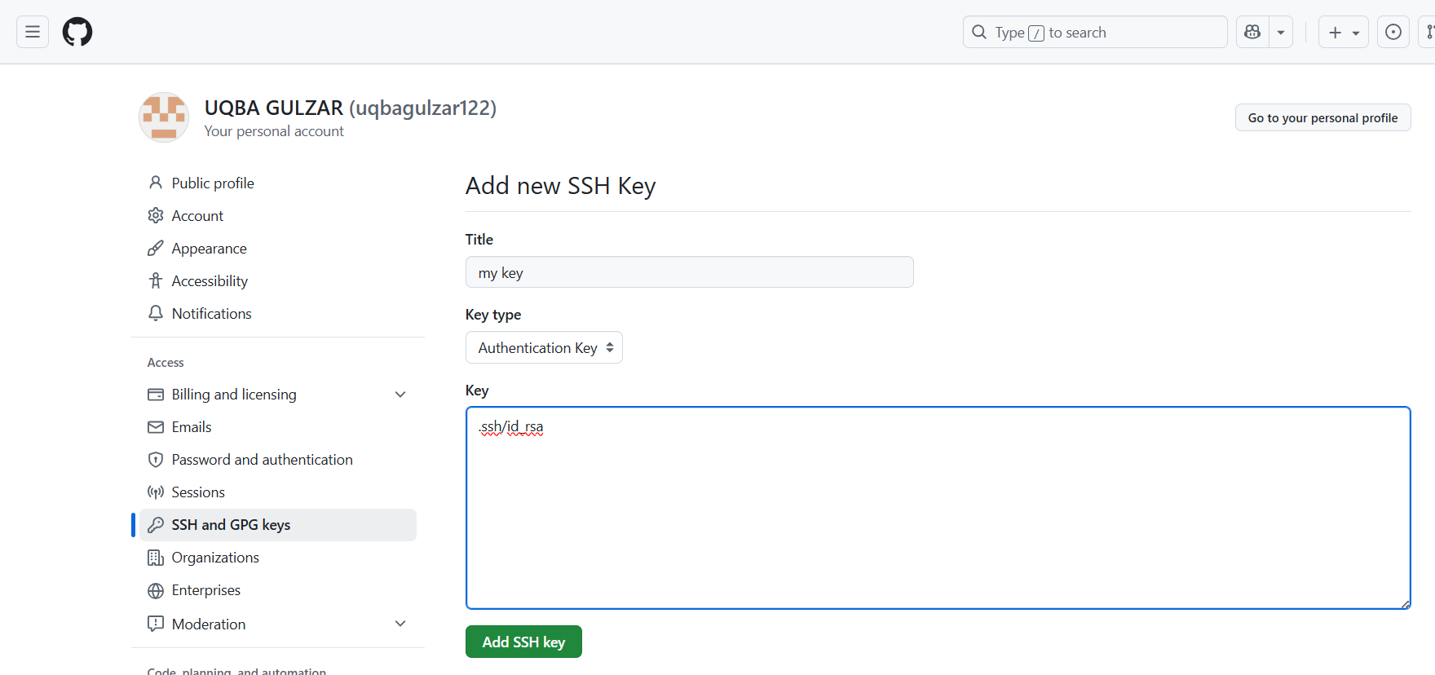

**Clone your Lab2 repo using SSH**

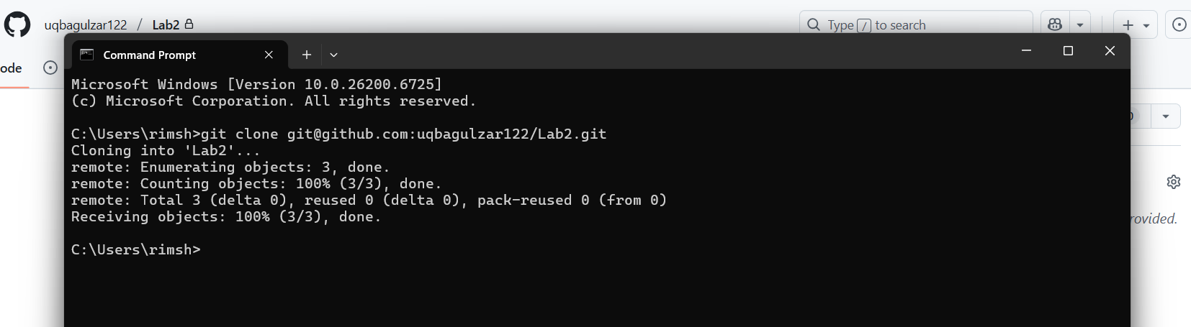

Configure Git Username And Email

**Set up your Git identity (this ensures all commits are linked to you):**

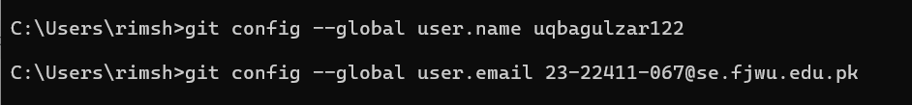

**Verify your configuration:**

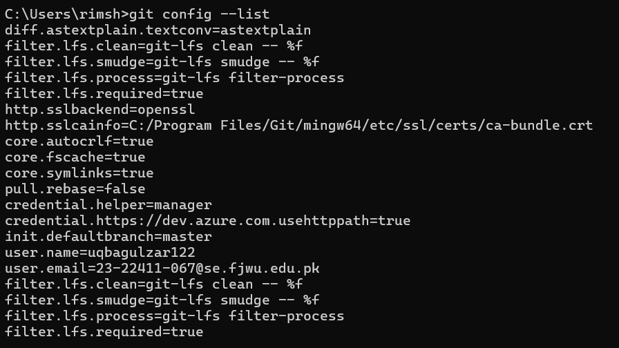

**ask 4: Explore the .git Folder**

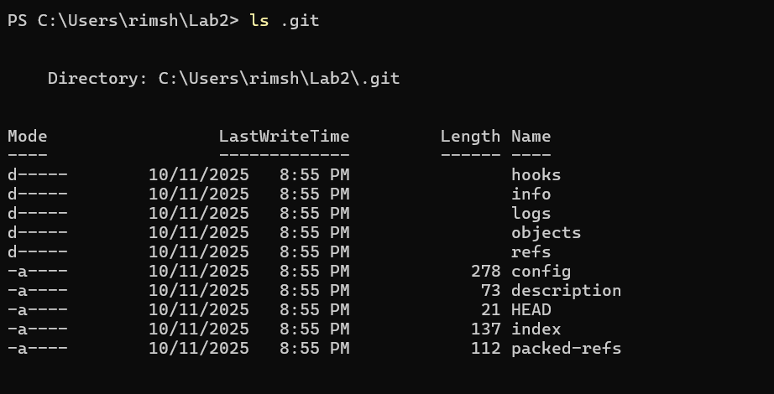

Task5 Local Repository Management

**Delete the existing .git folder from your cloned repo using Git Bash**

**Re-initialize the local git repository**

