**Supplementary Material I**

**RAZA: A Rapid, 3D z-crossings Algorithm to segment electron tomograms and extract organelles and macromolecules**

**Supplemental Figures**

An integral part of RAZA’s functionality is that each of the contoured objects that it generates can be defined as a single mathematical entity and not just a set of contouring pixels. Each object has a measurable *length*, *width*, *height*, *surface area* and *volume*. These five parameters provide a ‘*structural fingerprint*’ for each segmented object, which can be used to selectively identify discrete classes of subcellular objects. These parameters are independently calculated for each object in an orientation independent manner. This overcomes the analytical problem of the random orientation of organelles and protein complexes in cells. This is illustrated in Fig. S1, which shows a cell volume (pink) containing tubules (yellow, long and thin), organelles (blue, rounded) and macromolecules (orange). In this example, the small macromolecules and can be readily distinguished from the larger organelles and tubules as they have significantly smaller volumes, surface areas and dimensions defined by the major (longest), middle (second longest axis orthogonal to the major axis) and minor axis (orthogonal to the major and middle axis). The rounded organelles (blue) and tubules (yellow) which may have similar volumes and surface areas, can be readily distinguished, as the latter have one very long axis (major) and two much smaller axes (middle and minor). In contrast the three axes of the organelles (blue) are more similar in length. Natural variability of organelles can also be addressed through the use of threshold setting for each of these five parameters (e.g. +/-30% of a given average reference value based on a manually selected subset of particles). By reducing the search range threshold (e.g. +/-5% of a given reference value) and/or increasing the number of the five variables used for the search (e.g. all variables versus volume only) the stringency with which particles are identified can be significantly increased. Object’s center are also calculated to enable subvolume extraction.

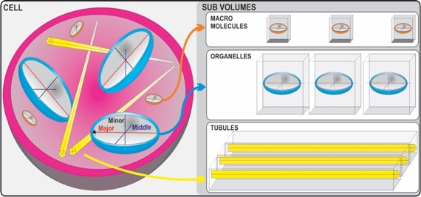

**Fig. S1: Structural finger printing.** Each contoured object has a defined volume, surface area, major, middle and minor axis and z-crossings value that can be used for object classification.

**RAZA performance testing using a noise free simulated truth set**

To validate the performance of RAZA nine hollow cubes of different greyscale intensity from white (32767) to black (-32767) were embedded into larger 3D volumes of black (Fig. S2 A), grey (Fig. S2 C) and white (Fig. S2 E). In each panel (Fig. S2 A-F) one of the nine tests cubes is not visible as it has the same greyscale intensity as the large 3D volume in which it is embedded.

In all cases RAZA successfully identified both the outer and inner contours of the eight hollow 3D cubes shown in panels Fig. S2 A, C and E as is respectively shown in panels B, D and F. This confirms that RAZA is able to accurately detect objects in a range of noise free backgrounds across the full range of greyscale intensities (white to black backgrounds). In all cases the contours accurately aligned with the outer and inner edges of the hollow cube. The details of the RAZA filter settings for each of these experiments is provided in the Fig. S2 legend.

The key lessons learned from this experiment included the following. The size of the object can be used to determine the best sigma (σ) value. Small values of σ (<0.4) can facilitate the detection of objects with smaller diameters (e.g. membranes), whereas large σ values (e.g. 1-3) can assist with the detection of larger objects, as they smooth out small objects. Positive z-crossings values can facilitate selection of lighter objects on dark backgrounds. Negative z-crossings values assist with selection of darker objects on light backgrounds. Although this is signal-to-noise ratio dependent, using a 16 bit grey scale image (32767 to -32767), typically differences in intensity of at least 50 are required between the edge and the background for successful object detection in noisy tomograms.

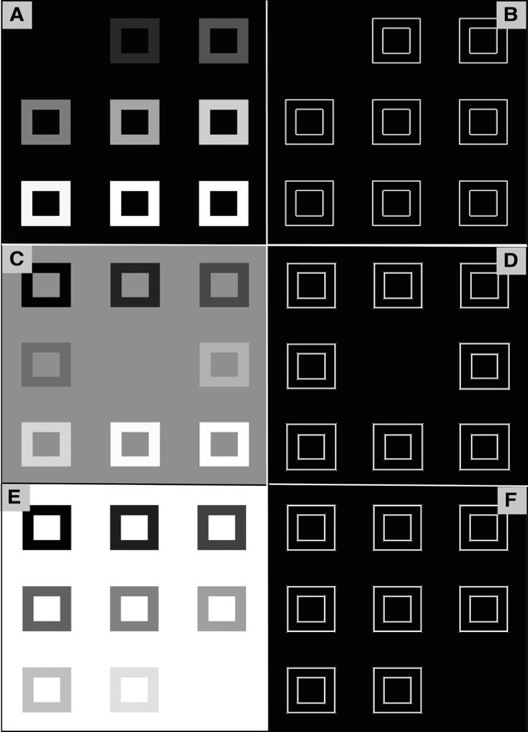

**Fig. S2: Synthetic 3D volumes showing a wide intensity range (-32767 to 32767) on different backgrounds.** (A) A slice of a 3D volume having dark background (Intensity value = -32767). (B) RAZA based segmentation of A with z-crossings value = 8404 and s = 0.44. (C) A slice of a 3D volume having mid grey background (Intensity value = 0). (D) RAZA based segmentation of C with optimized settings (z-crossings = -13910, s = 0.44). (E) A slice of a 3D volume having white background (Intensity value = 32767). (F) RAZA based segmentation of E with optimized settings (z-crossings = -8404, s = 0.44). RAZA robustly detected all edges.

**RAZA proformance testing using a simulated molecular truth set**

The performance of RAZA was next analyzed using a simulated test volume containing twelve GroEL molecules in different orientations (Ali et al., 2012) as shown in Fig. S3. The test volumes were noise free as in Fig. S2, but in this example the reference particles resembled those of real macromolecules positioned in random orientations.

Following optimization of the filter parameters (z-crossings value = -1, σ = 1) edges were detected and converted to contours defining each object (Fig. S3-B, surface-rendered objects shown in Fig. S3-C). In Fig. S3-D the major (blue), middle (green) and minor (red) axes of the detected were then assigned, allowing the object centroid to be defined (the point of intersect of the three axes). The centroid coordinates provided a suitable basis for the extraction of objects for further classification and subvolume averaging.

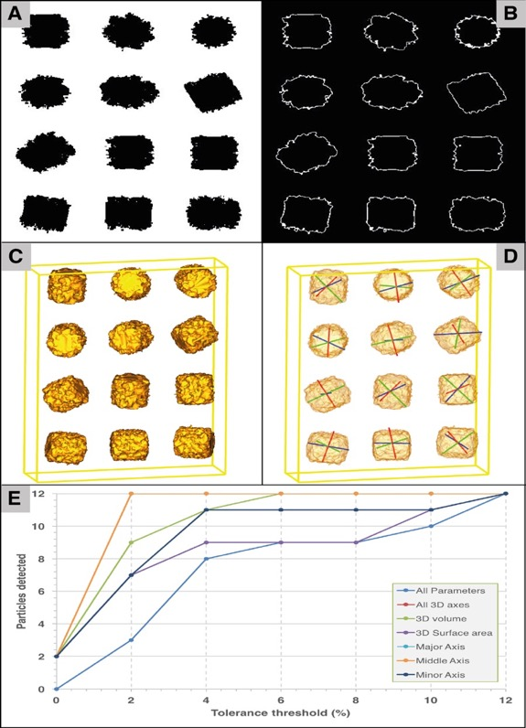

**Fig. S3. RAZA based molecular segmentation** using a test volume populated with twelve GroEL molecules. (A) A slice taken from a 3D volume containing twelve GroEL molecules having a range of orientations. (B) Application of RAZA (z-crossings value = -1 and σ = 1) which traced outlines around boundaries of the objects. (C) The surface rendered views of the GroEL molecules detected on the basis of selection using all 3 axes (major, middle and minor), 3D surface area and 3D volume. All 12 GroEL molecules were detected at +/-2% tolerance threshold (based on the length of the middle axis). (D) The major (blue), middle (green) and minor (red) axes are highlighted. Their point of intersection represents the object centroid. (E) The Number of detected GroEL molecules within the truth set, based on reference values obtained from two randomly chosen particles, the applied tolerance threshold and the chosen search parameters (major axis, light blue; middle axis, orange, minor axis, dark blue; surface area, purple; volume, green; all three axes, red; all parameters, mid blue).

We next tested whether RAZA could automatically identify all test objects in the test volume based on parameters derived from a subset (n = 2) of randomly chosen reference particles (Fig. S3-E). Thresholds were adjusted to identify objects with parameters falling within 1-12% of the average values represented in the reference objects for major, middle and minor axis lengths, surface area and volume (Fig. S3-E). Objects were detected based on whether the parameter value fell within the defined tolerance range (Fig. S3-E: major axis, sky blue; mid axis, orange, minor axis, denim; surface area, purple; volume, green ). Two more discriminating criteria were also evaluated: selection on the basis of ‘all 3D axes’ lengths falling within the tolerance range (Fig. S3-E: All 3D axes, red) or having all three axes plus surface area and volume fall within the threshold (Fig. S3-E: All parameters, light blue).

At a +/-0% tolerance threshold using the most stringent “all parameters” mode, none of the twelve GroEL molecules were detected. This may reflect inaccuracies in segmentation or more likely interpolation errors associated with placing the objects within the test volume in different orientations (Park et al., 2009). The number of detected particles increased as the threshold was relaxed, until all particles were detected at a +/-12% threshold. This indicated that for this set of 12 randomly oriented particles, there was a maximum of 12% error in the measurement of at least one of the five structural fingerprint parameters.

Not surprisingly, when less stringent selection criteria were applied (e.g. using one rather than all parameters for selection), RAZA selected more particles. For example, when either the middle axis length or the major axis length was used, all twelve GroEL molecules were detected at a tolerance of +/-2%. For volume, all particles were detected at a 6% threshold setting while an 11% threshold was required to detect all particles on the basis of minor axis length or the moderately stringent “3D axes” criteria. Interestingly, the 3D surface area was found to be the most variable parameter within the truth set, likely due to interpolation errors, requiring a 12% threshold setting before all twelve molecules were detected. Larger threshold settings may be required for the detection of objects which are less homogeneous e.g. mitochondria. The centroid of each object is an output of RAZA and enables particle extraction for downstream subvolume averaging.

Table S1 lists the respective mathematical fingerprints (length of major, middle and minor axes, surface area and volume) and their deviation from the parameters derived from the reference objects. By setting a 2% tolerance threshold based on the mean average value (Mean, bottom row), we found that on average, the detected length of major (Maj), middle (Mid) and minor (Min) axes respectively have 1.22%, 7.88% and 4.25% deviation from the reference objects. Similarly, the respective deviation of surface area (SA) and volume (Vol) from reference objects were 4.65% and 1.86% respectively. Note that in this example only the ‘middle axis’ was used to search for similar objects. The structural parameters of two reference objects were averaged to calculate the % deviation. Deviation = ((value obtained from detected particle – value obtained from reference particle) / value obtained from reference particle) *100). Because all objects are rotated versions of the same GroEL molecule, ideally we would expect 0% deviation from reference object. The deviations observed may be due to the fact that the rotation algorithms use approximation criteria. These results suggest that RAZA accurately detects all objects of GroEL volumes with a maximum threshold of 12% (see highlighted 11.97% deviation in the Surface Area).

**Table S1.** **Structural fingerprints based detection of twelve GroEL particles detected at a 2% tolerance threshold using mid axis as the search parameter**.

|  |  |  |  |  |  |  |  |  |  |  |  |
| --- | --- | --- | --- | --- | --- | --- | --- | --- | --- | --- | --- |
| **Object Number** |  | **Area Length (µm)** | | | | | **3D Surface Area (µm2)** | | | **3D Volume (µm3)** | |
| **Maj** | **% Dev** | **Mid** | **% Dev** | **Min** | **% Dev** | **SA** | **% Dev** | | **Vol** | **% Dev** |
| 1 | 97 | 1.44 | 93 | 0.09 | 74 | 7.01 | 34312 | | 7.85 | 266760 | 1.80 |
| 2 | 94 | 1.69 | 93 | 0.09 | 78 | 1.98 | 36171 | | 2.86 | 265887 | 2.12 |
| 3 | 95 | 0.65 | 92 | 1.16 | 78 | 1.98 | 38439 | | 3.23 | 275658 | 1.48 |
| 4 | 95 | 0.65 | 94 | 0.99 | 84 | 5.56 | 38958 | | 4.63 | 269640 | 0.74 |
| 5 | 97 | 1.44 | 93 | 0.09 | 78 | 1.98 | 37428 | | 0.52 | 267405 | 1.56 |
| 6 | 95 | 0.65 | 93 | 0.09 | 80 | 0.53 | 36030 | | 3.23 | 267622 | 1.48 |
| 7 | 95 | 0.65 | 93 | 0.09 | 78 | 1.98 | 37822 | | 1.58 | 267201 | 1.63 |
| 8 | 95 | 0.65 | 92 | 1.16 | 78 | 1.98 | 38439 | | 3.23 | 275658 | 1.48 |
| 9 | 97 | 1.44 | 92 | 1.16 | 73 | 8.26 | 35729 | | 4.04 | 265839 | 2.14 |
| 10 | 96 | 0.40 | 93 | 0.09 | 80 | 0.53 | 39506 | | 6.10 | 269245 | 0.88 |
| 11 | 98 | 2.49 | 92 | 1.16 | 80 | 0.53 | 41693 | | 11.97 | 277999 | 2.34 |
| 12 | 98 | 2.49 | 92 | 1.16 | 78 | 1.98 | 39696 | | 6.61 | 258963 | 4.67 |
| **Mean** | **96** | **1.22** | **86** | **7.88** | **77** | **4.25** | **37852** | | **4.65** | **268990** | **1.86** |

% Deviation = (value obtained from detected particle – value obtained from reference particle) / (value obtained from reference particle × 100)

## *Comparing manual vs automated segmentation*

The performance of RAZA was next tested on a biological sample and compared with manual segmentation by an expert analyst. Fig. S4 A shows a tomogram of a high pressure frozen, freeze-substituted, resin-embedded pancreatic beta cell, which in Fig. S4 B has been overlaid with a number of manually segmented contours of clathrin-positive endolysosomal compartments (red), mitochondria (dark green) and Golgi (pink, red, light green and blue), compartments that differ significantly in size and shape (Marsh et al., 2001). Fig. S4 E shows the extracted 3D objects defined by these contours.

For comparison, Fig. S4 C shows the corresponding contours generated using RAZA settings selected to detect these different objects. Overlaying these contours onto the input tomogram (Fig. S4 D) shows that the quality of the output is high and similar to that of manual segmentation (Fig. S4 F).

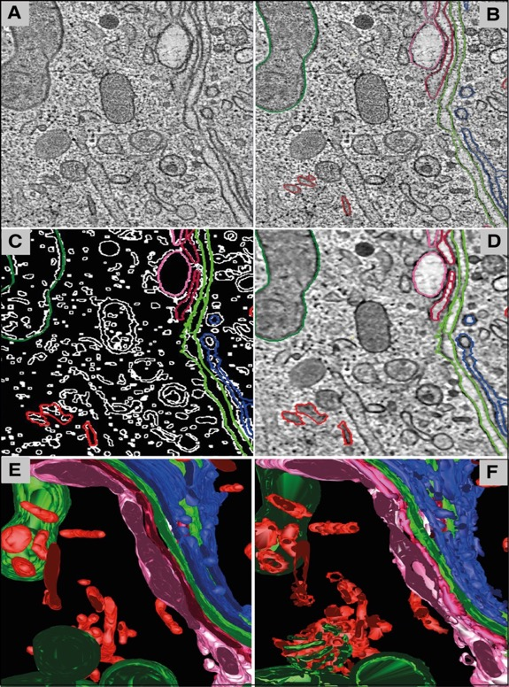

**Fig. S4 Segmentation of the Golgi region of an insulin-secreting pancreatic beta cell.** (A) A slice of the raw tomographic volume. (B) Manually contoured clathrin-positive endolysosomal compartments (red), mitochondria (dark green) and Golgi (pink, red, light green and blue) which differ significantly in size and shape (Marsh et al., 2001). (C) RAZA traces contouring clathrin-positive endolysosomal compartments (red, z-crossings value = -10 and σ = 0.49), mitochondrial (dark green, z-crossings value = 2 and σ = 0.49) and Golgi (pink, z-crossings value = -10 and σ = 0.49; red, z-crossings = -10 and σ = 0.49; light green, z-crossings = -10 and σ = 0.49 and blue, z-crossings value = -10 and σ = 0.49) which are overlaid upon the binary output (z-crossings value = -2 and σ = 0.49) and on the actual tomogram (D). (E) 3D representation of the manually contoured objects shown in (B). (F) 3D representations of RAZA contoured objects shown in (D).

To compare the accuracy of RAZA-based and manual segmentation statistically, we quantified the surface areas and volumes obtained using both techniques. Specifically we calculated the surface area and volume of mitochondria, Golgi and endo-lysosomal elements as representatives of differently sized objects generated manually and using RAZA (see Table S2).

**Table S2:** **Comparison of surface area and volume using RAZA and manual segmentation.** Percentage difference(Dev %) is also indicated.

|  |  |  |  |  |  |  |
| --- | --- | --- | --- | --- | --- | --- |
| Object Name | Surface Area (SA) μm2 | | | Volume (V) μm3 | | |
| RAZA | Manual | Dev (%) | RAZA | Manual | Dev (%) |
| Mitochondria | 146624 | 147857 | 0.84 | 376389 | 365226 | 2.97 |
| Golgi | 967716 | 983916 | 1.67 | 2296214 | 2328761 | 1.42 |
| Endolysosomes | 216835 | 150638 | 30.53 | 403028 | 267398 | 33.65 |

The surface area of Golgi elements and mitochondria defined by the two methods matched closely (Dev values within 2% of each other). Similarly, the volumes of mitochondria (dark green) and Golgi elements (pink, red, light green and blue**)** obtained using RAZA and manual segmentation differed by a maximum of less than 3%. When we compared the results obtained using both methods for the endolysosomal compartments (red), which are smaller and have a lower SNR than the Golgi and mitochondria, we found that the volume and surface area differed by 33.65%. Upon closer inspection of the data, however, the RAZA filter appears to have retained a higher level of detail (compare Fig. S4 E and F; see red clathrin-positive endolysosomal compartments) and also detected a few additional (true positive) objects. This difference is expected to increase the total surface area and volume and we therefore conclude that this discrepancy does not reflect inaccuracy in the RAZA filter, but rather is indicative of incomplete manual segmentation.

**RAZA- from tomograms to sub-tomograms**

RAZA supports both edge detection and particle selection. Initially it detects edges based on 3D edge detection algorithm that combines a Gaussian denoising filter with a Laplacian operator to generate a second derivative image volume. An integral part of RAZA’s functionality is that each detected object is defined by a complete 3D contour defining it as a discrete entity. Consequently, RAZA yields a 3D edge map, which contains all the information related to the detected edges and their positions. Edges are identified according to a user defined, arbitrary z-crossings value. That is, when the voxel intensity crosses the arbitrarily defined z-crossings, it is marked as being an edge voxel. The end result of the filteration process is a binary volume highlighting all the edges detected throughout the whole tomogram. As electron tomograms are inherently noisy, the prior application of Gaussian filtering reduces the sensitivity of the Laplacian filter to noise. Applying the Laplacian filter directly to a noise corrupted input tomogram can yield many small spurious edges that detract from the more meaningful edges with higher SNR. To overcome this, the first component of the RAZA filter has two parameters that can be tuned: sigma (σ, the width of the Gaussian kernel which controls the degree of smoothing) and the z-crossings value (a threshold that defines which edges are detected). Typically the user will on the first cell segmenation run examine the image (e.g. grey scale values of the edges of selected target volumes), broadly examine different parameter combinations (e.g. negative or positive z-crossings values for darker objects on light background or light objects on dark background, small or large σ for small or large objects, before fine-tuning to determine optimal parameter settings for the task at hand. Based on these analyses batch files can be prepared for higher throughput segmentation runs. Thus, RAZA provides user flexibility and speed.

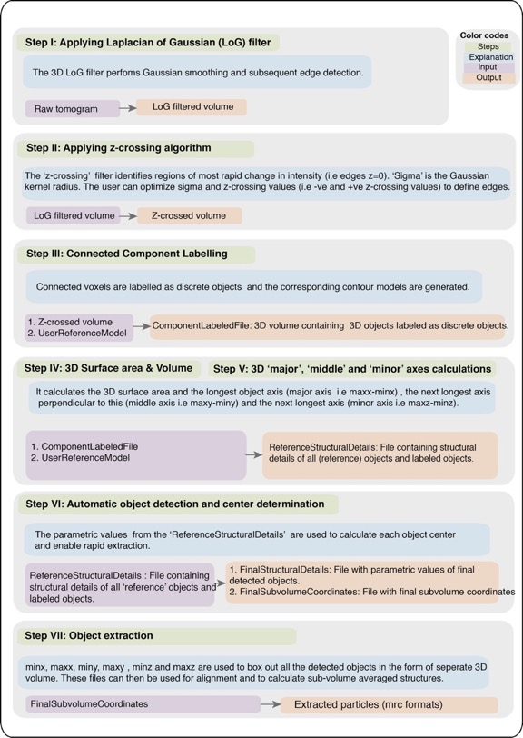

**Fig. S5. Flow diagram indicating steps involved in RAZA algorithm.**

For object identification RAZA uses an input file *‘UserReferenceModel’* containing the coordinates of ‘reference objects’. For each object, RAZA then calculates the lengths of the longest axis (*major axis*), the next longest axis (*middle axis*) orthogonal to the major axis and finally the third longest axis (*minor axis*) mutually orthogonal to both longest and middle axes, as well as the surface area and 3D volume of the reference volumes and stores these in *‘ReferenceStructuralDetails’*. Based on these values, a tolerance threshold range can be defined (e.g. -/+ 10% of the 100% reference values). Upon adjusting σ (Gaussian filter radius) and z-crossings values (a threshold value ranging from negative to positive or vice-versa, that defines which edges are detected), RAZA is able to calculate final output sub-tomograms. Two output files are produced: 1) the *‘FinalSubvolumeCoordinates’* file which contains the coordinates of the centers of the final subvolumes of detected objects; and 2) the *‘FinalStructuralDetails’* file which contains all the structural information of detected objects i.e. estimated values of height, width, length, surface area and volume. The program structure provides users with a generally applicable approach and the flexibility to optimize parameters further for a given task, if required. The RAZA workflow consists of seven steps and is summarized in Fig. S5.

#### 3D Laplacian of Gaussian (LoG) method

RAZA first applies a Laplacian of Gaussian (LoG) filter to suppress noise, thereby effectively smoothing the image to yield a LoG filtered volume for subsequent edge detection (Fig. S5- Step I). This algorithm has two parameters, which affect edge detection: the σ and the z-crossings values. RAZA requires the generation of a Laplacian of Gaussian (LoG) volume. The operation calculates voxel intensities, which range from negative to positive or vice-versa. This step outputs a volume named *‘LoG-filtered volume’.*

#### Arbitrary z-crossings vs traditional zero-crossings concept in 3D

Theoretically, the contour defining an edge does not have to be traced along the position of the greatest rate of change (i.e. z-crossings value = 0). The selection of a non-zero value, either positive or negative, allows the user to fine tune the position of the traced edge as part of this semi-automated process of tomogram segmentation. Furthermore, while the use of z-crossings value = 0 detects all edges in the tomogram, the selection of a non-zero arbitrary Z value can assist with the detection of specific objects.

In implementing an arbitrary z-crossings approach, RAZA checks whether the focal voxel intensities are greater or less than an arbitrary number ‘Z’. That is, if the Z value is negative then a contour is seeded by a LoG voxel (26-way connectivity) less than or equal to Z. The ‘LoG filtered volume’ is then thresholded according to the specified z-crossings value, to identify regions of most rapid change in intensity (for example z-crossings value = 0), which correspond to edges (Fig. S5- Step II). Typically, z-crossings values define where there is a significant change in intensities and based on these values a ‘z-crossed volume’ is generated.

#### Connected component labelling approach

RAZA requires a reference volume, which containsa selected set of objects of interest. To generate a ‘*UserReferenceModel’* the user can open the tomogram in IMOD and select the object(s) to be used as the reference input model(s) for RAZA by using the IMOD ‘drawing tool’. The next step drives connected component labelling. After applying the z-crossings approach (Fig. S5- Step II) to a raw tomogram, binary volumes containing edges are identified. To distinguish the boundaries of all objects and detect the connected regions of each object in a binary digital volume, a connected component labelling algorithm (Shapiro, 2002) was used. Specifically, all connected voxels are labelled and stored as discrete objects, so that identifiable structures are in a sequence that allows the corresponding contour models to be generated as single geometric objects. Each labelled object represents a connected set of contour pixels. The algorithm scans the binary volumes voxel by voxel from top to bottom and left to right (by moving along a x- and y-axes) through multiple passes. In the first pass, it scans through the whole volume, checking the neighboring voxels, and if the neighboring voxels are not assigned with a label, it assigns a new unique label, otherwise the focal voxel is assigned the label of the neighboring voxel. Then, in the second pass it re-scans all the labels and replaces each temporary label with the unique label of its equivalent class.

After this step, each object can then be reduced to a mathematically defined unit having a discrete volume, surface area and major, middle and minor axes each with measurable lengths (Fig. S5- Step III). The output file of this step is called the *‘ComponentLabeledFile’*, which is a 3D volume containing 3D objects labeled as discrete objects.

RAZA uses the *‘ComponentLabeledFile’* and ‘*UserReferenceModel’* to completes a 3D volume and 3D surface area calculation (Fig. S5- Step IV). It also estimates (Fig. S5- Step V). The length of major axis, middle axis and minor axis of *‘reference objects’* are saved in a file *‘ReferenceStructuralDetails’*. The same parametric values are calculated from the discrete objects obtained from (Fig. S5- Step III). An advantage of this approach is that it is independent of the random orientations of the detected objects in cell.

#### Automated object detection and center determination

RAZA conducts semi-automated object detection, calculates their centers and uses the parametric values (width, height, length, surface area and volume) as search parameters to identify objects within the defined structural range. The values of the length of *major*, *middle* and *minor* axes of each object from *‘ReferenceStructuralDetails’* are then compared (Fig. S5- Step VI) with the parametric values obtained from ‘*ComponentLabeledFile’.* The tomogram is then exhaustively searched to complete automatic particle selection. The details of each identified object is saved in the ‘*FinalStructuralDetails’ file*. Based on this comparison, all the objects within a set tolerance threshold range (e.g. +/- 10%) of the 100% threshold settings of objects selected in the ‘*UserReferenceModel’* will be detected. After detection of all the objects, RAZA provides the capability to box out the detected objects, based on the calculated center of the particles. The segmented tomograms will only show the selected objects.

The identification of the object center enables RAZA to conduct automated subvolume selection and the extraction of centered particles for 3D subvolume averaging. Once all the necessary information has been calculated and similar objects have been identified, the next step is to determine , and vectors for each object. The voxel where these three vectors intersect determines the center of that object. Mathematically, the vector passes through MINx (minimum x-coordinate of object on x-axis) and MAXx (maximum x-coordinate of object on x-axis) , passes through MINy (minimum y-coordinate of object on y-axis) and MAXy (maximum y-coordinate of object on y-axis) and passes through MINz (minimum z-coordinate of object on z-axis), MAXz (maximum z-coordinate of object on z-axis). By using the above information, the coordinates of the center of a detected object enables rapid subvolume extraction (Fig. S5- Step VII). Specifically, the coordinates of a detected object are used to box out all the detected objects in the form of separate 3D volumes. These files can then be used for alignment and to calculate structures using subvolume averaging techniques. It is of note that the center of the objects is located at the center of the x, y and z coordinates of the 3D box. In this way step VII achieves the first alignment step for subsequent subvolume averaging. The major, middle and minor axes provide additional variables for first pass alignment of extracted subvolumes.

#### Automated Particle extraction

After detecting all particles of interest within a volume, the last step is to box them out and save them as separate files. To complete this task RAZA reads the coordinates of MINx and MAXx, MINy and MAXy and MINz, MAXz from the text file (FinalSubvolumeCoordinates, Fig. S5; Step VI) and trims the volumes based on user defined volume limits and the centroid x,y,z coordinates. The extracted subvolumes are saved as separate 3D volumes. To allow for the fact that the reference and detected objects may not have exactly the same structural fingerprints, RAZA gives users the option to provide a tolerance threshold for each parameter.

**Comparing RAZA with other benchmark 3D edge detectors**

The performance of RAZA was tested on previously reported (Ali et al., 2012) synthetic “truth” reference volumes which included 2, 4 and 8 pixel wide hollow 3D cylindrical, spherical, triangular and rectangular objects contaminated with different combinations of Gaussian and impulse noise as shown in Fig. S6 (A1-A5). RAZA’s performance was compared with the outcome obtained by 3D Bilateral Edge filter Fig. S6 (B1-B5), the 3D Recursive filter Fig. S6 (C1-C5), the 3D Canny filter Fig. S6 (D1-D5), 3D LoG based Zero crossings filter Fig. S6 (E1-E5), and RAZA both before Fig. S6 (F1-F5) and after Fig. S6 (G1-G5) structural fingerprinting. The 3D surface views of test datasets detected by these filters clearly highlight their differences in performance.

At low noise levels (G 0/I 0, G 20/ I 20 and G 40/I 40), the results obtained by RAZA are comparable or better than the other filters tested (Fig. S6). At the 40 % level of Gaussian and Impulse noise, by the3D Canny (Fig. S6 D3) , the 3D LoG based Zero crossings filter (E3) and RAZA (F3, G3), the 3D reference structure could be robustly separated from the background noise.

At higher levels of noise (60 and 80 % of Gaussian/ impulse noise) the 3D Bilateral edge filter (B4 and B5) and 3D recursive filters (C4 and C5) no longer effectively resolved the reference objects with edge widths of 2 pixels. The 3D Canny (D4 and D5) and 3D LoG based Zero crossings filters (E4 and E5) located the objects, but lost a significant amount of structural information due to noise contamination. This is likely due to the fact that the canny edge detector applies Gaussian smoothing as its first step. This blurs the corners and junctions making them hard to detect, and resulting in non-continuous edges. The 3D LoG based Zero crossings filter suffers from the fact that zero crossing are sensitive to noise than z-crossings (see Fig. 1) . In contrast, RAZA detected all (2, 4 and 8 pixel wide) objects even at the highest noise levels tested (E5 and F5), although this is more clearly seen in the latter (F5) after the test objects have been separated from the noise using RAZA structural fingerprinting option.

To statistically evaluate the performance of RAZA, the root mean square error (RMSE) values (shown in Table S3) were calculated between the filtered volumes and the truth set. Analogous to (Ali et al., 2012), the truth set was constructed by applying Canny edge-detector to the noise/CTF/envelope-free variant of Fig. S6 (A1). 3D BLE yields lower RMSE values in each case when compare to recursive filter and 3D LoG based zero crossings filter, however in all tests the Canny filter outperformed the 3D BLE, the recursive and 3D LoG based zero crossings filter, and yielded the lowest RMSE scores. Fig. S6 suggests that RAZA performed significantly better than the other filters (compare G5 to B5 – E5). The fact that the Canny yielded only the second lowest RMSE score (Table S3) for the test set shown in Fig. S6 A5 (Canny RMSE 45.62; RAZA RMSE= 52.62) may be due to the fact that the truth set is based on the Canny filtered volume, which is expected to favour it.

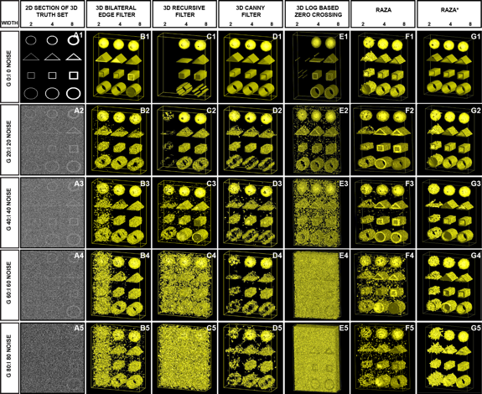

**Fig. S6. Application of RAZA to synthetic phantoms corrupted with Gaussian and impulse noise.** Performance of the 3D BLE, 3D recursive, 3D Canny and 3D LoG based Zero-crossings and RAZA was assessed using a volume of 3D synthetic phantoms contaminated with increasing levels of Gaussian and impulse noise. (A1-A5) 2D sections taken from synthetic volumes contaminated with increasing level of Gaussian and impulse noise. (B1-B5) 3D surface rendering of results obtained from 3D BLE filter. (C1-C5) Surface rendering of the 3D recursive filtered synthetic datasets. (D1-D5) Surface rendering of the 3D Canny-filteres synthetic datsets. (E1-E5) Surface rendering of the application of 3D LoG-based zero crossings filter. (F1-F5) 3D surface rendering of application of RAZA based filtering without fingerprinting. (G1-G5) 3D surface rendering of application of RAZA* particle selection using structural fingerprinting.

**Table S3:** **Statistical evaluation of filter performance using synthetic volumes contaminated with different levels of Gaussian and impulse noise** shown in Fig. S6

|  |  |  |  |  |  |  |
| --- | --- | --- | --- | --- | --- | --- |
| 80/80 | 67.86(7.08) | 124.96 (24.01) | 45.62(3.2) | 161.18(39.64) | 58.19(5.1) | 52.61(4.2) |
| **60/60** | **63.36**(6.17) | **123**(23.27) | **43.73**(2.94) | **90.27**(12.44) | **54.61**(4.6) | **51.93**(4.1) |
| **40/40** | **52.52**(4.2) | **120.74**(22.42) | **42.05**(2.72) | **59.81**(5.46) | **48.08**(3.5) | **47.64**(3.4) |
| **20/20** | **46.24**(3.2) | **118.46**(21.58) | **38.52**(2.28) | **55.89**(4.77) | **45.38**(3.1) | **48.18**(3.5) |
| **0/0** | **29.66**(1.35) | **30.03** (1.39) | **26.91**(1.11) | **37.82**(2.19) | **55.62**(4.7) | **55.62**(4.7) |
| **Noise Gaussian/Impulse** | **3D BLE (%)** | **3D Recursive (%)** | **3D Canny (%)** | **LoG-based Zero-crossings(%)** | **RAZA(%)** | **RAZA*(%)** |

aRMSE scores between the input volumes (Fig.S6 A1-A5) and the six filter outputs are shown in bold. The lowest scores (underlined) represent the highest levels of correlation with the input volume. Values in brackets are the percentage voxel variation between the input volumes and the filtered outputs.

*Application of RAZA using fingerprints.

**Computational performance tests**

To evaluate the computational performance of RAZA, the number of variables that require tuning, CPU processing time and memory usage were analysed. Experiments were conducted using a Mac OS X (2.5 GHz processor) and a 385 x 512 x 128 voxel test volume.

**No. of adjustable parameters:** Of the filters tested, the 3D Canny with its 3 adjustable parameters, is the most complex to optimize followed by RAZA, the 3D zero crossings filter and the 3DLE and recursive filters.

**CPU:** Once optimized the Canny exhibited the lowest CPU requirement (Table S4) but this saving was outweighed by the optimization time. The 3D Zero crossings filter and RAZA are quicker to optimize and also have low CPU usage compared to the 3D BLE and 3D recursive filters.

**Memory usage:** Memory usage was ranked from the best to worst: 3D recursive, 3D BLE, 3D z-crossings, RAZA to the 3D Canny.

**Particle selection:** Only RAZA was able to automate this step which gives it a significant advantage.

**Table S4:** **Comparison of processing resources consumed by each of the three filters evaluated using a synthetic volume (385 x 512 x 128 voxels) contaminated with different levels of Gaussian and impulse noise.**

|  |  |  |  |
| --- | --- | --- | --- |
|  | No. of adjustable parameters | CPU time Totala (filter) sec | Memory Mb |
| **3D BLE** | 0 | 169 (63) | 240.8 |
| **3D recursive** | 0 | 186 (11) | 221.6 (272) |
| **3D Canny** | 3 | 21b | 485.0 |
| **3D zero crossings** | 1 | 34 (11) | 406 |
| **RAZA** | 2 | 33 (11) | 407 |

a Total processing time includes pre-processing and post processing.

b Although the run time of the Canny filter is short, the process is not automated.

**Missing wedge limits**

The focus of this paper was on edge detection based segmentation and not on the optimisation of imaging or post treatment of electron tomograms. All single or dual axis tomograms collected by transmission electron microscopy lack high tilt data resulting in the missing wedge or cone. Missing wedge/cone correction was not applied prior to the use of RAZA as this process is considered prone to artefacts. The reason for this is that in the missing cone no amplitude or phase data is measured. In the case of repeating structures such as 2D crystals, the amplitude and phase date can be extrapolated in an attempt to estimate these values within the missing cone. However, in the case of cellular tomograms that consist of none repeating or periodic structures the extrapolation of the amplitude and phase data is more inaccurate. More importantly, through the use of rapidly advancing EM methods such as 3-View, FIB and cryo-FIB, the missing wedge/cone effect will be less of a problem or eliminated entirely by using isometric voxels for imaging. Examples of the use of RAZA for FIB-SEM data segmentation are provided below.

**Application of RAZA on dataset generated by FIB-SEM**

To demonstrate the RAZA’s ability to segment SEM-FIB dataset *Chlamydomonas reinhardtii* (strain CC-124 wild type mt) cells were fixed in 0.4% osmium tetroxide 0.3% potassium ferricyanide and 0.8% glutaraldehyde then embeded in agarose. Further processing involved additional fixation, dehydration and infiltration details with durcupan resin and final embeding in durcupan. This yields a block for serial section imaging in a FEI SCIOS focused ion beam/scanning electron microscope (FIB/SEM) DualBeam system. Before milling, a one micrometre thick platinum layer was deposited on the sample surface covering the area of interest to prevent it from damage caused by the ion bombardment. The serial sectioning of the volume was carried out at 1nA 30kV ion beam current and the SEM images were collected at 1.5kV and 0.8nA electron beam current. The voxel size of the SEM images is 8nm(x)*8nm(y)*8nm(z, slicing thickness).

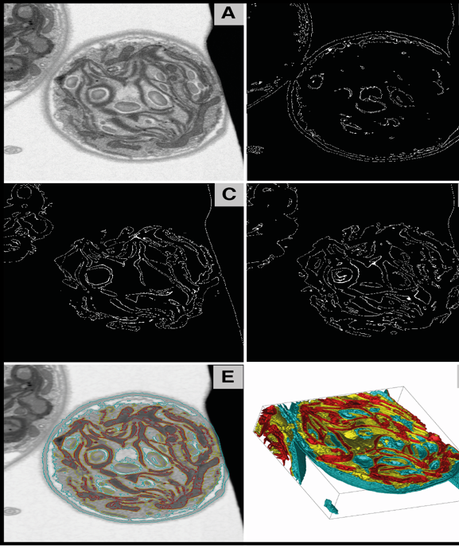

**Fig. S7**. Application of RAZA to 3D volume generated by FIB-SEM. Performance of the RAZA was assessed using a 3D volume obtained from *C. reinhardtii* cells. (A) A gray scale 2D section (slice number = 263) taken from 3D input volume. (B) RAZA results showing the boundaries of cell using σ = 1, z-crossings value = 29000. (C) RAZA results individual membranes using σ = 1, z-crossings value = 15000. (D) RAZA results showing contours highlighting the stacks of membranes using σ = 1, z-crossings value = 2000. (E) Combined contours (shown in B, C and D) laid on input slice ( shown in A). (F) 3D surface rendering of contours detected by RAZA.

**Supplemental References**

Ali, R.A., Landsberg, M.J., Knauth, E., Morgan, G.P., Marsh, B.J., Hankamer, B., 2012. A 3D image filter for parameter-free segmentation of macromolecular structures from electron tomograms. PLoS One 7, e33697.

Bartesaghi, A., Sprechmann, P., Liu, J., Randall, G., Sapiro, G., Subramaniam, S., 2008. Classification and 3D averaging with missing wedge correction in biological electron tomography. J Struct Biol 162, 436-450.

Deng, Y., Chen, Y., Zhang, Y., Wang, S., Zhang, F., Sun, F., 2016. ICON: 3D reconstruction with 'missing-information' restoration in biological electron tomography. J Struct Biol 195, 100-112.

Marsh, B.J., Mastronarde, D.N., Buttle, K.F., Howell, K.E., McIntosh, J.R., 2001. Organellar relationships in the Golgi region of the pancreatic beta cell line, HIT-T15, visualized by high resolution electron tomography. Proc Natl Acad Sci U S A 98, 2399-2406.

Moussavi, F., Heitz, G., Amat, F., Comolli, L.R., Koller, D., Horowitz, M., 2010. 3D segmentation of cell boundaries from whole cell cryogenic electron tomography volumes. Journal of Structural Biology 170, 134-145.

Paavolainen, L., Acar, E., Tuna, U., Peltonen, S., Moriya, T., Soonsawad, P., Marjomaki, V., Cheng, R.H., Ruotsalainen, U., 2014. Compensation of missing wedge effects with sequential statistical reconstruction in electron tomography. PLoS One 9, e108978.

Park, W., Leibon, G., Rockmore, D.N., Chirikjian, G.S., 2009. Accurate image rotation using Hermite expansions. IEEE transactions on image processing: a publication of the IEEE Signal Processing Society 18, 1988.

Shapiro, L., Stockman, G. , 2002. Computer Vision Prentice Hall.