Student ID No: __________Name: ______________________________ Date: _____________
Course & Year/Section: _______________________ Score: ____________

PERFORMANCE TASK 3
PROJECT KICKOFF & ENVIRONMENT SETUP
General Directions
- Read and understand each statement carefully.
- Write your answers on your activity sheet.

Objective:
By the end of this lab, students should be able to:
- Identify the tools required for system integration development and collaboration.
- Set up a project repository for team-based work.
- Document the initial project overview and team assignments.
- Demonstrate proper use of version control for collaboration.

Overview:

This lab sets up your team repository and working structure for the semester-long integration project. You’ll form teams, assign roles, create a properly structured repository, draft your initial project overview, and practice collaboration using Git. Treat the repository as a living workspace—it will be used and expanded throughout the course.
Step 1: Repository Setup
- Create a new Git repository for your team project on your chosen platform.
Recommended naming convention (include course code):
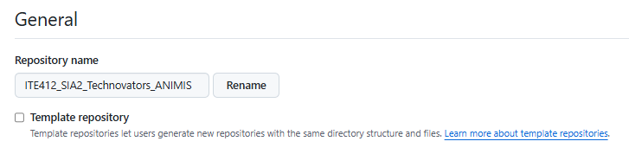

- Initialize structure (create these folders at the repo root):
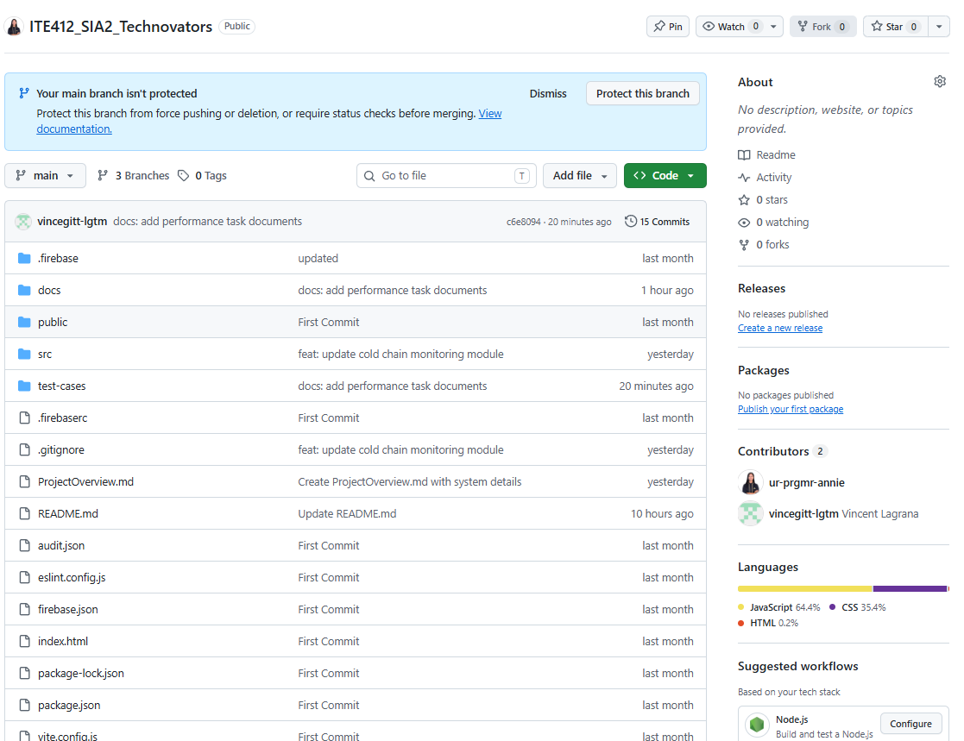
/docs → project documentation
/src → source code
/tests → test cases
/integration → integration scripts/configs

- Add a README.md containing:
  - Team name and members (with roles)
  - Project title (tentative)
  - Short description of the system to be integrated
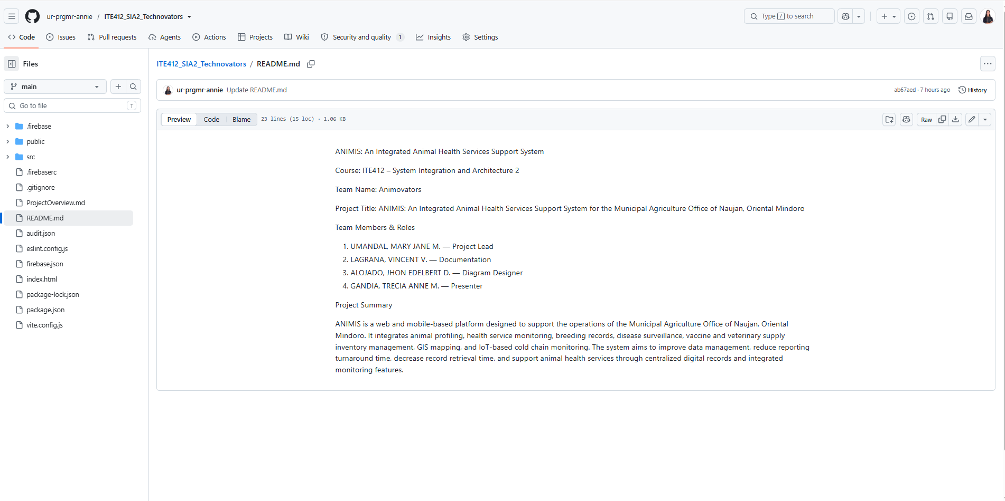
  - Repository usage notes (how to clone/run if applicable)

Step 2: Project Overview Document
Inside the /docs folder, create ProjectOverview.md with:
- System Objectives – What problem will your project solve?
- Proposed Scope – Modules or systems to be integrated.
- Stakeholders – Identify at least 2 stakeholders (real or role-played).
- Tools/Technologies – List the tools you expect to use.
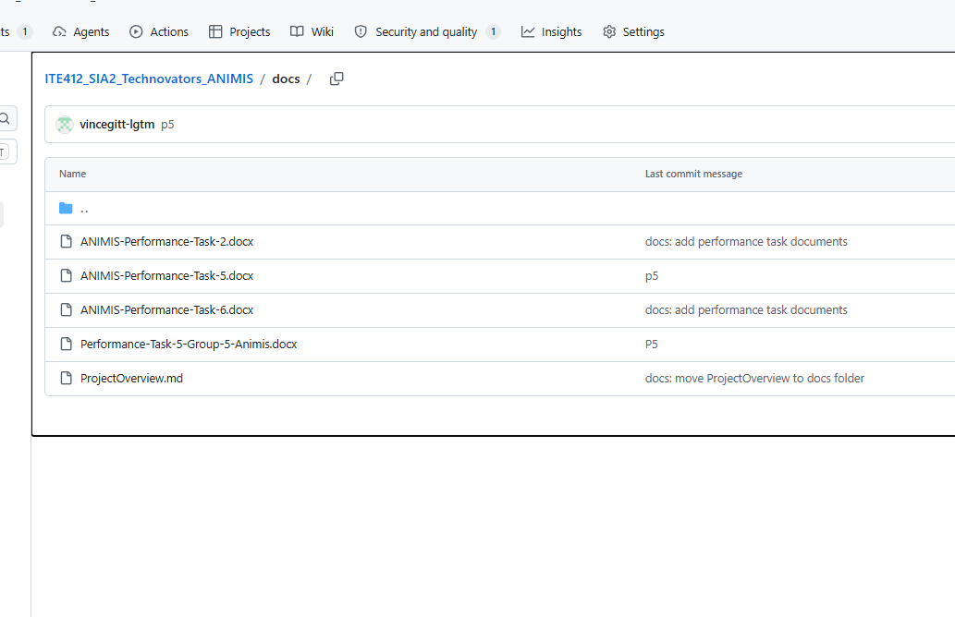

Note: Aim for clarity and feasibility. Keep it concise (1–2 pages).

Step 3: Version Control Practice
Each member must:
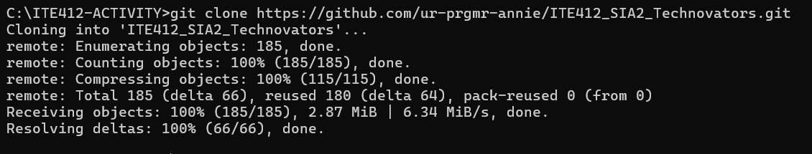
- Clone the repository:

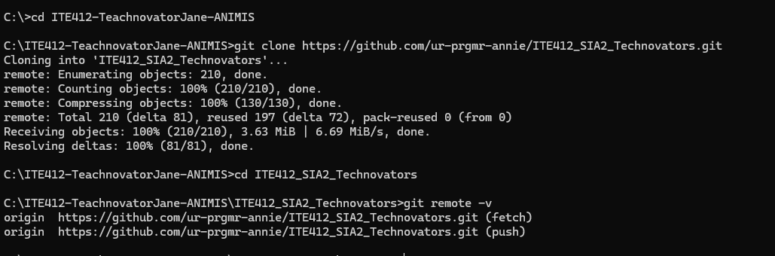

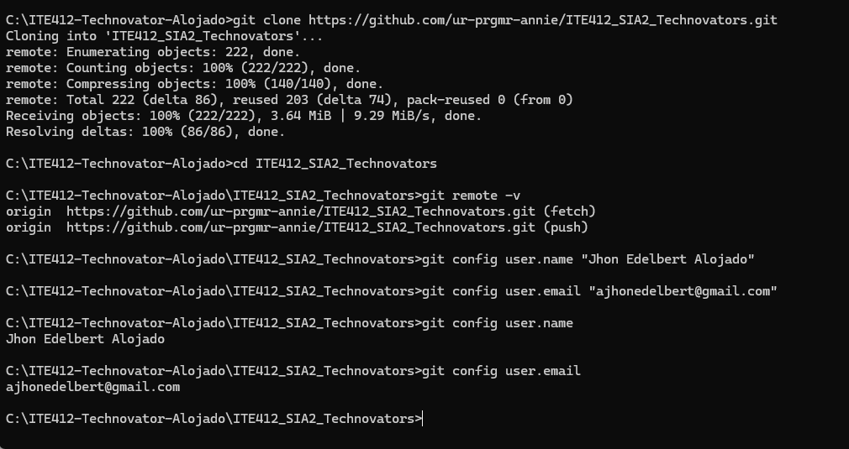

- Configure Git (if first time):
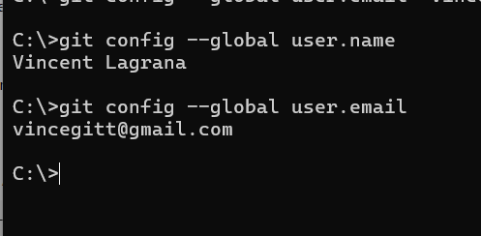

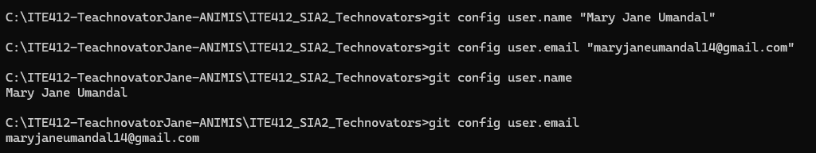

- Create a personal feature branch and make a small change
(e.g., add your name to README.md under “Team Members”):
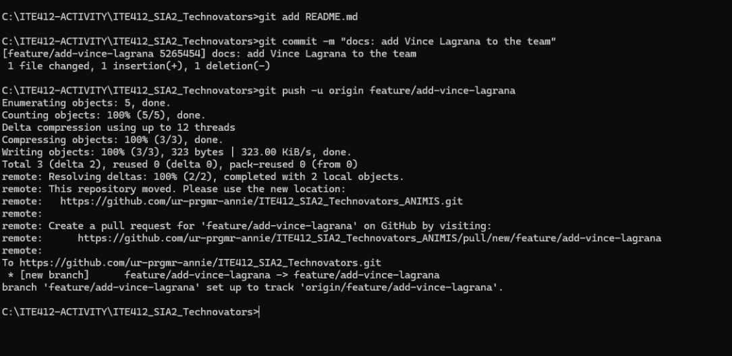

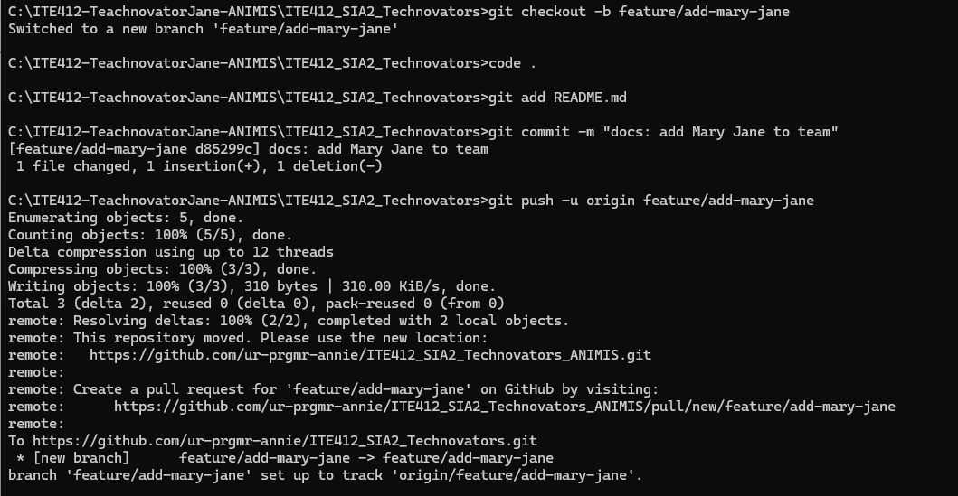

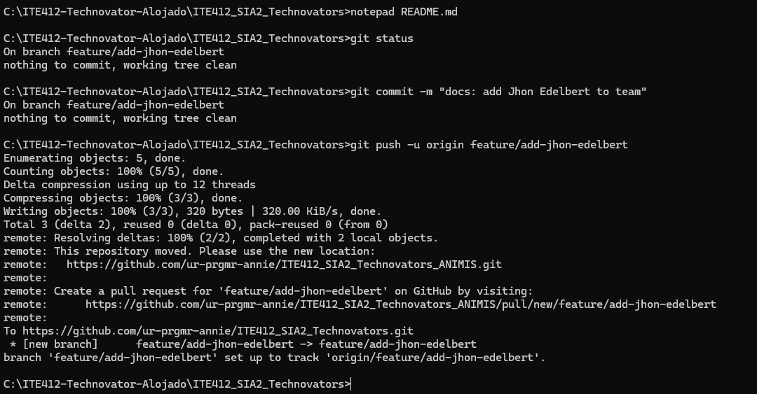

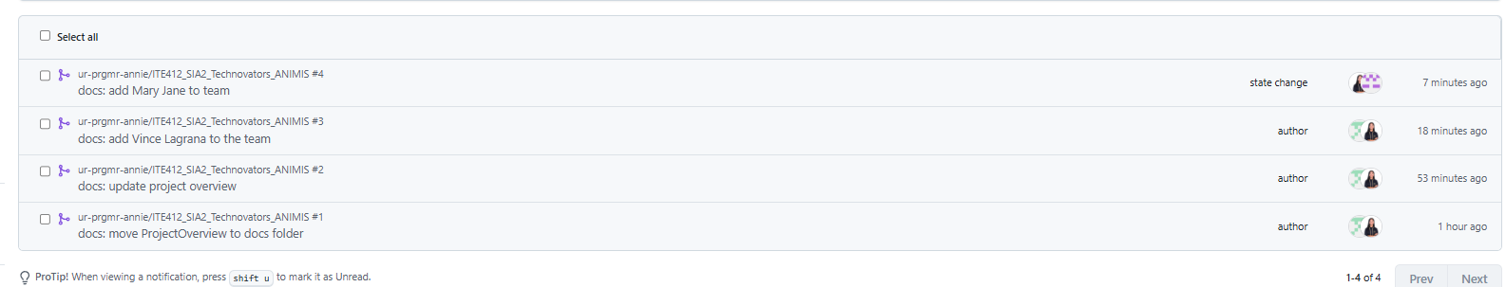
- Open a Pull/Merge Request and request review from a teammate.

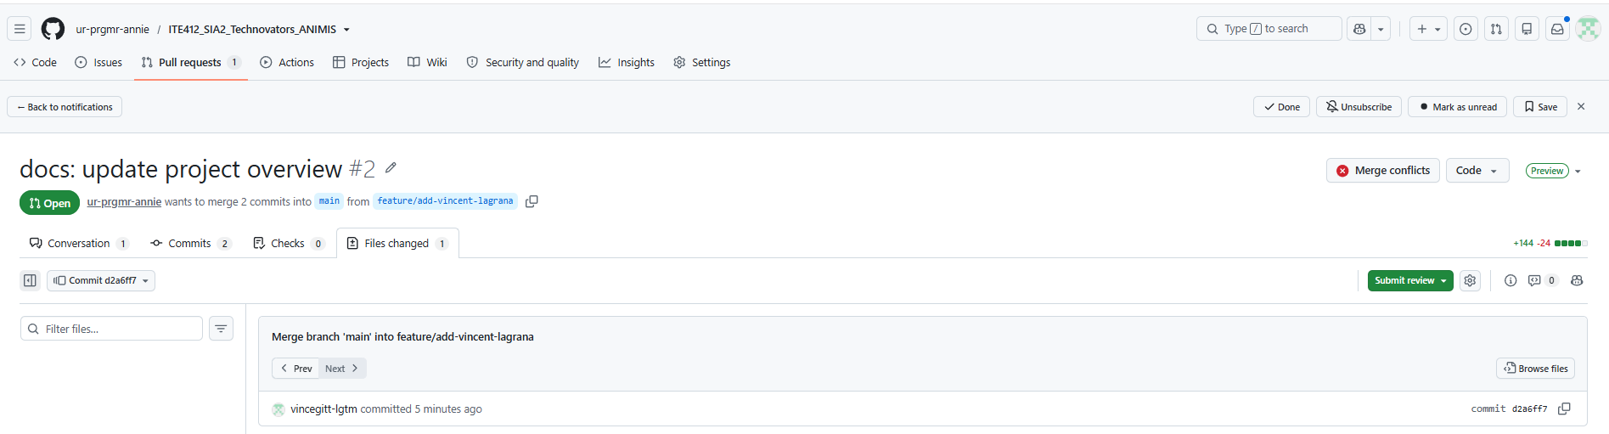

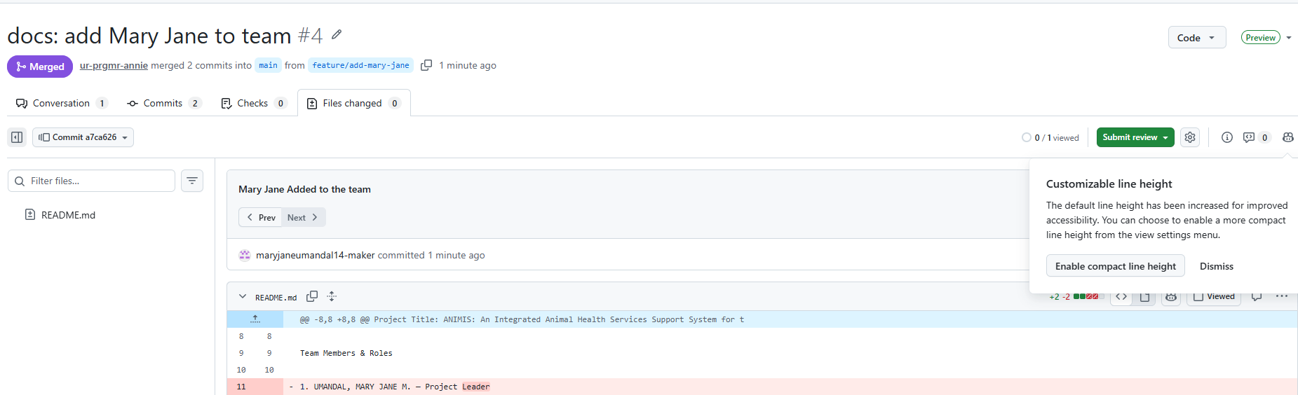

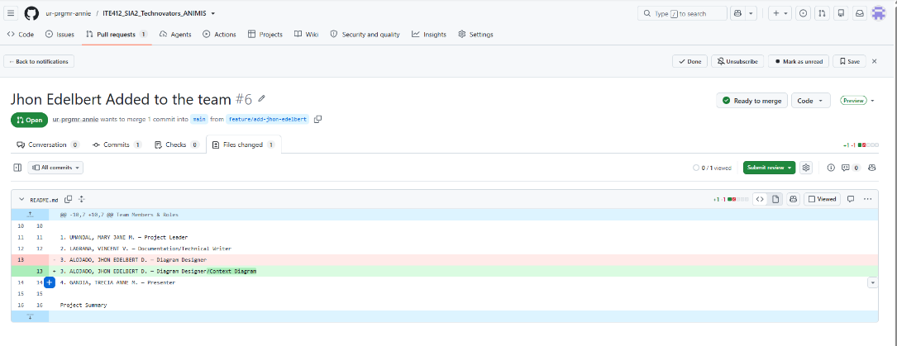

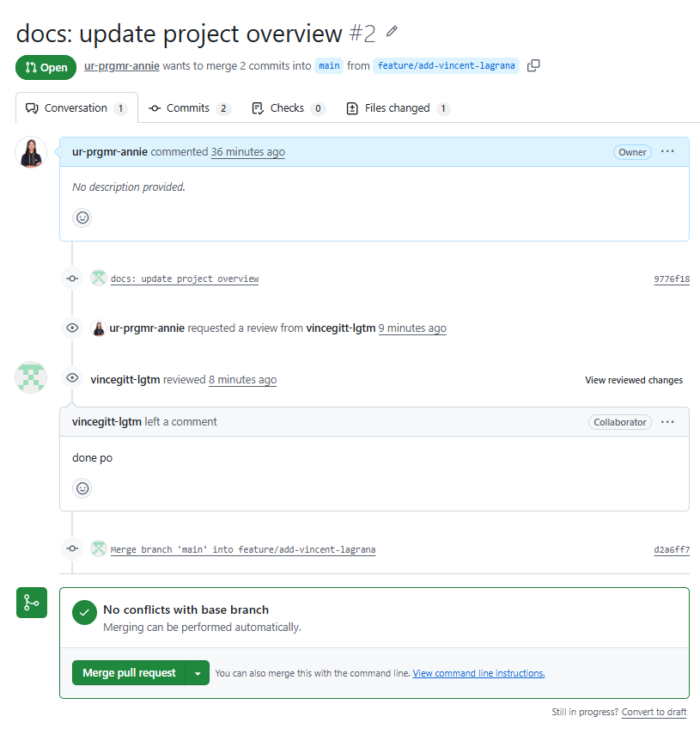
- Resolve conflicts if they occur, then merge into main.
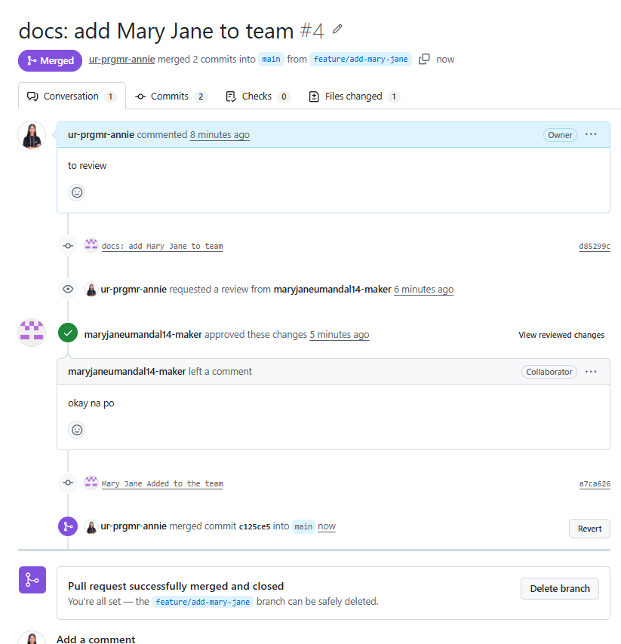

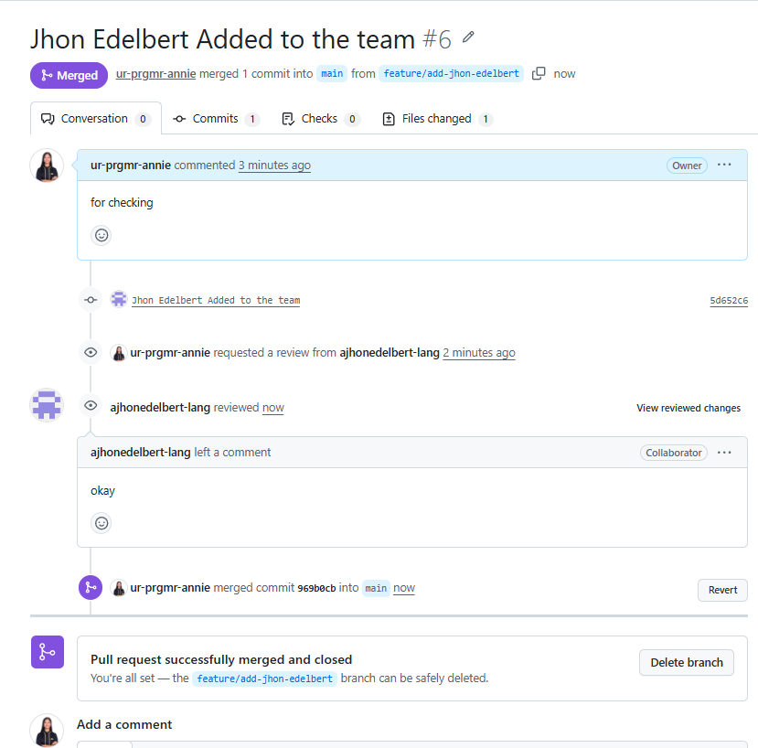

Deliverables:
- Repository Link (shared with instructor)
- README.md with team info & project overview
- /docs/ProjectOverview.md
- Evidence of commits from all members
  - Visible in Commit History / Insights → Contributors
  - Screenshots or PR links acceptable
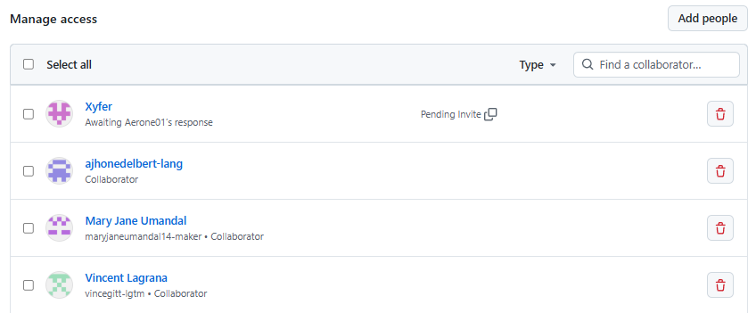

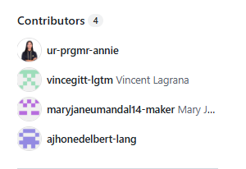
Submission method: Post the repo URL and screenshots/PR links to the MS Teams assignment titled Performance Task 3.
Evaluation Criteria (Total: 100 pts)
Criterion | Description | Pts
Repository Setup | Proper structure and naming conventions (ITE412_SIA2_[TeamName]_Project, correct folders, README present) | 30
Documentation | Complete and clear ProjectOverview.md (objectives, scope, stakeholders, tools) | 30
Version Control Usage | Each member contributed at least one commit via branch → PR/MR → merge | 20
Team Organization | Roles clearly defined and documented in README.md | 20
Total |  | 100

Templates & Samples
Template: README.md
# [Tentative Project Title]
**Course:** ITP41E – System Integration and Architecture 2
**Team Name:** [TeamName]
**Repository:** [link to repository]
## Team Members & Roles
- [Name] — Team Lead
- [Name] — Documentation Lead
- [Name] — Integration Lead
- [Name] — Developer
- [Name] — Tester
## Project Summary
A short paragraph (3–5 sentences) describing the system to be integrated and the intended user(s).
## Repository Structure
/docs /src /tests /integration
## Getting Started
- Clone: `git clone <REPO_URL>`
- Default branch: `main`
- Branch naming: `feature/<short-desc>`, `docs/<short-desc>`, `fix/<short-desc>`

## Collaboration Workflow
1. Create a branch → 2. Commit changes → 3. Push → 4. Open PR/MR → 5. Review → 6. Merge

## Communication
- Channel: [MS Teams]
- Meeting cadence: [e.g., weekly, Wednesdays 4:00 PM]

Template: /docs/ProjectOverview.md
# Project Overview
## 1. System Objectives
- What problem are you solving?
- Who benefits and how?
## 2. Proposed Scope
- Modules/systems to integrate (e.g., Auth, Payments, Messaging)
- In-scope features for Lab 1–3
- Out-of-scope (for now)
## 3. Stakeholders
- [Role/Name] — [Interest/Needs]
- [Role/Name] — [Interest/Needs]
## 4. Tools & Technologies
- Languages/Frameworks:
- Integration approach (e.g., REST APIs, Webhooks, Message Queue):
- Repos/Services (GitHub/GitLab/Bitbucket, CI/CD, etc.):
- Testing tools:
Suggested Git Workflow (Quick Guide)
- Default branch: main
- Feature branches: feature/<desc>
- Docs branches: docs/<desc>
- Fix branches: fix/<desc>
- Commit message style:
feat: ..., fix: ..., docs: ..., test: ..., chore: ...

Common Commands
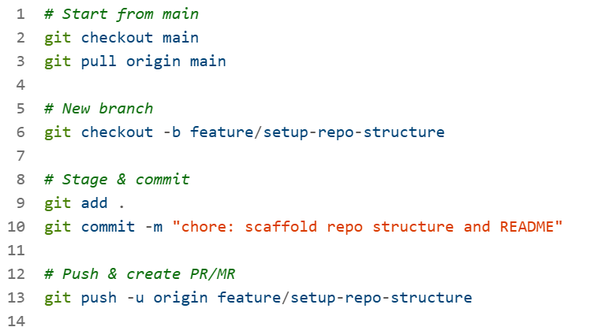
Troubleshooting Tips
- Authentication errors:
Use HTTPS with a Personal Access Token (PAT) or set up SSH keys.
- User identity missing:
git config --global user.name "Your Name"
git config --global user.email "you@example.com"
- Merge conflicts:
Open both versions in your editor, choose intended lines, then:
git add <file> → git commit → complete PR/MR.
- .gitignore not working:
File was already tracked—run git rm -r --cached . → git add . → git commit -m "chore: apply .gitignore"

