GROUP 5: ANIMIS: An Integrated Animal Health Services Support System for the Municipal Agriculture Office of Naujan, Oriental Mindoro
BSIT 4-F1
Team Members and Roles:
- Project Lead: UMANDAL, MARY JANE M.
- Documentation: LAGRANA, VINCENT V.
- Diagram Designer: ALOJADO, JHON EDELBERT D.
- Presenter: GANDIA TRECIA ANNE M.
Create a Context Diagram
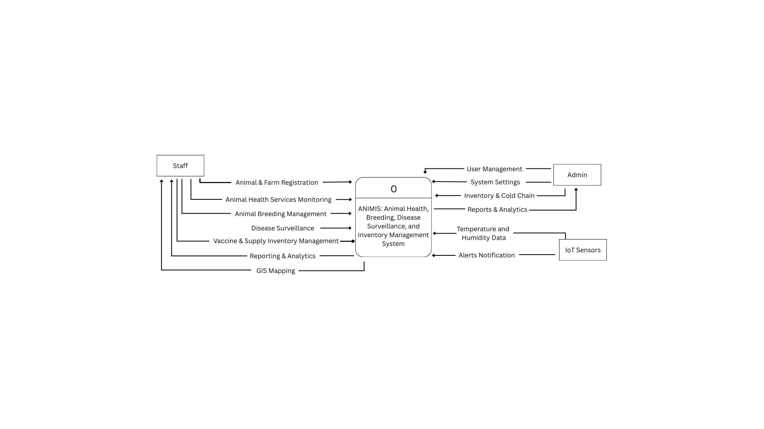

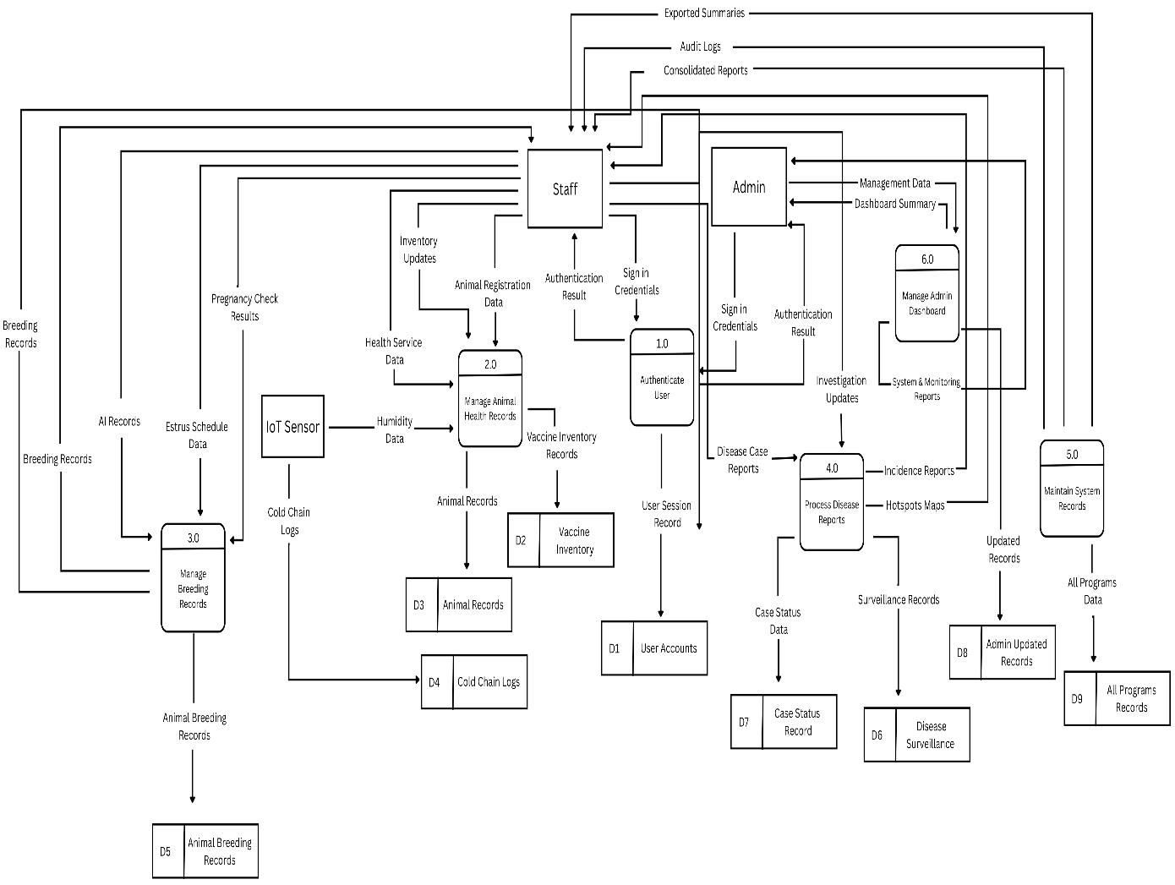
Create the Parent Diagram (Level 0 DFD)

Updated ProjectOverview.md with High-Level System Overview
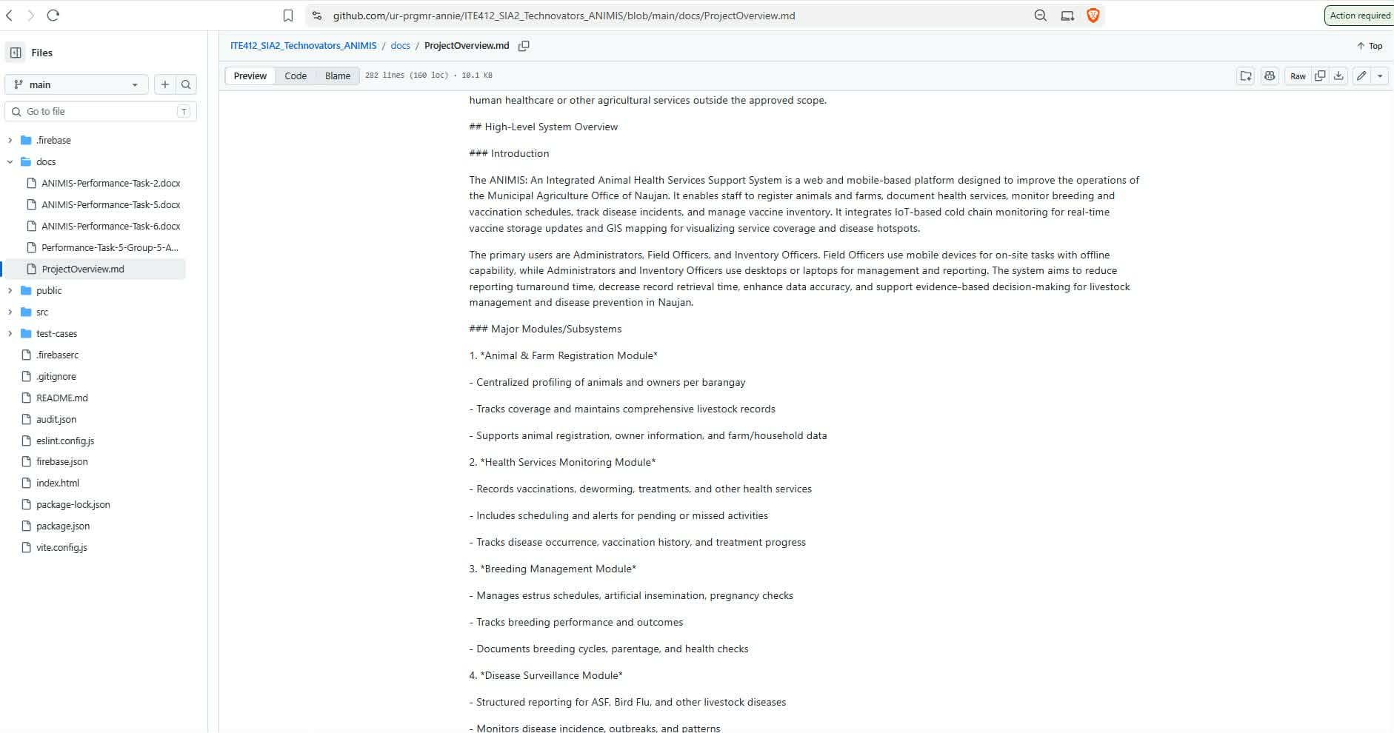
Git repository updated with contributions from multiple members
