Project Title: ANIMIS: An Integrated Animal Health Services Support System for the Municipal Agriculture Office of Naujan, Oriental Mindoro
Team Members and Roles:
- Project Lead: UMANDAL, MARY JANE M.
- Documentation: LAGRANA, VINCENT V.
- Diagram Designer: ALOJADO, JHON EDELBERT D.
- Presenter: GANDIA TRECIA ANNE M.

Project Objectives and Scope
- System Objectives:
The ANIMIS project aims to develop a centralized digital system that integrates animal profiling, breeding records, disease monitoring, and inventory management for the Municipal Agriculture Office of Naujan, Oriental Mindoro. Specifically, it seeks to reduce the average data consolidation and reporting turnaround time, decrease the average record retrieval time, and support the animal health services of MAO Naujan through features such as IoT-based cold chain monitoring for vaccines, GIS mapping for livestock and disease data, and mobile accessibility for field officers. The system is designed to replace the current manual, paper-based, and spreadsheet-driven processes that often result in delays, encoding errors, and difficulty in retrieving historical records.
- Scope:
The system will cover the digitization and streamlining of the following processes: animal and owner registration, breeding and health record management, disease surveillance , barangay-based monitoring, vaccine and veterinary supply inventory management, data analytics and reporting, user access control with role-based security, mobile accessibility with offline capability, IoT-based cold chain monitoring for vaccines, and GIS mapping for livestock and disease data. The system is limited to the specific operations of the Municipal Agriculture Office of Naujan and does not extend to other agricultural offices or veterinary facilities. It does not cover human healthcare or other agricultural services.

Identified Stakeholders
- Municipal Agriculture Office of Naujan (MAO Naujan)
- Livestock Owners and the Community
- Barangay Staff
- Future Researchers

Stakeholder Interview
Prepared Questions:
- What problems do you currently face in managing animal health, breeding records, disease surveillance, and veterinary supplies that the system should address?
- What are the key features you expect from this system to improve your daily operations?
- Who will primarily use the system (e.g., administrators, field officers, inventory officers, barangay staff)?
- How do you currently consolidate reports from different barangays, and how long does it take?
- What are your expectations regarding IoT-based cold chain monitoring and GIS mapping for disease surveillance?

Interview Notes:
Current Problems: The office relies heavily on manual processes, including paper-based records and spreadsheets. Consolidating reports from different barangays takes up to three months, and retrieving past records is extremely difficult, affecting timely reporting and planning.
Key Features Expected: A centralized digital system integrating animal profiling, breeding records, disease monitoring, and inventory management, with IoT-based cold chain monitoring for vaccines and GIS mapping for disease surveillance.
Primary Users: Administrators, field officers, and inventory officers. Field officers use mobile devices for on-site tasks, while administrators and inventory officers use desktops or laptops for management and reporting.
Reporting Timeline: Consolidating reports currently takes up to three months; the office expects the system to significantly reduce this through automated data consolidation and reporting.
IoT and GIS Expectations: Real-time temperature monitoring for vaccine storage with alerts, and GIS mapping to visualize service coverage, identify disease hotspots, and support better planning and surveillance.

Requirements Documentation
- Functional Requirements (FRs):
- The system shall allow users to register animals and farm/household information, including owner details, animal breed, category, and location.
- The system shall allow field officers to record health services such as vaccinations, deworming, treatments, and other health services with scheduling and alerts.
- The system shall allow users to manage breeding records, including estrus schedules, artificial insemination, pregnancy checks, and breeding performance tracking.
- The system shall allow users to record and monitor disease incidents, including ASF and Bird Flu case reporting, with GIS mapping for disease hotspots.
- The system shall provide a vaccine and supply inventory management module that tracks stock levels, batch numbers, expiry dates, and usage.
- The system shall integrate with IoT-based cold chain monitoring devices to provide real-time temperature and humidity data with alerts when conditions exceed safe thresholds.
- The system shall generate reports and analytics on services, breeding outcomes, disease trends, and inventory levels by barangay and program.
- The system shall implement user authentication and role-based access control for Administrators, Field Officers, and Inventory Officers.
- The system shall provide a centralized dashboard displaying registered animals, health services, breeding activities, disease reports, vaccine inventory, and IoT cold chain readings.
- Non-Functional Requirements (NFRs):
- The system shall be accessible via desktop, laptop, smartphone, and tablet devices.
- The system shall support offline capability for field officers with automatic data synchronization when connectivity is restored.
- The system shall implement secure login with encrypted credentials, role-based access control, and input validation.
- The system shall have a user-friendly interface for personnel with varying levels of technical expertise.
- The system shall provide real-time data synchronization between mobile devices and the cloud backend using Firebase services.
- The system shall maintain data accuracy and integrity through audit logging, session management, and regular data backup and recovery.

Context Diagram 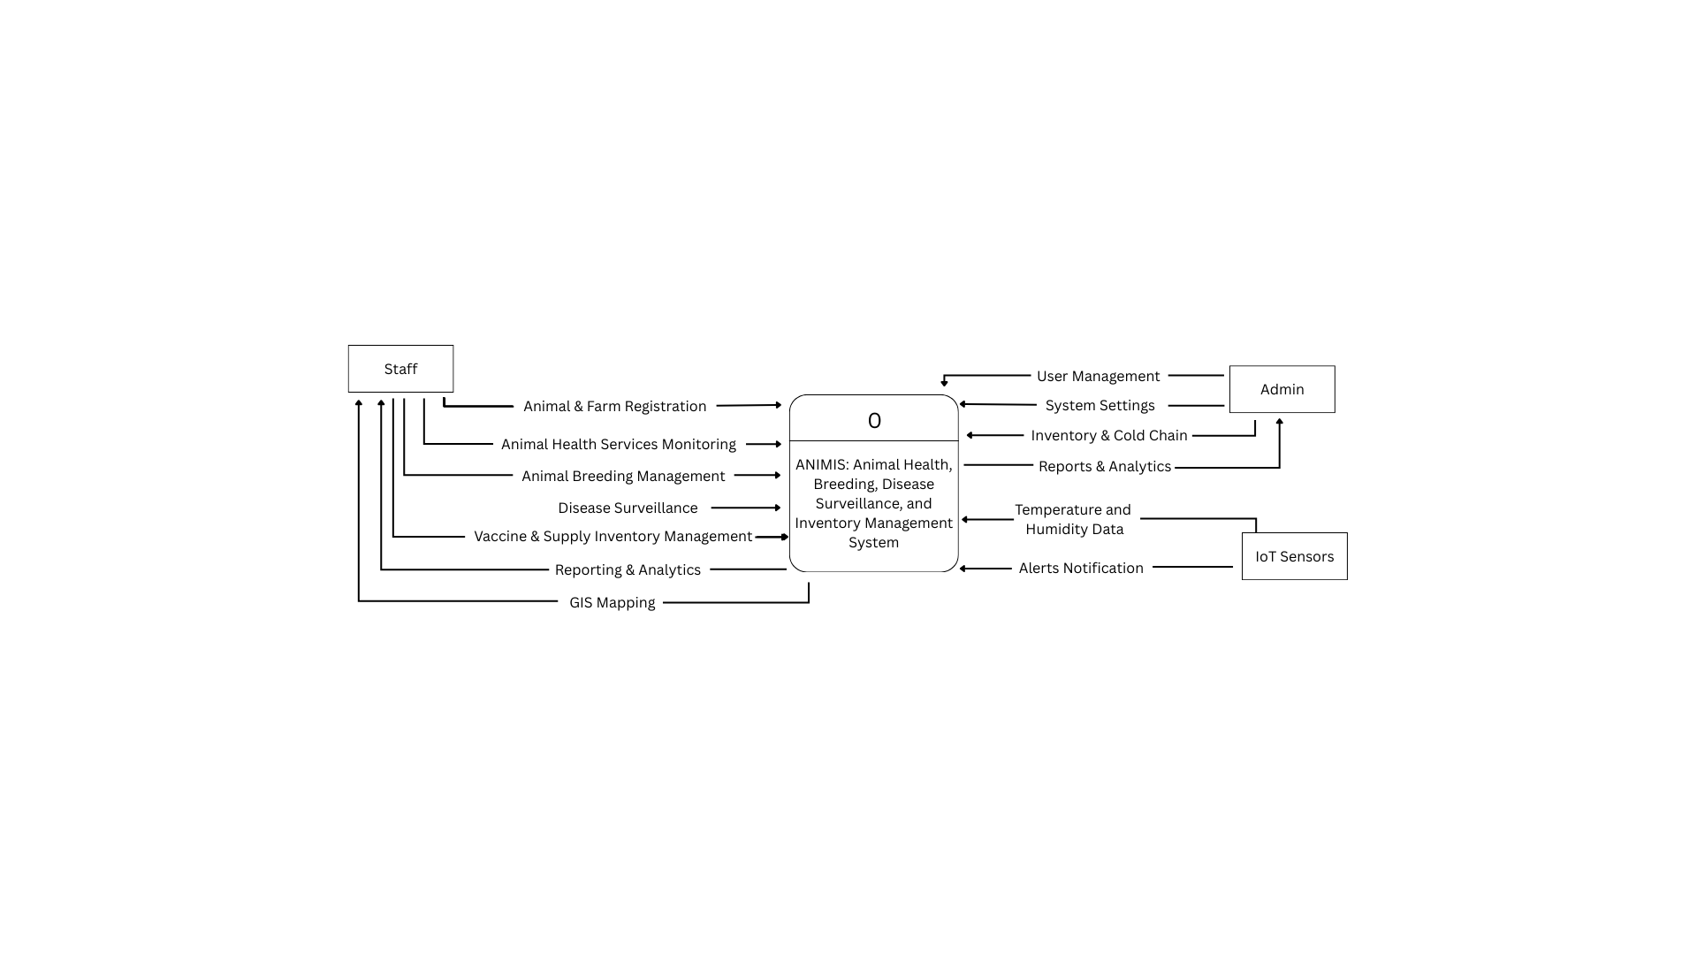
High-Level System Overview
The ANIMIS: An Integrated Animal Health Services Support System is a web and mobile-based platform designed to improve the operations of the Municipal Agriculture Office of Naujan. It enables staff to register animals and farms, document health services, monitor breeding and vaccination schedules, track disease incidents, and manage vaccine inventory. It integrates IoT-based cold chain monitoring for real-time vaccine storage updates and GIS mapping for visualizing service coverage and disease hotspots.
The primary users are Administrators, Field Officers, and Inventory Officers. Field Officers use mobile devices for on-site tasks with offline capability, while Administrators and Inventory Officers use desktops or laptops for management and reporting. The system aims to reduce reporting turnaround time, decrease record retrieval time, enhance data accuracy, and support evidence-based decision-making for livestock management and disease prevention in Naujan.

