Student ID No: __________Name: ______________________________ Date: _____________
Course & Year/Section: _______________________ Score: ____________

PERFORMANCE TASK 6
HIGH-LEVEL ARCHITECTURE DIAGRAM WITH INTEGRATION PATTERNS

General Directions
- Read and follow each step carefully.
- Document your answers, screenshots, and reflections in your lab report.

Objectives:
By the end of this lab, students should be able to:
- Identify and apply common system integration patterns (P2P, Hub-Spoke, Pub-Sub).
- Develop a high-level architecture diagram for their proposed system project.
- Demonstrate how modules interact and exchange data using appropriate integration patterns.
- Document the rationale for selecting a specific integration pattern for their project.
Tools/Resources Needed
- Diagramming tool: Draw.io, Lucidchart, Miro, MS Visio (or equivalent)
- Project repository from Weeks 1 & 2
- Microsoft Word for documentation
Lab Instructions
Step 1: Review Previous Work
- Open your ProjectOverview.md and Context Diagram from Weeks 1 & 2.
- Identify the key modules and external systems/entities.

Step 2: Select an Integration Pattern
- Choose one integration pattern (P2P, Hub-Spoke, or Pub-Sub) that best fits your project.
- Justify your choice in a short-written explanation.

Step 3: Create High-Level Architecture Diagram
- Draw your system modules as components.
- Show communication links based on the chosen integration pattern.
  - P2P: Each module directly connects to others.
  - Hub-Spoke: A central hub routes communication.
  - Pub-Sub: A message broker handles publish/subscribe message.
  - Annotate each connection with type of communication (e.g., API call, database query, message queue).

Step 4: Documentation

Inside /docs, update ProjectOverview.md with a new section:
- Integration Pattern Applied – Name the pattern.
- Rationale – Explain why it fits your system.
- Diagram Reference – Insert your architecture diagram file (e.g., HighLevelArch.png).

Step 5: Version Control & Submission
- Save your diagram as HighLevelArch.png in /docs.
- Commit and push changes to the repository.

Deliverables
- High-Level Architecture Diagram (HighLevelArch.png in /docs)
- Updated ProjectOverview.md with Integration Pattern & Rationale

Grading Rubric for Lab Activity
Criteria | Excellent (5) | Good (4) | Satisfactory (3) | Needs Improvement (2-1) | Weight
Diagram Clarity | Well-structured, correct use of chosen pattern, clear labels | Mostly clear, minor missing details | Understandable but lacks clarity | Confusing or incorrect | 40%
Pattern Application | Correctly applies chosen pattern with justification | Mostly correct, justification minor | Pattern applied but weak explanation | Incorrect application or no justification | 30%
Documentation | Complete, well-written rationale & references | Mostly complete, minor gaps | Basic documentation only | Incomplete or missing | 20%
Repository Usage | Properly updated, file organized in /docs | Updated but disorganized | Incomplete updates | No repository update | 10%
Total: 100%

STUDENT WORKSHEET

Part 1 – System Information
- Team Name: TEAM ANIMIS
- System Title: ANIMIS: An Integrated Animal Health Services Support System for the Municipal Agriculture Office of Naujan, Oriental Mindoro
- Selected Integration Pattern:Hub-Spoke

Part 2 – Architecture Diagram

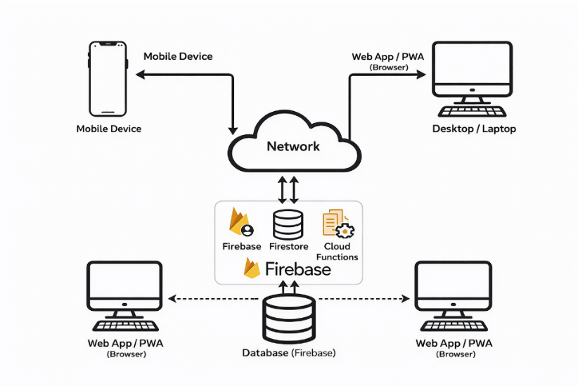

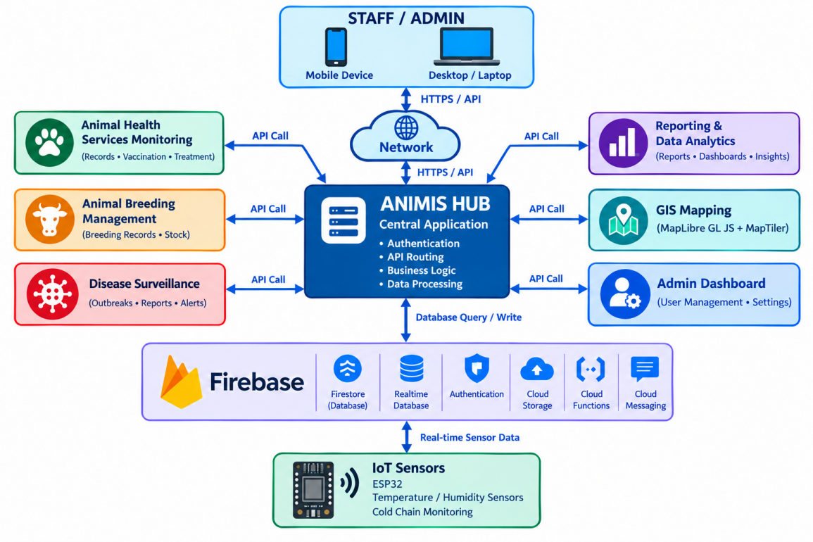

Part 3 – Module Description
- Fill in the table with at least 3 modules in your system.

Module Name | Function/Responsibility | Interfaces (APIs, Middleware, etc.) | Integration Notes
Animal Health Services Monitoring | Manages animal health records, vaccination, and treatment information. | Firestore Database | Sends and receives animal health data through the ANIMIS Hub.
Animal Breeding Management | Manages animal breeding records and related information. | Firestore Database | Exchanges breeding data through the ANIMIS Hub.
Disease Surveillance | Manages disease reports, outbreaks, and alerts. | Firestore Database | Sends disease information through the ANIMIS Hub.
Reporting & Data Analytics | Generates reports, dashboards, and data insights. | REST API, Firebase Database | Receives processed information through the ANIMIS Hub.
ColdChain | Monitor the right temperature of the vaccine storage | Realtime Database
Module Name | Function/Responsibility | Interfaces (APIs, Middleware, etc.) | Integration Notes
Admin Dashboard | Handles user management and system settings. | REST API, Firestore Authentication, Realtime Database | Communicates with the ANIMIS Hub for administrative operations.

Part 4 – Data Flow Narrative
- Write a short narrative (5–7 sentences) explaining how data flows between modules and external entities in your system under the chosen integration pattern.

The ANIMIS system uses the Hub-Spoke integration pattern, where the ANIMIS Hub serves as the central point for communication between users, system modules, and cloud services. Staff and administrators access the system through mobile devices or desktop computers using HTTPS/API communication. Requests from the Animal Health, Breeding, Disease Surveillance, Reporting, GIS, and Admin modules are routed through the ANIMIS Hub. The Hub processes the requests and communicates with Firebase for database queries, data storage, authentication, and other cloud services. IoT sensors using ESP32 collect temperature and humidity data for cold-chain monitoring and send real-time sensor data to Firebase. The processed information can then be accessed by the appropriate ANIMIS modules and users through the central hub. This integration pattern allows the different components of ANIMIS to communicate through a central point.

