GROUP 5: ANIMIS: An Integrated Animal Health Services Support System for the Municipal Agriculture Office of Naujan, Oriental Mindoro
BSIT 4 F1
Team Members and Roles:
Project Lead: UMANDAL, MARY JANE M.
Documentation: LAGRANA, VINCENT V.
Diagram Designer: ALOJADO, JHON EDELBERT D.
Presenter: GANDIA TRECIA ANNE M.

Part 1: REST API Exploration
Send a GET request to retrieve posts.
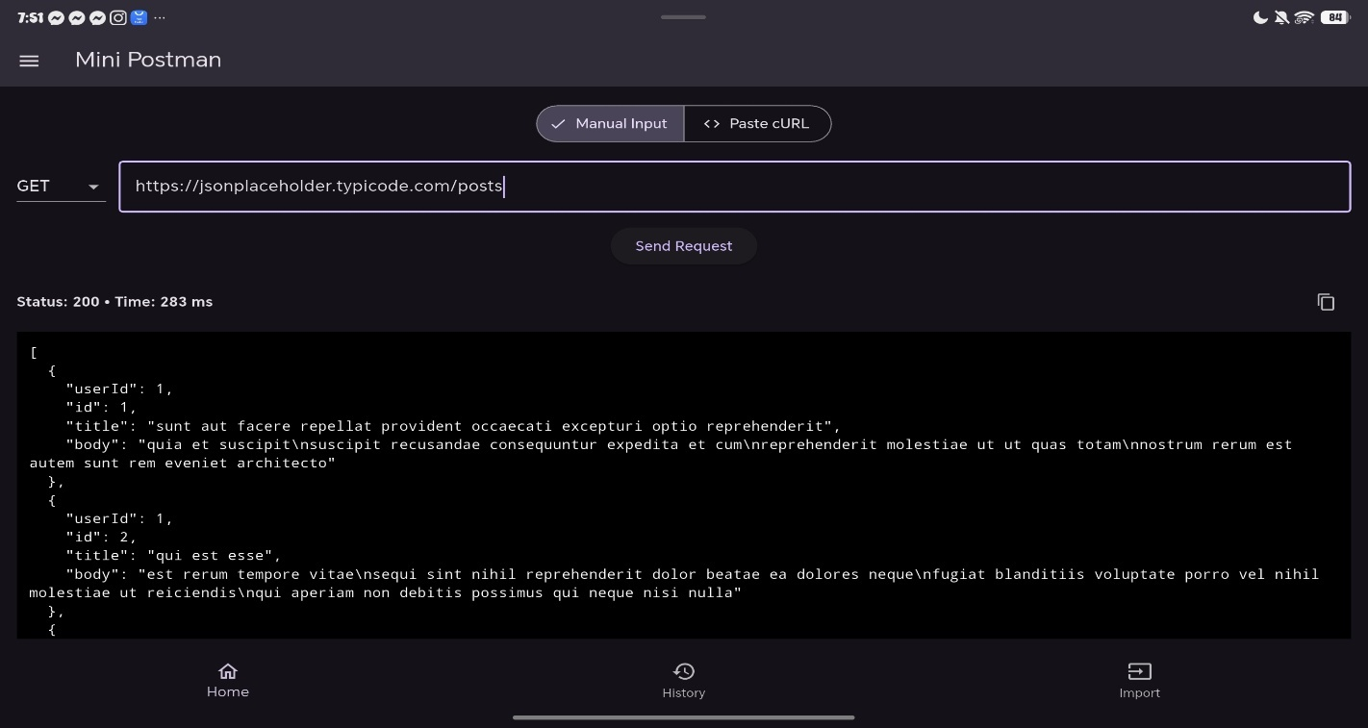

Send a POST request with your own test data (title, body, userId).
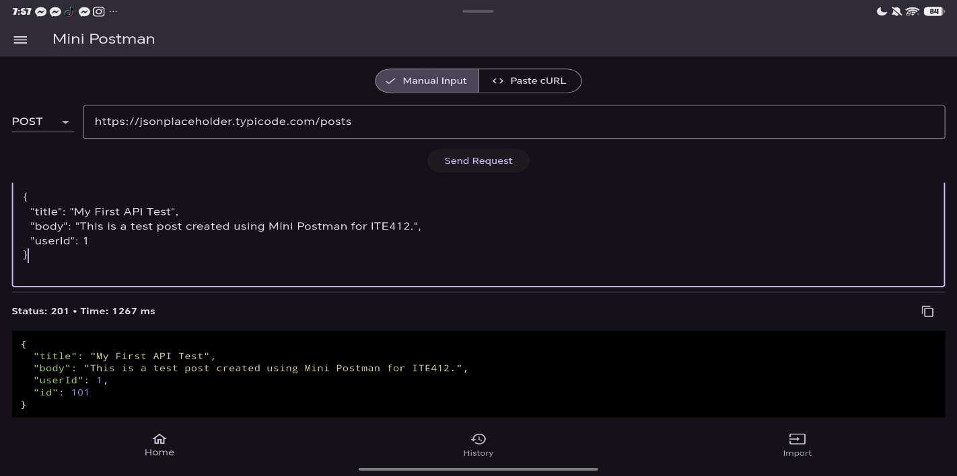
Question 1: What HTTP methods did you use?
I used two HTTP methods in this activity: GET and POST. I used GET to retrieve the list of posts from https://jsonplaceholder.typicode.com/posts, which returned a Status 200 OK response with a JSON array of 100 posts. GET is safe and idempotent, meaning it does not modify data on the server and returns the same result every time it is called. I used POST to create a new post by sending a JSON body containing title, body, and userId. The server returned a Status 201 Created response with the new post assigned id: 101. Unlike GET, POST is not idempotent because each call may create a new resource with a new unique ID. These methods follow the CRUD operations of REST architecture, and other methods like PUT, PATCH, and DELETE are also used for updating and deleting resources.
Question 2: How does the response format (JSON) differ from SOAP’s XML?
JSON is lightweight, compact, and human-readable. It uses key-value pairs enclosed in curly braces, arrays with square brackets, and separates items with commas. It natively supports data types such as strings, numbers, booleans, arrays, objects, and null. JSON is easy to parse in almost every programming language, especially JavaScript, making it ideal for web and mobile applications. XML, on the other hand, is more verbose and formal. Every piece of data must be wrapped in opening and closing tags, and SOAP messages must follow a strict envelope structure with <soap:Envelope>, <soap:Header>, and <soap:Body> elements. XML also relies on namespaces and XML Schema for data typing, which makes it more complex but also more rigid and standardized. In summary, JSON is smaller, faster to parse, and easier to read, while XML is larger, more rigid, and requires more bandwidth but offers strong typing and built-in error handling through SOAP Fault.

Part 2: SOAP Web Service Exploration
- Go to the SOAP service example:
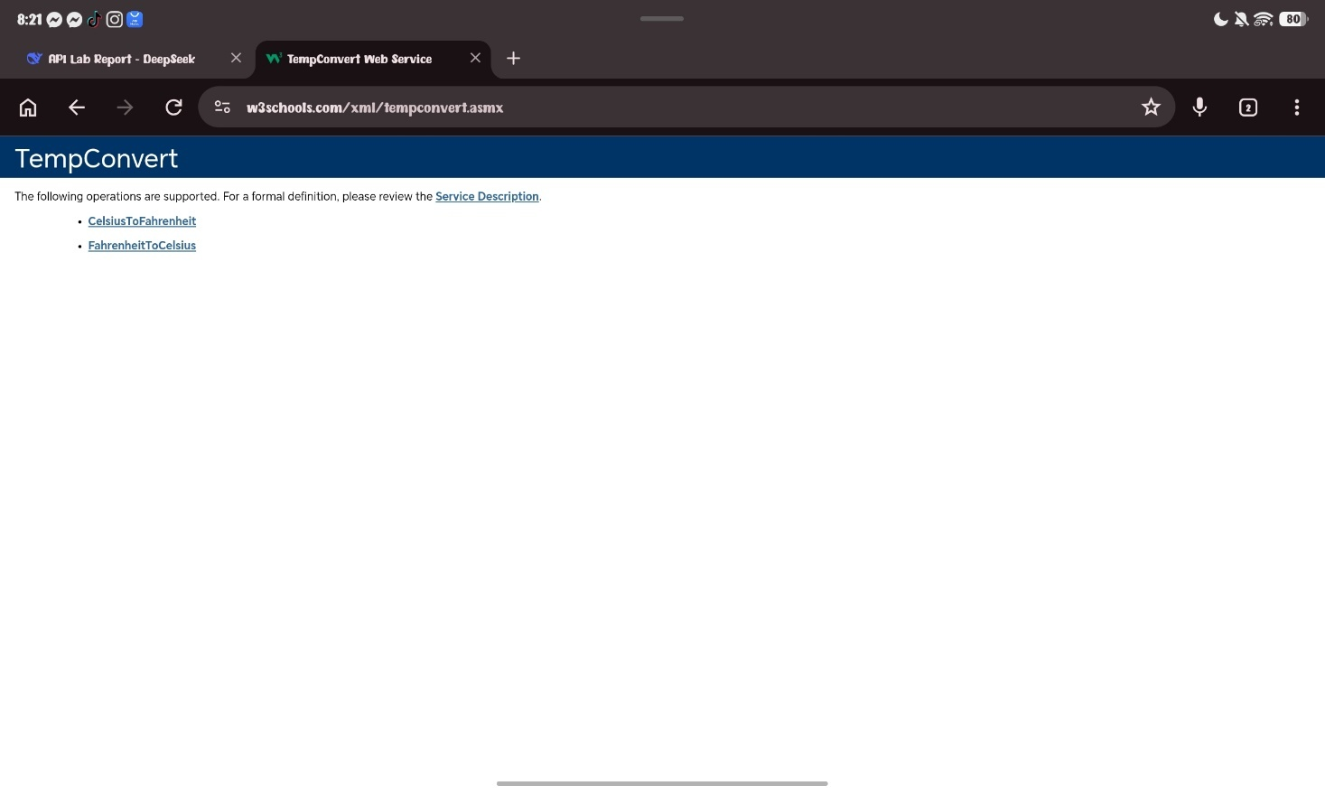

- Using the service description (WSDL), test the following operations:
  - CelsiusToFahrenheit
  - FahrenheitToCelsius

- Task:
CelsiusToFahrenheit
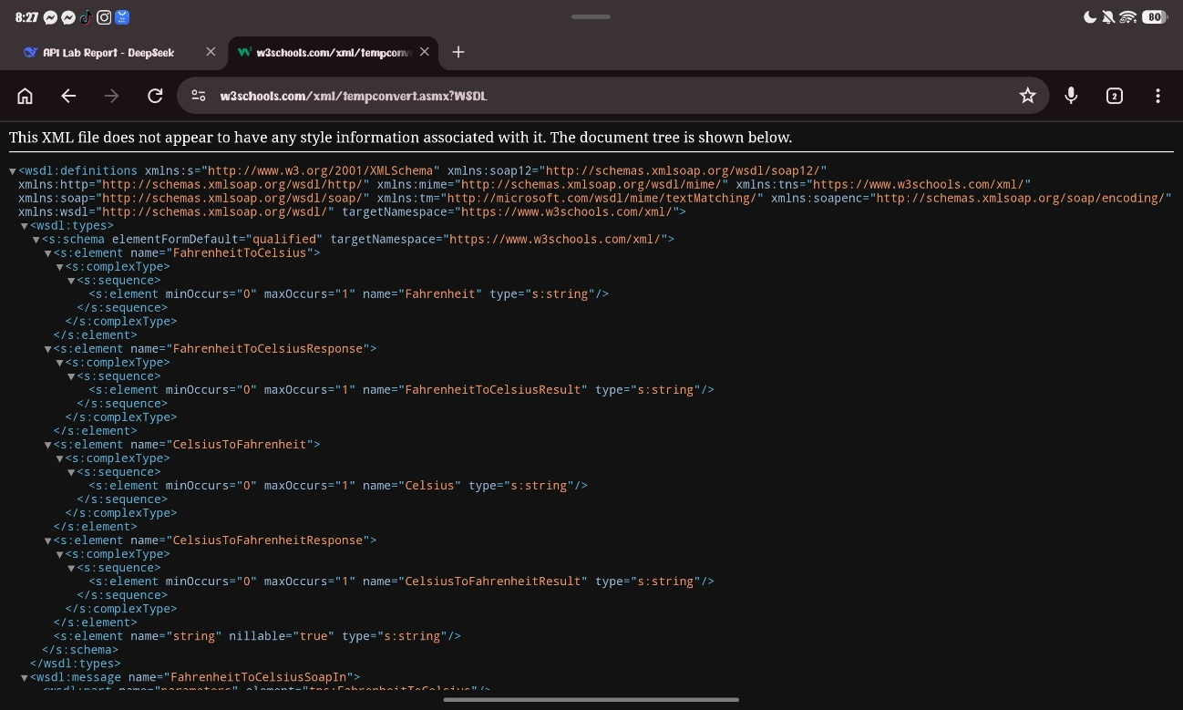
  - Input 100°C → Convert to Fahrenheit.
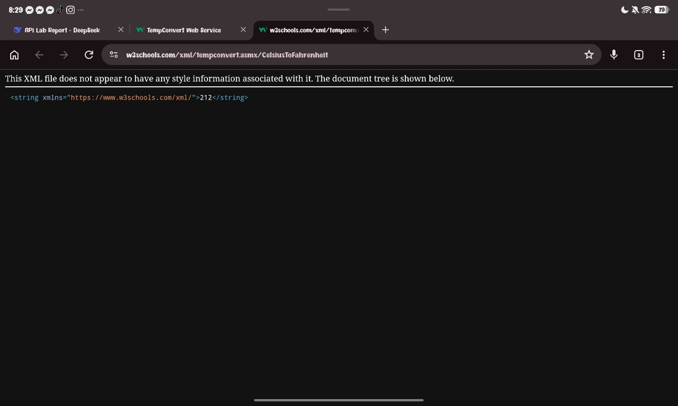
  - Input 212°F → Convert to Celsius.
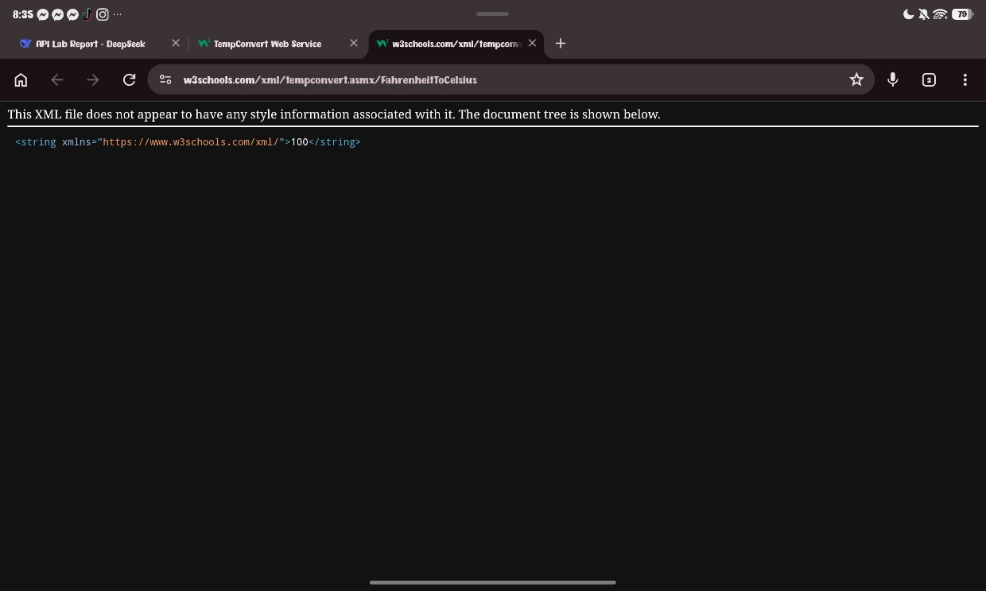

Reflection Questions:
  - How is the SOAP response structured compared to REST?
The SOAP response is structured very differently from a REST response. SOAP responses are wrapped inside a strict XML envelope with three main parts: the <soap:Envelope> (root element), the <soap:Header> (optional metadata such as authentication or routing), and the <soap:Body> (actual payload). Inside the Body, the response element matches the operation name, such as <CelsiusToFahrenheitResponse>, and contains the result, such as <CelsiusToFahrenheitResult>212</CelsiusToFahrenheitResult>. In contrast, a REST response is typically a plain JSON object or array without any mandatory wrapper. REST relies on HTTP status codes (200, 201, 404, 500) and HTTP headers to convey metadata, while SOAP embeds status and error information inside the XML body using a <soap:Fault> element when something goes wrong. REST is more direct, lightweight, and easier to read, while SOAP is more formal, verbose, and rigidly structured because it must follow the WSDL contract.
  - What format is used in SOAP messaging?
SOAP uses XML (eXtensible Markup Language) exclusively for all message exchange. Both requests and responses are XML documents that conform to the SOAP envelope specification. Every SOAP message includes an XML declaration, a SOAP envelope with defined namespaces, an optional Header, a required Body, XML namespaces to avoid naming conflicts, and a WSDL contract that defines the operations, messages, and data types. Unlike REST, which can return JSON, XML, HTML, or plain text, SOAP does not natively support JSON — it is strictly XML-based. This makes SOAP messages larger and slower to parse, but it provides strong typing, built-in error handling through SOAP Fault, and interoperability across heterogeneous platforms. SOAP is commonly used in enterprise systems such as banking, payment gateways, and telecommunications where security, transactions, and ACID compliance are critical.
Part 3: GraphQL Query Exploration
Run the following GraphQL query
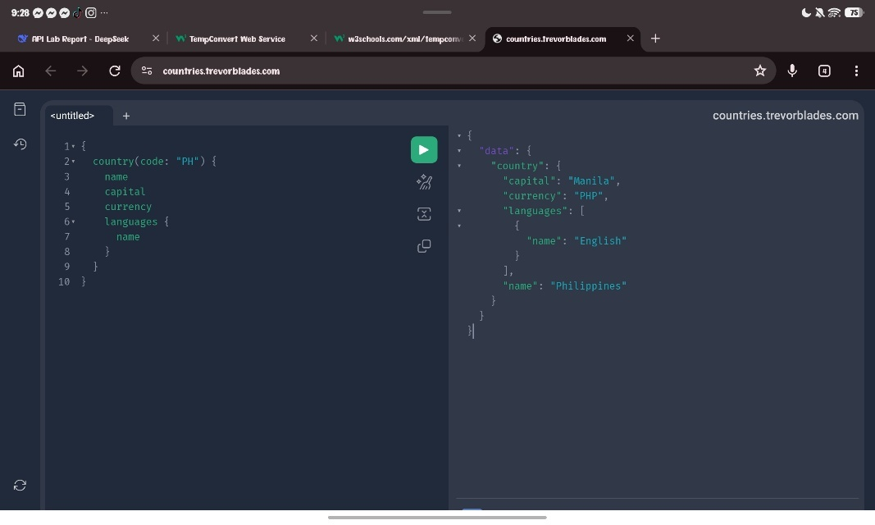
Modify the Query for Another Country - (Japan – JP)
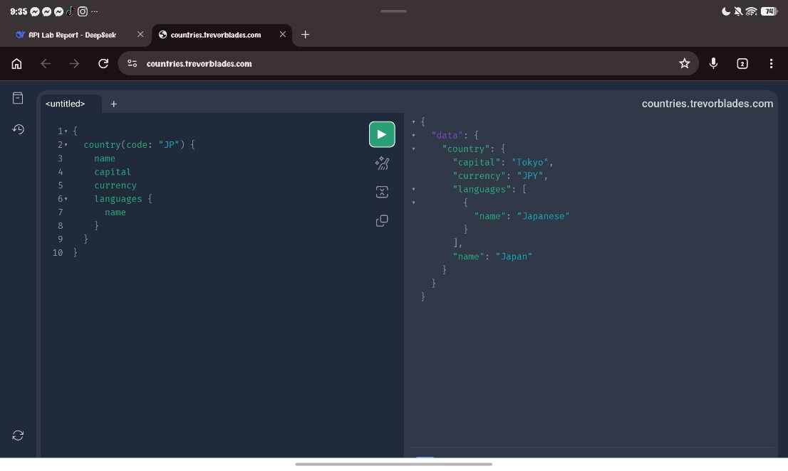
Part 3: GraphQL Reflection
- How does GraphQL give flexibility in choosing the data returned?
GraphQL gives flexibility by allowing the client to define the exact shape of the response. Unlike REST, where the server decides what data to return for each endpoint, GraphQL lets the client specify exactly which fields it needs — nothing more, nothing less. For example, in the Philippines query, I requested only name, capital, currency, and languages { name }, and the server returned exactly those fields. If I only needed name and capital, I could simply remove currency and languages from the query, and the response would be smaller. If I needed more data such as continent, phone, emoji, or states, I could add them to the same query without making additional requests. This flexibility eliminates two common problems in REST: over-fetching, where you get more data than you need, and under-fetching, where you do not get enough data and must make multiple requests. With GraphQL, a single query can retrieve nested data from multiple related resources, and the client has full control over the response structure.
- What are the main advantages you observed compared to REST?
The main advantages of GraphQL over REST that I observed are: first, precise data fetching — I got exactly the fields I asked for, with no extra data, which reduces payload size and improves performance especially on slow networks. Second, single endpoint — all queries go to one URL, unlike REST which requires different endpoints for different resources. Third, strongly typed schema — the GraphQL Playground provides autocomplete and validation, making it easy to discover available fields and types. Fourth, nested queries — I retrieved a country and its languages in one request, whereas REST might require two separate requests. Fifth, no versioning — new fields can be added to the schema without breaking existing queries, unlike REST which often requires versioning the API. Sixth, client-driven — the client decides what data it needs, which is ideal for modern front-end frameworks like React, Vue, and mobile apps. However, GraphQL also has limitations: it is more complex to set up on the server, caching is harder than REST, it always returns HTTP 200 even when there are errors, and it can be overkill for simple CRUD applications. In summary, REST remains simpler for basic operations, while GraphQL excels in complex, data-driven applications where flexibility and efficiency are critical.

Part 4: Comparative Analysis
Fill out the following table in your lab report:
Feature | REST | SOAP | GraphQL
Data Format | JSON | XML | JSON
Request Structure | HTTP methods (GET, POST, PUT, DELETE) + URL + headers/body; multiple endpoints | POST with SOAP envelope (Header + Body) + SOAPAction header; single endpoint; WSDL contract | POST with query language to single endpoint; client defines exact fields and nested data
Flexibility of Response | Fixed per endpoint; server decides fields; prone to over-fetching/under-fetching | Fixed by WSDL schema; client cannot modify response shape | Highly flexible; client chooses exact fields including nested objects; no over-fetching
Ease of Use (your POV) | Easy — intuitive HTTP methods, readable JSON, clear status codes | Moderate to difficult — verbose XML, rigid envelope, complex WSDL, special headers | Easy for queries; moderate for server setup; harder caching
Best Use Case Example | Public APIs, CRUD apps, microservices (JSONPlaceholder, Twitter API) | Enterprise systems with security/transactions (banking, payment gateways) | Complex data-driven UIs, mobile apps (GitHub API, Shopify, Countries API)

