Expected Annual Damage
Assessment Summary Report
Right Bank of Indus River — Sindh Province, Pakistan
Flood Risk Assessment under Climate Change Scenarios
Covering 9 Districts · 3 Maintenance Levels · 7 Return Periods

Umair Rabbani
April 2026

1. Executive Summary
This report presents the Expected Annual Damage (EAD) assessment for flood risk across 9 districts on the Right Bank of the Indus River in Sindh Province, Pakistan. The analysis integrates flood damage estimates across seven return periods (2.3 to 500 years) to produce a single annualized damage metric for each district and economic sector.
The assessment covers two climate scenarios (Present and Future) and three infrastructure maintenance levels (Breaches, Reduced Capacity, and Perfect Maintenance), resulting in six scenario combinations. Damage is quantified for four asset categories: Agriculture, Kacha (mud) buildings, Pakka (brick) buildings, and High-Rise structures.
Under the Present Climate with Breaches scenario, the total EAD across all districts is $1.92B. Under the Future Climate scenario, this increases to $2.09B, representing a 8.9% increase due to climate change impacts.
With Perfect Maintenance of flood infrastructure, the Present Climate EAD reduces to $1.86B, demonstrating the significant protective value of well-maintained embankments and flood control structures.

2. Methodology

2.1 Expected Annual Damage (EAD)
The Expected Annual Damage is a standard metric in flood risk assessment that represents the long-term average damage per year when considering all possible flood events. It is computed by integrating the damage-probability curve using the trapezoidal rule:
EAD = Σ 0.5 × (Dᵢ + Dᵢ₊₁) × |1/RPᵢ - 1/RPᵢ₊₁|
Where Dᵢ is the economic damage at return period RPᵢ. The formula calculates the area under the damage-frequency curve, where frequency (1/RP) represents the annual probability of exceedance.

2.2 Scenario Matrix
The analysis encompasses 42 individual flood scenarios organized as follows:
• 7 Return Periods: 2.3, 5, 10, 25, 50, 100, and 500 years
• 2 Climate Conditions: Present Climate and Future Climate (projected)
• 3 Maintenance Levels: Breaches (flood 2022 conditions), Reduced Capacity, and Perfect Maintenance

2.3 Asset Categories
Four categories of economic assets are evaluated:
• Agriculture: Crop areas exposed to flooding (measured in hectares)
• Kacha Buildings: Mud-walled residential structures
• Pakka Buildings: Brick/stone permanent structures
• High-Rise Buildings: Multi-story commercial and residential structures

2.4 Study Area
The study covers 9 districts along the Right Bank of the Indus River: Dadu, Jacobabad, Jamshoro, Kashmore, Larkana, Naushahro Feroze, Qambar Shahdadkot, Shaheed Benazirabad, and Shikarpur.

[Insert Study area map showing 9 districts here]

Figure: Study area map showing 9 districts

3. EAD by District

3.1 Present Climate
The following table presents the Expected Annual Damage for each district under Present Climate conditions, showing results for the Breaches maintenance scenario.
Dadu has the highest EAD at $721.19M, followed by Qambar Shahdadkot ($383.14M) and Jamshoro ($241.56M).
District | Agriculture | Kacha | Pakka | High-Rise | Total EAD
Dadu | $52.40M | $151.89M | $405.91M | $110.99M | $721.19M
Qambar Shahdadkot | $31.88M | $91.76M | $231.31M | $28.19M | $383.14M
Jamshoro | $22.32M | $48.14M | $132.35M | $38.76M | $241.56M
Shaheed Benazirabad | $20.85M | $29.51M | $73.16M | $9.64M | $133.15M
Jacobabad | $8.30M | $31.45M | $75.07M | $7.09M | $121.92M
Naushahro Feroze | $11.79M | $27.85M | $67.54M | $7.55M | $114.72M
Shikarpur | $1.60M | $4.59M | $10.77M | $3.18M | $20.15M
Larkana | $868K | $4.41M | $10.38M | $2.65M | $18.31M
Kashmore | $951K | $4.28M | $10.04M | $1.05M | $16.32M
TOTAL | $151.01M | $436.04M | $1.12B | $218.55M | $1.92B
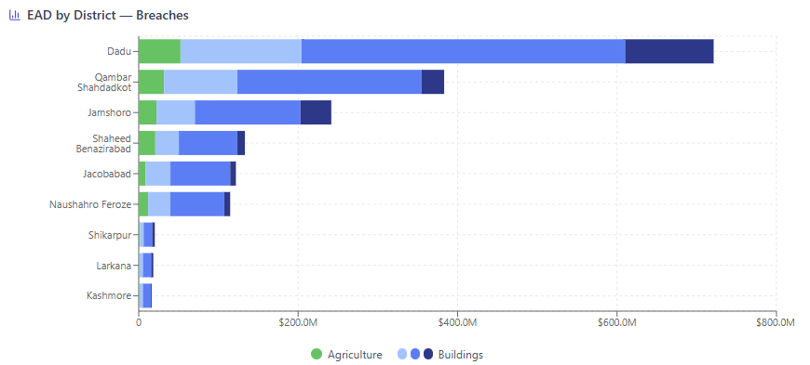
Figure: Bar chart — EAD by District (Present Climate, Breaches scenario)

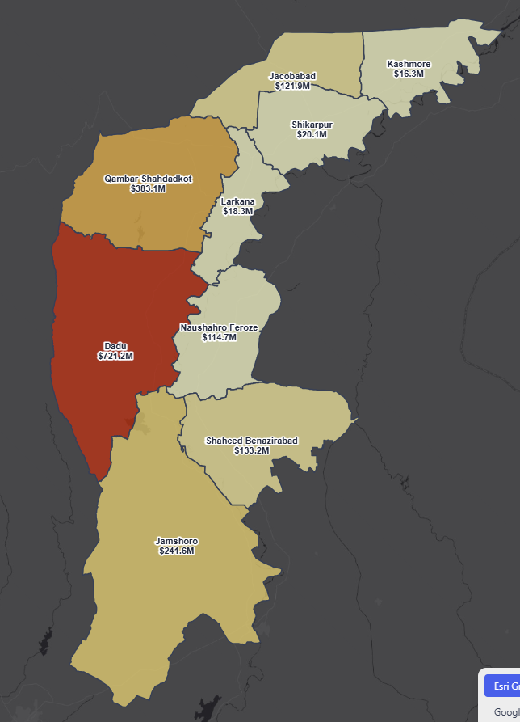
Figure: Choropleth map — EAD spatial distribution (Present Climate)

3.2 Future Climate
The following table presents the Expected Annual Damage for each district under Future Climate conditions, showing results for the Breaches maintenance scenario.
Dadu has the highest EAD at $808.13M, followed by Qambar Shahdadkot ($438.87M) and Jamshoro ($250.11M).
District | Agriculture | Kacha | Pakka | High-Rise | Total EAD
Dadu | $59.48M | $173.60M | $457.37M | $117.68M | $808.13M
Qambar Shahdadkot | $38.72M | $107.22M | $264.44M | $28.50M | $438.87M
Jamshoro | $23.01M | $50.34M | $137.47M | $39.29M | $250.11M
Shaheed Benazirabad | $21.05M | $30.06M | $74.14M | $9.53M | $134.78M
Jacobabad | $8.60M | $32.84M | $77.50M | $6.99M | $125.92M
Naushahro Feroze | $11.88M | $28.56M | $68.88M | $8.11M | $117.43M
Shikarpur | $1.70M | $5.10M | $11.96M | $3.69M | $22.45M
Larkana | $874K | $4.74M | $11.08M | $2.88M | $19.57M
Kashmore | $907K | $4.08M | $9.56M | $1.01M | $15.56M
TOTAL | $166.28M | $481.32M | $1.22B | $227.41M | $2.09B

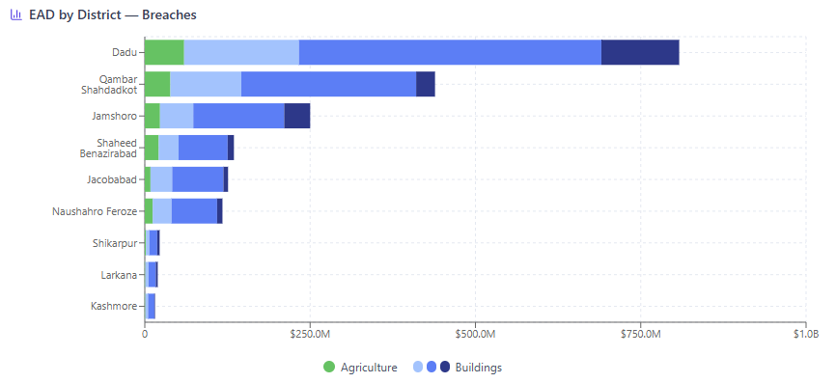
Figure: Bar chart — EAD by District (Future Climate, Breaches scenario)

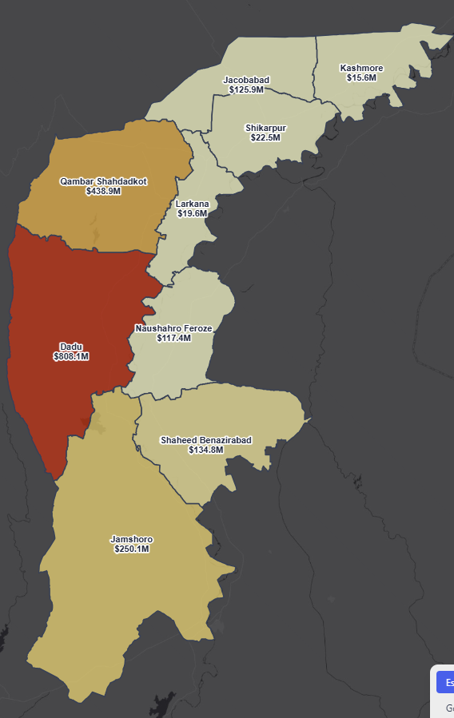
Figure: Choropleth map — EAD spatial distribution (Future Climate)

4. EAD by Sector

4.1 Sector Breakdown — Present Climate
This section disaggregates the Expected Annual Damage by economic sector across the three maintenance levels.
Table: EAD by Sector — Present Climate
Maintenance Level | Agriculture | Kacha | Pakka | High-Rise | Total
Perfect | $146.68M | $422.46M | $1.08B | $211.12M | $1.86B
Breaches | $151.01M | $436.04M | $1.12B | $218.55M | $1.92B
Reduced Capacity | $146.69M | $422.93M | $1.08B | $211.68M | $1.86B
With Perfect Maintenance, total EAD reduces by 3.1% compared to the Breaches scenario, from $1.92B to $1.86B.

4.3. Agriculture — Present Climate
The top three districts for Agriculture EAD are Dadu ($52.40M), Qambar Shahdadkot ($31.88M), and Jamshoro ($22.32M).

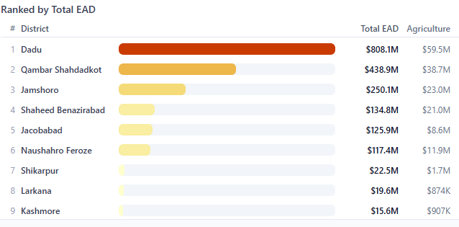
Figure: Chart — Agriculture EAD by District (Present Climate)

4.4. Buildings — Present Climate
The top three districts for Kacha EAD are Dadu ($151.89M), Qambar Shahdadkot ($91.76M), and Jamshoro ($48.14M). The top three districts for Pakka EAD are Dadu ($405.91M), Qambar Shahdadkot ($231.31M), and Jamshoro ($132.35M). The top three districts for High-Rise EAD are Dadu ($110.99M), Jamshoro ($38.76M), and Qambar Shahdadkot ($28.19M).
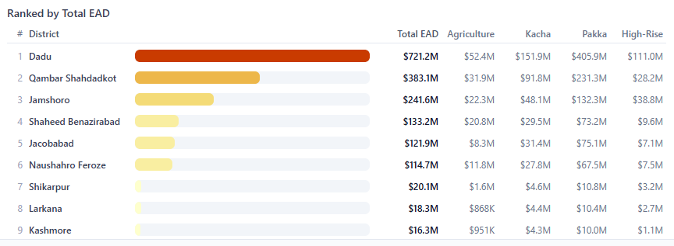
Figure: Chart — Agriculture and Buildings by District (Present Climate)

4.2 Sector Breakdown — Future Climate
Table: EAD by Sector — Future Climate
Maintenance Level | Agriculture | Kacha | Pakka | High-Rise | Total
Perfect | $161.62M | $467.46M | $1.18B | $221.86M | $2.03B
Breaches | $166.28M | $481.32M | $1.22B | $227.41M | $2.09B
Reduced Capacity | $161.34M | $466.17M | $1.18B | $220.89M | $2.03B
With Perfect Maintenance, total EAD reduces by 2.8% compared to the Breaches scenario, from $2.09B to $2.03B.

4.7. Agriculture — Future Climate
The top three districts for Agriculture EAD are Dadu ($59.48M), Qambar Shahdadkot ($38.72M), and Jamshoro ($23.01M).
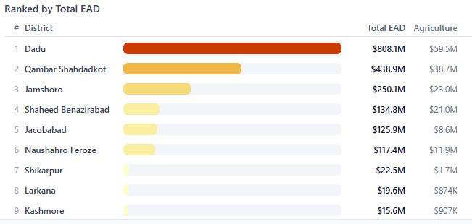
Figure: Chart — Agriculture EAD by District (Future Climate)

4.8. Buildings — Future Climate
The top three districts for Kacha EAD are Dadu ($173.60M), Qambar Shahdadkot ($107.22M), and Jamshoro ($50.34M). The top three districts for Pakka EAD are Dadu ($457.37M), Qambar Shahdadkot ($264.44M), and Jamshoro ($137.47M). The top three districts for High-Rise EAD are Dadu ($117.68M), Jamshoro ($39.29M), and Qambar Shahdadkot ($28.50M).

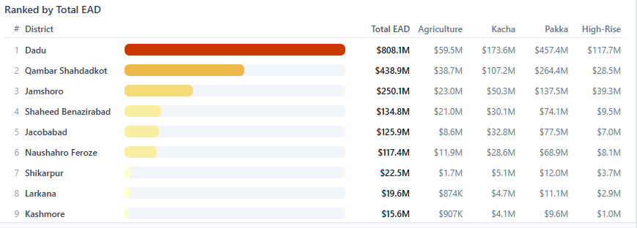
Figure: Chart —Buildings EAD by District (Future Climate)

5. Climate Change Impact on EAD
This section compares Present and Future climate EAD to quantify the impact of climate change on flood risk.
District | Present EAD | Future EAD | Change | % Change
Dadu | $721.19M | $808.13M | $86.94M | 12.1%
Qambar Shahdadkot | $383.14M | $438.87M | $55.74M | 14.5%
Jamshoro | $241.56M | $250.11M | $8.55M | 3.5%
Jacobabad | $121.92M | $125.92M | $4.01M | 3.3%
Naushahro Feroze | $114.72M | $117.43M | $2.71M | 2.4%
Shikarpur | $20.15M | $22.45M | $2.31M | 11.4%
Shaheed Benazirabad | $133.15M | $134.78M | $1.63M | 1.2%
Larkana | $18.31M | $19.57M | $1.26M | 6.9%
Kashmore | $16.32M | $15.56M | $-767641 | -4.7%
TOTAL | $1.92B | $2.09B | $170.31M | 8.9%

Overall, climate change is projected to increase total EAD by 8.9%, from $1.92B to $2.09B under the Breaches maintenance scenario. The most affected district is Dadu with a 12.1% increase.

6. Impact of Infrastructure Maintenance
This section evaluates how the condition of flood protection infrastructure affects annualized damage levels.

6.1 Present Climate
Table: EAD by Maintenance Level — Present Climate
District | Breaches | Reduced Capacity | Perfect | Reduction (B→P)
Dadu | $721.19M | $687.28M | $686.82M | 4.8%
Jacobabad | $121.92M | $121.87M | $121.86M | 0.0%
Jamshoro | $241.56M | $239.68M | $238.56M | 1.2%
Kashmore | $16.32M | $16.39M | $16.39M | -0.4%
Larkana | $18.31M | $18.32M | $18.33M | -0.1%
Naushahro Feroze | $114.72M | $114.69M | $114.69M | 0.0%
Qambar Shahdadkot | $383.14M | $361.81M | $360.98M | 5.8%
Shaheed Benazirabad | $133.15M | $133.15M | $133.08M | 0.1%
Shikarpur | $20.15M | $20.19M | $20.19M | -0.2%

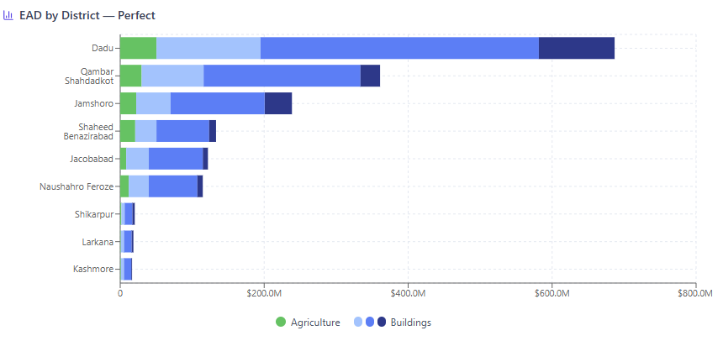
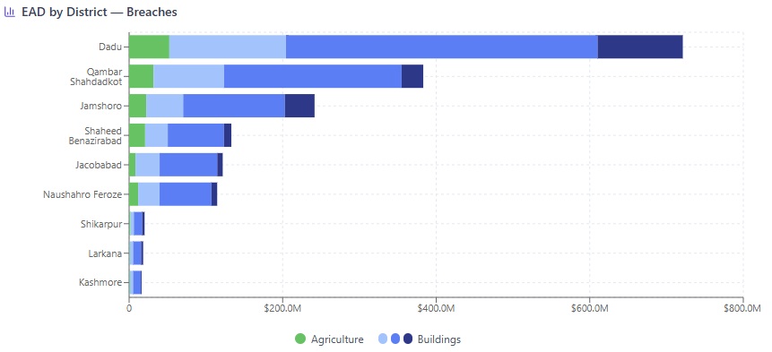
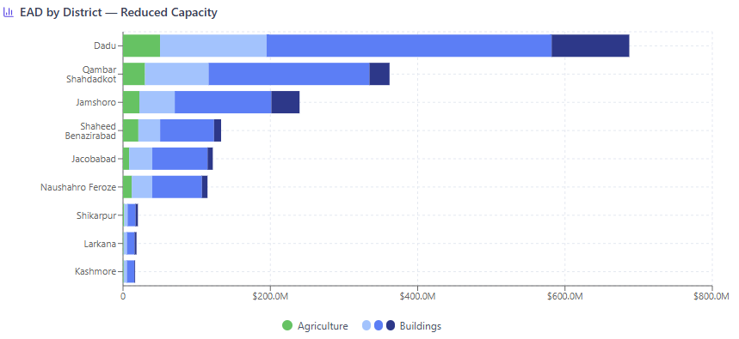
Figure: Grouped bar chart — EAD by Maintenance Level (Present Climate)

6.2 Future Climate
Table: EAD by Maintenance Level — Future Climate
District | Breaches | Reduced Capacity | Perfect | Reduction (B→P)
Dadu | $808.13M | $777.32M | $782.52M | 3.2%
Jacobabad | $125.92M | $125.90M | $125.98M | -0.0%
Jamshoro | $250.11M | $248.16M | $248.78M | 0.5%
Kashmore | $15.56M | $15.59M | $15.63M | -0.5%
Larkana | $19.57M | $19.59M | $19.62M | -0.2%
Naushahro Feroze | $117.43M | $117.46M | $117.50M | -0.1%
Qambar Shahdadkot | $438.87M | $406.78M | $406.67M | 7.3%
Shaheed Benazirabad | $134.78M | $134.93M | $135.05M | -0.2%
Shikarpur | $22.45M | $22.47M | $22.49M | -0.1%

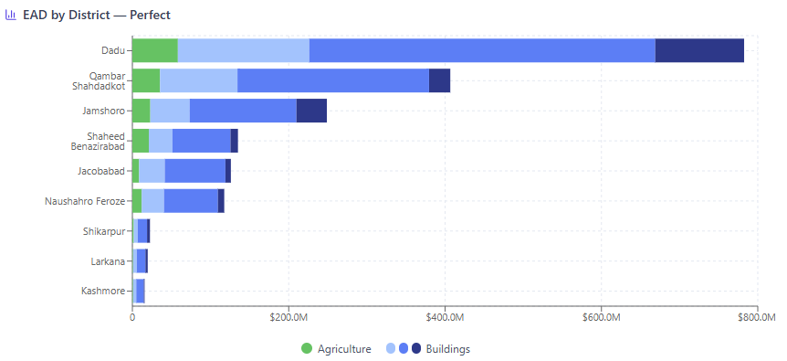
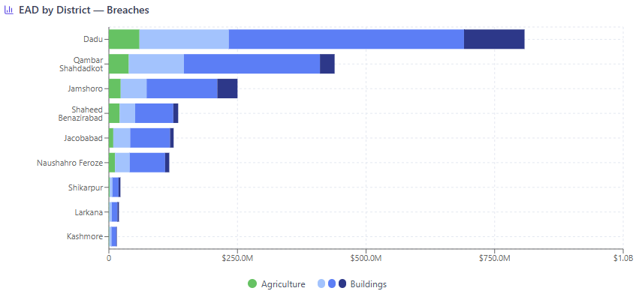
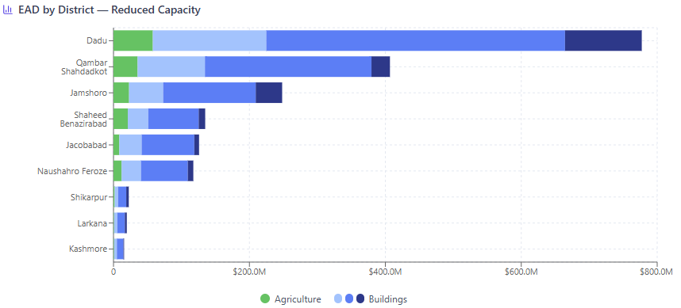
Figure: Grouped bar chart — EAD by Maintenance Level (Future Climate)

7. Conclusions
The Expected Annual Damage assessment reveals several key findings:
1. The total EAD for the Right Bank of Indus River study area ranges from $1.86B (Present Climate, Perfect Maintenance) to $2.09B (Future Climate, Breaches), underscoring the critical role of both climate adaptation and infrastructure maintenance in managing flood risk.
2. Dadu consistently experiences the highest EAD across all scenarios, indicating it should be the primary focus of risk reduction investments.
3. Climate change is projected to increase flood damage by approximately 8.9%, emphasizing the need for forward-looking flood management strategies.
4. Maintaining flood infrastructure in perfect condition can reduce EAD by approximately 3.1% under Present Climate conditions, demonstrating the high return on investment in infrastructure maintenance.
5. Agriculture constitutes the largest share of damage in most districts, followed by Pakka (brick) buildings. This suggests that crop insurance and building code improvements should be prioritized in flood risk management plans.

