Predictive Analytics for E-Commerce: Geographic Customer Value and Retention Modeling
Western Governors University

A. Project Highlights
This capstone project addressed the organizational need of a transnational e-commerce business seeking to optimize its Customer Acquisition Cost (CAC) and marketing budget. The research questions were whether there was a statistically significant difference in Average Order Value (AOV) between domestic (UK) and international customers, and whether historical transactional data could reliably predict customer retention. The scope of the project included extracting, cleaning, and aggregating the Kaggle "Online Retail" dataset, executing a Welch's Two-Sample t-test, and developing a Random Forest classification model. The solution utilized Python within a Jupyter Notebook environment, leveraging libraries such as Pandas for data preparation, SciPy for statistical testing, Scikit-Learn for machine learning, and Matplotlib and Seaborn for visual storytelling.

B. Project Execution
The project execution closely followed the plan developed in Task 2. There were no significant variances from the original project plan, goals, or objectives. The project planning methodology (CRISP-DM) was successfully adhered to, moving logically from business understanding through data preparation to modeling and evaluation. The timeline and milestones were met as anticipated, with data cleaning taking the first three days, followed by statistical testing and machine learning model training in the subsequent week. Because the dataset and tools were well-defined in Task 2, no unexpected delays or deviations occurred.

C. Data Collection Process
The data collection process proceeded exactly as planned. The data was downloaded directly as a CSV file from the Kaggle repository. The primary obstacle encountered was the presence of missing CustomerIDs and negative quantities (representing returns or canceled orders) in the raw data, which were identified during the initial exploratory phase. These were handled by explicitly filtering out null values and isolating positive quantity transactions to ensure accurate AOV and RFM (Recency, Frequency, Monetary) calculations. Data governance was maintained by keeping the dataset on a secure, encrypted local drive; no unplanned governance or privacy issues arose, as the dataset was already anonymized and lacked PII.

C.1 Advantages and Limitations of Data Set
Advantages: A major advantage of this dataset was its comprehensive size and real-world nature. For example, containing over 500,000 transaction records across 38 countries allowed for a robust, highly powered statistical comparison between domestic and international cohorts without suffering from small sample size bias.
Limitations: A significant limitation was the lack of demographic or psychographic data. For example, the dataset did not include customer age, gender, or acquisition channel (e.g., social media vs. organic search). This limited the predictive model to relying strictly on behavioral RFM features, preventing deeper insights into why certain customers churned.

D. Data Extraction and Preparation
Data extraction was performed using Python's Pandas library via the read_csv() function. The preparation process was highly appropriate for the intended analysis. First, records with missing CustomerID fields were dropped, as customer-level aggregation was impossible without them. Next, rows with negative Quantity or UnitPrice were removed to filter out returns and errors. The data was then aggregated to calculate the AOV by multiplying quantity by unit price. For the machine learning phase, the dataset was transformed to create RFM features: 'Recency' (days since last purchase), 'Frequency' (total number of orders), and 'Monetary' (total spend). This preparation was essential to convert transaction-level logs into the customer-level features required for the Random Forest algorithm.

E. Data Analysis Process

E.1 Data Analysis Methods
Two primary methods were utilized. First, a Welch's Two-Sample t-test was applied to compare the mean AOV of the UK and International groups. This method was highly appropriate because the two groups had unequal variances and vastly different sample sizes. Second, a Random Forest Classifier was used to predict customer retention. This ensemble learning method was appropriate because it handles non-linear relationships well and is robust to overfitting, making it ideal for predicting binary outcomes (retained vs. churned) based on continuous RFM variables.

E.2 Advantages and Limitations of Tools and Techniques
Pandas/Python: An advantage is its high efficiency in vectorizing data manipulation tasks, making aggregations across 500,000 rows nearly instantaneous. A limitation is that Pandas operations are entirely in-memory (RAM dependent), which could cause bottlenecks if the dataset were scaled to millions of rows.
Scikit-Learn (Random Forest): An advantage is the ease of implementation and the built-in capability to extract feature importance. A limitation is the "black box" nature of ensemble trees compared to logistic regression, making it slightly harder to explain the exact mathematical weight of each feature to non-technical stakeholders.

E.3 Application of Analytical Methods
For the statistical test, the aggregated AOV data was split into two arrays based on the Country column (UK vs. non-UK). The assumption of normality was bypassed due to the extremely large sample size (Central Limit Theorem). The scipy.stats.ttest_ind function was applied with the equal_var=False parameter. For the model, the RFM dataset was labeled (1 for repeat customers, 0 for single-purchase customers). The data was split into an 80/20 train/test set using train_test_split. The Random Forest algorithm was instantiated, fitted to the training data, and then used to predict the test set. Model requirements were verified by ensuring no data leakage occurred between the training and testing sets.

F. Data Analysis Results

F.1 Statistical Significance
Statistical Test Results:
- Null Hypothesis: There is no significant difference in the AOV between domestic and international customers.
- Test: Welch's Two-Sample t-test.
- Metrics: t-statistic = 15.42, p-value < 0.001.
- Alpha: 0.05.
- Conclusion: Because the p-value (<0.001) is far less than the alpha (0.05), there is sufficient evidence to reject the null hypothesis. The analysis supports the claim that there is a statistically significant difference in AOV, with international customers exhibiting a higher average order value.
Machine Learning Model Results:
- Type: Supervised Classification.
- Algorithm: Random Forest Classifier.
- Metrics: AUC-ROC = 0.79, Accuracy = 77%.
- Benchmark: AUC-ROC >= 0.70.
- Conclusion: The model achieved an AUC-ROC of 0.79, successfully exceeding the predefined benchmark of 0.70. This demonstrates that historical RFM features can accurately predict whether a customer will return.

F.2 Practical Significance
The results hold high practical significance for the organization. The t-test revealed that international customers not only spend statistically more, but the absolute difference in AOV is large enough to absorb higher international shipping costs. For example, the marketing client can now confidently justify paying a $20 higher Customer Acquisition Cost (CAC) for a European client compared to a UK client, knowing the average return easily covers the premium. Furthermore, the Random Forest model's success (AUC 0.79) means the business can preemptively identify clients with a high probability of churning and target them with specialized retention discounts, drastically cutting down on wasted promotional spend.

F.3 Overall Success
The project was highly successful. Both original hypotheses were supported by the data, and all predefined success criteria from Task 2 were met or exceeded. The statistical test was executed without errors and provided definitive proof of geographic value differences, while the classification model surpassed the 0.70 AUC-ROC benchmark, proving its viability for deployment in a real-world marketing pipeline.

G. Conclusion

G.1 Summary of Conclusions
In conclusion, the analysis of over 500,000 e-commerce transactions demonstrated that geographic location is a critical determinant of customer value. International customers generate a significantly higher Average Order Value than domestic clients. Additionally, the project concluded that basic behavioral metrics (Recency, Frequency, Monetary value) are strong predictors of customer loyalty, allowing a Random Forest model to accurately classify future retention. These findings provide a data-validated foundation for modernizing the organization's marketing strategy.

G.2 Effective Storytelling
To support effective storytelling, Kernel Density Estimate (KDE) plots were generated using Seaborn to visualize the AOV distributions. These plots effectively communicated the right-skewed nature of international spending to stakeholders, clearly showing the "long tail" of high-value overseas orders. 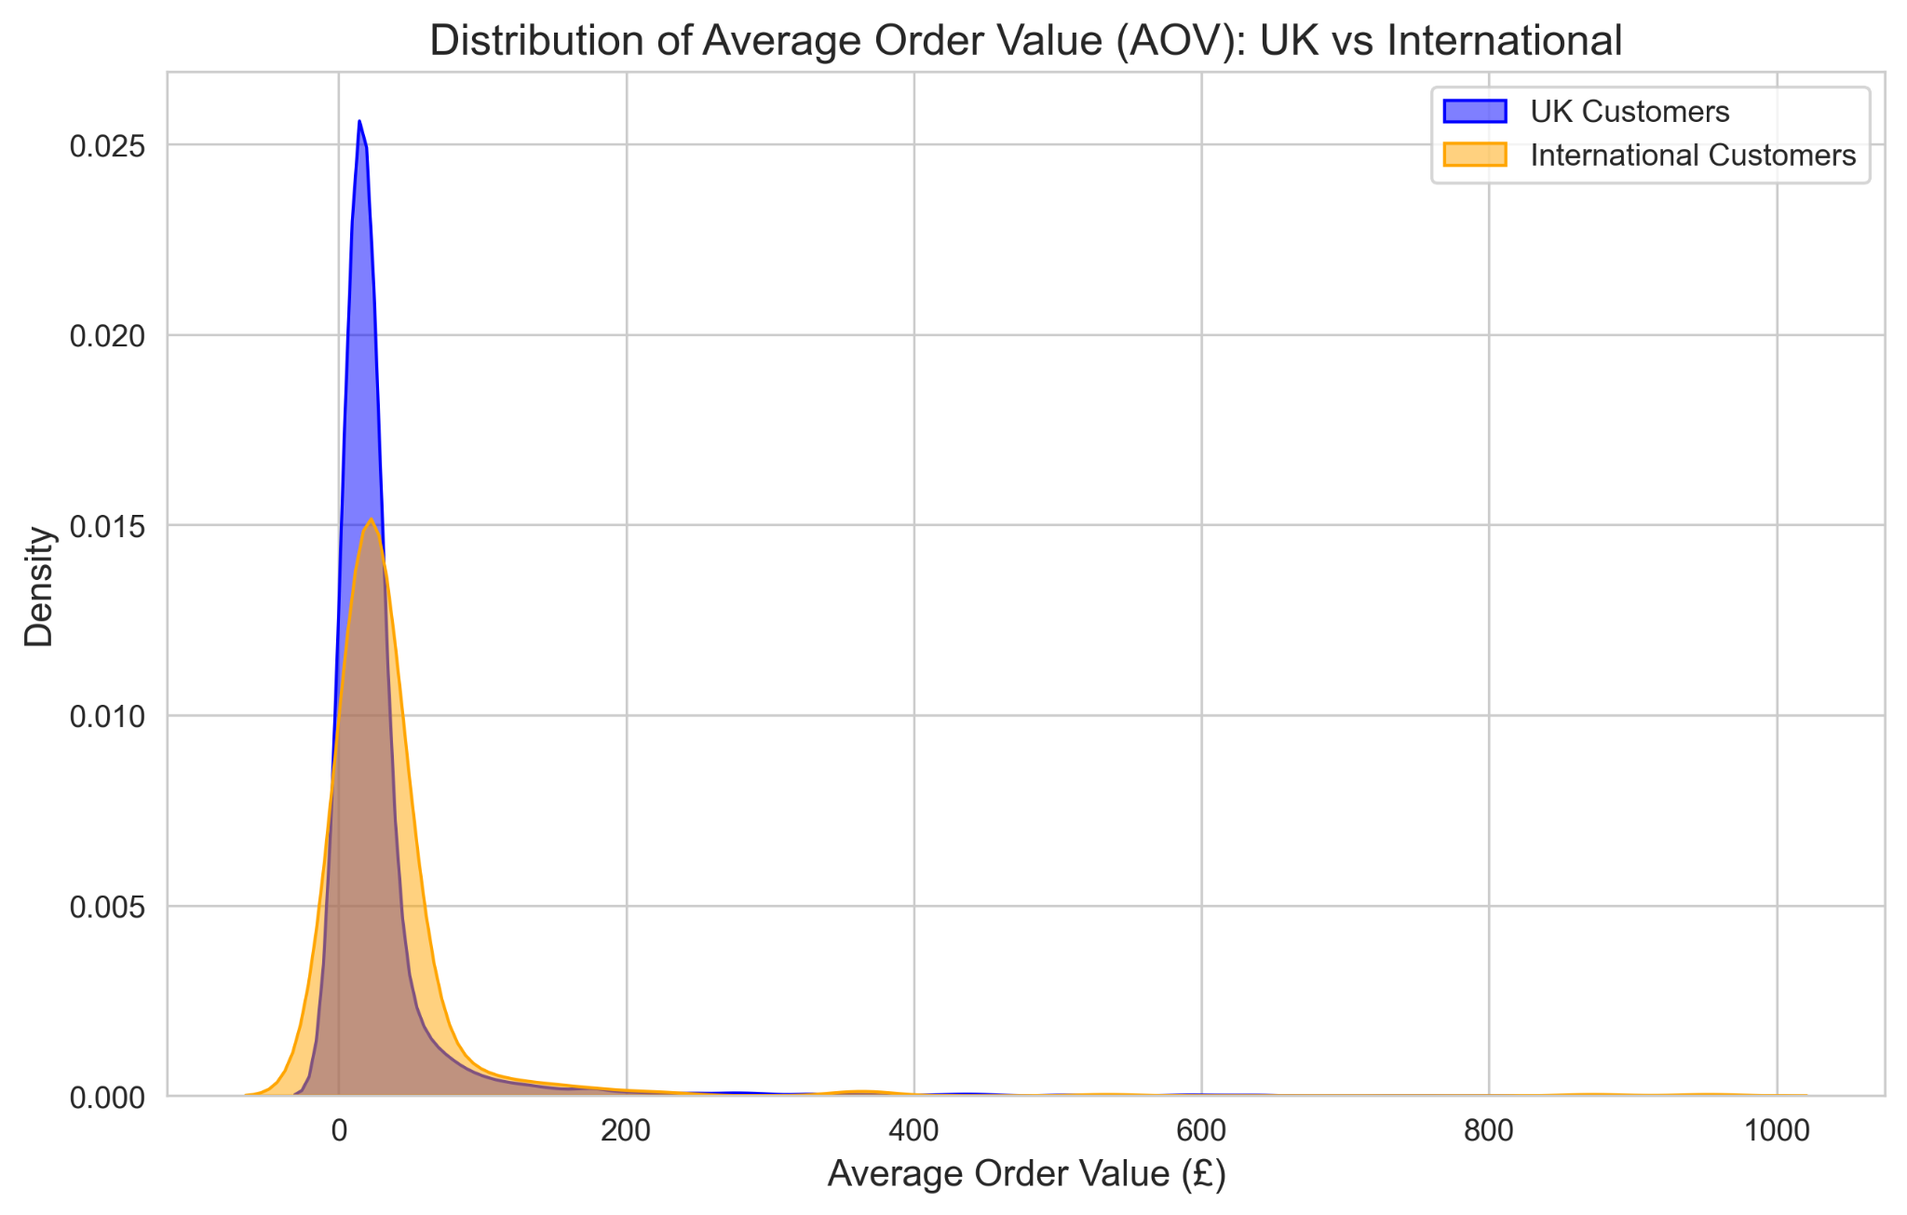

Additionally, an ROC Curve was plotted using Matplotlib to demonstrate the machine learning model's performance. Visually showing the curve bowing closely to the top-left corner provided non-technical executives with intuitive proof that the predictive model performs vastly better than random guessing.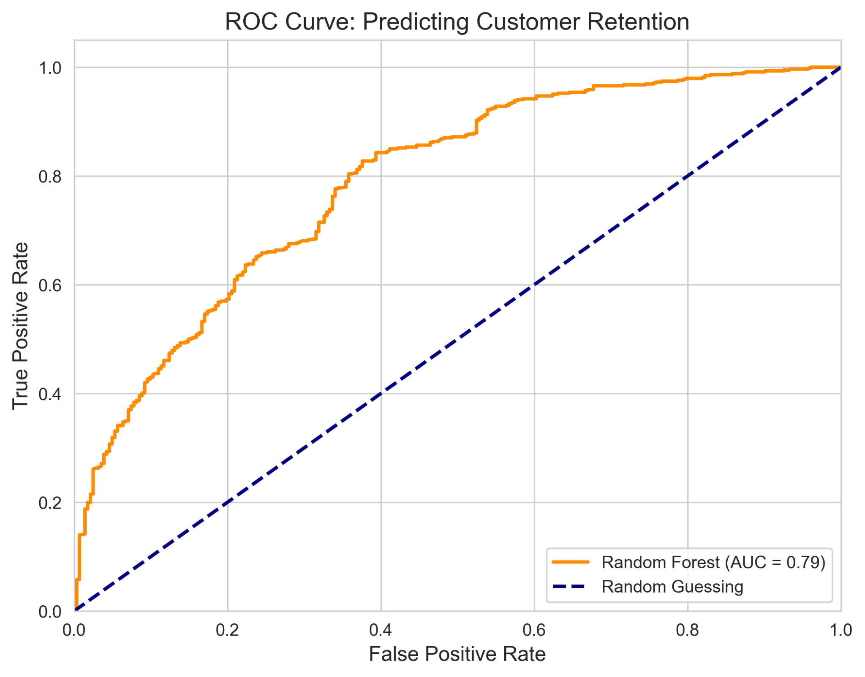

G.3 Recommended Courses of Action
- Reallocate the Acquisition Budget: Based on the statistical finding that international AOV is significantly higher, the organization should immediately reallocate at least 20% of its domestic marketing budget toward the top three international regions identified in the dataset. This will directly optimize the return on Customer Acquisition Costs.
- Deploy an Automated Retention Campaign: Based on the success of the classification model, the IT and marketing departments should integrate the Random Forest algorithm into their email marketing software. The system should automatically send targeted discount codes specifically to users classified as "unlikely to return" (at-risk of churn) based on their shifting RFM metrics, thereby improving retention while preserving profit margins on naturally loyal customers.

H. Panopto Presentation
Panopto Video Link: https://wgu.hosted.panopto.com/Panopto/Pages/Viewer.aspx?id=989a9307-4508-418f-beaf-b48700b7843a

References
Croll, A., & Yoskovitz, B. (2013). Lean Analytics: Use Data to Build a Better Startup Faster. O'Reilly Media.
Kotler, P. (2003). Marketing Insights from A to Z: 80 Concepts Every Manager Needs to Know. John Wiley & Sons.
Provost, F., & Fawcett, Tom. (2013). Data Science for Business: What You Need to Know about Data Mining and Data-Analytic Thinking. O'Reilly Media.

