Exercises

Basic Programming Exercise:

A bit of programming
Connect your ESP32 to the PC using the micro USB cable and start thonny. Locate the shell window and check if you see the PEPL prompt ">>>". If not, try to press <enter>. Make sure the shell window has the input focus. If this does not work, press the stop button. If this also doesn't help, press the reset button on the ESP32 CPU board.

Playing with REPL
print("Hello World!")
calculate 127.9 * 157.6 * 17.2 /(3.5*2**4) # 2**4 means 2 to the power of 4
you may try to calculate e.g 2**4 separately first and check that you get the result expected
Continue experimenting with REPL

Hello World
Instead of working on the shell window, we will now write a Python script (a small program). For this to work, select File -> New. This will create an editor window named <untitled>. Save this empty program to the disk on your PC. Select File -> Save, select "This Computer" give it a file name (e.g. hello.py) and press "OK". The window title changes to hello.py.

Now enter
print("Hello World!")
Finally, run the program by pressing the green button with the white triangle. You should see "Hello World!" printed in the shell window. This is what you should get:

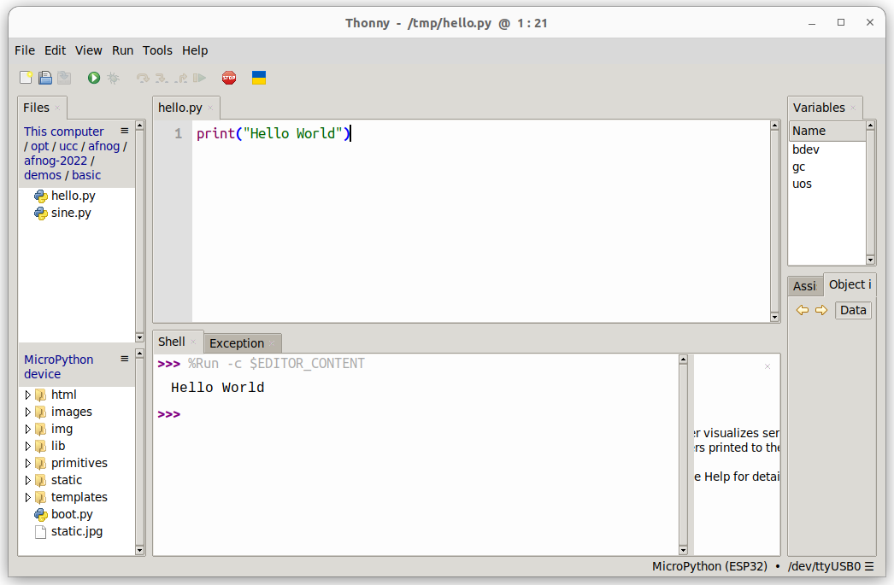

Some Arithmetic
Assign 2 values to 2 variables a and b. Calculate the sum, the difference, the product and the division and print the results. Start assigning integer values. Try integer and float division.

Then assign float values and try again.

Conditions
Assign again values to two variables a and b with a being bigger than b . In your program, check if a is equal, bigger or smaller than b. Modify the values you assign to a and b, with b now bigger than a and try again.

In the lectures, we used the "<" and the ">" conditions to find out if the value in the variable a is bigger, smaller or equal to the value in variable b. Can you modify the program using "<" and "!=" to find out?

What happens if you try:
if a:
print("yes")
else:
print("No")
Try this with a being assigned to zero and a being assigned to 7. What do you conclude?

Loops
Write a script that prints "Hello World!" forever. You can stop the program with the red Stop button.

Write a program that prints "Hello World!" 7 times. Do this using a while loop and in a second program, using a for loop, Which of the programs is more elegant?

Too easy? Try to calculate the Fibonacci numbers
The Fibonacci numbers are defined as follows:
- F(0) = 0
- F(1) = 1
- F(n) = F(n-1) + F(n-2)
Write a program that prints the Fibonacci series of numbers for n=10, n=20, n=30.

This is the end of the first exercise session

Exercises on Functions and Modules

MicroPython modules
Modify the loop program in such a way that "Hello World!" is printed only every second. Import the utime module and make the program sleep for 1s after each print statement.

Import the sin function and the value of pi from the math module

from math import sin,pi
Remember that the sin function takes its values in units of radians. The angle values for a complete sin period will range 0 .. 2*pi. Print the angles and the sin values for a full sin period using 30 equidistant angle values. (x and sin(x)).

Creating and using your own function
Create a sin_deg function which takes angles in units of degrees instead of radians. Print the angles and the sin values for 36 equidistant angle values.

You may copy/paste the result to a new editor window in thonny and save them to a file on the PC. Then you can plot the function using gnuplot.

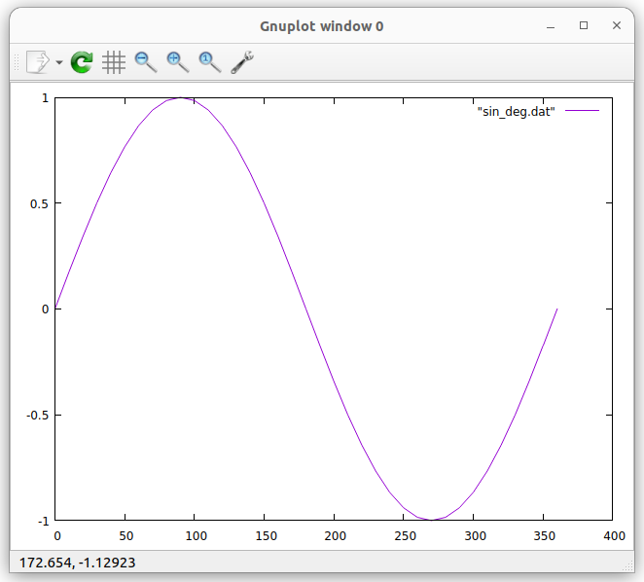

Too easy? Calculate the throwing parabola
If the above is too simple for you, you may try to calculate the throwing parabola. Let's say, a stone is thrown at a speed of 30m/s and an angle of 30° with respect to ground. Calculate the trajectory of the stone until it hits the ground. You way define a function trajectory, taking initial speed, the angle and the time resolution for which you want to calculate the stone positions.
v_hor = v_initial * cos(angle)
v_ver = v_initial * sin(angle)
x(t) = v_hor * t
y(t) = v_ver * t - 1/2 * g * t**2
Like this, you can easily calculate the trajectories for different angles and different initial speeds. Use a time resolution of 0.1 ms to get enough curve points.
In the plot below an initial speed on 30 m/s is assumed. Tp_10 shows the trajectory for an angle of 10 degrees.
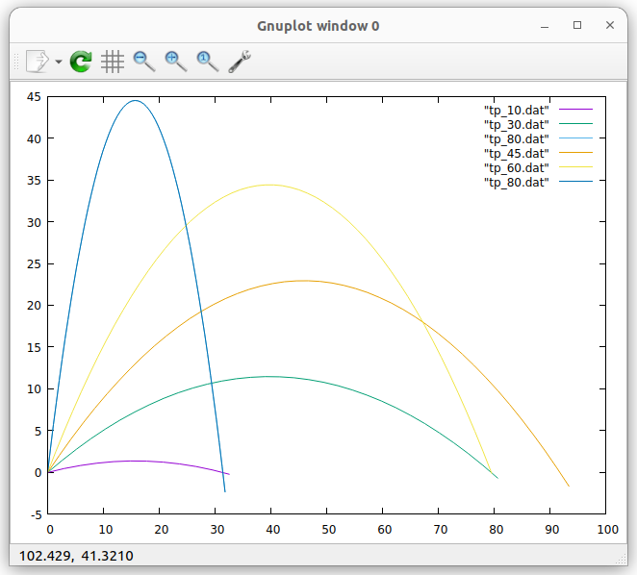
Improving the program
This program can further be improved by plotting the same number of points for each parabola. To achieve this, we can first calculate the total flight duration until the object hits the ground again:
vt = 1/2*g*t**2, v => 1/2*g*t, t= 2*v/g
v is the vertical speed in this case.
Then we calculate a fixed number of points (e.g. 50) for each parabola in a for loop.
Like this, we can easily see that for an angle of 30° and 60° the distance covered is the same. This is also true for 10° and 80° or 20° and 70°.
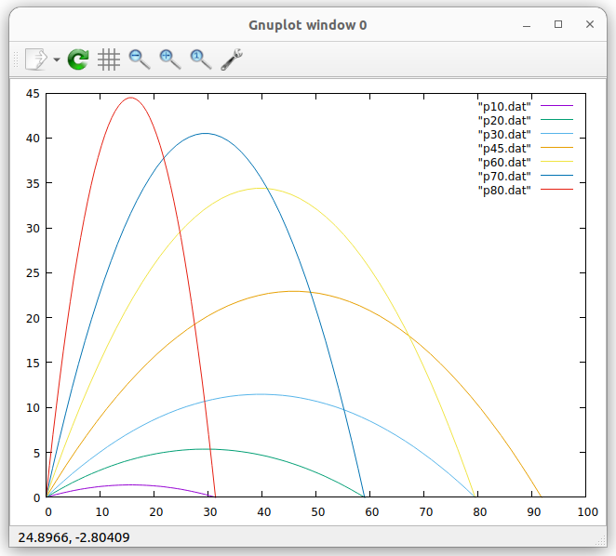
End of the second exercise session

Exercises with GPIO, the Pushbutton and LEDs

Programming the user LED on the CPU card
Switch the LED on and off using the REPL (the shell window of thonny)
Write a program that blinks the user programmable LED on the CPU card at a frequency of 1 Hz (500 ms on, 500 ms off)
The user LED on the CPU card is connected to GPIO 2.

Write a function that blinks the LED once with a delay that is passed as a parameter:

def blink_once(delay):
Test the function with a main program calling is with different delays.

Use the function to implement a program that blinks an SOS: 3 short pulses, followed by 3 long pulses, followed by 3 short pulses, followed by a 2s pause. You may use a 200 ms delay for the short pulses and 700 ms delay for the long ones.

Reading the pushbutton
Plug the pushbutton shield into the triple base.
Write a program that reads the push button state ever 100 ms and prints its state (pressed or released). The push button is connected to GPIO 17.

Improve the program printing the state only when there was a state change.

Too easy? Change the light intensity on the LED using PWM
Write a program that linearly increases the light intensity of the user programmable LED using Pulse Width Modulation ( PWM).
End of the third exercise session

Exercises with Analogue Signals and NeoPixels

Reading an analogue signal level from the slider potentiometer
Read the documentation of the ADC driver in the MicroPython manual
Connect the potentiometer to the triple base according to this table:
Potentiometer | Triple Base
OTA | A0 (ADC) GPIO 36
VCC | 3V3
GND | GND

Create an ADC object and make sure you set the attenuator to 11 dB
Read the slider value every 100 ms and print its raw 12 bit value.
Move the slider and observe the changes in the value

Controlling the rgb LED ring
The LED ring consists of 7 WS2812B addressable and cascadable LEDs. Each rgb LED consists of 3 tiny single color LEDs emitting red, green and blue light. The color you finally see is the mixture between these color components. The MicroPython driver for this type of LED is called NeoPixel. ￼The color is defined as a tuple with three 8 bit color component intensities. 8 bits means that you can have values in the range 0..255. Since the LEDs are extremely bright, please restrict the values to 0..31.

Write a program trying to find out to which LED an LED number corresponds to. Where on the LED ring is LED0, LED1 ... Do this by lighting the LEDs one by one with only the red color component switched on. The green and blue are set to zero.
Create a mapping table such that the first LED is mapped to the top one, the following LEDs are addressed clockwise and the last LED is the middle one.

Then change the color. Try all color combinations (31,0,0), (0,31,0), (0,0,31) but also (31,31,0), (31,0,31) ... Which colors do you get?

You can further modify the colors by changing the intensity values. For example: (12,27,5) Play around trying to generate as many different colors as you like.

Write a program that lights the top LED in blue and then lights the following LEDs in clockwise direction to :

- blue (top LED)
- cyan
- green
- yellow
- magenta
- red
- the middle LED becomes white

Too easy? Program the Color Wheel
Write a program that shows all the colors of the color wheel on the LEDs of the rgb LED ring. The color on the LEDs will slowly change from red to yellow to green … to magenta to red.

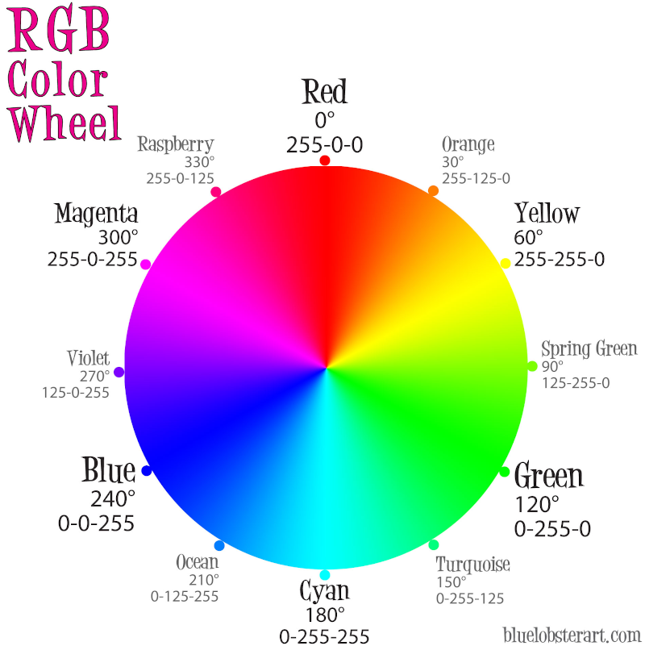
A small project
As a small project, we are going to combine the reading of the ADC and the control of the rgb LED ring. As we saw, the ADC delivers values between 0 and 4095 (12 bits). We can divide this range in 7 slices, corresponding to the 7 LEDs in the ring. For the lowest slice, the top LED will be lit. Then we go clockwise around the ring: the next LED lit will be to the right of the first one. For the highest slice, the middle LED will be lit.
First, print the led number for the signal level read from the slider. Move the slider and make sure that you get the correct LED number.
Then light the LED you found with a single color, e,g, red.
Very often, the color indicates the signal level: For low signal levels, we use "cold" colors (blue, cyan) for higher levels we use "hot" colors (magenta, red, white). The color for the top LED will therefore be blue, the color for the middle LED will be white.

We can then attribute a different color to each LED, as the lighting of the LED depends on the signal level reached. We only use the basic colors:

LED number color
1 blue (0,0,31)
2 cyan (0,31,31)
3 green … you find the others
4 yellow
5 magenta
6 red
0 white
The top LED (lowest signal level) will therefore have the color blue, while the middle LED (highest signal level) will become white.
Light the LED with the color corresponding to the signal level.

Exercises of the I2C bus

Finding I2C addresses
Connect the BMP180 temperature and air pressor sensor to the WeMos D1 mini bus.
Find the addresses of all I2C slaves connected to the bus and print them. Use the ESP32 hardware interface of the I2C bus connected to bus no. 1. The I2C interface uses the following pins:
 | Bus number | SCL | SDA
 | 1
GPIO |  | 22 | 21

You can find the MicroPython functions to be used with the I2C bus on https://docs.micropython.org/en/latest/esp32/quickref.html#hardware-i2c-bus and
https://docs.micropython.org/en/latest/library/machine.I2C.html#machine.I2C
i2c.scan returns an address list of all I2C slaves found on the bus. With just the SHT30 connected you should see:
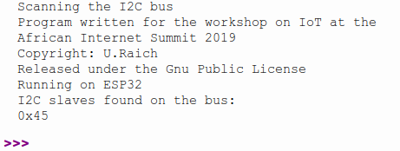
I found this program very useful because each time an I2C interface is tested we need to make sure that the device is actually seen by our program. Try to improve the formatting of the program to print all I2C addresses in a table:
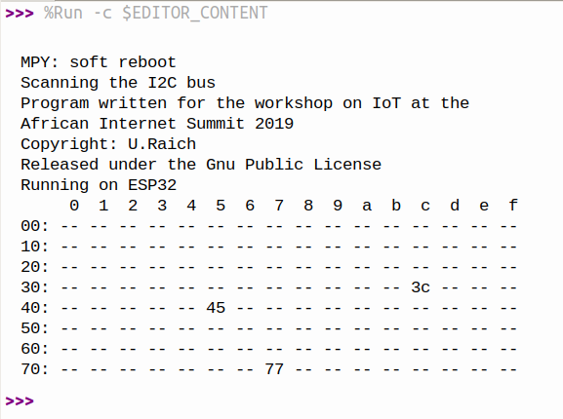

Exercises on the SSD1306 display driver and the 128x64 pixel OLED display
Instead of reading and writing the SSD1306 registers directly, we will rely on a software module, the SSD1306 class, which is already included in the MicroPython firmware. In fact the SSD1306 class is a sub-class of framebuf (https://docs.micropython.org/en/latest/library/framebuf.html) and inherits all its methods. The SSD1306 class does not write into the display's pixel memory directly but uses a memory buffer on the ESP32 RAM having the same size as the display. The SSD1306 documentation (https://docs.micropython.org/en/latest/esp8266/tutorial/ssd1306.html) shows how to use the driver and also provides simple example code. Just remember that on our ESP32, SCL is connected to GPIO 21 and SDA to GPIO 22.
- Modify the example code correspondingly and try the "Hello World!" example.
- Then copy/paste the example code showing the MicroPython logo and some text.
- Try the graphics primitives to draw lines, rectangles, circles, text, triangles (there is no primitive to draw triangles but you can easily draw them by drawing 3 lines). You may also experiment with filling these graphics elements.
Here is how the result may look like:
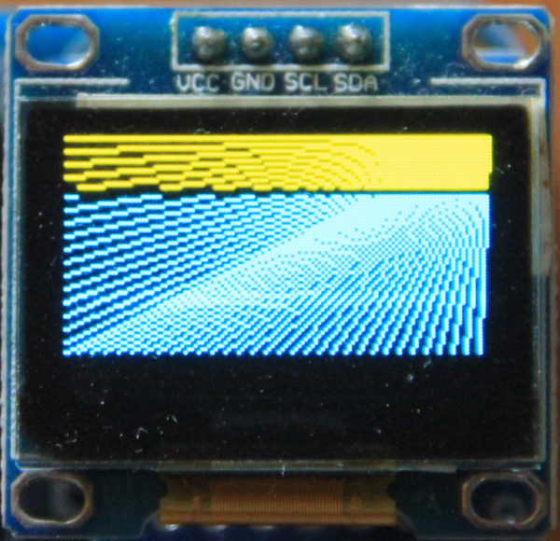 | 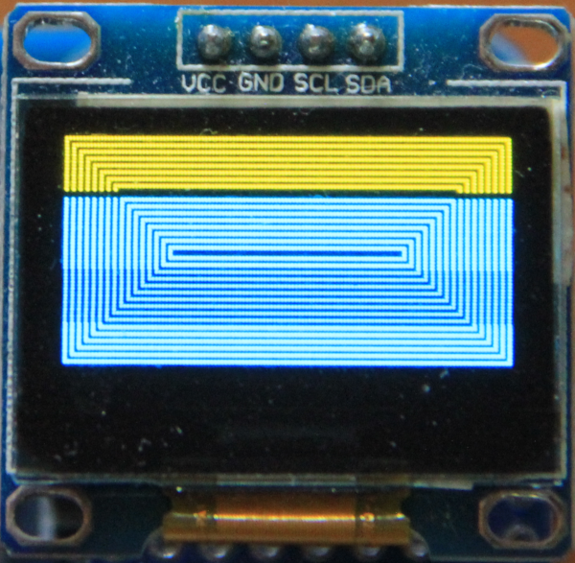
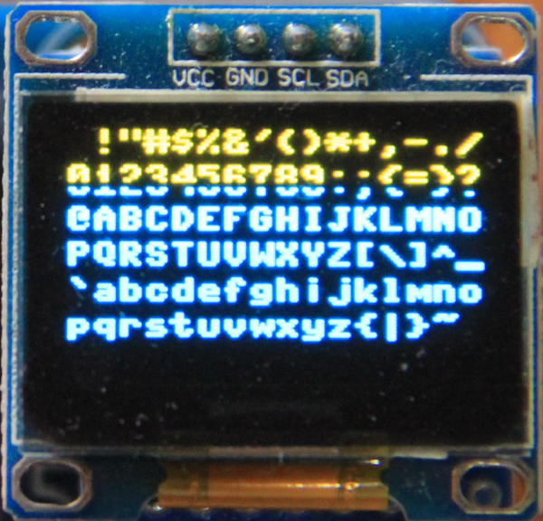 | 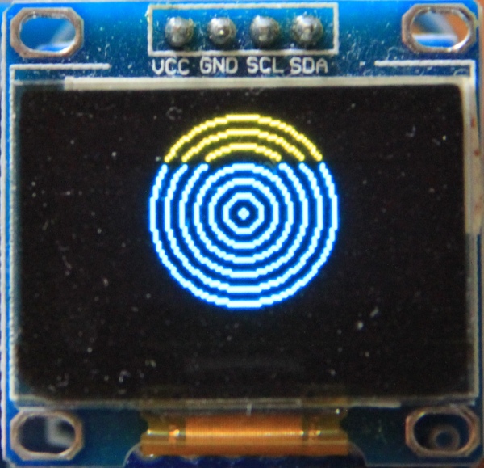
The text examples shows all ASCII characters from 0x20 to 0x7e. The other codes are command codes and are not visible.

Exercises on I2C programming and the BMP180
The BMP180 is a barometric pressure and temperature sensor. On this sensor we can easily try the I2C read and write functions. All the necessary descriptions are found in the BMP180 data sheet.
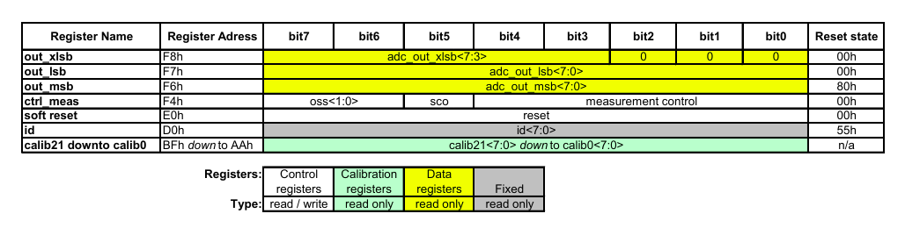
As we can see from the table below, there is the ID register at address 0xD0, which, when being read, returns the constant value 0x55 identifying the device as a BMP180. The ctrl_meas register is a read/write register and which we can use to test reading and writing.
In order to further explore I2C access we want to try reading and writing a register on the BMP180 air pressure sensor.
- Write a program that reads the BMP180 ID register and returns its value. Use the method readfrom_mem of the MicroPython I2C class (https://docs.micropython.org/en/latest/library/machine.I2C.html#machine.I2C) to accomplish this.
- Write the value 0xC0 to the BMP180 ctrl_meas register (method writeto_mem) and read the register back. Make sure you read the same value that you have written (You should only write the two most significant bits).
- You may also try to start a measurement and check if the conversion has been accomplished by looking at the sco bit in the ctrl_meas register.

The Bmp180Class
The algorithm to convert raw temperature and humidity values into physical values is pretty complex. Therefore a driver class is provided in the MicroPython firmware, hiding this complexity.
- Write a program reading and printing temperature and air pressure from the BMP180 using the Bmp180 class. You must import Bmp180 from the Bmp180Class module, create a Bmp180 object, call the measure() method and finally read the temperature and air pressure with getTemperature() and getPressure(). These methods will return physical values in °C for the temperature and hPa for the air pressure.

Exercise reading temperature and humidity on the SHT30
Sensors can be quite complex devices with a big number of registers and programming them can be a challenge. You may check this out for yourself, having a look at the SHT30 data sheet.
To make things easier for you, a driver is included in the MicroPython interpreter installed on your ESP32 CPU.
Here are the methods you need to make temperature and humidity measurements with the driver:
First import the SHT3X and SHT3XError modules:
# import the SHT3X class
from sht3x import SHT3X,SHT3XError

After that, create an SHT3X object:
# create a SHT3X object
try:
sht30 = SHT3X()
except SHT3XError as exception:
if exception.error_code == SHT3XError.BUS_ERROR:
print("SHT30 module not found on the I2C bus, please connect it")
sys.exit(-1)
else:
raise exception
Now we are ready to read the serial number and to start measurements and read the results:
# read out the serial number
print("Serial number: 0x{:02x}".format(sht30.serialNumber()))

# start a measurement and read the results
tempC, humi = sht30.getTempAndHumi()

- Write a program to read the serial number of your SHT30 and then repeatedly read the current temperature and humidity at a frequency of 1 Hz and print the results.

A small project: The weather station
Now that we know how to read temperature , humidity and the air pressure and we also know how to write text to the OLED display, we can create a simple weather station.
- First write the text frame onto the OLED display into which the measurement results will be inserted.
- Write a program that reads temperature, humidity and air pressure and prints the results onto the serial monitor
- Calculate the position where the results must be written onto the OLED screen and integrate the values into the weather frame.
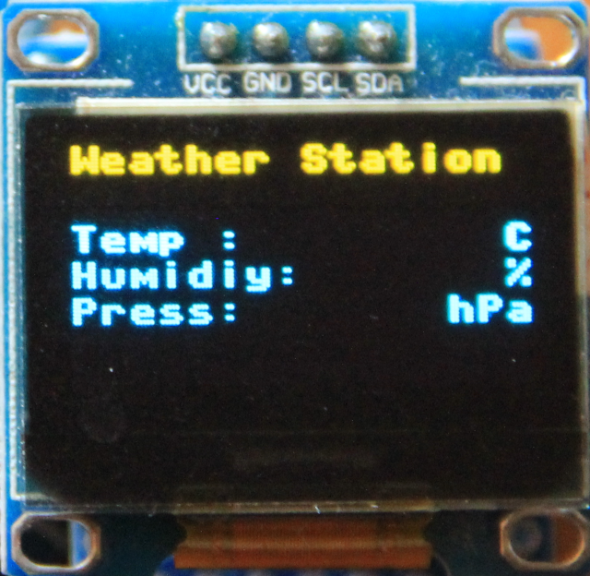 | 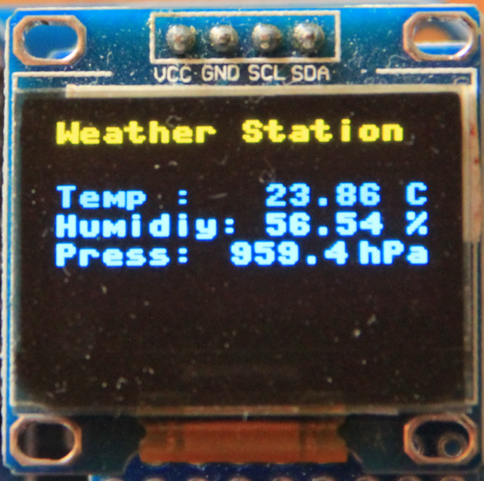
The frame for the weather station | The weather station with results integrated

Stepping motor exercise
Before you start programming, the stepper motor driver card must be connected to the WeMos D1 mini bus. Please make the connections as described in the connection table. Please double check the connections before powering the micro-controller.
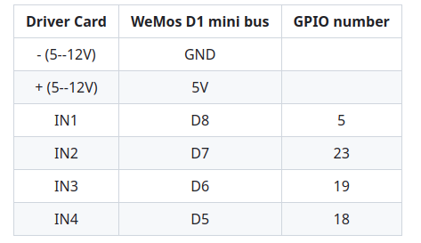
A stepping motor driver, implemented as a Python class, is already available in the MicroPython firmware. The module name is stepper, the class name is steppingMotor. You can therefore create an object of the steppingMotor class with the following code:
from stepper import steppingMotor
stepper = steppingMotor() # this creates an object of class steppingMotor # named stepper

Here are the features of the class:
move(noOfSteps) # move noOfSteps using the current stepping motor mode (default: single step forward)
clrAll() # sets all four coil signals to GND
stepMode(mode) # if mode == None: returns the current mode else: sets the stepping mode to "mode"
# mode can be:
# stepper.SINGLE_PHASE_FORWARD
# stepper.SINGLE_PHASE_BACKWARD
# stepper.DOUBLE_PHASE_FORWARD
# stepper.DOUBLE_PHASE_BACKWARD
# stepper.HALF_STEP_FORWARD
# stepper.HALF_STEP_BACKWARD

waitAfterSteps(ms__wait) # wait for for ms_wait [ms] after each step
#(if ms_wait != None). ms_wait must be
# in the range 2..1000
# else return the current ms_wait value

- Write a program that makes use of the steppingMotor class. Try the different stepping modes and change the movement speed.
- Write a program to move the stepping motor in single phase forward mode, without passing though the driver. At first use a long delay between each step (500ms). This allows you to see the state of the phases on the hardware driver LEDs.

espnow
As we will have to write 2 programs, we can split into 2 sub-groups: One group implementing the servers and the other one implementing the clients.
For all:
- Write a program printing the MAC address of your ESP32 in standard MAC format.
For the server group:
- recover the program reading switches (only prints change of states)
- Integrate this into your server program:
  - setup the network
  - setup espnow
  - configure the clients MAC address in espnow
  - read the switch and if you see a state change, communicate the new state to the client in a text message
For the client group:
- recover the program that lights the user LED on the CPU card
- integrate this into your client code
- setup the network
- setup espnow
- read espnow messages coming from your server colleague
- light the LED correspondingly.

