Supplementary exercises on pure Python programming

Exercise 1:
Write a program to ask its user for an angle 0..360 degrees. Print the sin value of this angle. Please check that the answer is correct. For which angles is sin(angle) == 1/2 ? For which angles is it -1/2 ?

Exercise 2:
Calculate 100 values of the sine curve. Produce 100 angle values (in radians) in equal steps between 0 and 2*pi and calculate sin(angle). Print the angle and the corresponding sin value.
You may re-direct the output of your program to a file (./sine_curve.py > sin_curve.dat) and then plot it with gnuplot. If gnuplot is not installed on your system, then install it with apt.
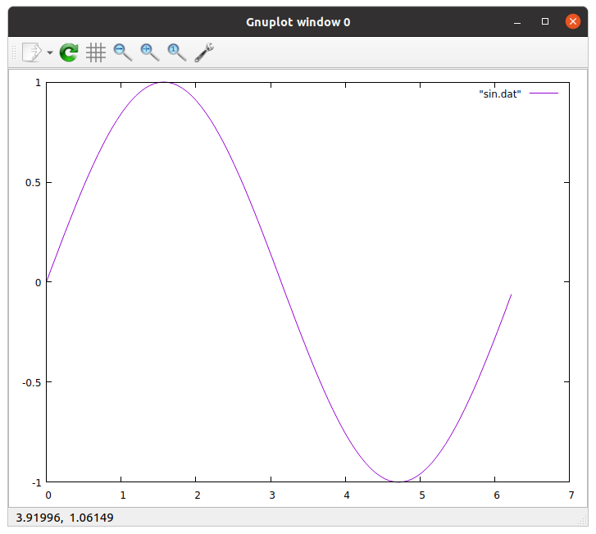

Exercise 3:
In order to generate a sine function on the 8 bit Digital to Analogue Converter (DAC) we need sine values in the range 0..255. Modify your sine curve program such that the output values are integer values mapped to the 0..255 range.

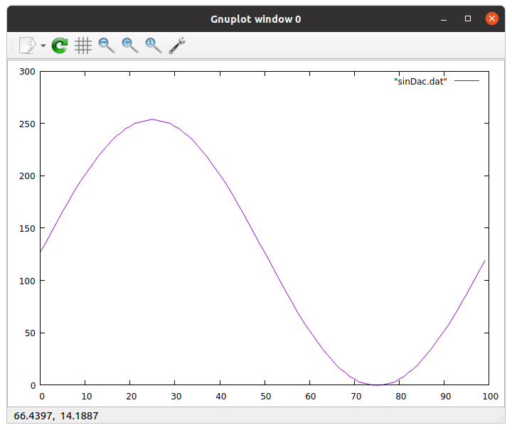
Please note the change in the axis values.

Exercise 4:
Modify exercise 2 in such a way that the plot is created within the program using the matplotlib library. You may have to install this library first with
pip3 install matplotlib
Try to find the documentation and/or example programs on the WEB. This is how the plot will look like:
