Course Internet of Things

WiFi exercises:

Exercise 1:
Verify the available access points before the activation of the ESP32 WiFi.
Study the MicroPython documentation on the WLAN class.
- Configure the WiFi interface as an access point.
- Check if the interface is already active and activate it, if not. Confirm that activation succeeded. If activation fails, emit an error message.

The netwwork before the ESP32 access point activation | The network after the activation
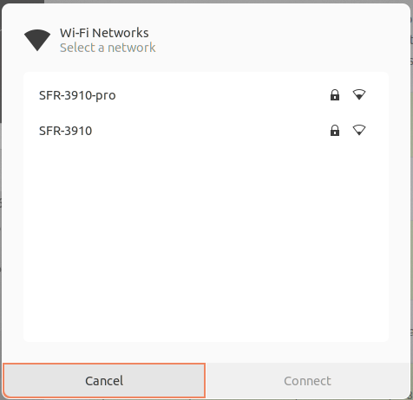 | 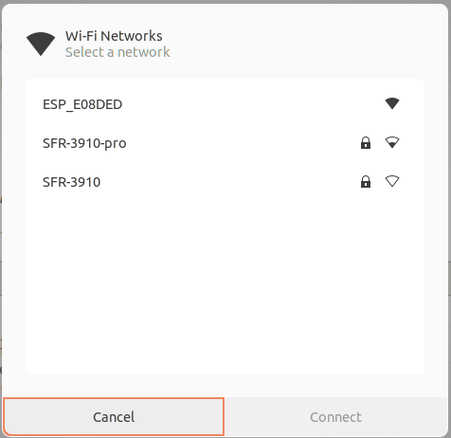

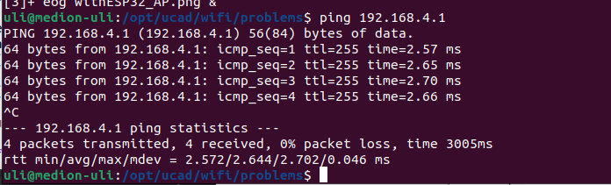
Connect the PC to the new access point and verify that communication works using ping.

Exercise 2 :
Configure the ESP32 as "station interface"
- Verify if the interface is active, activate it if not.
- Scan the network and print all available information about the SSIDs found in a tabular format
- Connect the ESP32 with the router specifying the SSID and the password
- Verify that the connection was successful. (This may take a few seconds. Wait up to 10 s for the connection to be established)
- Print the IP address assigned to your ESP32
- Print the MAC address of the ESP32 WiFi interface
- Verify with ping that the ESP32 is accessible
Here is a screen dump of the solution:
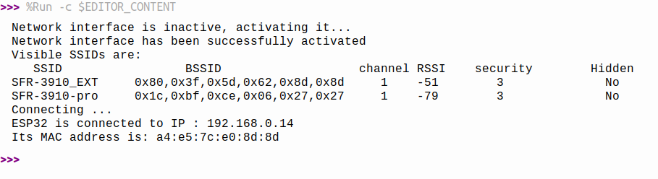
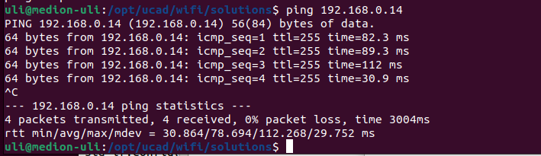

Exercise 3 :
Write a module: wifi.py which encapsulates the functionality of exercise 2. Upload the module to the /lib folder on the ESP32.
The code connecting to the ESP32 will then be as simple as this:
from wifi import
connect ()

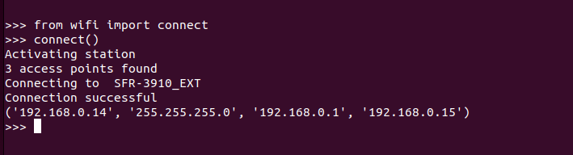

Exercise 4:
Add a function returning the ESP32's IP address.
Read the current UTC time from the network using NTP. Set the real time clock on the ESP32. Provide a function that converts UTC into your local time.

