Infrared remote control
In order to get at the IR data the driver sets up a callback on any change of the IR data signal. I measures the time between these changes and saves these into a list.
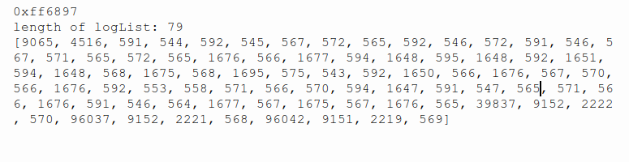
We can reconstruct the signal using the times as values on the x-axis (adding them up) and plotting y-values that switch from high to low or from low to high for every value in the above table:
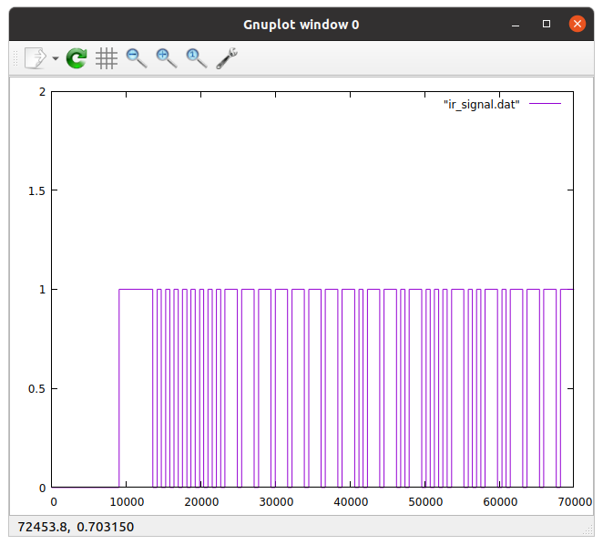
As can be seen from the plot, the signal is zero as long as no button I pressed on the remote. Then it switches to high and the data transfer starts. Every short pulse corresponds to a zero, while every long pulse corresponds to a 1. This gives us: 0000 0000 1111 0110 1000 1001 0111.
A simple analysis program confirms this:

