Solutions to Exercise 2: LEDs

Exercise 1:
Here is the screen dump of a REPL session switching the builtin LED on and off:
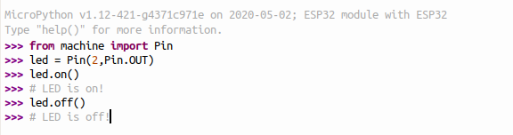

Exercise 2:
This is the most simple program in embedded systems. So... nothing much to say!
See blink.py

Exercise 3:
Exercise 3 is not much more difficult neither. We create a function called pulse, which takes a !pulseLength as parameter. This function switches the LED on for pulseLength seconds and off again for another pulseLength seconds. This function is called 3 times with a short !pulseLength, 3 times with a long pulseLength and again 3 times with a short pulseLength.
Here is the code:
See sos.py

Exercise 4:
This was an exercise we did during the IoT workshop at the African Internet Summit 2019 in Kampala, Uganda and the solution comes from this workshop.
It defines a function intensityCycle, which increases the PWM duty cycle in steps given by the resolution parameter and keeps this intensity stable for a duration given by the duration parameter. It does so for duty cycle 0 up to duty cycle 1 and then back to duty cycle 0.
At the Kampala workshop we also had a demo program cycling the intensity not in a linear but a sinusoidal fashion. Both programs are given here:
pwmExerciseSol.py: the linear cycle and
pwmLED.py: the sinusoidal cycle

Exercise 5:
Switching on the LEDs one by one we see that
- address 0 corresponds to the middle LED
- address 1 to the top LED
- and the others in clockwise progressing around the circle
See ws2812/ws2812Addresses.py

Exercise 6 and 7:
Once we know the LED addresses it is easy to switch them on clockwise and anticlockwise
See ws2812/ws2812Colors.py and ws2812/ws2812ColorsCCW.py
Changing the colors is done by passing the corresponding RGB (Red,Green,Blue) values to the WS2812 driver.

