IoT4AQ workshop exercises

Exercises of WiFi
- Write a program that connects to the WiFi router
- Print its IP address
- Check with ping that the ESP32 node has appeared on the network

Too easy?
- Disconnect from the network
- Scan the WiFi network and print the relevant information for each node you have found
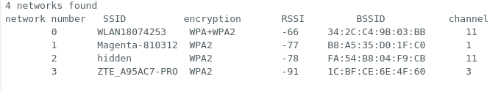

Still too easy?
- Write a TCP server on your PC and a TCP client on the ESP32
- Send messaged between the client and the server

