Iot4AQ workshop exercises

Basic C++ exercises
- Write a program that prints “Hello World!” every second. Use Serial.println to print the text to the serial monitor. Use a baud rate of 115200.
To just compile the program, use the checked button on the left of the Arduino SDK window.
To compile and upload, use the right arrow.
The serial monitor can be started with the button that looks like a magnifying glass (top right)
Make sure the serial monitor is also set to 115200 baud.
This is what you should see:
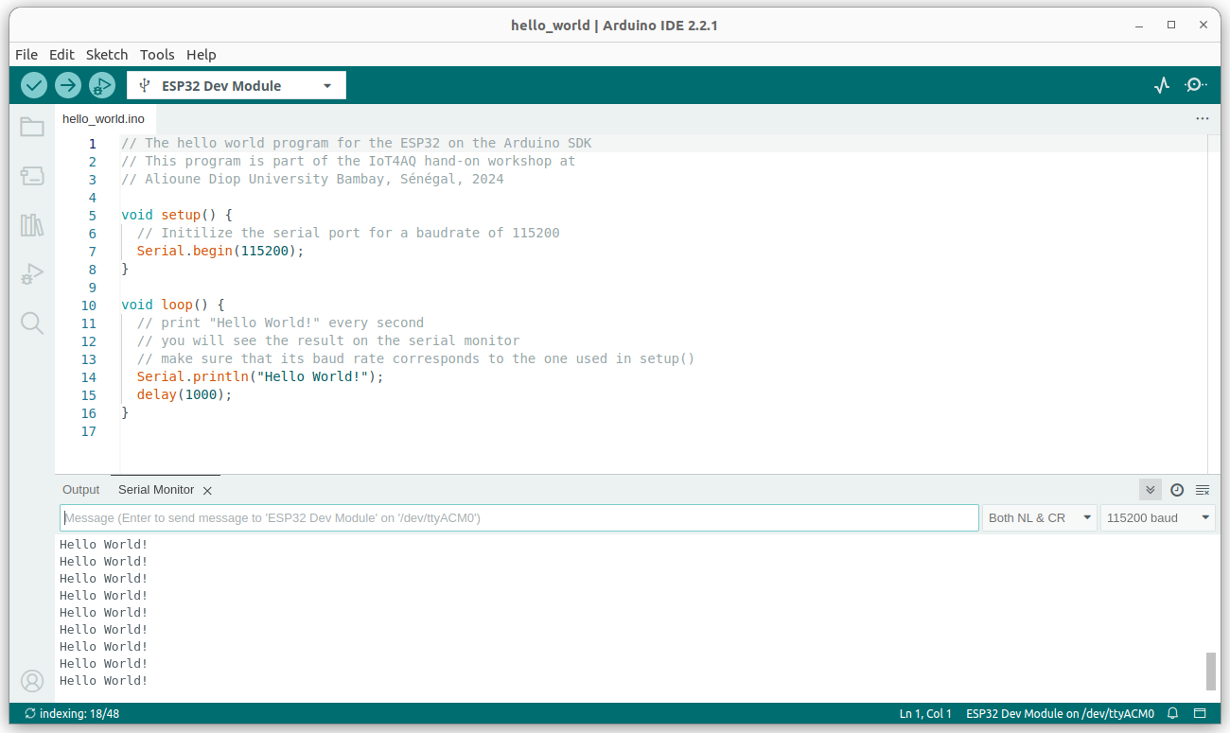
- Write a program that counts up from zero to 40 and then down to zero again. Use “while” loops to do this.
Then modify the program to use “for” loops.
Modify the program again using 2 functions, one for the up counter and one for the down counter. Pass the maximum value to be reached, as a parameter.
You may use the plotting function (the button left of the serial monitor button, showing a signal) to visualize the counters.
- Plot the sin and cos functions as you did with the counters above. You must include the math library to get access to the trigonometric functions as well as the constant M_PI.
#include <math.h>
Use 40 values per period. This is how it looks like:
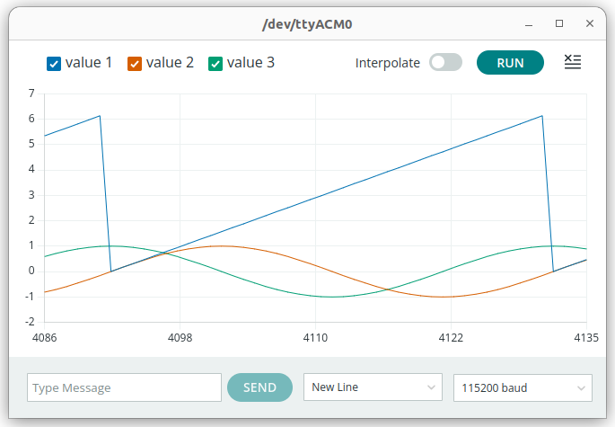
The blue curve corresponds to the x values of sin(x) or cos(x). To which function does the green and yellow curve belong?

