IoT4AQ workshop exercises

Exercises on the DHT11
The DHT11 is a temperature and humidity sensor using its own proprietary serial communication protocol. A DHT11 driver is available on github. In order to understand this driver and how exactly the DHT11 works you must read the DHT11 data sheet.
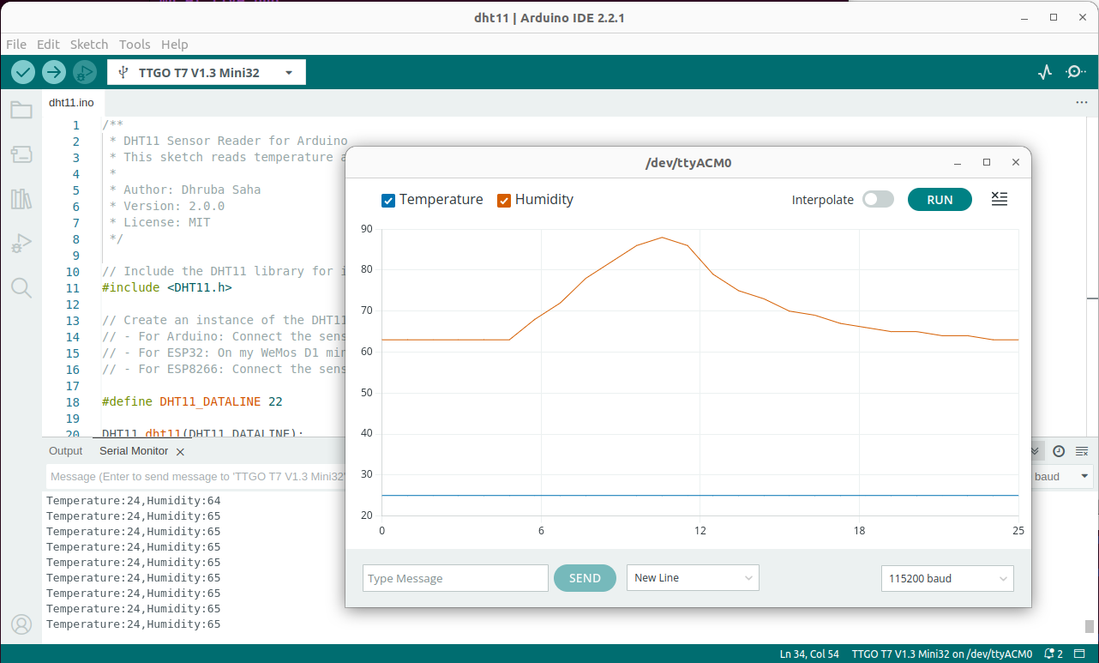
- Initialize the DHT11 class
Read the temperature and humidity and print the results. Make sure that a 1s interval between measurements is respected.
Observe the measurements on the Arduino SDK plotter
Check for possible errors and print them if they occur ( you may run the program without the DHT11 connected and observe what happens). On the screen dump below I put my finger onto the detector to see the rise in humidity.
- Too easy? … and you want to know the details on how the DHT11 protocol works? Be ready for a rough ride!
Without using the driver:
  - set the data pin to output and start a measurement
  - once the measurement is started convert the data line to input and read its state every 4 ms
  - Shift the data read into an array of 32 uint32_t integers: first bit: highest significant bit of the first integer, last bit: lowest significant bit of the last integer and print the array on the serial line.
  - Copy/paste the results into a text editor of your PC
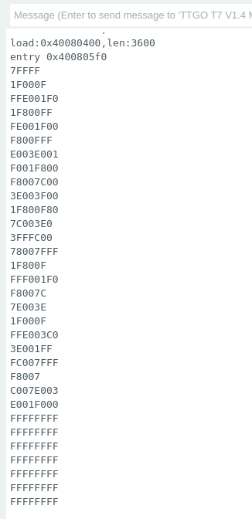
  - Write a program to extract the zeros and ones into a new file.
  - Plot this file on your PC. It will show a
logic analyzer type of plot.

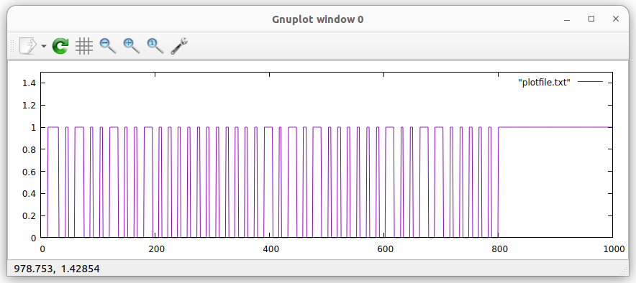
  - Extract the results from the protocol by hand. The long pulses correspond to “1” the short ones to “0”
  - Make sure the checksum is correct
  - Extract the results from the plot file by program on the PC

