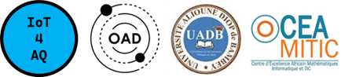 | Internet of Things Lab for Air quality Monitoring (IoT4AQ)  International Workshop – Air Quality & IoT-based Air Sensors  14-15 March 2024, Alioune Diop University, Senegal

IoT4AQ workshop exercises

Exercises on ThingSpeak

Basics
- Register a user on github
- Create a channel with only one field (e.g. for temperature)
- Write a program that creates a triangular stream of values (20, 21, 22,… 40, 39, 38,...20)
- Write a program on the Arduino SDK, which sends a new value to the ThingSpeak channel and field every 15s
- Observe that the chart is updated
- Add a gauge widget to the dashboard
- Observe the value on the gauge
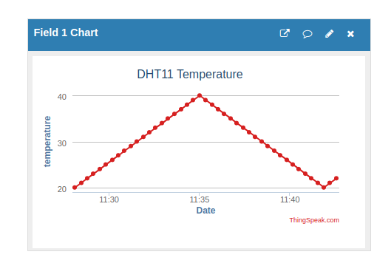  Temperature Graph | 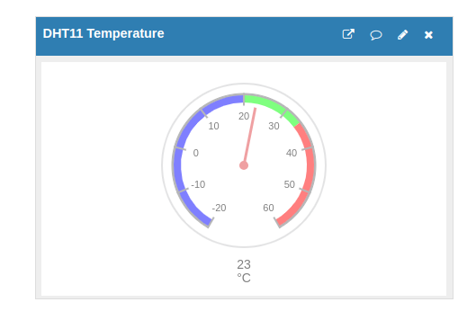  Temperature Gauge

Final ThingSpeak program
- Create a channel with fields for
  - temperature
  - humidity
  - pm 1.0, pm 2.5, pm 10
- Read temperature, humidity and dust concentrations
You need a delay of 1s between the measurements of temperature and humidity and dust concentrations. Therefore it takes 3 s for a complete set of values.
Since ThingSpeak only takes values every 15s (for a free ThingSpeak account) we have time to read 5 complete sets of values and average them. Send the result to the ThingSpeak channel.

Too easy?
- Write a program that can run without Internet access. In this case you must get time and date from the Real Time Clock (set the ESP32 RTC at the beginning of the program from the external DS3231 RTC). Write the time stamp as well as the measured data onto the SD card. Write time,date and current measurement results onto the LCD display.

