|  |  |
| --- | --- |
|  | *Internet of Things Lab for Air quality Monitoring (IoT4AQ)*  *International Workshop – Air Quality & IoT-based Air Sensors*  *14-15 March 2024, Alioune Diop University, Senegal* |

IoT4AQ Workshop Exercises

## Exercises on the 2004 LCD

The 2004 LCD can display 4 rows of 20 characters each.

**Exercise 1:**

Write the following text to the display:

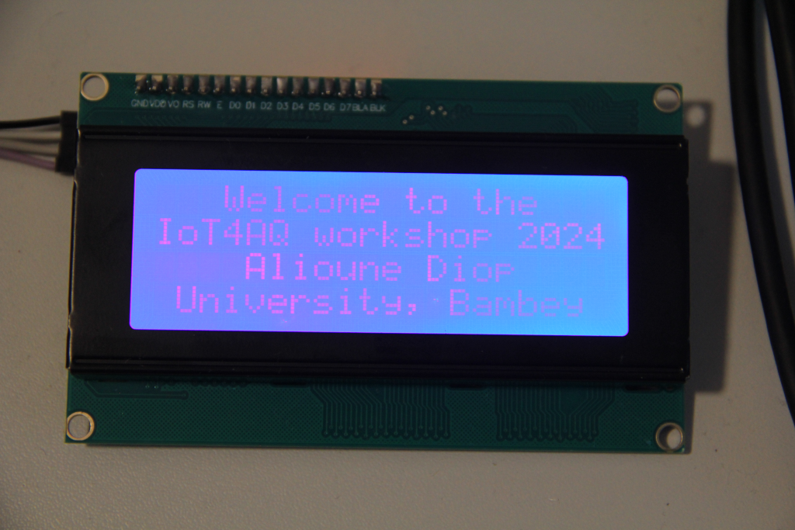Welcome to the  
IoT4AQ workshop 2024  
 Alioune Diop  
 University, Bambey

|  |  |
| --- | --- |
|  | *Internet of Things Lab for Air quality Monitoring (IoT4AQ)*  *International Workshop – Air Quality & IoT-based Air Sensors*  *14-15 March 2024, Alioune Diop University, Senegal* |

**Exercise 2:**

Read the temperature and humidity from the DHT11  
Read the pm1.0, pm2.5 and pm10 values from the PMS5003

Print the results on the display in the following format:  
Temperature: 22deg  
Humidity: 56%  
pm1.0: 5 pm2.5: 6  
pm10: 10

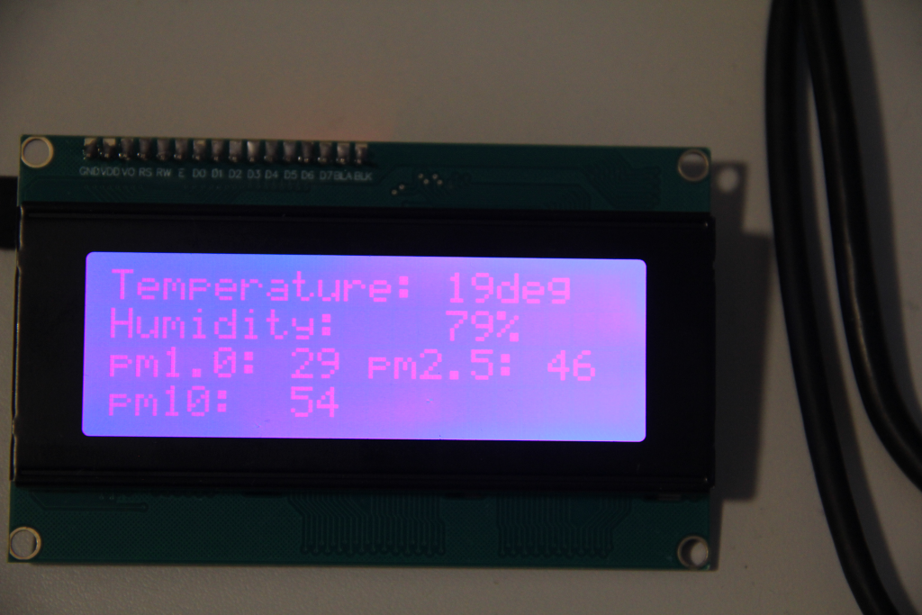

**Too easy?**

**Exercise 3:**

Replace “deg” in the second program by °C. The “°” character does not exist in the ROM character table but can be added as a user defined character.

|  |  |
| --- | --- |
|  | *Internet of Things Lab for Air quality Monitoring (IoT4AQ)*  *International Workshop – Air Quality & IoT-based Air Sensors*  *14-15 March 2024, Alioune Diop University, Senegal* |

