|  |  |
| --- | --- |
|  | *Internet of Things Lab for Air quality Monitoring (IoT4AQ)*  *International Workshop – Air Quality & IoT-based Air Sensors*  *14-15 March 2024, Alioune Diop University, Senegal* |

IoT4AQ workshop exercises

# Exercises on I2C

**Exercise 1:**

Write a program that prints the I2C addresses of all I2C slaves connect to the bus. This is how the output of the program could look like:

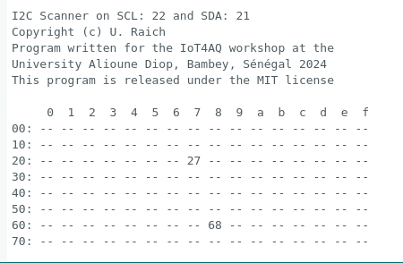

The address 0x68 corresponds to the DS3231 RTC while 0x27 is the address of the PCF8574 I/O extender attached to the LCD display.

## Too easy?

**Exercise 2:**

Try reading and writing registers of the DS3231. You may try to set the time manually and then read it back to check that everything has worked as expected.