|  |  |
| --- | --- |
|  | *Internet of Things Lab for Air quality Monitoring (IoT4AQ)*  *International Workshop – Air Quality & IoT-based Air Sensors*  *14-15 March 2024, Alioune Diop University, Senegal* |

Iot4AQ workshop exercises

## Basic C++ exercises

**Exercise 1:**Write a program that prints “Hello World!” every second. Use Serial.println to print the text to the serial monitor. Use a baud rate of 115200.  
To just compile the program, use the checked button on the left of the Arduino SDK window.  
To compile and upload, use the right arrow.  
The serial monitor can be started with the button that looks like a magnifying glass (top right)  
Make sure the serial monitor is also set to 115200 baud.  
This is what you should see:

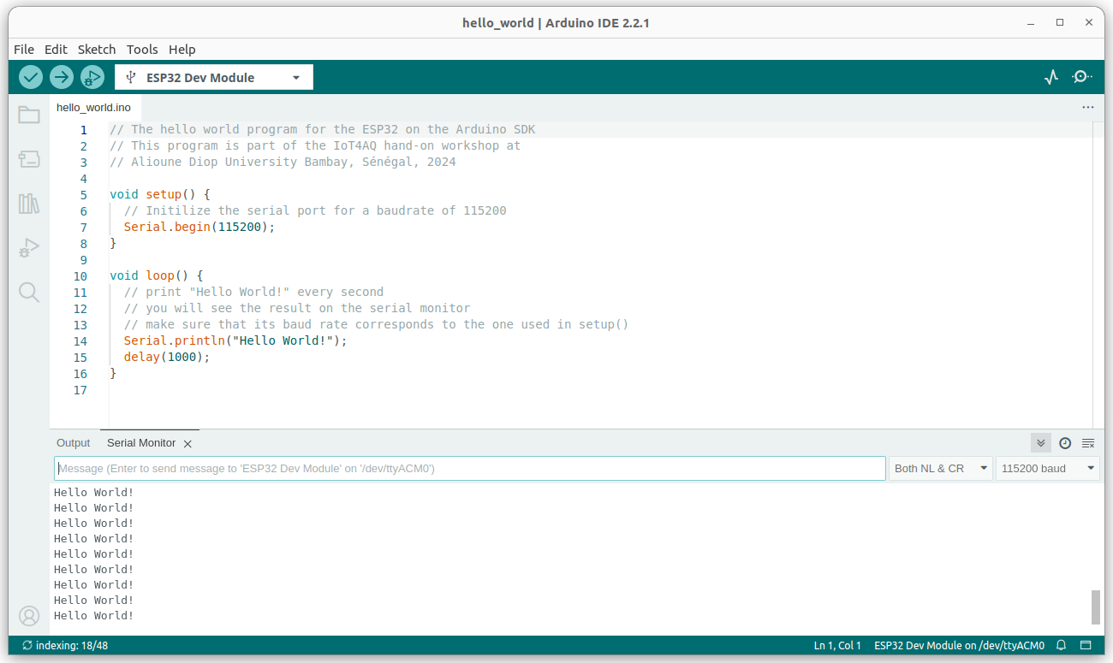

**Exercise 2:**

Modify the program adding two numbers, that was shown during the lecture, and extend it to all four basic arithmetic operations: add, subtract, multiply, divide.

|  |  |
| --- | --- |
|  | *Internet of Things Lab for Air quality Monitoring (IoT4AQ)*  *International Workshop – Air Quality & IoT-based Air Sensors*  *14-15 March 2024, Alioune Diop University, Senegal* |

What is the result when you divide and why?  
What will change it instead of declaring the variables as integers you declare them as floats?

**Exercise 3:**Write a program that counts up from zero to 40 and then down to zero again. Use “while” loops to do this.  
Then modify the program to use “for” loops.  
Modify the program again using 2 functions, one for the up counter and one for the down counter. Pass the maximum value to be reached, as a parameter.  
You may use the plotting function (the button left of the serial monitor button, showing a signal) to visualize the counters.

**Exercise 4:**  
Write a function that calculates a parabola. The formula is:  
y=a*(x-h)2 + k  
Then use the function to print 50 values for x in the range of -2 .. 2. Have a look at the curve on the plotter.  
Try the values a=1.5, h=2.0, k=1.0

Once this is working, you may of course play with the values and see how the curve changes.  
How to calculate the x values? The total size of the range is 4 (-2 .. 2) and you need 50 x values. Therefore the step in x must be 4/50. Then you must offset these values by -2. The formula for the x values therefore is: x = 4.0/50.0 * i – 2.0. If you do not believe this, you can print the x values to see that there are 50 values starting at -2 and running up to +2 (actually +2 – 4/50).

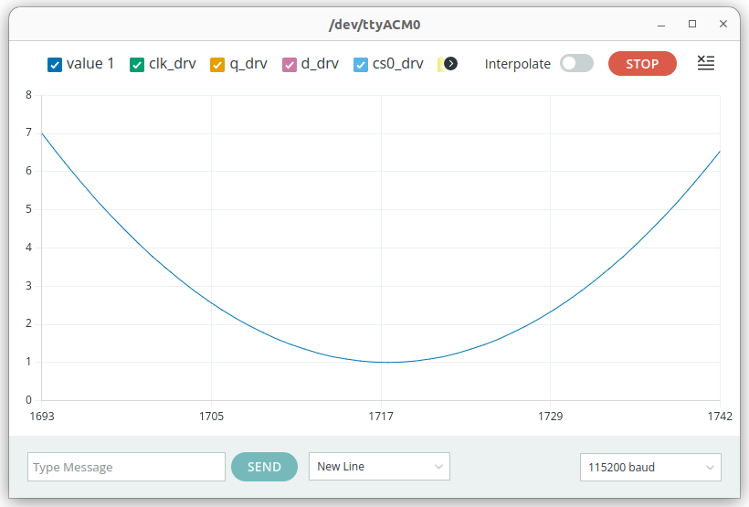

|  |  |
| --- | --- |
|  | *Internet of Things Lab for Air quality Monitoring (IoT4AQ)*  *International Workshop – Air Quality & IoT-based Air Sensors*  *14-15 March 2024, Alioune Diop University, Senegal* |

## Too easy?

**Exercise 5:**Plot the sin and cos functions as you did with the counters above. You must include the math library at the beginning of your program to get access to the trigonometric functions as well as the constant M_PI.   
#include <math.h>  
Use 40 values per period. This is how it looks like:

The blue curve corresponds to the x values of sin(x) or cos(x). To which function does the green and yellow curve belong?