|  |  |
| --- | --- |
|  | *Internet of Things Lab for Air quality Monitoring (IoT4AQ)*  *International Workshop – Air Quality & IoT-based Air Sensors*  *14-15 March 2024, Alioune Diop University, Senegal* |

IoT4AQ workshop exercises

## Exercises on the DHT11

The DHT11 is a temperature and humidity sensor using its own proprietary serial communication protocol. A [DHT11 driver](https://github.com/dhrubasaha08/DHT11) is available on github. In order to understand this driver and how exactly the DHT11 works you must read the [DHT11 data sheet](https://www.mouser.com/datasheet/2/758/DHT11-Technical-Data-Sheet-Translated-Version-1143054.pdf).

**Exercise 1:**Initialize the DHT11 class  
Read the temperature and humidity and print the results. Make sure that a 1s interval between measurements is respected.   
Observe the measurements on the Arduino SDK plotter  
Check for possible errors and print them if they occur ( you may run the program without the DHT11 connected and observe what happens). On the screen dump below I put my finger onto the detector to see the rise in humidity. 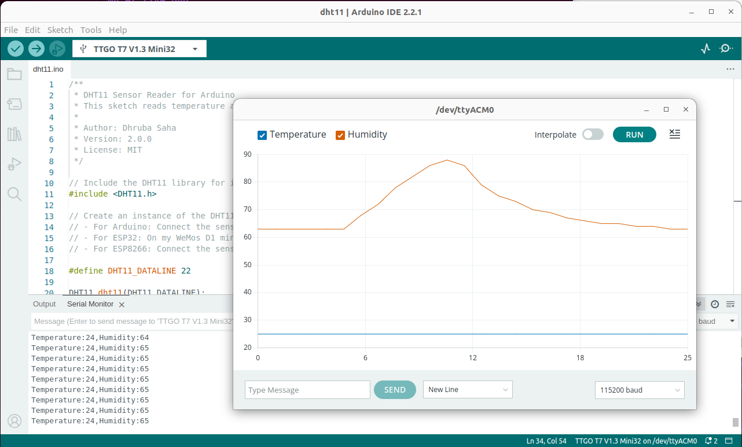

|  |  |
| --- | --- |
|  | *Internet of Things Lab for Air quality Monitoring (IoT4AQ)*  *International Workshop – Air Quality & IoT-based Air Sensors*  *14-15 March 2024, Alioune Diop University, Senegal* |

**Too easy?**

… and you want to know the details on how the DHT11 protocol works? Be ready for a rough ride!  
Without using the driver:

**Exercise 2:**

set the data pin to output and start a measurement

once the measurement is started convert the data line to input and read its state every 4 µs

Shift the data read into an array of 32 uint32_t integers: first bit: highest significant bit of the first integer, last bit: lowest significant bit of the last integer and print the array on the serial line.

Copy/paste the results into a text editor of your PC

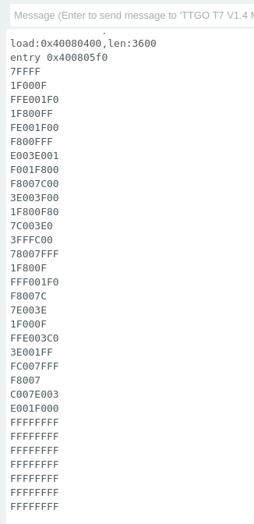**Exercise 3:**

Write a program to extract the zeros and ones into a new file.

Plot this file on your PC. It will show a   
logic analyzer type of plot.

|  |  |
| --- | --- |
|  | *Internet of Things Lab for Air quality Monitoring (IoT4AQ)*  *International Workshop – Air Quality & IoT-based Air Sensors*  *14-15 March 2024, Alioune Diop University, Senegal* |

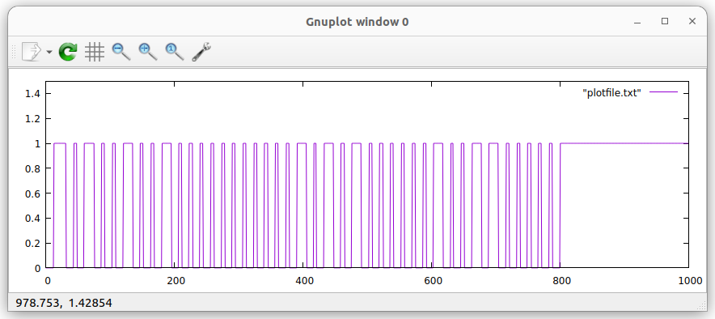

Extract the results from the protocol by hand. The long pulses correspond to “1” the short ones to “0”

Make sure the checksum is correct

In the above plot, the first long pulse is the response signal of the DHT11 (80 us) and should  
not be taken into account.  
Then we get:

0100 1001 = 0x49 = 73 relative humidity integral part in %  
0000 0000 = 0x00 = 0 relative humidity decimal part  
0001 0101 = 0x15 = 21temperature integral part in °C  
0000 0020 = 0x02 = 2 temperature decimal part  
0110 0000 = 0x60 checksum  
0x49 + 0x15 + 0x02 = 0x60 : checksum ok

Extract the results from the plot file by program on the PC