|  |  |
| --- | --- |
|  | *Internet of Things Lab for Air quality Monitoring (IoT4AQ)*  *International Workshop – Air Quality & IoT-based Air Sensors*  *14-15 March 2024, Alioune Diop University, Senegal* |

IoT4AQ workshop exercises

## Exercises of WiFi

**Exercise 1:**

Write a program that connects to the WiFi router

Print its IP address

Check with ping that the ESP32 node has appeared on the network

### Too easy?

**Exercise 2:**

Disconnect from the network

Scan the WiFi network and print the relevant information for each node you have found

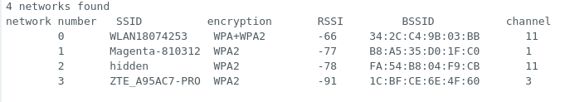

## Still too easy?

**Exercise 3:**

Write a TCP server on your PC and a TCP client on the ESP32

Send messages between the client and the server