Solutions to Exercise 1: REPL and standard Python programming

Exercise 1: Use of REPL
The screen shot shows the REPL session
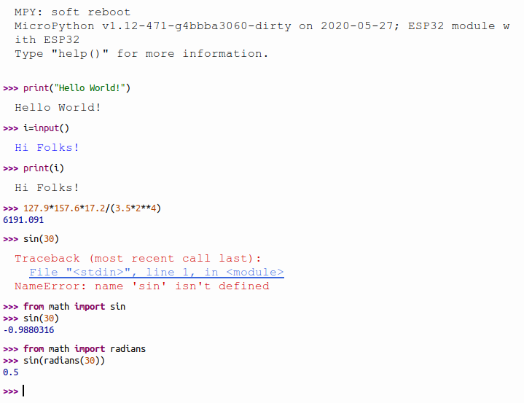

Exercise 2: A simple calculator
In the first example we use fixed values for the calculations. To print out the results I first use integer (%d) format and then floating point format (%f) to get the division right.
See calculatorV1.py
In the second example I define 4 functions for the 4 basic arithmetic operations. The dictionary with the operator as key and the function as value allows me to select the function to be called depending on the operator given. I write a simple parser to check that user input is correct. Since I force a space between operands and operator it becomes easy to split the calculation into 3 tokens: 2 operands and the operator. Now all I need to do is converting the operator strings to floating values and call the corresponding function.
See calculatorV2.py
The last example is quite a bit more tricky as you cannot use the string method split to separate operands and operator at a space character any more. However, you can use regular expressions to pick up the tokens for the two operands and the operator. in MicroPython you will find only a stripped down version of re, the regular expression module, which makes the solution a bit more obscure. I prefer to give you a solution that will work on both, CPython and MicroPython:
See calculatorV3.py
For more information about the regular expression module in MicroPython please consult: https://docs.micropython.org/en/latest/library/ure.html

Exercise 3: Conditions
There is nothing much new in this exercise except that it shows how to use conditional statements.
The first version uses the fixed values 5 and 7:
See conditionsV1.py
The second version takes user input, splits it along spaces and makes sure that exactly 2 tokens have been given
See conditionsV2.py
The third version also checks that the 2 tokens are valid integer numbers
See conditionsV3.py

Exercise 4: The Fibonacci Series
In this exercise we try to implement a mathematical function. This should allow you to write your own small algorithm and test it. The function you develop here will be used in exercise 6. Again there are 2 versions: The first one calculates the Fibonacci series F(n) where n is given by the user:
See fibonacciV1.py
while in the second version the user gives a maximum number not to be exceeded.
See fibonacciV2.py

Exercise 5: A bit of Mathematics: Calculate the sine function
Here we implement the calculation of the sine function we used with REPL in the first exercise. It shows how use external modules/libraries. This exercise is pretty simple.
See math.py

Exercise 6: Classes
This exercise is a bit bigger! It shows you how to develop your own modules and your own classes. In addition you may study some interesting mathematical number series. The last 4 series are actually approximations to well known mathematical constants:
- approximation of Euler's number e:
- the Gregory-Leibniz algorithm, an approximation of pi
- The Wallis algorithm, another approximation of pi
- approximation of ln(2)
When trying to get a good approximation for these numbers you will have to calculate a big number of iterations and you may see a difference between running the program on the PC and running it on the ESP32 where you may see this:3.14159 26535 89793 23846
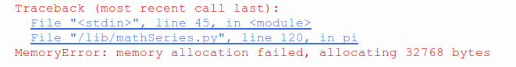
The reason is simple: My PC has 16 GBytes of RAM memory while the ESP32 has 520 kBytes of RAM. When calculating a big number of iterations you will not be able to keep the intermediate results in a list.
For comparison, here are the correct numbers for pi, e and ln(2)
- pi: 3.14159 26535 89793 23846
- e: 2.71828 18284 59045 23536
- ln(2): 0.69314 71805 59945 30941
The other difference is that the ESP32 has no high resolution screen attached to it such that plotting does not make much sense. (TFT screens do exist and can be attached to the ESP32 such that this statement must be taken with a bit of caution)
Here is a plot of the factorial series and the Fibonacci numbers. Since factorial uses multiplication while Fibonacci uses additions, factorial increases much faster.
See the scripts in mathSeries:
- mathSeries.py implements the class
- mathSeriesTest.py exercises the mathSeries module
- mathSeriesPlot.py does the plotting of the series for comparison
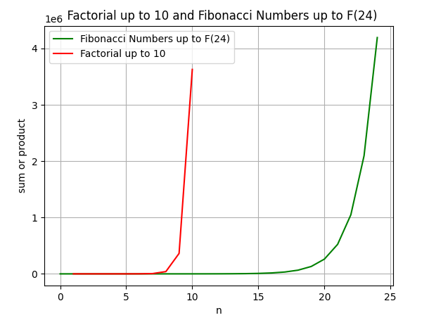
Here a comparison of the geometric and the harmonic number series. As you can easily see geometric series (here with base 2) converges while the harmonic series diverges (albeit slowly).
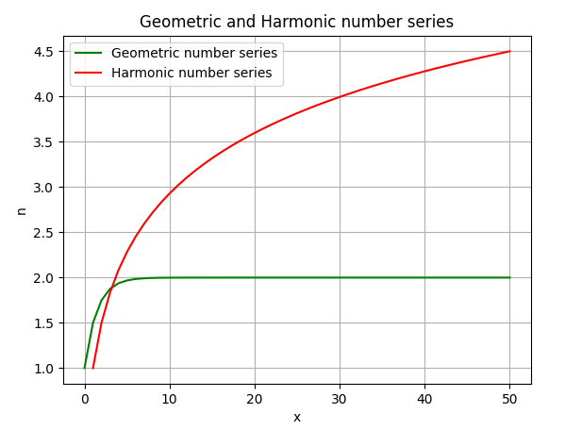
Finally the plot for the approximation of the mathematical constants. You can easily see that the Wallis algorithm converges faster that the Gregory-Leibniz one.
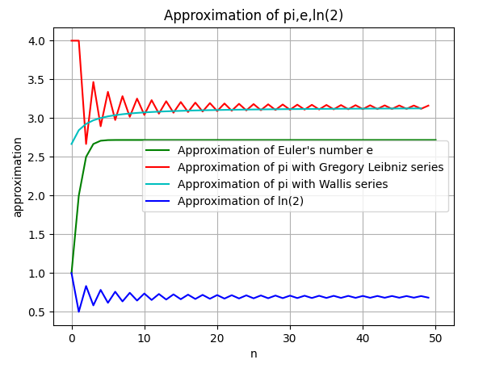
... and here is the code:
First we have the class implementing the calculation of the number series:
http://localhost/pub/UCC_Course_2020/SolutionsToREPLAndStandardPythonProgramming/mathSeries.py.txt
Then the test program, calling each if the methods in the class:
http://localhost/pub/UCC_Course_2020/SolutionsToREPLAndStandardPythonProgramming/mathSeriesTest.py.txt
and finally the program which generates the plots:
http://localhost/pub/UCC_Course_2020/SolutionsToREPLAndStandardPythonProgramming/mathSeriesPlot.py.txt

