========

Overview

========

Lattice Microbes (LM) is a software package for efficiently sampling trajectories from the chemical and reaction-diffusion master equations (CME/RDME) using Graphics Processing Units (GPU) [#LM1] .

It can even utilize multiple GPUs [#LM2] . It was recently used for the simulation of mRNA splicing in a HeLa cell [#LM3]_.

LM is designed to simulate cells with geometric shapes, because of limited availability of realistic shape information. However, LM originally can incorporate any shapes of cells and cellular structure, as shown in a previous study [#LM4] .

Here, we developed an extension of LM that incorporate realistic shapes of cells more efficiently, in particular, from the segmentation of volumetric images of electron microscopy (EM).

Morphologically realistic shapes of cellular structures, in particular, dendrites.

LD is designed to work together with UNI-EM annotator.

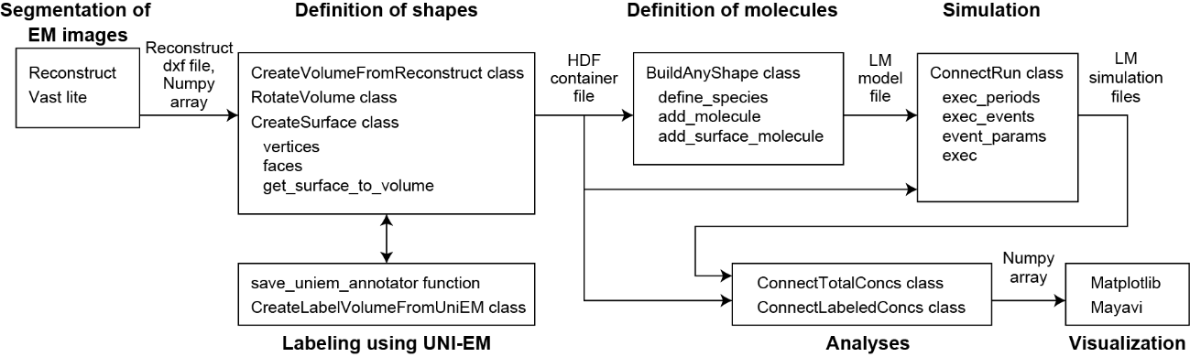

.. [#LM1] Roberts E, Stone JE, and Luthey-Schulten Z (2013) Lattice Microbes: high-performance stochastic simulation method for the reaction-diffusion master equation, J. Comput. Chem. 34(3):245-255, http://faculty.scs.illinois.edu/schulten/lm/ , http://faculty.scs.illinois.edu/schulten/Software2.0.html#1

.. [#LM2] Hallock MJ, Stone JE, Roberts E, Fry C, Luthey-Schulten Z (2014) Simulation of reaction diffusion processes over biologically-relevant size and time scales using multi-GPU workstations, Parallel Comput. 40:86-99

.. [#LM3] Ghaemi Z, Peterson JR, Gruebele M, and Luthey-Schulten Z (2020) An in-silico human cell model reveals the influence of organization on RNA splicing, PLOS Comput. Biol. 16(3): e1007717, https://eukaryoticcellbuilder.github.io/HeLa_Builder/

.. [#LM4] Earnest, TM, Watanabe, R, Stone, JE, Mahamid, J, Baumeister, W, Villa, E, & Luthey-Schulten, Z (2017) Challenges of integrating stochastic dynamics and cryo-electron tomograms in whole-cell simulations. J. Phys. Chem. B, 121(15):3871-3881