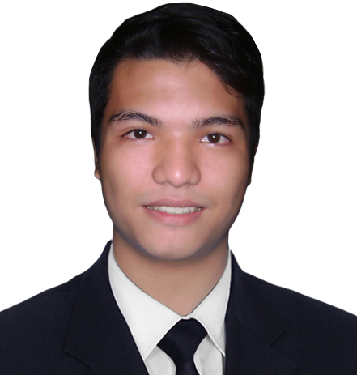

***Pol Maynard O. Imbing***

+63 960 211 2123

[Uraman2000@gmail.com](mailto:aaron.hernandez2@yahoo.com)

www.polimbing.dev/

Pol has more than 5 years of professional experience in the IT and business field, specifically on Android Development and Web Development. He is involved in developing and maintaining Android applications. He also has experience Mvp Architecture, Agile Methodology and Git for version control. He is a good team player, always open and eager to give suggestions, hard worker, enthusiastic, achievement oriented, and can work well under pressure.

**Education**

**Tertiary AMA Computer College**

Bolbok, Batangas City

Bachelor of Science in Computer Science

2013 – 2017

**Secondary** **University of Batangas**

Hilltop, Batangas

2009 – 2013

**Primary** **Batangas City East Elementary School**

P.Herera St. Batangas

2003 – 2009

**Technical Skill**

**Programming Languages** : JavaScript (ES6), TypeScript, Html, Css, Python,

PHP, Java, Kotlin, .Net Core, Unity (C#)

**Web Libraries & Framework** : Node.js, Nest.js, Express.js, TypeOrm,

Styled Component, Styled System, React,

Entity Framework , Axios , Bootstrap

**Android Libraries &** : Retrofit, RxJava, Glide/Picasso

**Framework**

**Software**  : Android Studio, Visual Studio, Photoshop

**Database/DBMS** : MySQL, Sqlite, Graphql, Postgre, MsSql, MongoDb

**Ohers**  : Agile Methodology, Git

**Professional Experience**

Nov 2023 – Present **Yempo - Your Employees Offshore**

**Senior React Developer**

* Participate in technical discussions and provide leadership in architectural decisions related to the front-end.
* Mentor and guide junior developers by providing code reviews, knowledge sharing, and on-the-job training.
* Stay up-to-date with the latest trends and advancements in React and related front-end technologies.
* Proactively identify and propose improvements to development processes and tools.
* Collaborate effectively with cross-functional teams (back-end developers, product managers) to achieve project goals.
* Take ownership of assigned features and applications, ensuring timely delivery and quality.
* Conduct thorough code reviews and provide actionable feedback to improve code quality, maintainability, and adherence to coding standards.

Feb 2021 – Nov 2023 **Accenture Phils, Inc.**

**Advance app Engineering Analyst**

* Designing, developing, and integrating APIs using TypeScript using Nest.js.
* Managing projects from conception to finished product, or with a team. Assistance for the developer’s changes and integrations.
* Contribute to team growth of and self-paced continuous learning.
* Assists the Software Developer Manager in implementing software development.
* Participates in providing ideas and options during planning sessions.
* Help junior developer for bug fixing

April – May 2020 **Gold Bell Financial Service (Singapore)**

**Front-end Web Developer**

* Develop Front-end application using React.js, Axios and Styled Component, Styled System for custom Design
* Develop / debug web view according to provided design specification. Build reusable component for future use.
* Worked with designer and Project Manager for deployment in the server.

Jul 2019 – Feb 2021 **Radio Wealth Finance Company, Inc. (Philippines)**

**Full Stack Web Developer**

* Develop Rest API Using Node.Js, TypeOrm, MsSql, Mysql.
* Develop Front-end applications using React.js and Material–UI.
* Develop a PDC monitoring system to monitor all the pdc transactions of all branches of the company.
* Develop api for Policy Portal using DotNet Entity Framework.

Aug 2018 – Nov 2018 **Tektos Ecosystems Limited (Philippines)**

**Android Developer**

* Created a custom UI view component for the app
* Improving and developing app

Feb 2018 – Aug 2018 **Infotouch (Philippines)**

**Android Developer**

* Work with API developer and App Designer to deliver a use friendly app Stock Marketing app for the company’s client.
* By Using **Retrofit** and **RxJava** for Api Integration
* By Using Kotlin language

**Personal Experience**

May – June 2017 **Thesis – “Basic Skill Set for Kids” Using Unity**

* This app helps kids to develop their problem-solving skills, memory skills creativity skills, etc.

November 2016 **Thesis – “Kto12 Grading System” And “Learning app for**

– March 2017 **kids (Android)”**

* Developed an Automatic Grading System that calculate the grades automatically like Spread Sheets.
* The Learning app for kids helps kids to describe and pronounce words, letters, animals, flags, and numbers. It also helps kids to learn to spell the animals.

August – October 2016 **Markvile Subdivision**

* Developed a subdivision’s billing system

August – October 2015 **Thesis – “BSU Document Tracker” And “Batangas Public Market Locator”**

* Developed a Document tracker that tracks all document from other offices and lets the student view where the document is, using Android app.
* The Batangas Public market helps people to locate/Search a specific store from the Android app.

May – September 2014 **Upwork Formly Odesk**

* Developed a Responsive Front – End website.
* Convert Psd Design to Website.