In [mathematics](https://en.wikipedia.org/wiki/Mathematics), the **Euclidean distance** between two points in [Euclidean space](https://en.wikipedia.org/wiki/Euclidean_space) is the [length](https://en.wikipedia.org/wiki/Length) of a [line segment](https://en.wikipedia.org/wiki/Line_segment) between the two [points](https://en.wikipedia.org/wiki/Point_(geometry)).

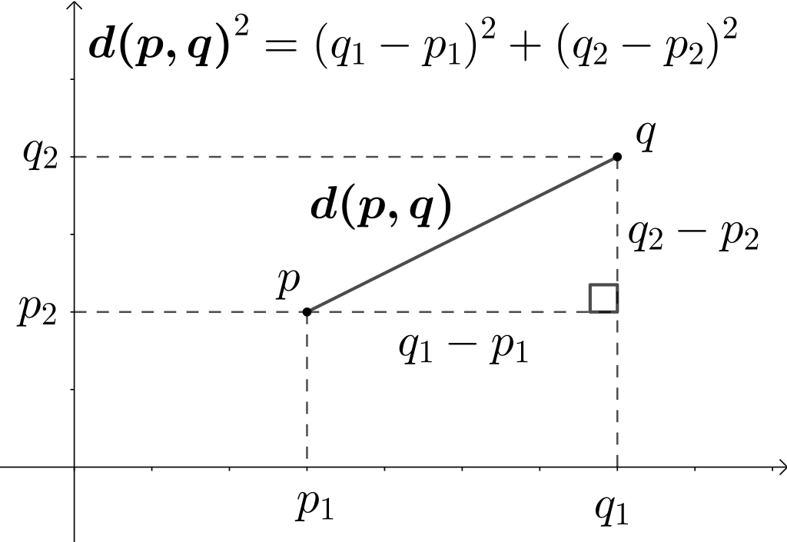

Figure 1. Using the Pythagorean theorem to compute two-dimensional Euclidean distance.

**One dimension**



### Two dimensions



### Higher dimensions



