**CashedRowSetTest**

Manually inserted some additional rows:

INSERT INTO employees VALUES (4,'Carla','Santos','1997-04-20',2,200000,NULL,NULL);

INSERT INTO employees VALUES (5,'Marina','Marin','2000-10-15',2,210000,NULL,NULL);

INSERT INTO employees VALUES (6,'Steve','Martin','2008-01-05',2,200000,NULL,NULL);

INSERT INTO employees VALUES (7,'Maria','Haas','2009-01-02',3,250000,NULL,NULL);

INSERT INTO employees VALUES (8,'Jane','Doe','2010-06-06',3,200000,NULL,NULL);

Table employees

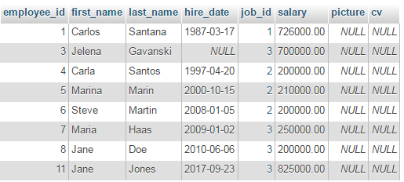

Row count: 7

Employee ID: 3, First Name: Jelena, Last Name: Gavanski, Hire Date: null, Salary: 700000.00

Employee ID: 4, First Name: Carla, Last Name: Santos, Hire Date: 20. Apr 1997., Salary: 200000.00

Employee ID: 5, First Name: Marina, Last Name: Marin, Hire Date: 15. Oct 2000., Salary: 210000.00

Employee ID: 6, First Name: Steve, Last Name: Martin, Hire Date: 05. Jan 2008., Salary: 200000.00

Employee ID: 7, First Name: Maria, Last Name: Haas, Hire Date: 02. Jan 2009., Salary: 250000.00

Employee ID: 8, First Name: Jane, Last Name: Doe, Hire Date: 06. Jun 2010., Salary: 200000.00

Employee ID: 11, First Name: Jane, Last Name: Jones, Hire Date: 23. Sep 2017., Salary: 825000.00

**CachedRowSetPagingTest**

Page #1

Row count of this page is 3

Employee ID: 1, First Name: Carlos, Last Name: Santana, Hire Date: 17. Mar 1987., Salary: 726000.00

Employee ID: 3, First Name: Jelena, Last Name: Gavanski, Hire Date: null, Salary: 700000.00

Employee ID: 4, First Name: Carla, Last Name: Santos, Hire Date: 20. Apr 1997., Salary: 200000.00

Page #2

Row count of this page is 3

Employee ID: 5, First Name: Marina, Last Name: Marin, Hire Date: 15. Oct 2000., Salary: 210000.00

Employee ID: 6, First Name: Steve, Last Name: Martin, Hire Date: 05. Jan 2008., Salary: 200000.00

Employee ID: 7, First Name: Maria, Last Name: Haas, Hire Date: 02. Jan 2009., Salary: 250000.00

Page #3

Row count of this page is 2

Employee ID: 8, First Name: Jane, Last Name: Doe, Hire Date: 06. Jun 2010., Salary: 200000.00

Employee ID: 11, First Name: Jane, Last Name: Jones, Hire Date: 23. Sep 2017., Salary: 825000.00