String inPicturePath = "picture3.jpg";

updateEmployeePicture(conn, pstmt, 3, inPicturePath);

String inPicturePath = "picture6.jpg";

updateEmployeePicture(conn, pstmt, 6, inPicturePath);

When trying to update employee 6 with picture6.jpg which is 156 KB (159744 bytes) large I got:

Updating employee's picture failed:

com.mysql.jdbc.MysqlDataTruncation: Data truncation: Data too long for column 'picture' at row 1

Max. length for BLOB is 65535 bytes and my picture is 159744 bytes large.

**I will resize picture6.jp to fit into BLOB column.**

Maximum lengths:

TINYBLOB : maximum length of 255 bytes

BLOB : maximum length of 65,535 bytes

MEDIUMBLOB : maximum length of 16,777,215 bytes

LONGBLOB : maximum length of 4,294,967,295 bytes

Changed picture6.jpg and saved it as picture6new.jpg and updated employee 6 with this new picture.

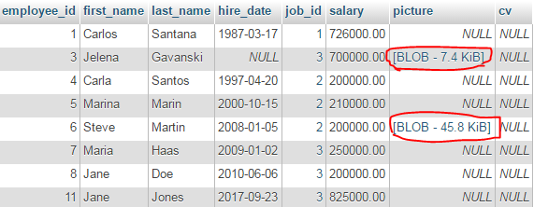

Problem:

inPicturePath set to null

updateEmployeePicture(conn, pstmt, 6, null);

Updating employee's picture failed:

java.sql.SQLException: No value specified for parameter 1

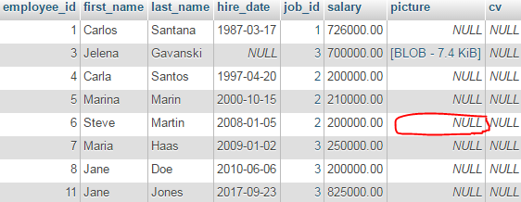

**Updates picture of employee 6 and retrieves it to out_picture6.jpg**

Before

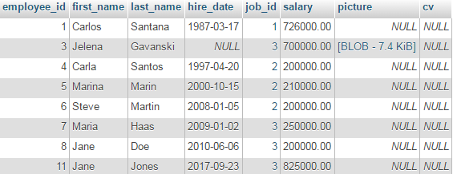

Updated employee's picture successfully.

Retrieved and saved employee's picture successfully

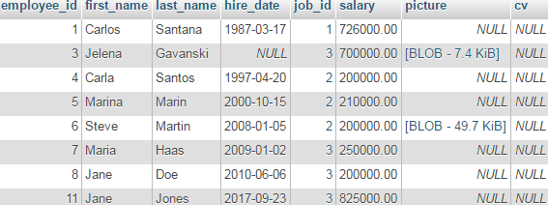

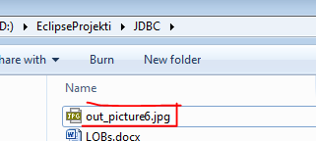

**Updates picture of employee 7 and retrieves it to out_picture7.jpg**

