**Queries**

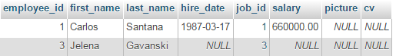

displayEmployee(pstmt, 1);

displayEmployee(pstmt, 3);

JDBC driver returned a forward - only cursor

Employee ID: 1, First Name: Carlos, Last Name: Santana, Hire Date: 17. Mar 1987., Salary: 660000.00

JDBC driver returned a forward - only cursor

Employee ID: 3, First Name: Jelena, Last Name: Gavanski, Hire Date: null, Salary: null

Employee selected and displayed successfully.

displayEmployee(pstmt, 2);

JDBC driver returned a forward - only cursor

No data.

Employee selected and displayed successfully.