**employees**

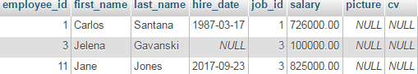

**jobs**

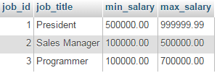

**Za sve zaposlene prikazi detalje o njihovom poslu**

SELECT first_name, last_name, salary, job_title, min_salary, max_salary

FROM employees JOIN jobs

ON employees.job_id = jobs.job_id

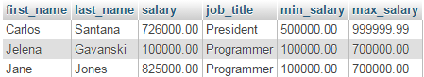

Jane Jones ima vecu platu od max_salary jer nigde ni u bazi ni u programu to ne kontrolisem.

**Samo za jednog zaposlenog prikazi detalje o poslu**

SELECT first_name, last_name, salary, job_title, min_salary, max_salary

FROM employees JOIN jobs

ON employees.job_id = jobs.job_id

WHERE employee_id = 1;



## Stored procedure

DELIMITER $$

DROP PROCEDURE IF EXISTS get_employee_job_details $$

CREATE PROCEDURE get_employee_job_details(IN employee_id_param INT)

BEGIN

SELECT first_name, last_name, job_title, salary, min_salary, max_salary

FROM employees JOIN jobs

ON employees.job_id = jobs.job_id

WHERE employee_id = employee_id_param;

END $$

DELIMITER ;

**Provera postojanja procedure**

SELECT routine_definition

FROM information_schema.routines

WHERE

routine_name = 'get_employee_job_details' AND routine_schema = 'mycompany';

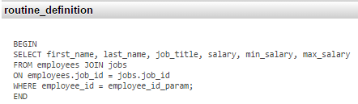

**Execute procedure**

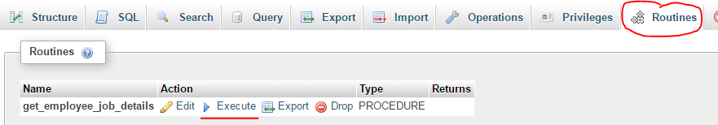

**Izvrsenje procedure programski** pokretenjem **StoredProcedureResultSetTest**

procedura pozvana sa parametrom 1

First Name: Carlos, Last Name: Santana, Job Title: President, Salary: 726000.00, Min. Salary: 500000.00, Max. Salary: 999999.99