Before update (giveRaise(pstmt, 1, BigDecimal.valueOf(10.0));)

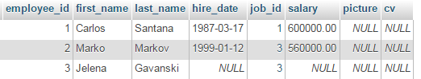

After update

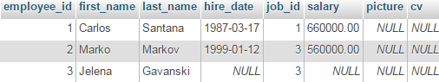

Before update (giveRaise(pstmt, 3, BigDecimal.valueOf(10.0));)



After update



Ne uradi nista

salary = salary + salary \* (?/100)

salary = NULL + NULL \* (10/100) = NULL