**Updates using ResultSet**

Before update

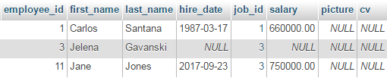

After update

