CREATE DATABASE translators;

CREATE TABLE employees (

employee_id INT NOT NULL,

first_name VARCHAR(30) NOT NULL,

last_name VARCHAR(30) NOT NULL,

sex CHAR(1) NOT NULL CHECK (sex IN ('m', 'f')),

degree VARCHAR(20),

picture BLOB,

PRIMARY KEY (employee_id)

);

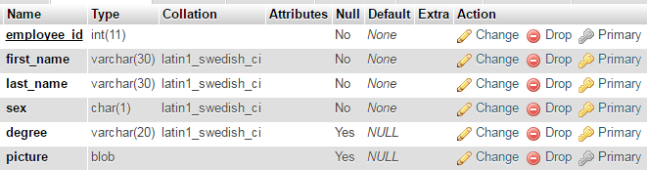

INSERT INTO employees(employee_id, first_name, last_name, sex, degree)

VALUES (1,'Carlos','Santana','m', 'PhD');

INSERT INTO employees(employee_id, first_name, last_name, sex, degree)

VALUES (2,'Carla','Bruni','f', 'PhD');

INSERT INTO employees(employee_id, first_name, last_name, sex)

VALUES (3,'Marconi','Mayer','m');

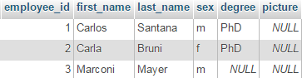

Provera check contraint na sex koloni

INSERT INTO employees(employee_id, first_name, last_name, sex)

VALUES (4,'Stella','Pioni','g');

Ovo je proslo sto znaci da mi check constraint ne radi!!!

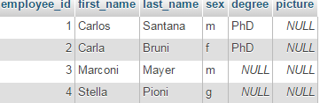

<http://www.w3resource.com/mysql/creating-table-advance/constraint.php>

The CHECK clause is parsed but ignored by all storage engines!!! The reason for accepting but ignoring syntax clauses is for compatibility, to make it easier to port code from other SQL servers

Predlozeno resenje pisanje trigera. Kakva budalastina ovaj mysql, da pisem trigere za ovako nesto.

Idem bez check constraint.

## ERD

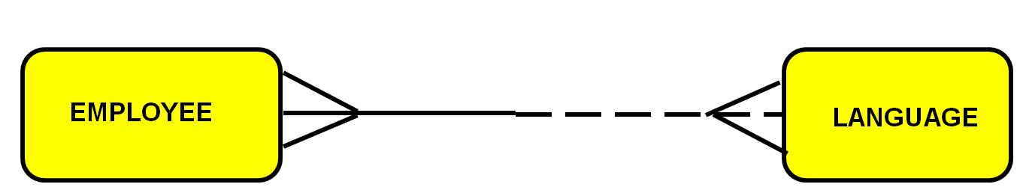

Employee must speak one or more languages.

Each language may be spoken by one or more employees.

|  |  |
| --- | --- |
| Attributes of employee: | Attributes of language: |
| # employee_id  * first_name  * last _name  * sex  o degree  o picture | # language_id  * name |

## Transforming M:M relationship

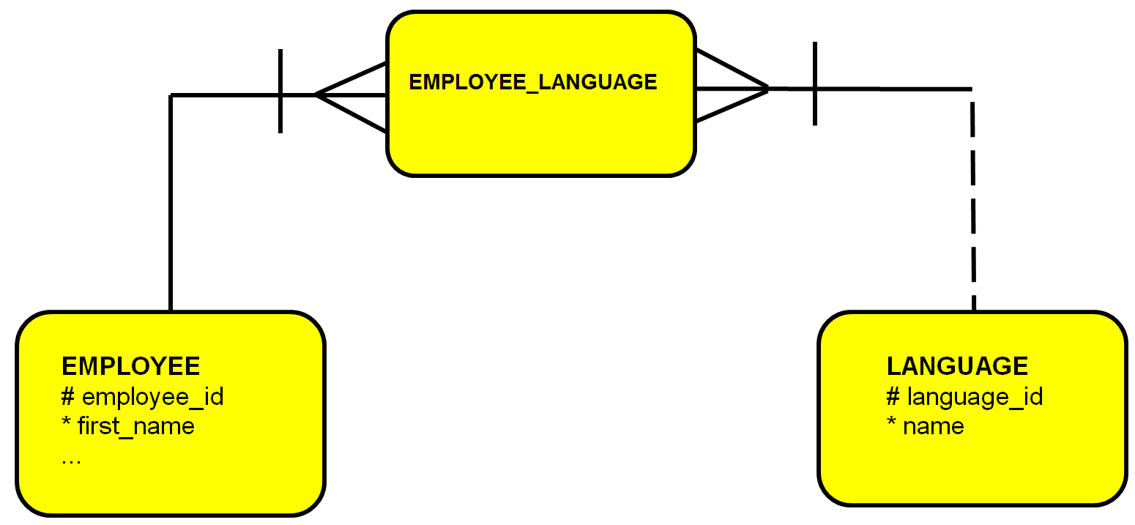

I could add level of language knowledge in EMPLOYEE_LANGUAGE entity.

## Mapping

|  |  |  |  |
| --- | --- | --- | --- |
| **EMPLOYEES** (EPE) | | | |
| *tip ključa* | *opcionalnost* | *naziv kolone* | *tip podataka* |
| pk | * | employee_id | INT |
|  | * | first_name | VARCHAR(30) |
|  | * | last_name | VARCHAR(30) |
|  | * | sex | CHAR(1) |
|  | o | degree | VARCHAR(20) |
|  | o | picture | BLOB |

|  |  |  |  |
| --- | --- | --- | --- |
| **LANGUAGES** (LGE) | | | |
| *tip ključa* | *opcionalnost* | *naziv kolone* | *tip podataka* |
| pk | * | language_id | INT |
|  | * | name | VARCHAR(30) |

|  |  |  |  |
| --- | --- | --- | --- |
| **EMPLOYEES_LANGUAGES** (ELE) | | | |
| *tip ključa* | *opcionalnost* | *naziv kolone* | *tip podataka* |
| pk, fk1 | * | employee_id | INT |
| pk, fk2 | * | language_id | INT |

Kako ugraditi pravilo da svaki zaposleni mora da govori bar jedan jezik?

svi primarni kljucevi tabele employees moraju da postoje negde u tabeli employees_languages

DROP TABLE employees;

CREATE TABLE employees (

employee_id INT NOT NULL,

first_name VARCHAR(30) NOT NULL,

last_name VARCHAR(30) NOT NULL,

sex CHAR(1) NOT NULL,

degree VARCHAR(20),

picture BLOB,

PRIMARY KEY (employee_id)

);

CREATE TABLE languages (

language_id INT NOT NULL,

name VARCHAR(30) NOT NULL,

PRIMARY KEY (language_id)

);

CREATE TABLE employees_languages (

employee_id INT NOT NULL,

language_id INT NOT NULL,

CONSTRAINT ele_pk PRIMARY KEY(employee_id, language_id),

CONSTRAINT ele_fk1 FOREIGN KEY(employee_id) REFERENCES employees (employee_id),

CONSTRAINT ele_fk2 FOREIGN KEY(language_id) REFERENCES languages (language_id)

);

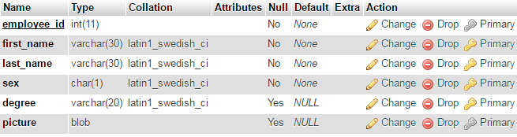





INSERT INTO employees(employee_id, first_name, last_name, sex, degree)

VALUES (1,'Carlos','Santana','m', 'PhD');

INSERT INTO employees(employee_id, first_name, last_name, sex, degree)

VALUES (2,'Carla','Bruni','f', 'PhD');

INSERT INTO employees(employee_id, first_name, last_name, sex)

VALUES (3,'Marconi','Mayer','m');

INSERT INTO employees(employee_id, first_name, last_name, sex)

VALUES (4,'Stella','Pioni','f');

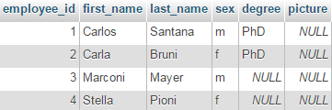

INSERT INTO languages(language_id, name)

VALUES (1, 'English');

INSERT INTO languages(language_id, name)

VALUES (2, 'German');

INSERT INTO languages(language_id, name)

VALUES (3, 'Italian');

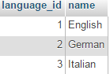

INSERT INTO employees_languages (employee_id, language_id)

VALUES (1, 1);

INSERT INTO employees_languages (employee_id, language_id)

VALUES (1, 2);

INSERT INTO employees_languages (employee_id, language_id)

VALUES (2, 1);

INSERT INTO employees_languages (employee_id, language_id)

VALUES (2, 3);

INSERT INTO employees_languages (employee_id, language_id)

VALUES (3, 1);

INSERT INTO employees_languages (employee_id, language_id)

VALUES (4, 1);

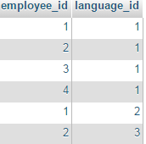

**Provera foreign key da li radi za ovu tabelu**

Ubacujem jezik koji ne postoji u tabeli languages:

INSERT INTO employees_languages (employee_id, language_id)

VALUES (1, 4);

ne dopusta

#1452 - Cannot add or update a child row: a foreign key constraint fails (`translators`.`employees_languages`, CONSTRAINT `ele_fk2` FOREIGN KEY (`language_id`) REFERENCES `languages` (`language_id`))

Ubacujem zaposlenog koji ne postoji u tabeli employees:

INSERT INTO employees_languages (employee_id, language_id)

VALUES (10, 4);

ne dopusta

#1452 - Cannot add or update a child row: a foreign key constraint fails (`translators`.`employees_languages`, CONSTRAINT `ele_fk1` FOREIGN KEY (`employee_id`) REFERENCES `employees` (`employee_id`))