Napravljena je web aplikacija prema maven archetype za web aplikacije

D:\MAVEN\hf>**mvn archetype:generate -DarchetypeArtifactId=maven-archetype-webapp**

sa sledecim podesavanjima

groupId: **com.jelena**

artifactId: **employees**

version: **1.0-SNAPSHOT**

package: **war**

**pom.xml**

**ubacen tomcat plugin (u build element)**

<plugins>

<plugin>

<groupId>org.apache.tomcat.maven</groupId>

<artifactId>tomcat7-maven-plugin</artifactId>

<version>2.2</version>

</plugin>

</plugins>

**ubacen dependency za servlete, a izbacen junit**

<dependency>

<groupId>javax.servlet</groupId>

<artifactId>javax.servlet-api</artifactId>

<version>3.1.0</version>

<scope>provided</scope>

</dependency>

**web.xml**

Ubačeni su sledeći elementi:

servlet i servlet-mapping za klasu koja je servlet a to je **EmployeeServlet**

i welcome file (difoltni fajl aplikacije) je index.jsp

<?xml version="1.0" encoding="UTF-8"?>

<web-app version="2.5"

xmlns="http://java.sun.com/xml/ns/javaee"

xmlns:xsi="http://www.w3.org/2001/XMLSchema-instance"

xsi:schemaLocation="http://java.sun.com/xml/ns/javaee

http://java.sun.com/xml/ns/javaee/web-app_2_5.xsd">

<display-name>Archetype Created Web Application</display-name>

<servlet>

<servlet-name>**EmployeeServlet**</servlet-name>

<servlet-class>**com.jelena.EmployeeServlet**</servlet-class>

</servlet>

<servlet-mapping>

<servlet-name> **EmployeeServlet** </servlet-name>

<url-pattern>**/employee**</url-pattern>

</servlet-mapping>

<welcome-file-list>

<welcome-file>index.jsp</welcome-file>

</welcome-file-list>

</web-app>

**Napravljen je folder src/main/java/. Unutar njega com, pa unutar njega jelena i tu je stavljena klasa EmployeeServlet.java**

package com.jelena;

import java.io.*;

import javax.servlet.*;

import javax.servlet.http.*;

//http://localhost:8080/employees/employee

// Na ovaj servlet se POST metodom dolazi preko forme klikom na submit dugme submit

public class **EmployeeServlet** extends HttpServlet {

@Override

protected void **doPost**(HttpServletRequest request, HttpServletResponse response)

throws ServletException, IOException {

String name = **request.getParameter("username");**

**request.setAttribute("name", name);**

RequestDispatcher view = request.getRequestDispatcher("/view.jsp");

view.forward(request, response);

}

}

Servlet uzima parametre o zaposlenom sa forme, postavlja ih u request i salje reques, response ka view.jsp

view.jsp ce izvaditi sve o zaposlenom iz requesta i prikazati

**form.html**

<html><body>

**<form method="POST" action="employee">**

Username: <input type="text" **name="username"**><br/>

<input type="submit" value="submit">

</form>

</body></html>

**view.jsp**

<html><body>

Hello

<%= **request.getAttribute("name")** %>

</body></html>

**index.jsp**

<html>

<body>

<h2>Hello World!</h2>

</body>

</html>

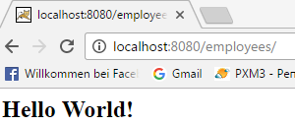

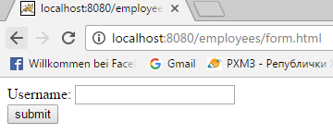

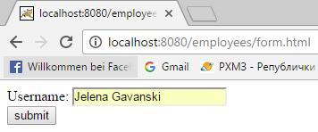

klik na submit

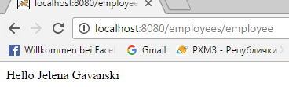

**Sada sve podatke o zaposlenom snimam ne u jedan String nego u objekat Employee** i stavljam ga u request kao atribut.

Employee.java je biznis klasa, stavljam je u folder src/main/java/com/jelena/business

**Employee.java**

package com.jelena.business;

public class Employee {

private String firstName;

private String lastName;

public Employee() {

firstName = "";

lastName = "";

}

public Employee(String firstName, String lastName) {

this.firstName = firstName;

this.lastName = lastName;

}

public String getFirstName() {

return firstName;

}

public void setFirstName(String firstName) {

this.firstName = firstName;

}

public String getLastName() {

return lastName;

}

public void setLastName(String LastName) {

this.lastName = lastName;

}

}

**U Servletu u doPost metodi ubaceno**

**String firstName = request.getParameter("firstName");**

**String lastName = request.getParameter("lastName");**

**Employee emp = new Employee(firstName, lastName);**

**request.setAttribute("employee", emp);**

RequestDispatcher view = request.getRequestDispatcher("/view.jsp");

view.forward(request, response);

**Forma preradjena za unos firstName i lastName**

**form.html**

<html><body>

**<form method="POST" action="employee">**

First Name: <input type="text" **name="firstName"**><br/>

Last Name: <input type="text" **name="lastName"**><br/>

<input type="submit" value="submit">

</form>

</body></html>

View moze preko EL da vadi podatke iz java bean-a, jer imamo getere za firstName i lastName.

**view.jsp**

<html>

<head>

<meta charset="utf-8">

<title>Employee Data</title>

</head>

<body>

First Name: **${employee.firstName}**<br/>

Last Name: **${employee.lastName}**<br/>

</body>

</html>

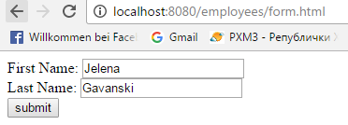

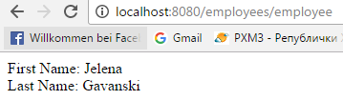

Dalje razvijamo formu sa svim mogucim kontrolama

i dodajemo snimanje employee u bazu