**Koje sve jezike govori svaki zaposleni?**

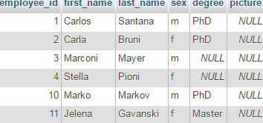 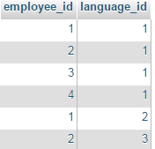 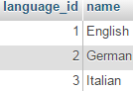

SELECT employees.employee_id, employees.first_name, employees.last_name, employees_languages.language_id

FROM employees JOIN employees_languages

ON employees.employee_id = employees_languages.employee_id

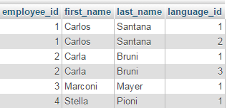

SELECT employees.employee_id, employees.first_name, employees.last_name, languages.name AS language

FROM employees JOIN employees_languages

ON employees.employee_id = employees_languages.employee_id

JOIN languages

ON employees_languages.language_id = languages.language_id

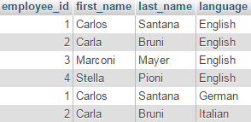

**Koji id ima dati jezik?**

SELECT languages.language_id

FROM languages

WHERE languages.name = "english";



ako nema trazenog jezika select ne daje nikakav rezultat