<http://nvie.com/posts/a-successful-git-branching-model/>

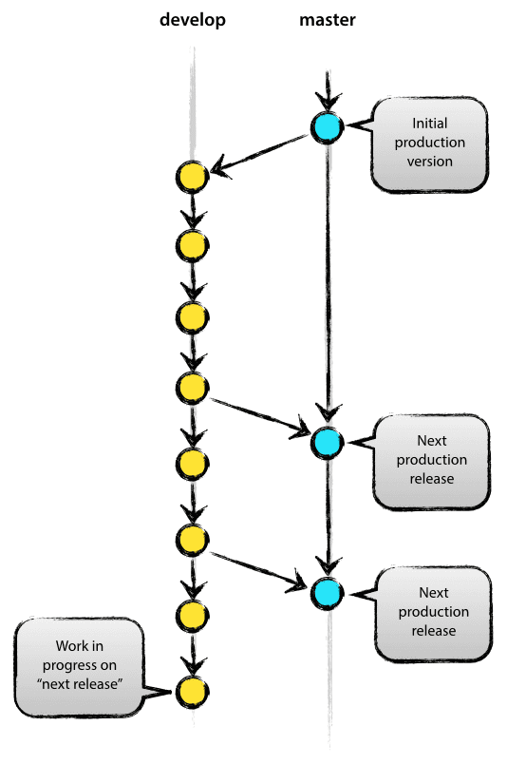

two main branches with an infinite lifetime:

* master
* develop

We consider origin/master to be the main branch where the source code of HEAD always reflects a *production-ready* state.

We consider origin/develop to be the main branch where the source code of HEAD always reflects a state with the latest delivered development changes for the next release.

When the source code in the develop branch reaches a stable point and is ready to be released, all of the changes should be merged back into master somehow and then tagged with a release number.