FEATURES

• Compatible with SMIC 0.13um EE
Process

• Operating VDD Range
- write: 1.35V~1.65 V
- read: 0.80V~1.65V(Vdd expected to work down to 0.7V)

• Memory Organization
- 4K bits(64x64) Main Memory Array

• High Performance
- Program Time: 2~2.5ms /word
- Erase Time: 2~2.5ms /word
- Read Speed：Max 1MHz

• Memory Density
- 0.10mm^2~0.12mm^2

• High Product Endurance/Retention
- Typical 10 years data retention
- Typical 100000 programming cycles

• Consumption
- Read Consumption (typical) :
3~4µA @500KHz / 16bits / VDD=1.0V
2.5~3uA @320KHz / 16bits / VDD=1.0V
1.5~2uA @160KHz / 16bits / VDD=1.0V
- Write Consumption (typical) :
8~12uA@6.25us windows / 16bits / VDD=1.5V
6~10uA@average / 16bits / VDD=1.5V
- Typical 0.1 µA standby current

• Operating Temperature Range
- -40 ^{O} C to +85 ^{O} C

GENERAL DESCRIPTION

The S13EE_X64Y64 is a Electrically Erasable Programmable Read-Only Memory (EEPROM) block compatible with the SMIC 0.13um EE process. The new EERPOM core achieves industry-standard 10-year retention and 100,000-cycle endurance. The memory operates using a single supply voltage, and is organized as 2 word sectors, each 16x16 Bytes. Peripheral circuits—including charge pumps, oscillator, memory controller, and bias circuits—are integrated into the EEPROM core.

MODES OF OPERATION

The S13EE_X64Y64 supports two operating modes: User Mode and Test Mode. User Mode provides three standard memory operations: Read, Erase and Program. Test Mode provides two operations: All WordLines On Mode and Margin Read Mode.

SUPPORT CIRCUITS

The S13EE_X64Y64 includes a charge pump circuit to generate the high voltage necessary for programming the floating gates. The EEPROM block also incorporates an internal oscillator to control the charge pump operation and the digital logic.

CONNECTION DESCRIPTION

Interface

Pin Name | Direction | Description
addr<13:4> | I | Address input bus——addr<13:12> for all words-select ;addr<11:6> for X-dec; addr<5:4> for Y-dec
din<15:0> | I | Parallel data inputs for write operation
dout<15:0> | O | Memory bits output
read | I | Read enable signal
pgm | I | Program enable signal
erase | I | Erase enable signal
testmr | I | Test mode—Margin Read
sync | I | Synchronous signal for data loading and read operation
clk | I | Clock signal for driving high voltage charge pump
bufrst | I | Pulse signal to clear the data input buffers in data loading
loaden | I | Enable signal for write data loading
dby2 | I | Clk frequency will be divided by 2 when dby2=‘1’
vdd | Power | 0.8~1.65V power supply for memory operation
gnd | Power | Power ground

addr <13:12> Truth Table:
addr <13:12> | Of Which Portion All Word Lines Will Be Activated?
0 0 | Regular single word line operation
0 1 | All 16 word lines of lower 2kbit’s block
1 0 | All 16 word lines of upper 2kbit’s block
1 1 | All 32 word lines : " All Word Lines On" mode

EEPROM Core Mapping

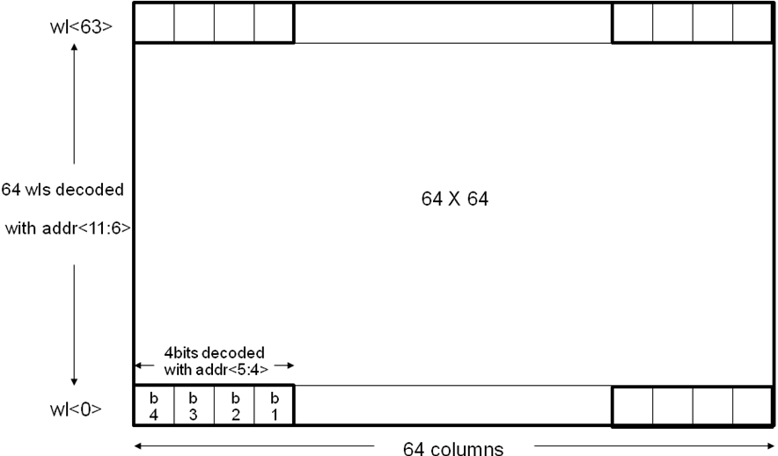

BLOCK DIAGRAM

din<15:0> dout<15:0>

OUT BUFFER
IN BUFFER

HIGH VOLTAGE SWITCH
OSCILLATOR
&PUMP CIRCUIT
clk

bufrst

MEMORY
CONTORLLER
DATA LATCH
SENSE AMPLIFIER
testmr
read
erase
pgm
loaden
sync
dby2
ADDRESS LATCH
Y-SELECT
Y-DECODER

MEMORY ARRAY
addr<13:4>
X-DECODER

DEVICE OPERATION

READ OPERATION
The access of S13EE_X64Y64 is similar as that of ROM. To obtain data at the outputs, three control functions must be satisfied:

1. During read operation, loaden、bufrst、din<15:0>、erase、pgm and clk should keep logic low. Word<1:0> should not keep logic high.
2. Reading is synchronous by input signal sync. The output dout will be ready after sync signal going to low.

PROGRAM OPERATION
The program operation is similar with writing data to SRAM and the data is programmed into the device (to a logical “0”) on a word basis. Clk and pgm signals activate a program operation. loaden、bufrst、sync、erase、read should keep logic low.The address and the data should be kept during the whole program cycle, too.
A data “0” can not be programmed back to a “1”. Only erase operation can convert “0”s to “1”s. It’s recommended that an erase operation is executed before the target array location is programmed.

ERASE OPERATION
The Erase instruction programs all bits in the specified memory location to the logical “1” state. Clk and earse signals activate a erase operation. loaden、bufrst、sync、pgm、read should keep logic low.The address and the data should be kept during the whole program cycle, too.

USER MODE TRUTH TABLE
Mode | loaden | bufrst | clk | sync | pgm | erase | read | din | dout | address
Standby | L | L | X | X | X | X | X | X | Z | X
Read | L | L | L | valid | L | L | H | X | valid | valid
Program | L | L | valid | L | H | L | L | valid | Z | valid
Erase | L | L | valid | L | L | H | L | valid | Z | valid
Notes: X stands for Logic Low or Logic High, L stands for logic Low, H stands for logic High, and Z stands for High impedance. Word[13:12] is not logic High.

DC OPERATING CONDITIONS
Parameter | Symbol | Min | Typ | Max | Units
Supply Voltage
Write voltage | vdd | 1.35 | 1.5 | 1.65 | Volt
Read voltage | vdd | 0.8 | 1.0 | 1.65 | Volt
Logic Voltage Level
Logic High Voltage | VIH | (vdd -10%) | vdd | (vdd + 10%) | Volt
Logic Low Voltage | VIL | (gnd – 0.2) | gnd | (gnd + 0.2) | Volt
Operating Temperature
Storage Temperature |  | -40 | 25 | 85 | ºC
Read Temperature |  | -40 | 25 | 85 | ºC
Write Temperature |  | -40 | 25 | 85 | ºC

DC CHARACTERISTICS
Parameter | Symbol | Condition | Min | Typical | Max | Units
Write Current^{[1]} | I_{CC} | @average / 16bits |  | 6 |  | µA
Read Current^{[2][3]} | I_{CC} | @500 kHz /16bits |  | 3 | 4.5 | µA
Standby Current | I_{CC} |  |  | 0.1 | 0.3 | µA
OFF Current | I_{CC} |  |  | 0.1 | 0.3 | µA
Note:
- Typical values are based on nominal conditions (Temperature=25ºC, V_{CC} =1.5V) and nominal process.
- Typical values are based on nominal conditions (Temperature=25ºC, V_{CC} =1.0V) and nominal process.
- Maximum values are based on worst case conditions (Temperature=85ºC, V_{CC} =1.65V) and worst case process corner.

DC CHARACTERISTICS
Parameter | Min | Typ | Max | Units
Timing
Program (per word) |  | 2.5 |  | ms
Erase(per word) |  | 2.5 |  | ms
Read (per bit) |  | 1500 |  | ns

RELIABILITY CHARACTERISTICS
Parameter | Typ | Max | Units
Data Retention | 10 | 20 | years
Endurance | 100000 | 200000 | cycles

PIN CAPACITANCE ( f = 1 MHZ, T = 25 ^{O} C)
 | Max | Units | Conditions
C_{IN} | 0.5 | pF | V_{IN} = 0V
C_{OUT} | 1 | pF | V_{OUT} = 0V

Buffer Reset and Data Loading Timing
(read=erase=pgm=clk=addr<13:12>=”low”) clk可以一直有效

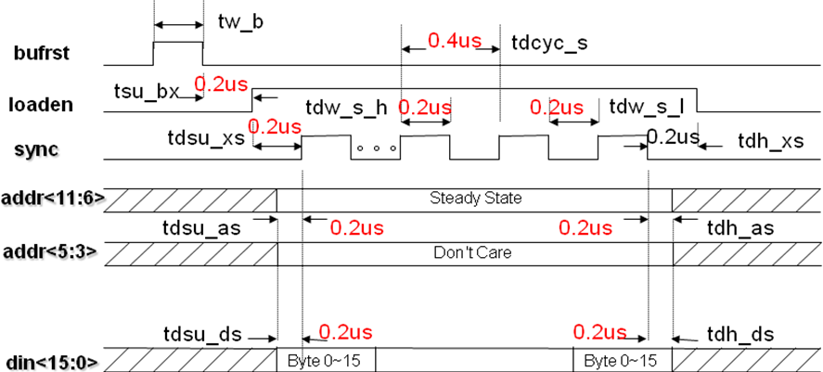

该时序图的addr<5:3>应该是addr<5:4>， 并且在sync到来之前要保持稳定，
且addr的最后两位要指定，图中 表示的don’t care 有误！
可以理解为：把addr<11:6>和addr<5:4> 可以合并成addr<11:4>来使用；
Note:
1). Each time you can load any 16 bit bytes data into the internal data-in buffers for later writing into the correspondent word line defined by addr<11:6>.
2). Before you are trying to load and write-in the data, you need to consider to apply a bufrst pulse. If you don't do so, the previous stored data in the internal data-in buffers (for any reason) might replace the byte(s) which you might not want them to be falsely replaced.
Applying this bufrst pulse is extremely needed when you start the first load and write-in operation just after you changed from any other non-programming modes or you just turned on the power of the chip.
3). If you program four bytes individually, the early programmed bytes will not be re-programmed with the same stored data. By doing this way, we can avoid the excessive programming cycles

该模式可以任意写入1-4个16bit数据，
写一个16bit sync 在loaden高电平期间就出现一个；
写两个16bit sync 在loaden高电平期间就出现两个；
依次类推；
写完成后，拉低loaden；

Parameter | Symbol |  |  |  |  | Unit
Parameter | Symbol | Min |  | Typ | Max | Unit
Pulse width of bufrst | tw_b | 0.2 |  |  | - | us
Setup time from bufrst low to loaden high | tsu_bx | 0.2 |  |  | - | us
Setup time from loaden high to sync high in data loading mode | tdsu_xs | 0.2 |  |  | - | us
Hold time from loaden low to sync low in data loading mode | tdh_xs | 0.2 |  |  | - | us
Setup time from addr to sync high in data loading mode | tdsu_as | 0.2 |  |  | - | us
Hold time from addr to sync low in data loading mode | tdh_as | 0.2 |  |  | - | us
Setup time from din to sync high in data loading mode | tdsu_ds | 0.2 |  |  | - | us
Hold time from din to sync low in data loading mode | tdh_ds | 0.2 |  |  | - | us
Pulse width of sync high in data loading mode | tdw_s_h | 0.2 |  |  | - | us
Pulse width of sync low in data loading mode | tdw_s_l | 0.2 |  |  | - | us
Cycle time of sync pulse in data loading mode | tdcyc_s | 0.4 |  |  | - | us

Write-Erase and Program-Timing 写时序中需要用到clk
(read=loaden=bufrst=sync=addr<13:12>=”low”)

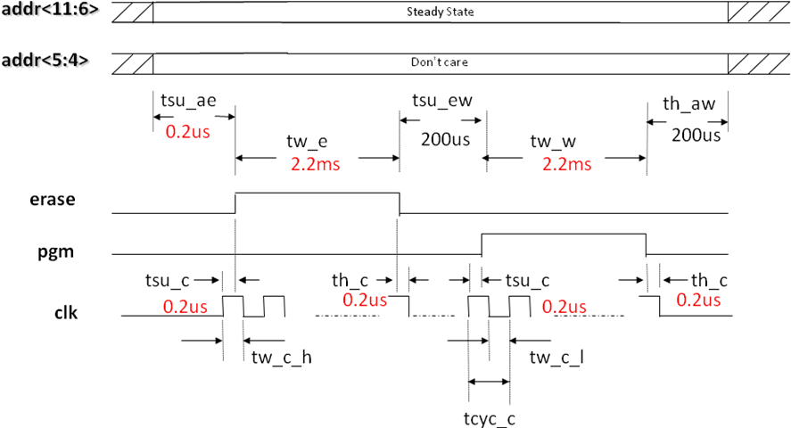

Dby2 (Clock Input Cycling Frequency Di
vided by 2) when writing:

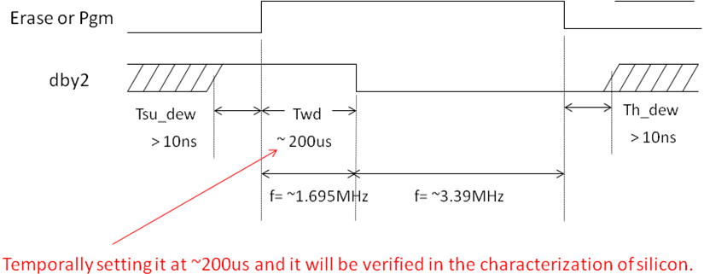

Notes:
1. When pin dby2 is set at “High”, the clock cycling time from system input will be divided by two and the power consumption for driving the internal charge pump will be reduced almost immediately.
2. The preliminary Timing waveform is suggested as below: (The timing of all other related signals can be referred in other pages.)

Parameter | Symbol | Min | Typ | Max | Unit
Setup time from addr to erase high | tsu_ae | 0.2 |  | - | us
Setup time from erase low to pgm high in program mode | tsu_ew | 100 |  | - | us
Hold time from addr to pgm low in write mode | th_aw | 100 |  | - | us
Pulse width of erase | tw_e | 2.4 |  | - | ms
Pulse width of pgm | tw_w | 2.4 |  |  | ms
Pulse width of clk high | tw_c_h | 240 |  | 280 | ns
Pulse width of clk low | tw_c_l | 240 |  | 280 | ns
Cycle Time of clk | tcyc_c | 416 |  | 624 | ns
Clk starts before erase or pgm go high | tsu_c | 0.2 |  | - | us
Clk stops after erase or pgm go low | th_c | 0.2 |  | - | us

Read Timing 每次读一个16bit
(loaden=bufrst=din<15:0>=clk=addr<13:12>=”low”)

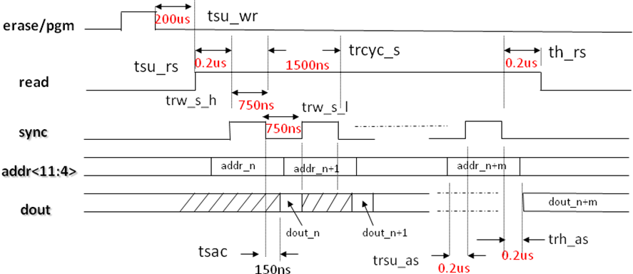

Notes:
1). During the read operation, loaden, bufrst, erase, pgm, clk always keep low.
2). Reading is synchronous by input signal sync. The output dout will be ready after sync signal going to low.

Parameter | Symbol | Min | Typ | Max | Unit
Setup time from write low to read/erase high inprogram mode | tsu_wr | 200 |  |  | us
Setup time from read high to sync high | tsu_rs | 0.2 |  |  | us
hold time from read low to sync low | th_rs | 0.2 |  |  | us
Pulse width of sync high in read mode | trw_s_h | 750 |  |  | ns
Pulse width of sync low in read mode | trw_s_l | 750 |  |  | ns
Cycle time of sync in read mode | trcyc_s | 1500 |  |  | ns
Dout ready after sync low | tsac | 150 |  |  | ns
Setup time of addr to sync high in read  mode | trsu_as | 0.2 |  |  | us
Hold time of addr to sync low in read mode | trh_as | 0.2 |  |  | us

TEST MODE : addr<13:12> (All Word Lines On Mode) 必须写入4个16bit数据，写完成后，就全片写入这4个16bit数据

In the "All Word Lines On" mode, all loaded byte data (up to 16 Bytes) will be written into all the same byte locations respectively in all 64 word lines.

1. Buffer Reset and Data Loading Timing (read=erase=pgm=clk=”low”)

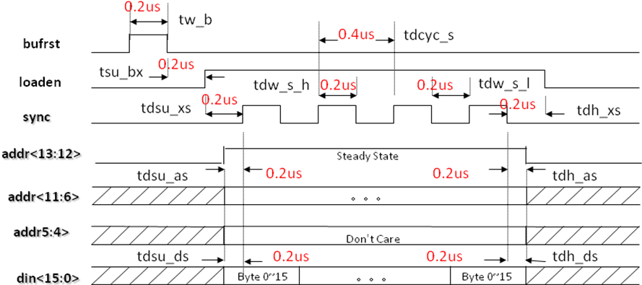
该时序图的addr<5:3>应该是addr<5:4>， 并且在sync到来之前要保持稳定，
且addr的最后两位要指定，图中 表示的don’t care 有误！
可以理解为：把addr<11:6>和addr<5:4> 可以合并成addr<11:4>来使用；

2. EEPROM Write-Erase and Program–Timing (read=loaden=bufrst=sync=”low”)
全片擦除
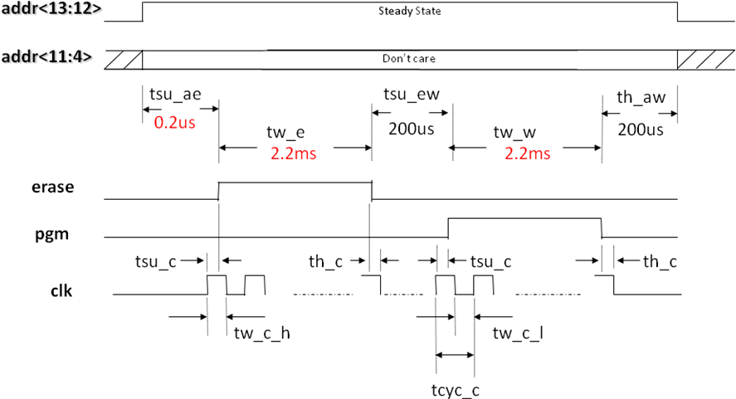
Notes:
a. Treat signal addr<13:12>as an one of the regular address bit.
b. All the timing spec will be same as that of the regular erase and program.

全片擦除的时候不需要pgm置高，全程保持低电平

新增需求：

这几个电压分别供电，其中vddio是IO电压，和单片机电位相同，固定接3.3v。其它电源会有调节的需求。1.测功能时，vdd_t和vddp短接(需外部供电)。2.测电流时，vdd_t和vddp分开供电，并需要测vddp的电流，vddp端口留有电阻端口和跳线。
每个外部供电都要GND的跳线（单排针）。另外再增加几个备用的GND测试点（单排针）

所有setup，hold time 时间下限10ns，尽量用单片机做调试；目前确认20ns
Clk时序要求不严格，只要有就行，clk的setup ，hold time不影响

Debug 时 ，vpp作为输入 vpp接高压16v，在erase 和 pgm高电平期间，供电；
在erase 和 pgm低电平期间为0，或者是vddp；

VPP禁止任何漏电， 离其他管脚远一点；
地址和数据可以变

PIN ASSIGNMENTS

clk
din<15:0>
addr<13:4>
pgm
erase
read
sync
EEPROM gnd
dout<15:0>
bufrst
testmr
loaden
dby2 vdd

Digital
Logic
Circuit

Date | Revision No. | Description of Changes | Page No.
Jan. , 2016 | V1.0 | First release | All

eeprom 模型管脚描述：
使用spartan 6开发板的外部扩展接口1
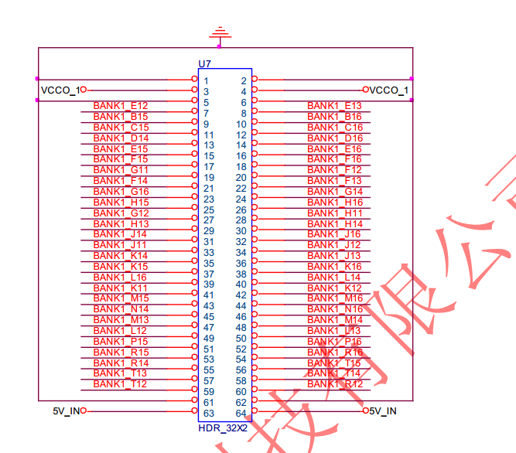

Eeprom管脚和fpga管脚对应关系:
NET "sys_clk" LOC = A10 | IOSTANDARD = LVTTL;
//reset signal
NET "sys_rst_n" LOC = T8 | IOSTANDARD = LVTTL;
//addr[13:4]
NET "addr[13]" LOC = E12 | IOSTANDARD = LVCMOS33;
NET "addr[12]" LOC = B15 | IOSTANDARD = LVCMOS33;
NET "addr[11]" LOC = C15 | IOSTANDARD = LVCMOS33;
NET "addr[10]" LOC = D14 | IOSTANDARD = LVCMOS33;
NET "addr[9]" LOC = E15 | IOSTANDARD = LVCMOS33;
NET "addr[8]" LOC = F15 | IOSTANDARD = LVCMOS33;
NET "addr[7]" LOC = G11 | IOSTANDARD = LVCMOS33;
NET "addr[6]" LOC = F14 | IOSTANDARD = LVCMOS33;
NET "addr[5]" LOC = G16 | IOSTANDARD = LVCMOS33;
NET "addr[4]" LOC = H15 | IOSTANDARD = LVCMOS33;
//data_in[15:0]
NET "data_in[15]" LOC = G12 | IOSTANDARD = LVCMOS33;
NET "data_in[14]" LOC = H13 | IOSTANDARD = LVCMOS33;
NET "data_in[13]" LOC = J14 | IOSTANDARD = LVCMOS33;
NET "data_in[12]" LOC = J11 | IOSTANDARD = LVCMOS33;
NET "data_in[11]" LOC = K14 | IOSTANDARD = LVCMOS33;
NET "data_in[10]" LOC = K15 | IOSTANDARD = LVCMOS33;
NET "data_in[9]" LOC = L16 | IOSTANDARD = LVCMOS33;
NET "data_in[8]" LOC = K11 | IOSTANDARD = LVCMOS33;
NET "data_in[7]" LOC = M15 | IOSTANDARD = LVCMOS33;
NET "data_in[6]" LOC = N14 | IOSTANDARD = LVCMOS33;
NET "data_in[5]" LOC = M13 | IOSTANDARD = LVCMOS33;
NET "data_in[4]" LOC = L12 | IOSTANDARD = LVCMOS33;
NET "data_in[3]" LOC = P15 | IOSTANDARD = LVCMOS33;
NET "data_in[2]" LOC = R15 | IOSTANDARD = LVCMOS33;
NET "data_in[1]" LOC = R14 | IOSTANDARD = LVCMOS33;
NET "data_in[0]" LOC = T13 | IOSTANDARD = LVCMOS33;
//dout[15:0]
NET "dout[15]" LOC = E13 | IOSTANDARD = LVCMOS33;
NET "dout[14]" LOC = B16 | IOSTANDARD = LVCMOS33;
NET "dout[13]" LOC = C16 | IOSTANDARD = LVCMOS33;
NET "dout[12]" LOC = D16 | IOSTANDARD = LVCMOS33;
NET "dout[11]" LOC = E16 | IOSTANDARD = LVCMOS33;
NET "dout[10]" LOC = F16 | IOSTANDARD = LVCMOS33;
NET "dout[9]" LOC = F12 | IOSTANDARD = LVCMOS33;
NET "dout[8]" LOC = F13 | IOSTANDARD = LVCMOS33;
NET "dout[7]" LOC = G14 | IOSTANDARD = LVCMOS33;
NET "dout[6]" LOC = H16 | IOSTANDARD = LVCMOS33;
NET "dout[5]" LOC = H11 | IOSTANDARD = LVCMOS33;
NET "dout[4]" LOC = H14 | IOSTANDARD = LVCMOS33;
NET "dout[3]" LOC = J16 | IOSTANDARD = LVCMOS33;
NET "dout[2]" LOC = J12 | IOSTANDARD = LVCMOS33;
NET "dout[1]" LOC = J13 | IOSTANDARD = LVCMOS33;
NET "dout[0]" LOC = K16 | IOSTANDARD = LVCMOS33;
// scalar port
NET "pgm" LOC = L14 | IOSTANDARD = LVCMOS33;
NET "erase" LOC = K12 | IOSTANDARD = LVCMOS33;
NET "sync" LOC = M16 | IOSTANDARD = LVCMOS33;
NET "bufrst" LOC = N16 | IOSTANDARD = LVCMOS33;
NET "loaden" LOC = M14 | IOSTANDARD = LVCMOS33;
NET "clk" LOC = L13 | IOSTANDARD = LVCMOS33;
NET "clk_out" LOC = P16 | IOSTANDARD = LVCMOS33;

