2018/5/3

test mode – buffer reset data load & erase & program

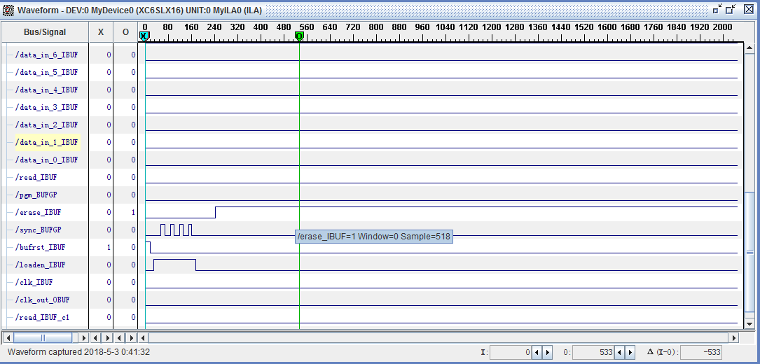

read timing

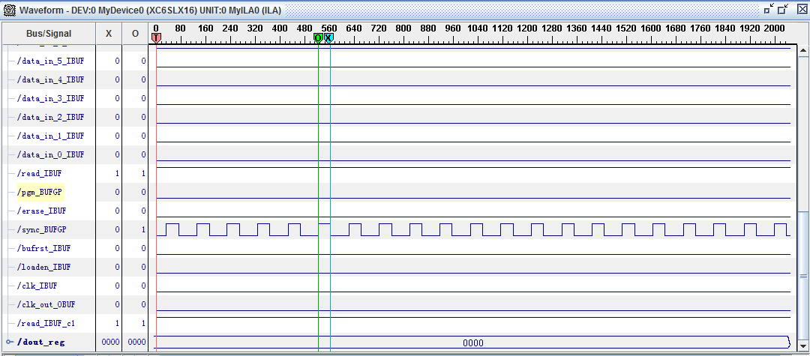

clk 信号没采集到，