

INTRODUCTION
Genesis Plus emulates a Sega Genesis or Megadrive console. It has been originally written by Charles MacDonald and ported to the Nintendo Gamecube and now the Wii by the “Genesis Plus” Team. It is an open source emulator and a community project which aims to bring you blast processing into the past. Using this “emulator” you will be able to enjoy all of your classic 16bit games in all of their glory. Genesis Plus has been converted from a PC based platform to run on the proprietary PPC Gekko processor and features customized code to give you the best gaming experience possible.
This port is based on Genesis Plus 1.2 source code but has been largely modified to improve overall compatibility, emulation accuracy as well as adding various peripheral supports and interface extra features. Please have a look at history.txt for a complete change log.

FEATURES

Accurate & full speed Sega Genesis/Megadrive emulation
- NTSC (60Hz) & PAL (50Hz) timings support
- cycle-accurate CPUs synchronization (68000, Z80, YM2612, SN76489)
- cycle-accurate VDP emulation (DMA, FIFO, HV interrupts, HBLANK,…)
- original frequency YM2612 emulation (High Quality FM)
- hardware latency emulation
- full overscan area (horizontal & vertical colored borders) emulation
- TMSS BIOS support
- PICO hardware support (experimental)

Support for various input peripherals
- 3-buttons & 6-buttons controllers
- Sega TeamPlayer & EA 4-Way Play multitap adapters
- Sega Menacer & Konami Justifier lightguns
- Sega Mouse & Sega Mega Mouse

Support for various cartridge internal hardware
- SVP DSP (Virtua Racing)
- J-Cart
- backup RAM (parallel SRAM/FRAM and serial EEPROM)
- ROM bankswitch (Super Street Fighter 2)
- SRAM switch (Phantasy Star 4, Legend of Thor, Sonic the Hedgehog 3)
- ROM mappers & copy protection devices used in many unlicensed/pirate cartridges
- Game Genie codes

Gamecube/Wii extra features
- Stereo Sound (@48 kHz)
- 1~4 Players support
- SRAM and SaveState files (on MemoryCard & SDCard)
- automatic SRAM/Savestate loading & saving
- ROM internal information screen
- support for zipped (.zip) and interleaved (.smd) roms
- load roms from SDCard or DVD
- original video modes (240p/240i/288p/288i) support
- interlaced (576i/480i) & progressive (480p) video modes support

Wii-only features
- up to 8 Players support
- Wiimote, Nunchuk & Classic Controller support

CREDITS

Genesis Plus core
- original emulation code by Charles Mac Donald
- additional code (core, extra features, compatibility fixes,…) by Eke-Eke
- Z80, 68000 and YM2612 cores by the M.A.M.E team
- alternate YM2612 core by Stef
- SN76489 core by Maxim
- SVP core by Notaz
- libsamplerate by Erik de Castro Lopo
- zlib by Jean-Loup Gailly and Mark Adler

additional thanks to
- Nemesis, for having tested and documented many unknown YM2612 features
- Tasco Deluxe for his work around the SVP chip and for his documentation of Realtec mapper
- Bart Trzynadlowski for his documentation about SSFII mapper and 68000 undocumented behaviour
- Haze for having found and documented many unlicensed cartridges protections
- Notaz & Stef for their help, the source code of their respective emulator, Picodrive and Gens, was also a great source of inspiration
- AamirM, author of Regen, for some good advices
- Charles Mc Donald for his excellent documentation about the Sega Genesis hardware and for having designed such a great emulator
- Spritesmind & SMS Power forums members for their technical help

Gamecube/Wii port
- original Gamecube's port by softdev, honkeykong & markcube
- additional features and Wii port by Eke-Eke
- graphical interface and icon design by brakken
- libFAT by Chism , ported to libogc by Sven Peter (svpe) & wintermute
- wiiuse library by Michael Laforest (para), ported to libogc by shagkur
- libDI by Erant
- libOGC by winterMute, shagkur and all contributors
- devkitpro & devkitPPC by winterMute

additional thanks to
- softdev for all his great work and inspiration
- tmbinc for having made Gamecube homebrew a reality
- Twiizer team for all the work they are doing for Wii homebrew
- brakken & Tehskeen's forum members for their feedback and support

COMPILE THE SOURCECODE
According to the GNU status of this project, the source code MUST be made available to anyone as soon as you have modified it and released a binary.
To recompile the source code, you will need to be familiar with development environment setup. If you don't, you might look at wiibrew or tehskeen's forum.
First, you will have to download and install the following tools/libraries:
- the last version of Devkitpro and DevkitPPC. Windows user should directly run the AutoInstaller version
- the CVS version of libogc.
- the last version of libfat. You can also get and compile the current source from CVS repository
- the last libDI source code.
Once you are done, grab the current genplus-gx source code from SVN (http://code.google.com/p/genplus-gx/source/checkout) then launch compile_all.bat from msys (installed with devkitpro)

RUN THE EMULATOR
genplus_cube.dol is the application running in Gamecube mode. They can be loaded on a Gamecube or a Wii (using GC compatible mode) through various methods (Bootable DVD, SDLOAD,...). If you have no idea on how to load a DOL, please go here on follow the available guides: http://modyawii.tehskeen.com (Booting Homebrew Section).
genplus_wii.dol is the application running in WII mode, using extra features like wiimotes and native SD slot support. They can be loaded on a Wii using either the TP Loader or the Homebrew Channel. See http://www.wiibrew.org/ and http://hbc.hackmii.com/ for more information on how to run .dol and .elf files on your Wii. To use it with the Homebrew Channel, simply rename genplus_wii.dol to boot.dol and place it, with meta.xml & icon.png, on your sdcard, in the /apps/genplus directory.

SETUP THE EMULATOR
Supported ROM files format are common .bin and .smd Sega Genesis/Megadrive ROM format. However, .zip files are also supported as long as they contain a valid ROM image file.
ROM files can either be loaded from a SDCARD or from a DVD. You can store them anywhere and it is strongly recommended to use subdirectories and limit the amount of ROM files per directory in order to speed-up the browsing process. According to the device you are using to load ROM files, please consider the following rules:
- SDCARD should be formatted in FAT16 (FAT). The emulator will always be looking in the directory "/genplus/roms" by default so it is recommended to create these directories (on a side note, configuration files are saved in the /genplus directory) and put your ROM files here. If the directory does not exist, the program will let you browse from the root of the SDCARD.
- The Gamecube version requires a SD-adapter inserted in one of the two memory card slots (automatically)
- The Wii version requires that you insert a SDCARD inside the front SD slot (SD-adapter is not supported).
  - DVD should use ISO9660 file format. The emulator starts looking for files from the root directory. The maximal size of the DVD depend on the type of the DVD drive: the Gamecube Mini-DVD drive allows up to 1.35GB of data and the Wii DVD drive allows up to 4.7GB of data (simple-layer).
- The Gamecube version requires a modchip to be able to read DVD-/+R
- The Wii version does not requires a modchip but you will have to install the DI layer “softmod” separately. If you have a modchip, you might need to install a patched IOS. More informations about the DI softmod can be found here: http://hackmii.com/2008/08/libdi-and-the-dvdx-installer/

USE THE EMULATOR
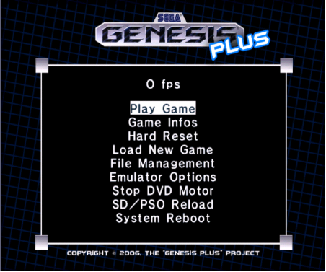
You'll start off with the main introduction screen and after pressing "A" you will be at the main menu.

When you are navigating through the menus, the following keys on your Gamecube controller are used:
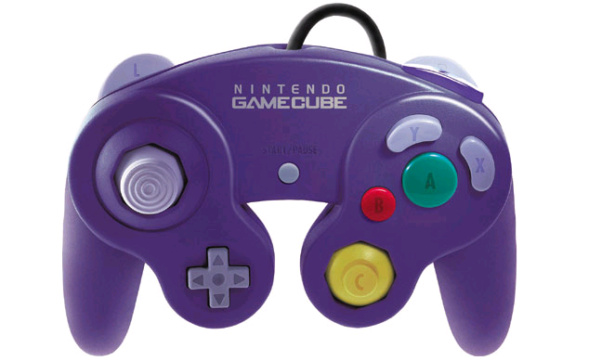

A Button : confirm selection

B Button : previous menu

Analog stick : items selection

D-PAD : items selection
Wii version :
You can also navigate through the menu using the Wiimote and expansion controller. In the Menu, keys are mapped as the following:
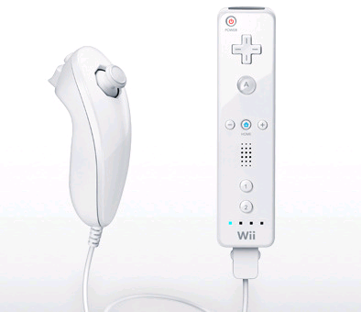

A Button : confirm selection

B Button : back to previous

D-PAD : items selection

Analog stick : items selection

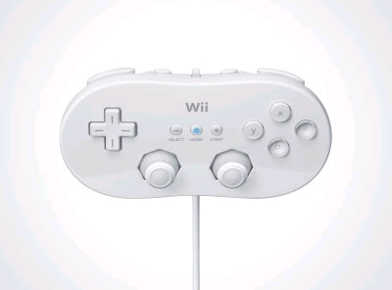

D-PAD : items selection

Left Analog stick : items selection

Button B : back to previous

Button A: confirm selection

PLAY GAME
This will takes you into or back to the game.
Gamecube version :
A gamecube controller is required. Wavebird controllers are known to have some issues, it is recommended to press any button during the initialization process to make them detected properly.
The default key mapping is listed in the table below, please note that grey entries are not reconfigurable but all others might be reconfigured in Controllers option menu.
Wii version :
Gamecube controllers are also supported and you can use the Wiimote and Nunchuk/Classic expansion controllers. There are 3 possible configurations depending on the type of expansion controller that is inserted when you play a game: WIIMOTE only, WIIMOTE + NUNCHUK combination or CLASSIC controller.
Each of three configurations have a default key mapping listed in the table below but can also be reconfigured separately from the Controllers option menu (apart from the grey entries signalled below). Please not that a maximum of 4 wiimotes can be synchronized.
Note: Soft Reset can also be performed by pressing the gamecube/Wii RESET button.
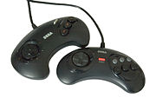 | 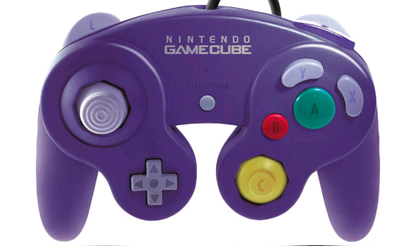 | 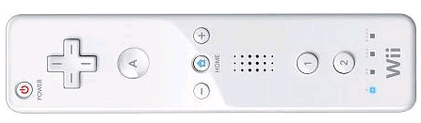
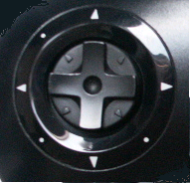 |    |  |  | 
 | START
 | 
 | 
 |  |  | Z
 | 
 | 
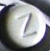 | 
MODE | START  Z
MENU | Z
SOFT RESET | L + Z
GAME INFOS
This screen shows some basic information for the loaded ROM. You can use Up/Down buttons or Analog Stick to scroll down the screen and display all informations. At the bottom of the list, you can see the peripherals that the game should be supporting: please note that if it supports 6-button gamepads, they are automatically selected for you. Otherwise, the standard 3-button pad is used (this can also be forced in Controllers option menu).

HARD RESET
This should be like switching OFF/ON the POWER button on a real Genesis. This will completely reinitialize the genesis virtual machine.

LOAD NEW GAME
Load Recent let you browse a ROM history list with the ten last opened ROM files. This is only available for ROM files previously loaded from SDCARD.
Load from SDCARD let you browse the SDCARD.
Load from DVD let you browse the DVD.
Stop DVD Motor will stop the DVD motor and the disc from spinning during playtime

Once you have selected an option, a file selection menu should appear. In this new selection menu, the following controls can be used:
GAMECUBE PAD
- A button : load the selected file
- B button : go up one directory
- Z button : quit the file selection menu
- L/R triggers : go down/up one full page
- Left/Right buttons or Analog stick : display the selected entry's full filename
- Up/Down buttons or Analog stick : select previous/next file

WIIMOTE, WIIMOTE+NUNCHUK
- A button : load the selected file
- B button : go up one directory
- HOME button : quit the file selection menu
- -/+ Buttons: down/up one full page
- Left/Right buttons or Analog stick : display the selected entry's full filename
- Up/Down buttons or Analog stick : select previous/next file

CLASSIC CONTROLLER
- A button : load the selected file
- B button : go up one directory
- HOME button : quit the file selection menu
- L/R triggers: down/up one full page
- Left/Right buttons or Analog stick : display the selected entry's full filename
- Up/Down buttons or Analog stick : select previous/next file

FILE MANAGEMENT

Let you managed SRAM and SaveState files:
SRAM Manager:
Let you load/save SRAM data from/to the selected device. SRAM files are only generated when the game have an internal saving feature. The SRAM data corresponds to the data saved by the game and will be used to later restore you progression.

STATE Manager:
Let you load/save SaveState data from/to the selected device . SaveState files is a feature that does not exist on real hardware and will let you save and restore your progress in ANY games, even those which don’t have internal saving feature. The SaveState data can be seen as a snapshot (or “freeze” state) of the current emulation state. Once restored, you will be able to continue your game at the exact point where you leaved it.
For each sub-menu, you can choose the device type (for SDCARD, the default slot is automatically detected upon start-up). Be sure to set this according to your system configuration before saving/loading files:
Notes:
- you can configure the emulator so that it will automatically save SRAM and/or SAVESTATE for the current game as soon as you load another game or quit the application. On the same way, SRAM and/or SAVESTATE can automatically be restored after you load a game, if the files exist. This feature can be enabled/disabled via the System Options menu.
- when using NGC Memory Card in SLOTA, some mounting errors may occur. In this case, remove and insert the Memory Card again before trying to save/load anything or use SLOTB. Be sure to have also enough space on the Card before trying to save something (Freeze State and SRAM files are usually compressed).
- when using SDCARD, the directory /genplus/saves is automatically created. The default SDCARD location is detected during initialization.

EMULATOR OPTIONS

VIDEO Options
Aspect let you change the display aspect ratio:
- ORIGINAL mode automatically set the correct aspect ratio exactly as if you connected a real Genesis/Megadrive on your TV.
- STRETCH mode let you adjust horizontal and vertical scale values so that the active display fits your TV screen..

Render let you change the display video mode:
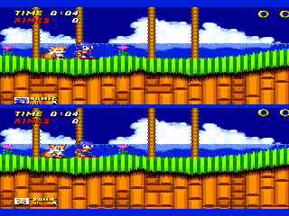
- ORIGINAL let you use the original Genesis/Megadrive rendering modes: these modes generally output a progressive 240 lines (288 lines for PAL) display. Interlaced modes (240i/288i), used in Sonic 2 (2 players mode) for example, are also supported and automatically detected. In this mode, games should look exactly as they did on the real hardware.
- BILINEAR vertically scales (using hardware filtering features) the original display to a 480 lines (574 lines for PAL) interlaced display. In this mode, because of the higher resolution, games generally look better than on the real hardware but some artefacts might appear during fast movements.
- PROGRESS enables Progressive Video Mode (480p), only use this with component cable and a compatible TV. In this mode, TV display is forced to 60Hz.

TV Mode let you change the TV mode:
- 50/60Hz: in this mode, the Wii/Gamecube automatically switches between the appropriates 50hz and 60Hz TV modes depending on the system region. This makes PAL & NTSC games looking exactly like they did on a real Megadrive/Genesis.
- 60Hz: in this mode, the Wii/Gamecube forces the display to 60Hz (NTSC or PAL60) TV mode, use this if your TV does not support 50Hz.

- 50Hz: in this mode, the Wii/Gamecube forces the display to 50Hz (PAL) TV mode, use this if your TV does not support 60Hz.

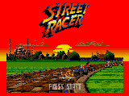
Borders let you enable/disable the border colour emulation: when ON, the background colour is used, like on a real Genesis/Megadrive. When OFF, borders are forced to black.

Center X/Center Y let you adjust the screen position while keeping the display aspect ratio.

Scale X/Scale Y let you adjust the display aspect ratio manually. This option is only accessible when using STRETCH aspect mode.

AUDIO Options

PSG Volume let you adjust the global volume level for the PSG output (0~200%)

FM Volume let you adjust the global volume level for the FM output (0~200%)
Boost Volume let you modify the overall sound level (0~4x). This could be useful when adjusting FM and PSG relative levels.
Setting those values too high may produce some bad effects. Default values depends on the current selected FM & PSG core and are automatically set when switching between cores (see below).
HQ YM2612: when enabled, the FM synthesiser chip is emulated at his original frequency to sound very much closer to the original. Sample rate conversion is done on the output to match the Gamecube/Wii rate (48000 Hz), using libsamplerate algorithms (MAME core only) or default linear interpolation (GENS core):
- OFF: the high-quality mode is disabled and no sample rate conversion is done
- LOW: Zero Order Hold converter (interpolated value is equal to the last value). The quality is poor but the conversion speed is very fast.
- LINEAR: linear interpolation is used, again the quality is poor but the conversion speed is very fast. This is the default option for GENS core.
- FAST: Slower than the previous ones, this is a very fast bandlimited interpolator, which provide much more quality than interpolators: it has an SNR of 97dB and a bandwidth of 80%
- MIDDLE: This is another bandlimited interpolator much like the previous one. This one has an SNR of 97dB and a bandwidth of 90%, providing better quality. The speed of the conversion is however a little slower than the previous ones.
- BEST: This is a bandlimited interpolator derived from the mathematical sinc function and this is the highest quality sinc based converter, providing a worst case Signal-to-Noise Ratio (SNR) of 97 decibels (dB) at a bandwidth of 97%. Obviously, this one is also much slower than any previous converters, This option is actually disabled because it increases the size of the application too much, it can be re-enabled by recompiling the source code with proper flag.
Please visit http://www.mega-nerd.com/SRC/api_misc.html#Converters for more informations about the sample rate converters algorithms.

FM CORE let you choose which YM2612 emulation core to use:
- GENS is the core used in Gens, a well-known Sega Genesis emulator for PC platforms
- MAME is the one used in the M.A.M.E emulator (default)

SYSTEM Options
Region let you force the region setting for the Sega Genesis/Megadrive, this will also force PAL or NTSC timings:
- AUTO: original game region is automatically detected through ROM header when loading the game
- EUR: europe (PAL 50Hz)
- USA: usa (NTSC 60Hz)
- JAP: japan (NTSC 60Hz)

Some games may display various things depending on the selected region setting but also may not work correctly if they have some internal region protection code.
Use BIOS let you enable/disable Genesis TMSS BIOS when starting a new game. If you want to use this feature (this is not required to play games), the BIOS (not provided) must be renamed as BIOS.bin and placed in the /genplus/ directory on the SDCARD.
Force DTACK can be useful to prevent games accessing illegal memory area to lock-up the system (as it indeed happens on the real hardware). When this option is enabled, the system continues to run even if an illegal area has been acceded (example: “Sonic Crackers” prototype).
SVP Cycles let you adjust the number of CPU cycles per line to run for the emulated SVP chip used in Virtua Racing. This additional CPU consumes a lot of resources so you can lower the default value to improve the emulation frame-rate. Although, keep in mind that the SVP chip will also be running slower, which will result in slower 3D rendering. In Wii mode, this should not be necessary to modified the default value as the CPU is more powerful.
SRAM AUTO let you enable/disable automatic SRAM loading when a new game has been loaded and auto-saving when you quit the emulator or load a new game. This option also let you specify the default location for the SRAM files : SDCARD, MEMCARD (slot A or slot B)
FREEZE AUTO let you enable/disable automatic SaveState loading when a new game has been loaded and auto-saving when you quit the emulator or load a new game. This option also let you specify the default location for the SaveState files : SDCARD, MEMCARD (slot A or slot B)

CONTROLS Options
PORTA and PORTB let you choose which type of device to be plugged in each two Genesis input ports:
- GAMEPAD: default genesis controller (3 or 6-buttons, see above)
- MOUSE: Sega Mouse controller
- TEAMPLAY: Sega TeamPlayer multitap (can be affected to each port for max. 8 players)
- WAYPLAY: EA 4-way play multitap (use both ports, max. 4 players)
- MENACER: Sega lightgun
- JUSTIFIERS: Konami lightguns
- NONE: unplugged

Notes:

- when loading some specific games, these options are automatically set to match the appropriate configuration.
- when a game is known to use J-CART, it is impossible to connect any multitap adapter.
- when using EA 4-way play, both ports are automatically used.
- it is impossible to have both port simultaneously unplugged or two simultaneous mousse
- it is only possible to connect lightguns (MENACER or JUSTIFIERS) on Port B.

Gun Cursor let you enable/disable guns cursor display when lightguns are emulated.
Invert Mouse let you invert Y Axis when Sega Mouse is emulated. This might be required by some games with buggy mouse routine (Populous 2 for example),

Set Player let you change the current player for the following configuration options.
Note: Up to 4 gamecube controllers and 4 wiimotes with expansion are supported, making a maximum of 8 players in the Wii version, and 4 players in the Gamecube version.
Device let you choose the type of device assigned to the current player.
- NONE: no device assigned
- GAMECUBE: gamecube controller
- WIIMOTE: Wii remote controller
- NUNCHUK: Wii remote & Nunchuk expansion controller
- CLASSIC: classic controller
Notes:
  - for GAMECUBE controller, the device port will automatically be set according to the player number: players 1-4 and Players 5-8 use gamecube ports 1-4.
  - other available controllers (wiimote, nunchuk or classic controllers) can be affected to any players.
  - when a classic controller is connected, the wiimote can be affected to a separate player.

Type let you change the default type of the connected gamepad (3-Buttons or 6-Buttons) : Genesis Plus automatically detects and set this option if the current game supports 6-Buttons but you can also force 3-Buttons gamepads if you want.
Note: When using a Wiimote, the pad type is automatically forced to 3BUTTONS as there aren’t enough available buttons to emulate a 6-Buttons pad.
Configure Inputs let you modify the default key mapping of the selected device.

Some notes about Peripherals:
- multitap is disabled by default. Only activate it with games supporting either EA 4-Way Play or Sega TeamPlayer adapters. If you don’t know which one the game is supporting, set TEAMPLAY as default, the emulator automatically detects if a game requires WAYPLAY and will switch the configuration automatically.
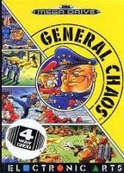
- most multiplayer games will work with TEAMPLAY plugged in PORTA but some of them require a GAMEPAD to be plugged in PORTA and the TEAMPLAY to be plugged in PORTB. Some games can support up to 8 players, this is enabled by plugging the TEAMPLAY in both ports. Please note that the gamecube version only support a maximum of 4 players.
.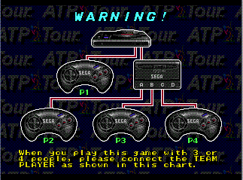

- J-CART games (Micro Machines series, Pete Sampras series, Super Skidmarks) had a cartridge built-in adapter which let you plug 2 additional. They are automatically detected by the system which configure itself to enable up to 4 players support.
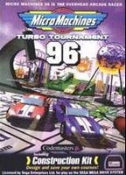

- when MENACER or JUSTIFIERS are enabled, lightgun games often require a gamepad to be connected on Port A. In that case, beware that the lightgun will be affected to player 2. When using JUSTIFIERS, player 2 AND player 3 can be affected, as two lightguns are emulated.
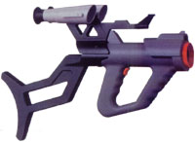

GAME GENIE Codes
This screen lets you enter up to eight Game Genie codes. Use the A key to select/release an entry and the B key to exit.
NOTE: Game Genie codes are reinitialized each time a game is reloaded.

RETURN TO LOADER will allow you to return to the loader used to launch the program, if any (Homebrew Channel, TP Loader, SDLOAD, PSOLOAD)
SYSTEM REBOOT will reboot your console (Gamecube Mode) or return to the Wii System Menu.

Thank you for reading !
eke-eke

