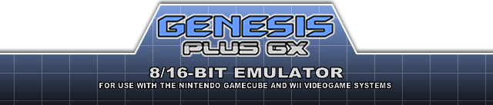

INTRODUCTION
This is a port of Genesis Plus, a Sega Mega Drive / Genesis emulator, originally written by Charles MacDonald, now running on Wii & Game Cube.
This port was initially based on Genesis Plus 1.3 source code but, with respect to initial goals, the original core has been largely modified, improving emulator accuracy, as well as implementing new features and adding support for lot of peripherals & extra cartridge hardware.
The result is that Genesis Plus GX is now extremely faithful to the “real thing”, can run the entire Genesis / Mega Drive game library (including all unlicensed & pirate available dumps) and the majority of Master System games (through Power Base Converter backwards compatibility). As a bonus, it now also provides very accurate emulation of SG-1000, Game Gear & Master System consoles hardware for 100% compatibility with the respective software libraries and available ROM dumps. Last but not least, it comes with plenty of exciting features that have nothing to envy to your most favorite PC emulators.

LEGAL NOTICE
This project is open-source and distributed under a specific license. The last version of the source code can always be found here: http://code.google.com/p/genplus-gx/ and can be reused under the terms of the aforementioned license, and, in particular, is strictly forbidden to use in any commercial project.
Also note that this program can not be distributed with any copyrighted software, including ROM files, and is not licensed by Sega Enterprises or Nintendo Co Ltd. All trademarks mentioned in this document are the property of their respective owners.
Although this program has been carefully tested and should not harm your console, the author of this port can not be held responsible for damage or dysfunction that could occur during the use of this program.

CREDITS

Genesis Plus core
- current version (improved emulation accuracy, new features, compatibility fixes & various cores modification) by EkeEke
- based on the original 1.3 version by Charles MacDonald
- original Z80 core by Juergen Buchmueller (MAME)
- original Musashi 68k core by Karl Stenerud (MAME)
- original YM2612 & YM2413 cores by Jarek Burczynski and Tatsuyuki Satoh (MAME)
- SN76489 core by Maxim
- SVP core by Notaz
- FIR Resampler, linear Blip Buffer & NTSC Video Filter by Shay Green (Blargg)
- 3-Band EQ implementation by Neil C

Additional thanks
- Nemesis, for having tested and documented many of the unknown YM2612 features and helping out improving FM emulation.
- Tasco Deluxe for his work around the SVP chip and for his documentation of REALTEC mapper used in a few unlicensed games.
- Bart Trzynadlowski for his documentation of the "Super Street Fighter II" mapper and some 68000 undocumented aspects.
- Jorge Cwik for his work on some 68000 undocumented timings and instruction prefetch.
- Haze for having found and documented many unlicensed game protections.
- Notaz & Stephane Dallongeville for sharing the source code of their respective emulators, Picodrive and Gens, which were also great sources of inspiration.
- Steve Snake, author of Kega and AamirM, author of Regen, for sharing some of their findings.
- Charles MacDonald, for his excellent documentation about the Sega Genesis hardware.
- Spritesmind & SMS Power forums members for their technical help.

Game Cube & Wii ports
- current version, Wii port, generic GUI design & coding by EkeEke
- based on the original Game Cube port by Softdev, Honkeykong & Markcube
- original icon, logo & button design by LowLines
- credit picture by Orioto
- memory card icon design by Brakken
- libFAT by Chism
- wiiuse library by Michael Laforest (para)
- libDI by Erant
- libOGC by Shagkur & many others
- asndlib and OGG player by Hermes incl. some fixes by Tantric
- libpng and libtremor by their respective authors

Additional thanks to
- Softdev for all his great work and inspiration
- Wintermute for devkitpro & devkitPPC
- Tmbinc for having opened the way to the Game Cube scene
- Twiizer team for all their contribution to the Wii scene
- Brakken & former Tehskeen forum members for their feedback, support and donations

FEATURES

Accurate & full speed 8-bit / 16-bit emulation
- Accurate emulation of SG-1000, Mark-III, Master System (I & II), Game Gear, Genesis & Mega Drive hardware models (incl. backwards compatibility modes) (*)
- NTSC (60Hz) & PAL (50Hz) hardware emulation
- highly accurate 68000 & Z80 CPU emulation
- highly accurate VDP emulation (all rendering modes, HBLANK, DMA, FIFO, HV interrupts, undocumented registers, mid-line display status changes…)
- cycle-accurate YM2612 & YM2413emulation (FM synthesis is done at the original frequency, using FIR resampling)
- cycle-accurate chip synchronization (68000/Z80/YM2612/SN76489)
- basic hardware latency emulation (VDP/68k, Z80/68k)
- full overscan area emulation (horizontal & vertical color borders) (*)
- internal OS ROM support, including accurate TMSS model emulation (*)
- Blargg's software NTSC filters support
- preliminary PICO emulation

Support for various input devices
- 2-buttons, 3-buttons & 6-buttons Control Pads
- Sega Team Player & EA 4-Way Play multitaps
- Sega Mouse
- Sega Paddle Control
- Terebi Oekaki tablet
- Sega Sports Pad
- Sega Light Phaser
- Sega Menacer
- Konami Justifiers (*)
- Sega Activator (*)
- XE-1AP analog controller (*)

Support for extra hardware found in game cartridges
- SVP DSP (Virtua Racing)
- J-Cart adapter (Micro Machines & Pete Sampras series, Super Skidmarks)
- SRAM chips (up to 64kB)
- I2C (24Cxx) & MicroWire (93C46) EEPROM chips (all known chips) (*)
- ROM bankswitch hardware (Super Street Fighter 2)
- SRAM bankswitch hardware (Phantasy Star 4, Legend of Thor, Sonic the Hedgehog 3)
- banking & copy protection devices used in all known unlicensed/pirate cartridges (*)
- all known Master System & Game Gear cartridge mappers
- Game Genie & Action Replay hardware emulation (*)
- Sonic & Knuckles “Lock-On” hardware emulation (*)
- support for ROM image up to 10MB (Ultimate MK3 hack)

Game Cube & Wii common features
- fully featured & optimized Graphical User Interface
- 48 kHz stereo sound
- optimized GX video rendering engine
- 100% smooth & skipping-free audio/video synchronization
- 50/60 Hz video output support
- original low-resolution video modes support (interlaced & non-interlaced)
- high-resolution video modes support (480i/576i/480p)
- hardware bilinear filtering
- configurable sound mixer (FM/PSG levels) and filtering (Low-Pass filter & 3-Band equalizer)
- 1~4 Players support
- automatic SRAM and State files loading/saving
- automatic ROM loading
- ROM files loading history
- load ROM files from SD/SDHC or DVD
- support for zipped (.zip), raw (.bin, .gen, .md, .sms, .gg & .sg) and interleaved (.smd & .mdx) ROM files
- internal ROM header information display
- internal ROM screenshot capture
- Game Genie & Pro Action Replay codes support through .pat files
- Cartridge "hot-swapping" (*)

Wii additional features
- up to 8 Players support
- Wiimote, Nunchuk & Classic controllers support
- Wiimote IR support for light gun emulation
- USB mouse support for mouse emulation
- load ROM files from USB drives (USB2 support through IOS58)
(*) Genesis Plus GX was the first emulator implementing these features.
RUN THE EMULATOR
- genplus_cube.dol is the application running in Game Cube mode. It can be loaded on a Game Cube by using various methods: see http://www.gc-linux.org/wiki/Getting_Started#Booting_Code for more details.
- genplus_wii.dol is the application running in Wii mode. The easiest way to run the emulator on a Wii is to install the Homebrew Channel. Once you are done, simply copy the /apps directory (included with this release) and its content to the root of your SD card or USB drive. There are other ways to run dol files on the Wii like building a dedicated channel or using an alternate DOL loader. Feel free to visit http://www.wiibrew.org for additional information.

SETUP THE EMULATOR
Genesis Plus GX supports Sega Mega Drive / Genesis, Master System, Game Gear & SG-1000 ROM images. Supported format are .bin, .gen, .md, .mdx, .smd, .sms, .gg and .sg ROM files. Compressed .zip files are also supported as long as they contain a single ROM file in one of the supported format.
To play a game, you first need to load a ROM file from one of the supported devices: you can either load it from DVD, SD card or USB drive (Wii only).
 There is a limit of 1000 ROM files per directory so it's strongly advised to create subdirectories. Reducing the number of ROM files per directory also improves menu interface speed and usability.

SD CARD
The SD card should have at least one partition formatted to FAT (FAT16 or FAT32). If not found, the emulator automatically creates a directory named “/genplus” at the root of your SD card, as well as a few subdirectories, all required by the emulator to store important files (configuration, cheat files, SRAM files, screenshots, etc).
By default, the emulator will look for ROM files in the /genplus/roms directory but you can place them anywhere you want, the menu keeping trace of the last accessed directory for each device.

USB DRIVE (Wii only)
The USB drive should have at least one partition formatted to FAT (FAT16 or FAT32), other file systems (NTFS, EXT2, etc) are not supported. If no SD card is inserted when the emulator starts, it automatically creates a directory named “/genplus” at the root of your USB drive partition, as well as a few subdirectories, all required by the emulator to store important files (configuration, cheat files, SRAM files, screenshots, etc).
By default, the emulator will look for ROM files in the /genplus/roms directory but you can place them anywhere you want, the menu keeping trace of the last accessed directory for each device.
To use an USB2 drive, you must have IOS58 installed (it should be automatically installed with System Menu 4.3 update). You should also load the emulator through the Homebrew Channel, using the provided meta.xml file and make sure Homebrew Channel is using IOS58 as default IOS.

DVD
The DVD should be formatted using ISO9660/Joliet (refer to the user manual of your DVD Burning software for more details). The Game Cube Mini-DVD drive allows up to 1.35GB of data while the Wii DVD drive allows up to 4.7GB of data (simple-layer).
By default, the emulator will look for ROM files at the root of your DVD but you can place them anywhere you want, the menu keeping trace of the last accessed directory for each device.
To use DVD on a non-chipped Wii, you should load the emulator through the Homebrew Channel and use the provided meta.xml file, in order to allow full access to the DVD drive.

USE THE EMULATOR
When you are navigating through the menus, the following keys are used:
Menu Action |  |  |  | 
Item selection
Confirm selection
Cancel & Previous menu

After the disclaimer screen, wait for the program to initialize then press the confirm button to enter the main menu.

LOAD GAME
First, you might want to load a new game. Choose the “LOAD GAME” option and enter the next menu, which will present you a new option set:
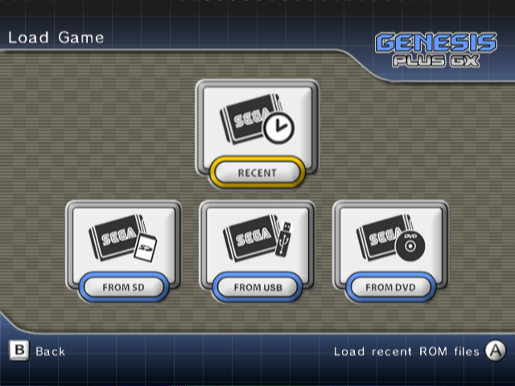

RECENT let you browse through the recent ROM files list. This list is constantly updated when you load new ROM files from SD, USB or DVD. This way you can have faster access to your favorite and last played games.
FROM SD let you browse ROM files on an inserted SD card, from the last accessed directory (if it exists). The SD card should not be removed or swapped once the emulator has been initialized.
FROM USB let you browse ROM files on a connected USB drive, from the last accessed directory (if it exists). The USB drive should not be disconnected once the emulator has been initialized. Both USB ports are usable but you can only connect one USB drive at one time. This option is only available in Wii mode.
FROM DVD let you browse ROM files on an inserted DVD, from the last accessed directory (if it exists). You can swap DVD after the emulator has been started, they will automatically be remounted when you try to load a new ROM file.
Please refer to the previous section to know how to setup each device. Pick one of the options to enter the next menu, which is actually the ROM file browser:
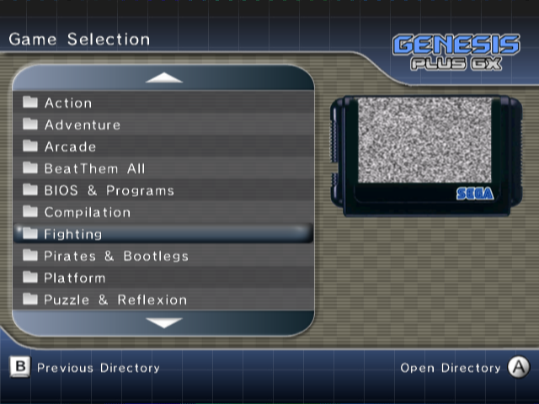
On the left side, you can browse the current directory, navigate within subdirectories or select a ROM file to load, by using the normal navigation buttons. You can also use the following buttons to perform special actions, specific to this menu:
Game Cube Controller
-  exit file selection menu
- go up one full page
- go down one full page

Wii Remote
- exit file selection menu
- go down one full page
- go up one full page

Classic Controller
- exit file selection menu
- go up one full page
- go down one full page

On the right side, a snapshot of the currently selected game will be displayed, if it exists.
Game screenshots should be put in the /genplus/snaps/ directory on your default FAT device and in their default subdirectories (/md for Genesis& Mega Drive ROM files, /ms for Master System ROM files, /gg for Game Gear ROM files and /sg for SG-1000 ROM files). Supported files are PNG image files in RGBA format (32-bit per pixel) and supported dimensions are 320x192, 320x224 & 320x240 pixels. To make things easier, the emulator has an internal screenshot feature, which can be accessed from the main menu, once a game has been started (please refer to Main Menu description in further section for more details).
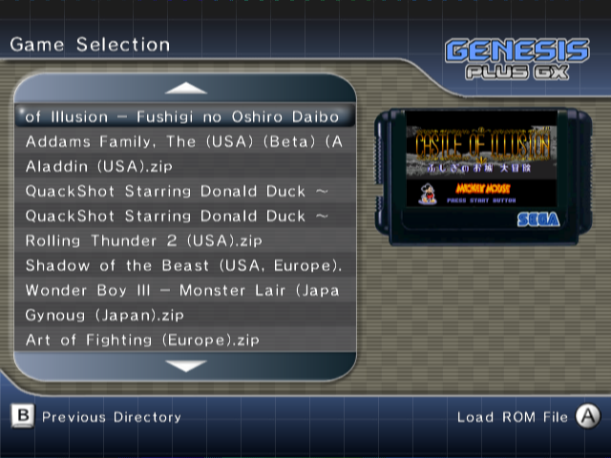
Once you have highlighted the game you want to play, press the Confirm button to load it. If everything went fine, the emulator automatically closes the menu and starts playing the game.
SOFT RESET
While playing a game, you can simulate the behavior of the original console RESET button by pressing the RESET button on your Gamecube or Wii console. Please note that this only works with console hardware that actually implemented a RESET button (i.e. only works when Mega Drive / Genesis or Master System model 1 hardware models are used)
MAIN MENU
Once a game has been started, you can switch back to the main menu anytime you want by pressing and simultaneously when using Game Cube controllers or when using Wii controllers.
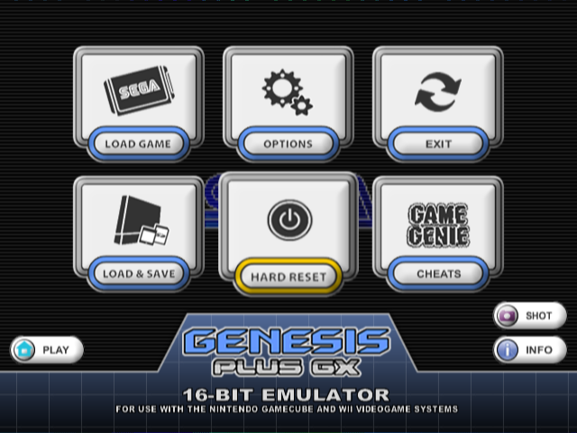

From the main menu, the following options are immediately accessible:
- Return to the game by pressing  / 
- Display ROM header information about the game by pressing 
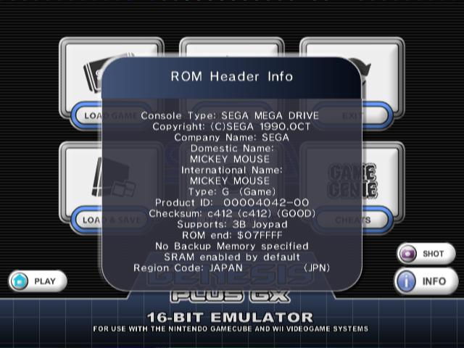
- Save a screenshot of the game by pressing 
- Only when Action Replay “Lock-On” emulation has been enabled through the System Settings (refer to the Option section below for more information), you can change the Action Replay switch position, just like with a real Action Replay cartridge:
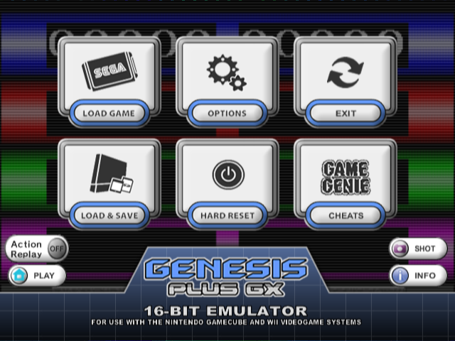
 Cheat Codes enabled
 Cheat Codes disabled
 Trainer Mode activated (PRO Action Replay only)

You have also the possibility to load another game by returning to the “LOAD GAME” menu or enter one of the other menus described below.

EMULATOR OPTIONS
In order to offer the most enjoyable and customizable experience for every users, the emulator let you configure various different settings, which are classified in five categories.
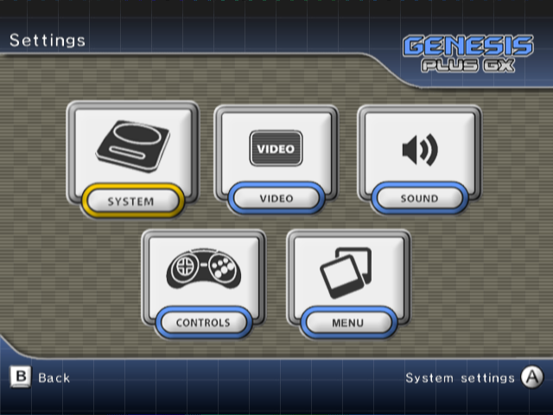

System Settings
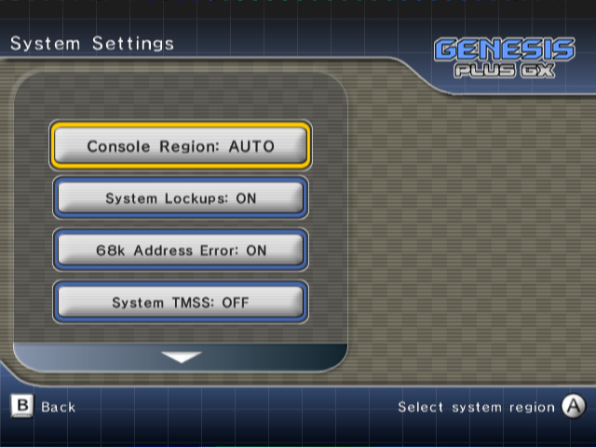
Console Hardware let you force the emulated hardware model:
- AUTO: hardware model is automatically detected through ROM file extension (and internal game database) when loading a new game. The default console hardware association for supported ROM file extensions are the following:
- SG-1000 hardware is automatically selected for .sg ROM files
- Master System model 2 hardware is automatically selected for .sms ROM files (except for a few games present in database that are only fully compatible with Mark III or Master System model 1 hardware and some demos that uses Genesis backward compatibility features).
- Game Gear hardware is automatically selected for .gg ROM files. A few games present in database are using Game Gear backwards compatibility mode (Master System mode).
- Genesis hardware is automatically selected for other ROM files.
- SG-1000: SG-1000 hardware emulation is forced (only compatible with .sg ROM files)
- MARK-III: Mark III hardware emulation is forced (compatible with .sg and .sms ROM files)
- SMS: Master System (model 1) hardware emulation is forced (compatible with .sg and .sms ROM files)
- SMS-II: Master System (model 2) hardware emulation is forced (compatible with .sg and .sms ROM files)
- GG: Game Gear hardware emulation is forced (compatible with .sg, .sms and .gg ROM files)
- MD: Mega Drive / Genesis hardware emulation is forced (compatible with .sms, .bin, .md, .gen, .mdx, and .smd ROM files)
When forcing console hardware emulation, the emulator will still use backwards compatibility mode if present, depending on ROM file extension. Please note that some games will only work properly on a specific hardware model, so use the AUTO mode if you want best compatibility and forced modes only if you know what you are doing or want to experiment the differences.
Console Region let you force the region setting for the Sega Genesis / Mega Drive. This will also force PAL or NTSC timings:
- AUTO: region is automatically detected (through ROM header) when loading the game
- EUR: Sega Mega Drive (overseas model), PAL (50Hz)
- USA: Sega Genesis (overseas model), NTSC (60Hz)
- JAPAN: Sega Mega Drive (domestic model), NTSC (60Hz)
Some games might act differently depending on the selected region setting but also may not work correctly if they have some internal region lockout code.
System Lockups let you enable/disable emulation of illegal address access. On real hardware, accessing prohibited area would make the software crash or freeze. This should not happen with commercial games but some demos or homebrew games might need you to disable it. This is enabled by default.
68k Address Error let you enable/disable emulation of address error exception. On real hardware, accessing misaligned addresses would cause an exception. This exception can be caused by game program to test it is running on real hardware as emulator generally don’t handle this properly. This can also cause badly programmed demos or hacks to crash when enabled. This is enabled by default. This option is only used with Genesis / Mega Drive games.
System TMSS let you enable/disable TMSS emulation and Genesis BIOS support. Later console models added some kind of internal protection that would ensure the inserted cartridge was a properly licensed game and would display a licensing screen when the console is switch on. If you want to use this feature, the uncompressed Genesis BIOS image (not provided) must be renamed as “BIOS.bin” and put in the “/genplus/” directory, on your default FAT device. This is not required to play games and should only be activated if you are missing the annoying license screen when booting a game. This is disabled by default. This option is only used with Genesis / Mega Drive games.
Lock-On let you enable/disable cartridge Lock-On emulation. Some special cartridges indeed had an extra connector with the possibility to connect another game cartridge, adding new features to the game. To use lock-on feature, enable one of the supported device below, make sure the ROM image for this device is properly installed then load any games as normal. As long as this option is not disabled, any game you load will be played through the selected “Lock-On” device. This option is only used with Genesis / Mega Drive games.
- GAME GENIE: This emulates internal Game Genie hardware. The Game Genie was a device that lets you cheat into games; please refer to the Game Genie user manual for more details. In order to enable Game Genie emulation, you must provide the uncompressed Game Genie ROM image (not included) and put it as “ggenie.bin” in the “/genplus” directory, on your default FAT device.
- ACTION REPLAY: This emulates internal Action Replay or PRO Action Replay hardware (PRO Action Replay 2 is only partially supported). Those were devices that let you cheat into games; please refer to the Action Replay or PRO Action Replay user manuals for more details. In order to enable Action Replay or PRO Action Replay emulation, you must provide the uncompressed ROM image (not included) and put it as “areplay.bin” in the “/genplus” directory, on your default FAT device. When Action Replay “Lock-On” is enabled and Action Replay software has been detected, you can modify the Action Replay switch position in the Main Menu (see previous section).
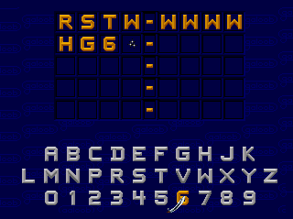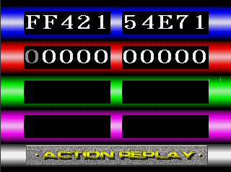
It is not obligatory to enable Game Genie or Action Replay “Lock-On” in order to use cheats. You could instead go the Cheat Menu and enter cheat codes manually (check later section). This option is there if you want to emulate cheat devices natively and run their original software. For example, using PRO Action Replay software, you can search for your own cheat codes using the “Trainer Mode”.
- SONIC & KNUCKLES: This will emulate Lock-On technology found in the Sonic & Knuckles cartridge. By using this feature, you can connect older Sonic’ games to the cartridge's pass-through port for extended & modified gameplay. You can also connect any other games and see what happen, just with a real Sonic & Knuckles cartridge. In order to enable Lock-On emulation, you must provide the uncompressed Sonic & Knuckles ROM image (not included) and put it as “sk.bin” in the “/genplus” directory, on your default FAT device. In order to properly run Sonic the Hedgehog 2 with Lock-On technology, you also need to provide the extra chip (UPMEM) ROM image and put it as “sk2chip.bin”, along the previous file.
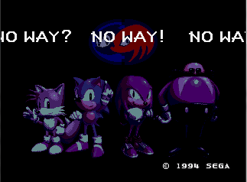
Cartridge Swap, when enabled, let you virtually swap any loaded game over the current one, without resetting the emulated console. Use this option only if you know what you are doing, as it can easily crash the game. This is disabled by default.
SVP Cycles let you adjust the number of CPU cycles emulated by scan lines for the SVP chip used in Virtua Racing cartridge. Indeed, emulating the SVP requires lot of additional resources so you can lower the default value if the emulation is too choppy. However, keep in mind that the SVP chip will therefore be running at a slower clock rate, which will result in slower 3D rendering. This option is only available once Virtua Racing has been loaded.

Video Settings
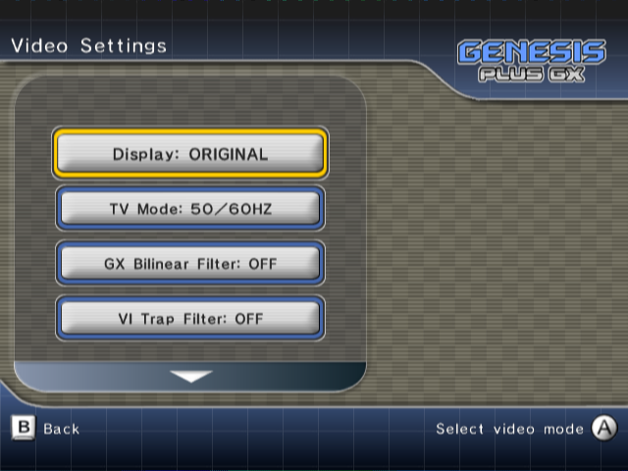

Display let you change the default rendering mode:
- ORIGINAL enables original consoles low-resolution modes support: these modes generally output a progressive 240 lines (288 lines for PAL) display. Interlaced modes (240i/288i), as used in Sonic 2 two player’s mode for example, are also supported and automatically switched. In this mode, games would look exactly the same as they did on real hardware, giving you the most faithful retro experience. However, this mode might not be compatible with some TVs when using the component cable.
- INTERLACED enables Interlaced Video mode (480i/574i) support. In this mode, because of the higher resolution, games generally look better than on the real hardware but some artifacts (motion blur) might appear during fast movements if bilinear filtering is disabled.
- PROGRESSIVE enables Progressive Video mode (480p) support. Only use this mode with a component cable and a compatible TV. In this mode, TV display is forced to 60Hz.
TV Mode let you change the default video signal type:
- 50/60 HZ: in this mode, the emulator automatically switches between 50Hz and 60Hz video signals, depending on the emulated console region.
- 60 HZ: in this mode, the emulator forces the display to 60Hz (NTSC or PAL60). Use this if your TV does not support 50Hz.

- 50 HZ: in this mode, the emulator forces the display to 50Hz (PAL). Use this if your TV does not support 60Hz.
GX Bilinear Filter let you enable/disable hardware bilinear filtering. Emulation speed is not affected by this setting. When enabled, the screen might look a little bit more blurry but, while, when using INTERLACED or PROGRESSIVE display modes, some graphic flickering might appear during screen scrolling if disabled.
VI Trap Filter let you enable/disable Video Encoder output filtering. This filter is usually implemented on modern consoles to improve color separation in the “low quality” Composite Video signal. On older consoles like the Genesis, this property of composite video was used by game developers to create additional “fake” colors on screen and various effects (shade, transparency). By disabling the filter, you can somehow recreate these effects as they were intended to be displayed (but still not exactly since the Wii still outputs a cleaner video signal than your old Genesis). This option is only available on Wii.
VI Gamma Correction let you change the default Gamma correction applied by the Video Encoder on the output. Default value is 1.0. This option is only available on Wii.
NTSC Filter let you enable/disable NTSC software filtering. This filter emulates the native artifacts produced by the NTSC Video Signal (color blending…). Some games indeed use this effect to simulate additional colors or transparency effects. Please note that this filter is very CPU consuming. Several predefined modes are available (COMPOSITE, S-VIDEO & RGB) which simulates a specific video signal type.
Borders let you enable/disable overscan color emulation: when enabled, the background color is displayed around the active screen area, like on the real consoles.
- ALL: full overscan area is emulated.
- H ONLY: only horizontal borders are emulated.
- V ONLY: only vertical borders are emulated.
- OFF: overscan emulation is disabled and border color is forced to black.
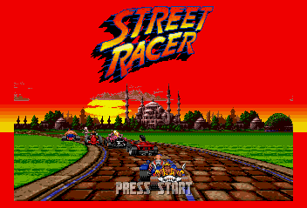
Aspect let you change the default screen aspect ratio:
- ORIGINAL (4:3) mode automatically set the correct aspect ratio, exactly as if you connected a real Genesis / Mega Drive to your TV.
- ORIGINAL (16:9) mode is the same as above except it is designed for those having their TV forced in 16:9 mode. The original aspect ratio is preserved by forcing pillar-boxing on both sides of active screen. Please note that since the original width is altered, the image quality will be degraded, especially when filtering is disabled. It’s generally better to manually switch your TV in 4:3 mode if it is possible, the TV hardware taking care of pillar-boxing for you.
- SCALED mode let you manually adjust horizontal and vertical scaling, using the “Screen Scaling” option below.
Game Gear games can be displayed “full screen” by setting Aspect Ratio to SCALED and disabling borders completely.
Screen Position let you adjust the screen position while keeping the current aspect ratio. This option is only effective when a game is currently running.
Screen Scaling let you adjust the display aspect ratio manually. This option is only effective in SCALED mode and when a game is currently running.

Audio Settings
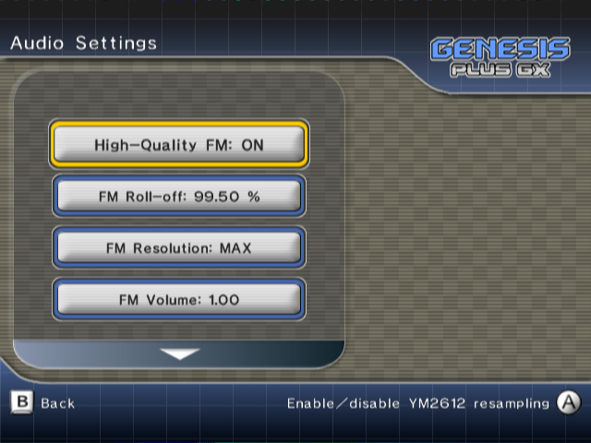
Master System FM let you configure YM2413 chip emulation when running Master System games.
- AUTO: FM sound is only enabled for games that support it.
- OFF: FM sound is always disabled.
- ON: FM sound is always enabled.
High-Quality FM, when enabled, let you emulate the FM synthesizer chip at its original frequency. This is required for more accurate sound reproduction, especially when games are dealing with very high frequencies. Resampling is done in real-time on the rendered stream in order to match Game Cube & Wii native samplerate (48 kHz), using optimized FIR filtering.
FM Roll-off let you configure the FIR filter used during the resampling. Higher values mean less filtering. This option is only available when High-Quality FM is enabled.
FM Resolution let you configure DAC resolution of the emulated FM synthesizer chip. This is an experimental feature; only modify this setting if you know what you are doing. Using a reduced range produces more quantization noise but might be more accurate to the original hardware.
FM Volume let you adjust the volume ratio of the emulated FM synthesizer chip. (0~200%).
PSG Volume let you adjust the volume ratio of the emulated PSG chip (0~200%)
PSG Boost Noise, when enabled, let you boost the noise channel volume of the PSG chip. This might make some games sound more accurate but, most of the time, it’s generally better to leave it disabled.
Filtering let you enable/disable additional output filtering: on real hardware, analog mixing circuitry is naturally filtering the sound output, you can try to reproduce this with a single-pole low-pass filter or with a more complicated 3-Band equalizer.
Low-Pass Rate let you adjust the amount of filtering when Low-Pass Filter is enabled. This option is only available when Low-Pass filtering is enabled.
Low / Middle / High Gain let you adjust the gain of each frequency range of the 3-Band equalizer, when it is enabled. This option is only available when 3-Band equalizer is enabled.
Low / High Frequency let you adjust the frequency ranges of the 3-Band equalizer, when it is enabled. This option is only available when 3-Band equalizer is enabled.

Controllers Settings
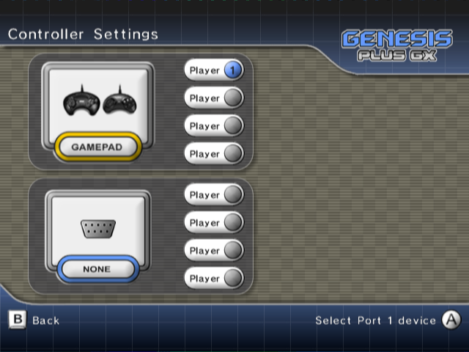
In this menu, you can select the type of controller device you want to connect to each of the two emulated console hardware input ports, just as with the real system.
The following devices are emulated (some of them have use restrictions that are mentioned below):
 | 3-BUTTONS / 6-BUTTONS control pad.
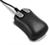 | Sega MOUSE (only one mouse can be connected at one time)
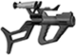 | Sega MENACER (can only be connected to Port B)
 | Konami JUSTIFIERS (can only be connected to Port B, adds 2 controllers)
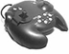 | XE-1AP (can only be connected to Port A, needs at least one analog stick)
 | Sega ACTIVATOR (needs two analog sticks, i.e. GameCube or Classic controller)
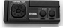 | 2-BUTTONS control pad (required by some Master System games)
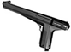 | Sega LIGHT PHASER
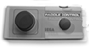 | Sega PADDLE
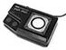 | Sega SPORTS PAD
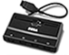 | Sega TEAM PLAYER (each connected device adds 4 controllers).
 | EA 4-WAY PLAY (uses both ports, adds 4 controllers).
 | NOT CONNECTED (might be required in some games to access specific play modes).

When loading a new game, the emulator will try to detect if it supports a special device and automatically configures the ports for you. The previous configuration will be restored when you load a new game with no special device support.
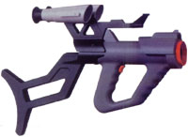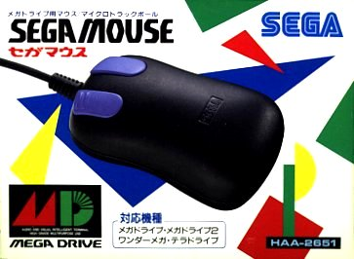
When detecting a game that is known to use J-CART hardware, the emulator will automatically connect a normal controller to port B and add 2 additional controllers.
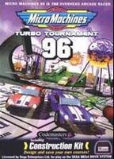
Only connect specific devices if you know the game actually supports them. Refer to the game manual for more information on the supported controllers and how to connect them. For example, some multi-player games supporting SEGA TEAM PLAYER will require you to connect a normal controller in port A and the multi-tap in port B.
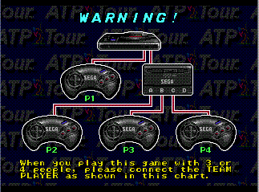
Also, games supporting Sega MENACER or Konami JUSTIFIERS require you to connect the gun in port B and a normal controller in port A. In this case, bear in mind that player 2 (and 3 when using Justifiers) will be controlling the light guns.
Finally, most Master System games are compatible with 3-buttons Control Pad. Some of them, however, will refuse to work which such device and require use of 2-Buttons Control Pad.
If the game is supporting it, you can have up to 8 simultaneous players by connecting a Sega TEAM PLAYER on each port. You must off course have enough real controllers connected to your system. For that reason, on the Game Cube, there are a maximum of 4 simultaneous players allowed.
Once you have setup input ports, the number of possible players is automatically updated to match the number of available controllers. You can now select each player and enter the associated controller configuration windows.
Depending on the type of emulated device, you will be able to configure device specific option, select the input controller to use in order to emulate it and remap the controller keys.
Gamepad specific options
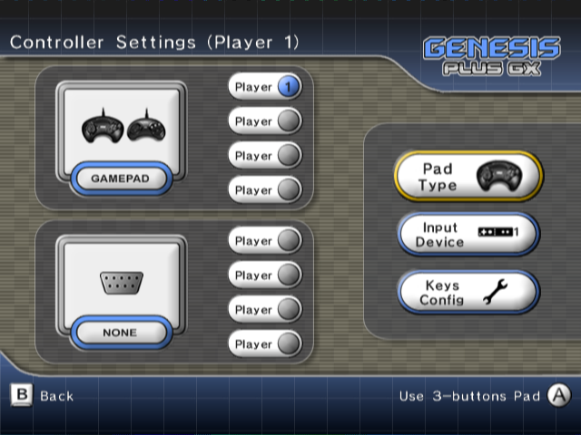
Here you can choose to emulate a 6-Buttons or 3-Buttons Control Pad.
Mouse specific options
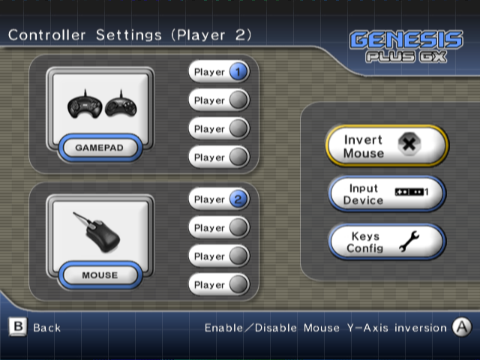
Here you can enable & disable Mouse Y-Axis inversion. This is required in some games (e.g. Populous 2).
Gun specific options
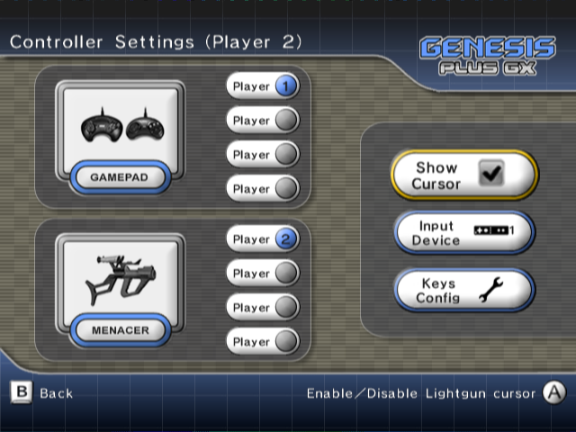
Here you can enable & disable Gun cursor on-screen display. Most games supporting light guns would render their own cursor on the active screen but some actually doesn’t, it should help you figuring where you are aiming at.

Select Input Controller
The emulator automatically detects controllers that are connected to your system and let you pick the one you want to use in order to control the emulated device. The following input controllers are supported:
GAME CUBE CONTROLLER
WII REMOTE (horizontally handled)
WII REMOTE + NUNCHUK
CLASSIC CONTROLLER
NO DEVICE
When multiple controllers of the same type are found, you can select which one you want to use (for example, Wii Remote #1 for player 1, etc).
Also, if a Classic Controller is connected to a Wii remote, it is possible to affect the Wii Remote to player 2 while the Classic Controller is used by player 1.
Game Cube controllers, however, are automatically affected: port 1 is affected to player 1 or 5, port 2 to player 2 or 6, etc… so be careful to connect them in the appropriate controller port when you want to use them.

Configure Keys
Once an input controller is selected, you can configure the key mapping to match the emulated controllers. In the dialog box, press the key you want to use for each specific controller button.
You can exit the dialog box anytime by pressing when using a Game Cube controller or when using a Wii controller.
The default key mapping for 3-Buttons & 6-Buttons Control Pad is detailed below:

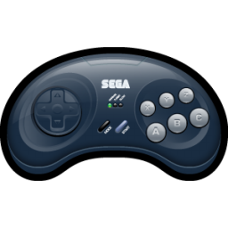 | D-PAD | START | A | B | C | X | Y | Z | MODE

Despite having specific buttons layout, all type of emulated devices share the same key mapping (i.e. there is one key configuration per input controller). When remapping keys of emulated device, you can see which buttons need to be configured but bear in mind that the updated keys configuration will affect other emulated device type when you swap them.
- Menacer & Justifier light guns use same button layout as 3-Button controller (A, B, C & START).
- Mouse CENTER, LEFT, RIGHT & START buttons are respectively mapped to keys for A, B, C & START buttons.
- Master System controllers (2-Buttons Control Pad, Light Phaser, Paddle, Sports Pad) Buttons 1 & 2 are respectively mapped to keys for B & C buttons. Additionally, PAUSE button is mapped to key for START button.
- XE-1AP analog controller A, B, C, D, E1, E2, START & SELECT buttons are respectively mapped to keys for A, B, C, X, Y, Z, START & MODE buttons.
Analog devices (lightguns, paddle, sports pad, XE-1AP, etc) do not have directional buttons like normal Control Pads:
- Light Gun screen position can be controlled using the Wii Remote pointer or left analog stick.
- Mouse can be controlled using the Wii Remote pointer, an USB mouse (only on Wii) or left analog stick.
- Paddle & Sports Pad can be controlled using left analog stick or D-PAD.
- Activator requires an input controller with TWO analog sticks (Game Cube or Classic Controller). Note that because the way it works, this device does not have any configurable “buttons”. The left stick position actually represents one of the eight positions of the “low” plane, while the right stick does the same but for the “high” plane, for a total of 16 inputs. Refer to the game manual to know which move corresponds to which input.
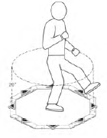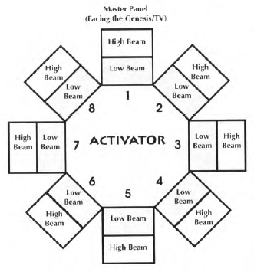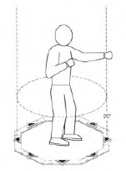
- XE-1AP requires an input controller with at least ONE analog stick (Game Cube, Nunchuk or Classic Controller). This stick is used to emulate XE-1AP Control stick while the Throttle/Speed slider is either emulated using the right analog stick, if available (Game Cube & Classic Controller), or D-PAD.
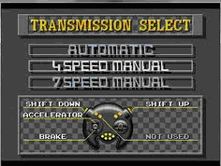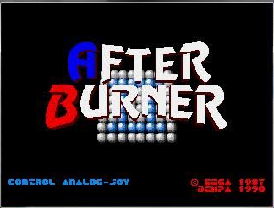

Menu Settings
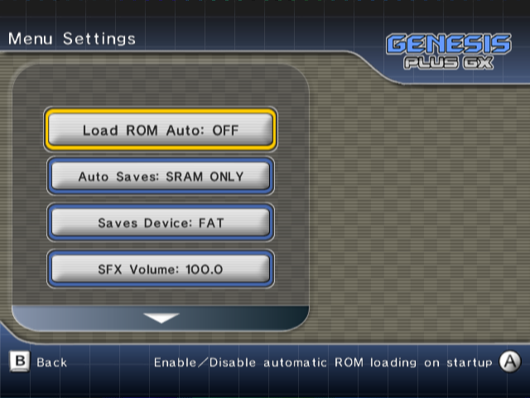
Auto ROM Load: when enabled, the last played ROM file (first entry of the history.ini file) will automatically be loaded when the emulator starts and if everything went fine (i.e. the ROM file has been found), the game will automatically starts, without you have to go through the Main Menu.
Auto Cheats: when enabled, cheat codes will automatically be activated (or deactivated) when you load a new game and cheat file is found. The initial state of cheat codes can be modified through the Cheats Menu and will be saved in the cheat file, for later use.
Auto Saves let you configure which kind of saves you want to be automatically loaded when you load a game. When enabled, the specified file type will be automatically saved when exiting the application or just before loading another game. The following options are available:
- SRAM only: if the game has an internal save feature (battery-backed RAM, Flash, serial EPROM, etc), data will automatically be saved to a .srm file each time you enter the menu and the game have modified the data. If found, the same .srm file will automatically be loaded when you load the game.
- STATE only: this will allow saving and restoring internal state for the game, even if it does not support native saves. A .gpz file will automatically be saved when exiting the game and reloaded (if found) when loading the game.
- ALL: this will enable automatic load/save for both types.
- NONE: this will completely disable automatic load/save.
You can always use the SAVE MANAGER menu to manage SRAM & STATE files for the current game. Refer to SAVE MANAGER menu description below for more information.
Saves Device let you configure the device to use when loading & saving SRAM & STATE files:
- FAT: files are stored in the /genplus/saves directory on the default FAT device. On Wii, when both SD card and USB drive are connected when the emulator starts, SD card will be used as default FAT device.
- MCARD A: files will be stored on the memory card inserted in Game Cube slot A.
- MCARD B: files will be stored on the memory card inserted in Game Cube slot B.
SFX Volume let you configure the volume of sound effects played in the menu
BGM Volume let you configure the volume of the background music played in the menu.
BGM is only played if you put an appropriate audio file in the /genplus directory on the default FAT device and named it Bg_music.ogg. Please note that only .ogg files are supported and because of console inner memory limitations, you should use limited-size audio files.
BG Type let you change the default menu background image & color.
BG Overlay let you enable/disable the default menu background overlay.
Screen Width let you configure the default menu screen scaling to fit with your TV.

SAVE MANAGER
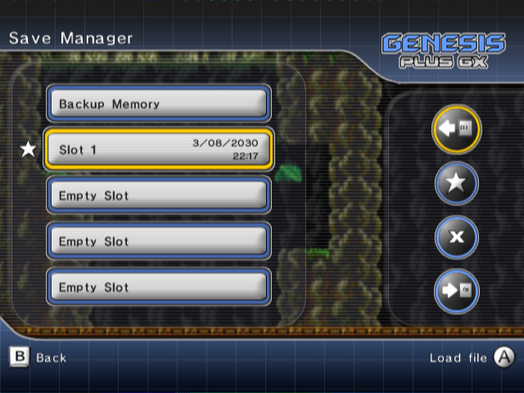
In this menu you can:
- Manage internal game saves if the current game originally supports internal cartridge backup memory. If you saved your progress in the game and the internal backup memory has been modified, a star will be displayed on the left, indicating you should now update the SRAM file. If the game does not support internal saves, this item will be disabled.
- Manage up to five different internal states for the current game. By using, this feature, you can save your progress in the game and restore it anytime you want, even if the game does not have internal saving support.
Select one of the available slots then press the Confirm button to display an additional window:
 Load the selected file from the default save device.
 Set the selected slot as the default state slot. This slot will be used when automatic state loading/saving is enabled.
 Delete the selected file from the default save device.
 Save the selected file to the default save device.
You can configure the emulator to automatically load & save SRAM and/or State files, as well as selecting the default device used to store these files. Please refer to the Menu settings for more information.
CHEATS MANAGER
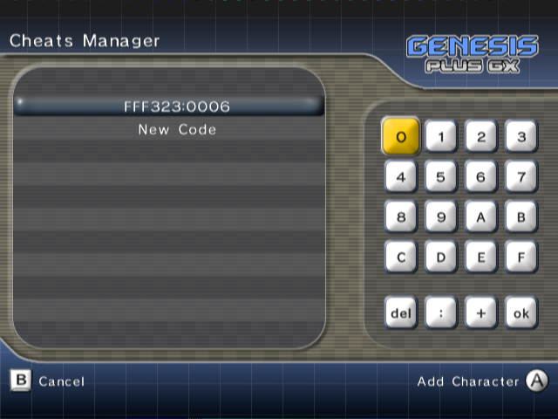
In this menu, you can manually add, remove or edit cheat codes for the current game. You can also enter a short description for each code as well as enable or disable a particular cheat.
Cheat codes are automatically loaded when you load a new game, from the associated cheat file (if it exists) and are automatically saved each time you modify or add codes.
Cheat files are stored as .pat files on the default FAT device, in the /genplus/cheats directory and their respective subdirectories (/md for Genesis& Mega Drive ROM files, /ms for Master System ROM files, /gg for Game Gear ROM files and /sg for SG-1000 ROM files) and should be exactly named as the ROM file (minus the extension). PAT files created from other emulators are supported, as long as they have the proper extension and name.
Both Game Genie and Action Replay code types are supported. Game Genie codes should come in the form of XXXX-YYYY (Mega Drive / Genesis) or XXX-YYY-ZZZ (Master System & Game Gear) while Action Replay codes format is XXXXXX:YYYY (Mega Drive / Genesis) or 00XXXX:YY (Master System & Game Gear).
The maximal number of cheat codes is 150. If the .pat files you are using have more than 150 codes, extra codes will be ignored and deleted. Also note that the length of the cheat description is also limited, a maximum of approximately 64 characters can be displayed.
In the cheat manager menu, the following keys are used:
Menu Action
Select Cheat | / | /
Display Cheat Code/Description | / | /
Edit Cheat & Enter Digit
Cancel & Previous menu
Enable/Disable Code
Delete Cheat

HARD RESET
Select this in order to completely reinitialize the emulated system and restart the game you were currently playing. This is like switching OFF then ON again the Power Button on the real console hardware.

EXIT
Select this in order to view the credits rolling screen or quit the program. Depending on the way you booted the program, you can either return to the loader and/or reset the console.
You can shutdown your Wii console and exit the program anytime (even while playing the game) by holding button on the Wii Remote.

