Introduction

This project is about the EHR system implementation. The overall structure is based on Blockchain for Secure EHRs Sharing of Mobile Cloud Based E-Health Systems by Dinh C. Nguyen, Pubudu N. Pathirana, Ming Ding, Aruna Seneviratne.

Sequence diagram

<upload>

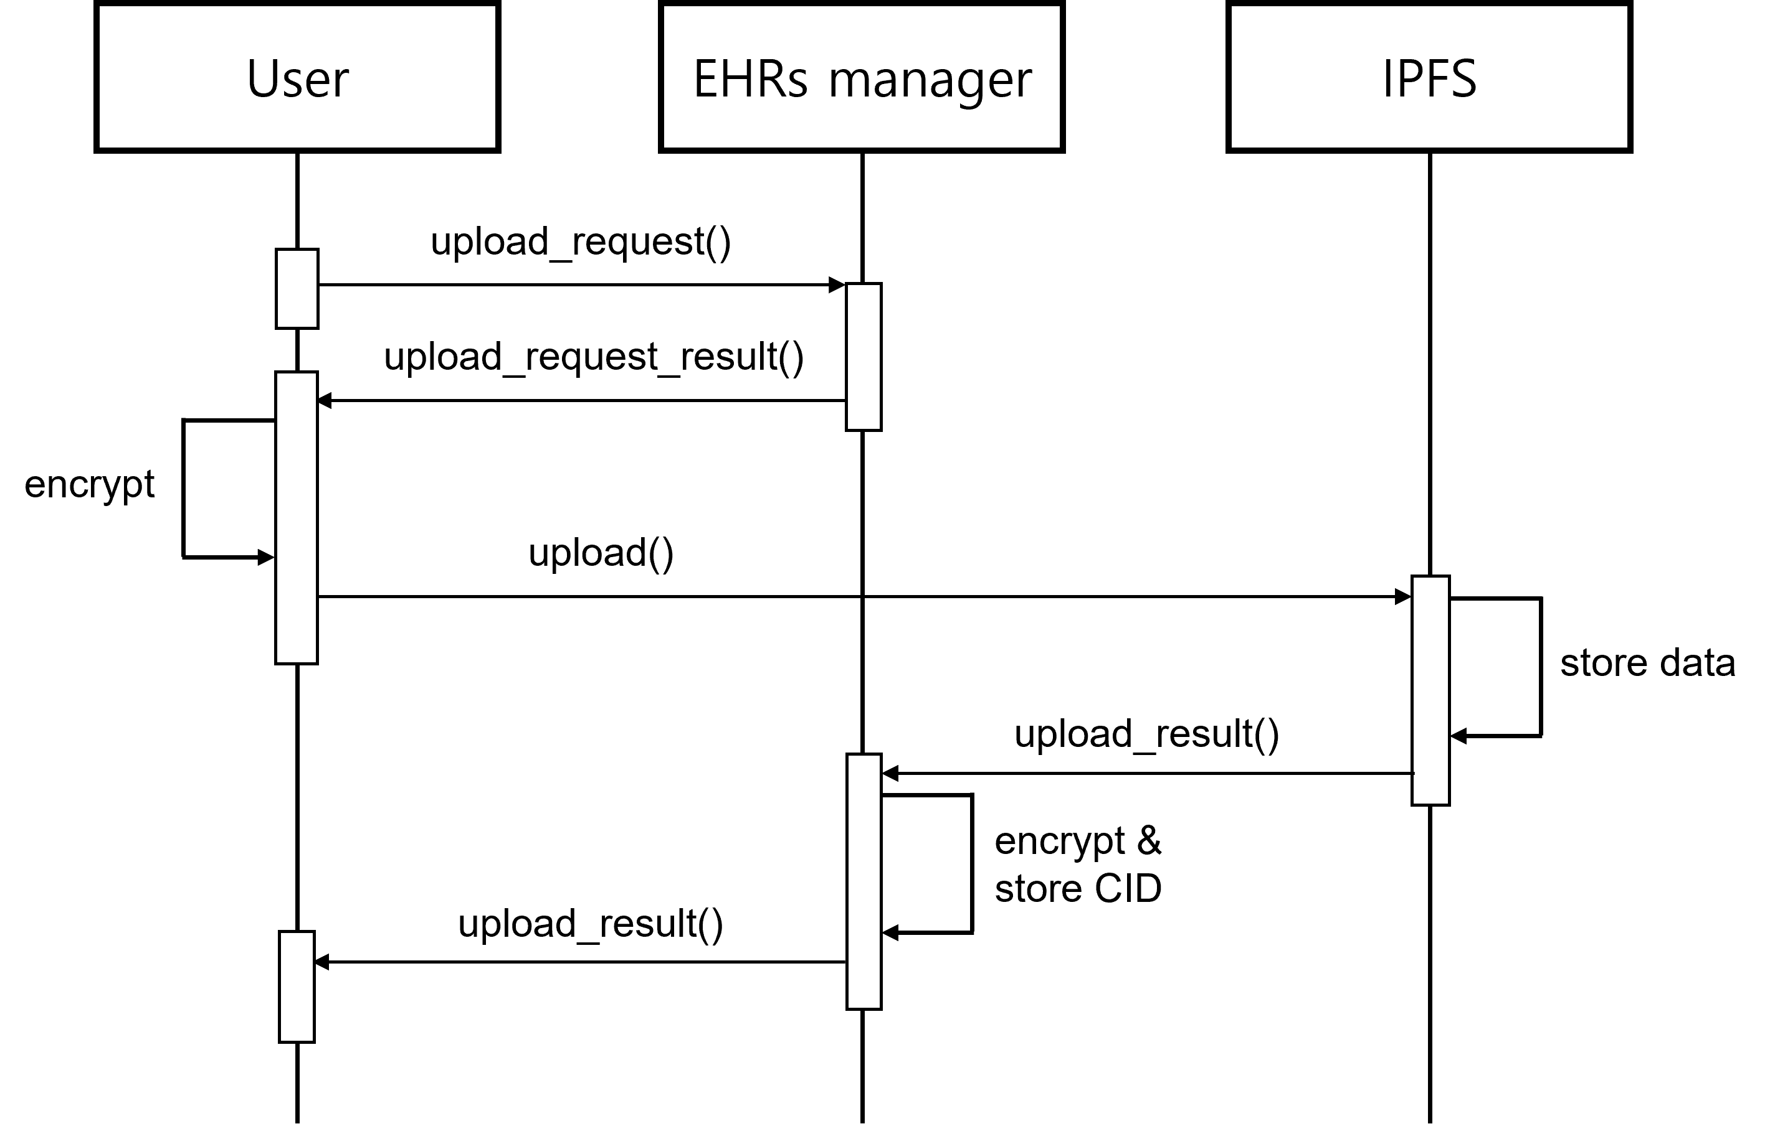

<retrieve>

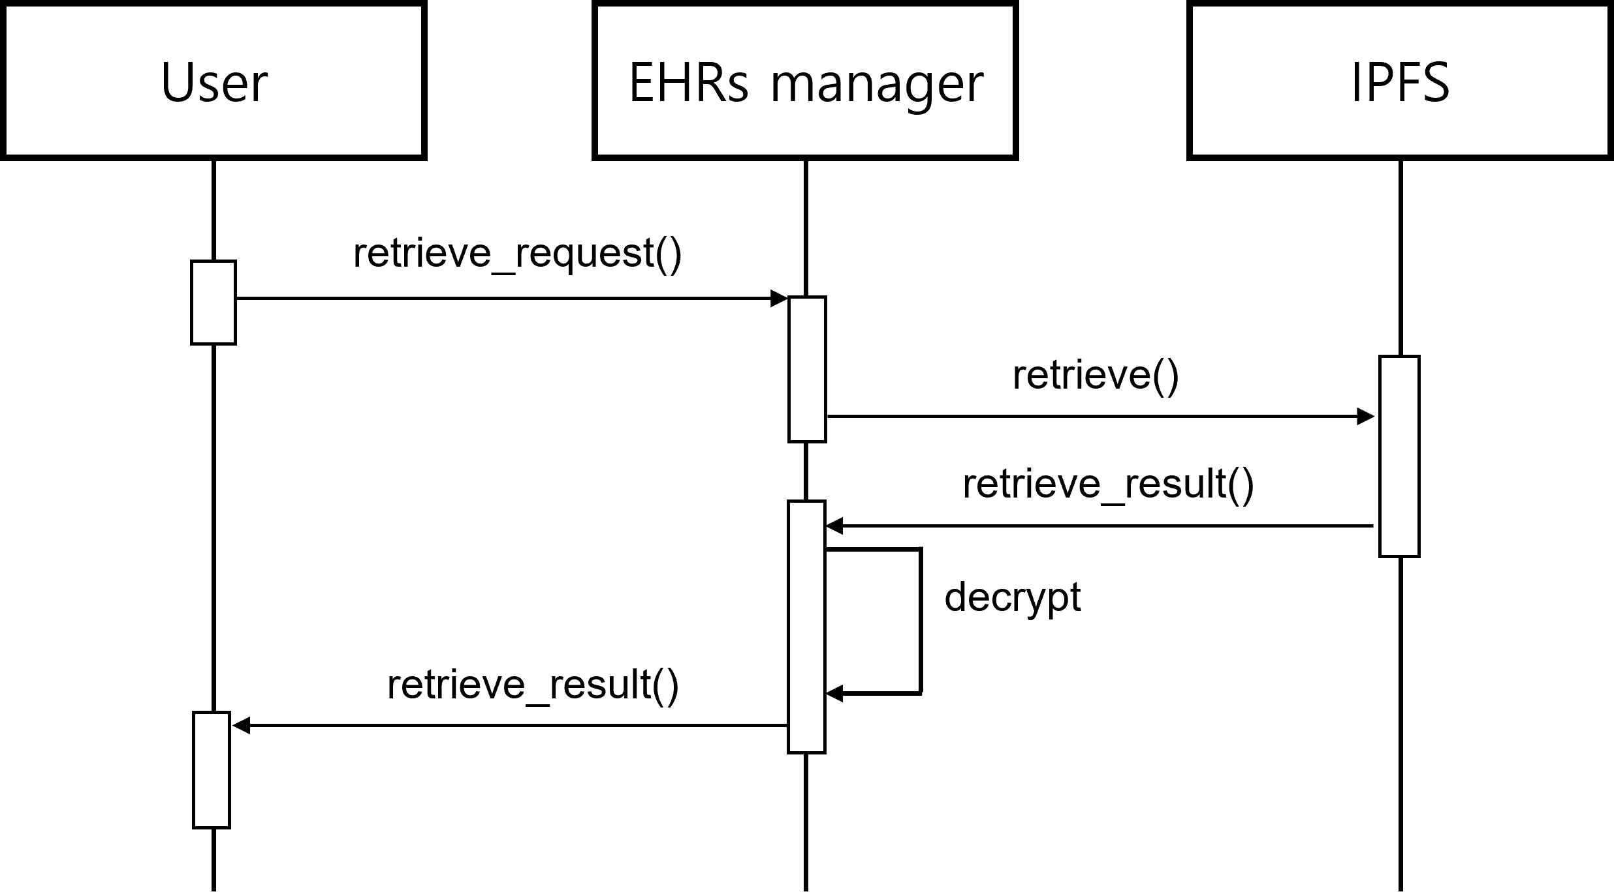

Environment

Program language

\* EHRs manager (main server), ipfs server : python.

\* client-side web : js.

\* smart contract : solidity.

Run environment

\* Ganache + Remix

\* accounts[3] for EHRs manager and accounts[4] for ipfs server are fixed.

\* After deploying the contract, modify address.txt and abi.tex.

Result

<upload>

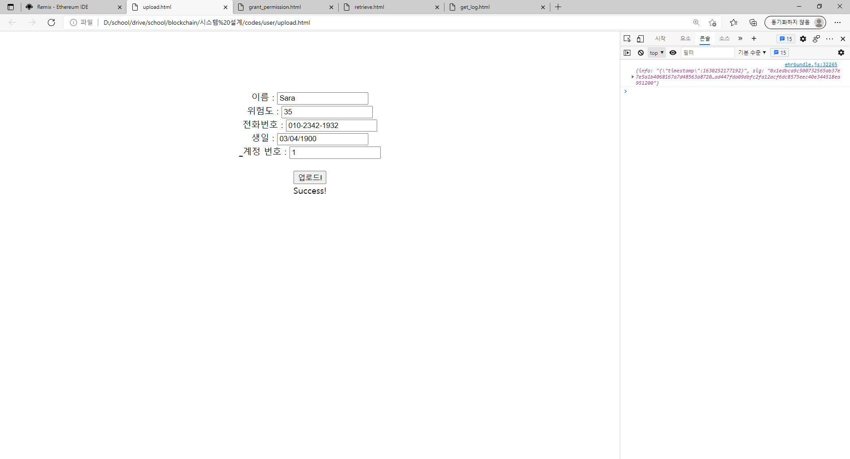

<grant permission>

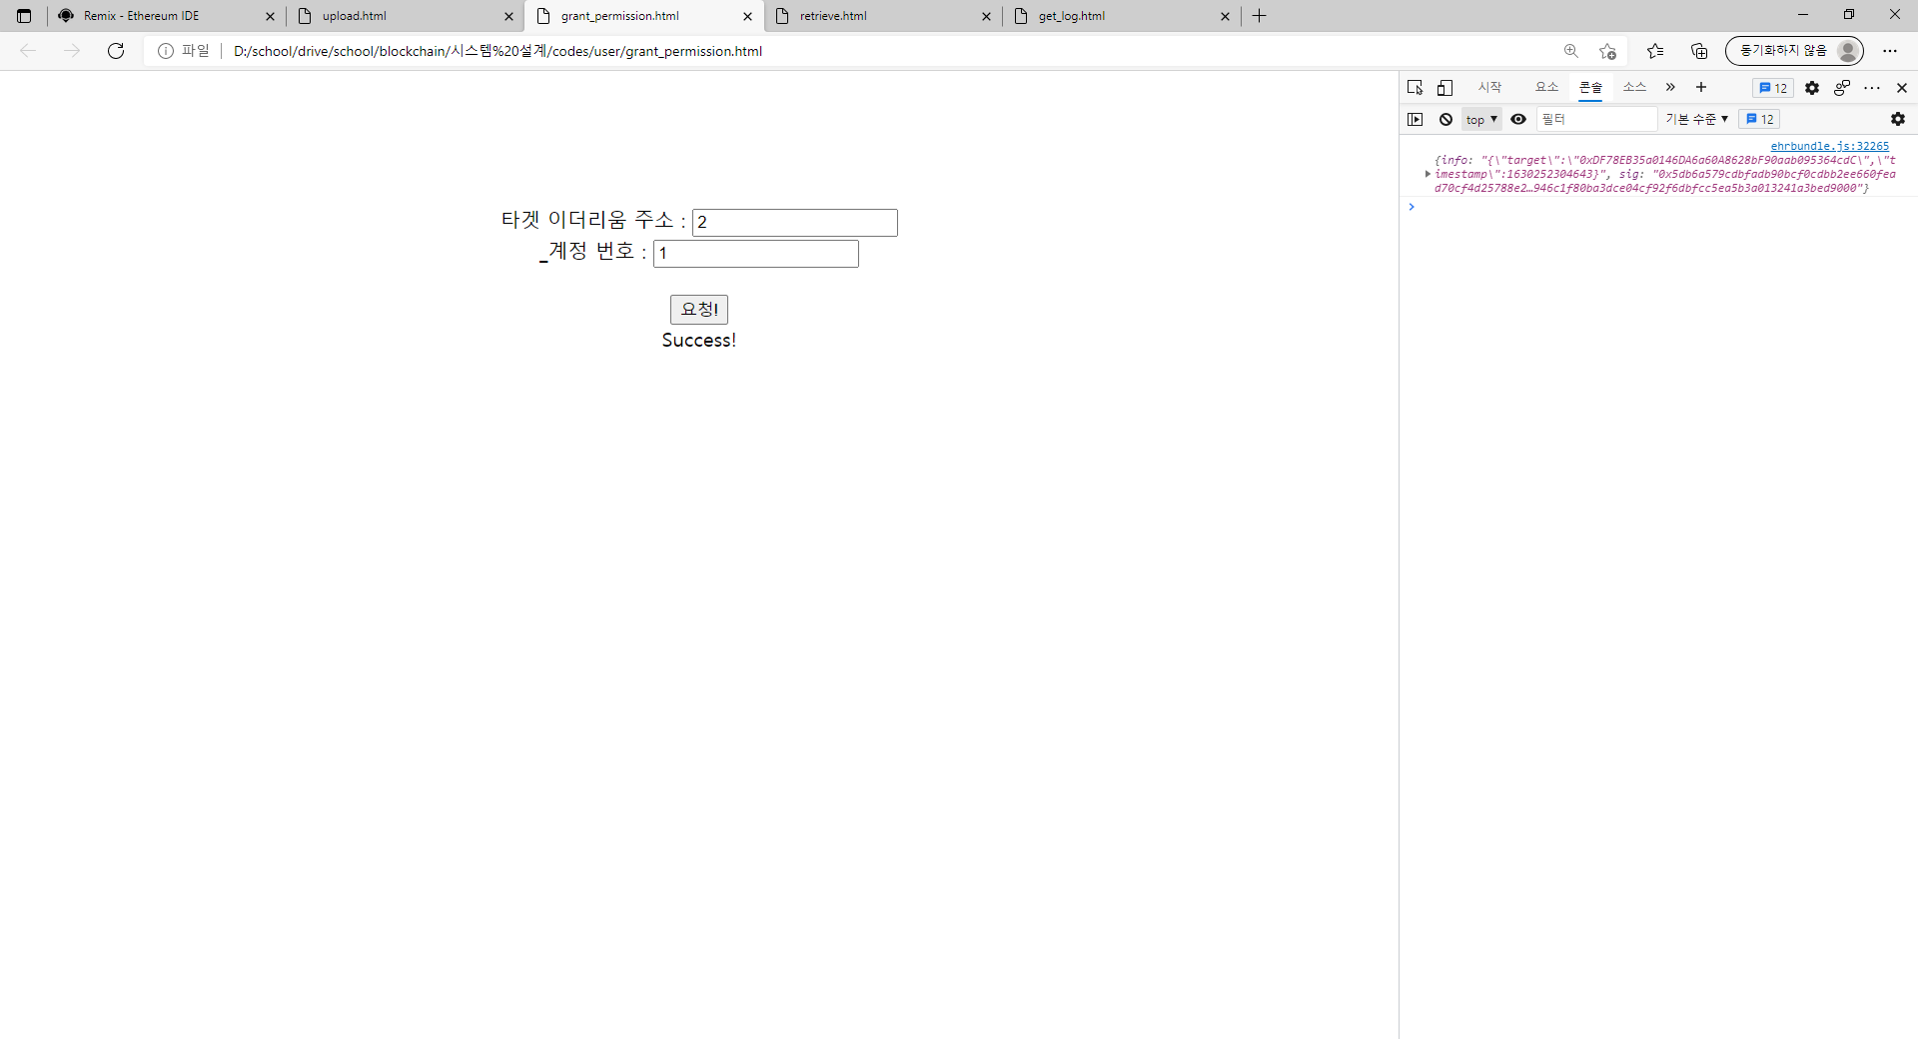

<retrieve>

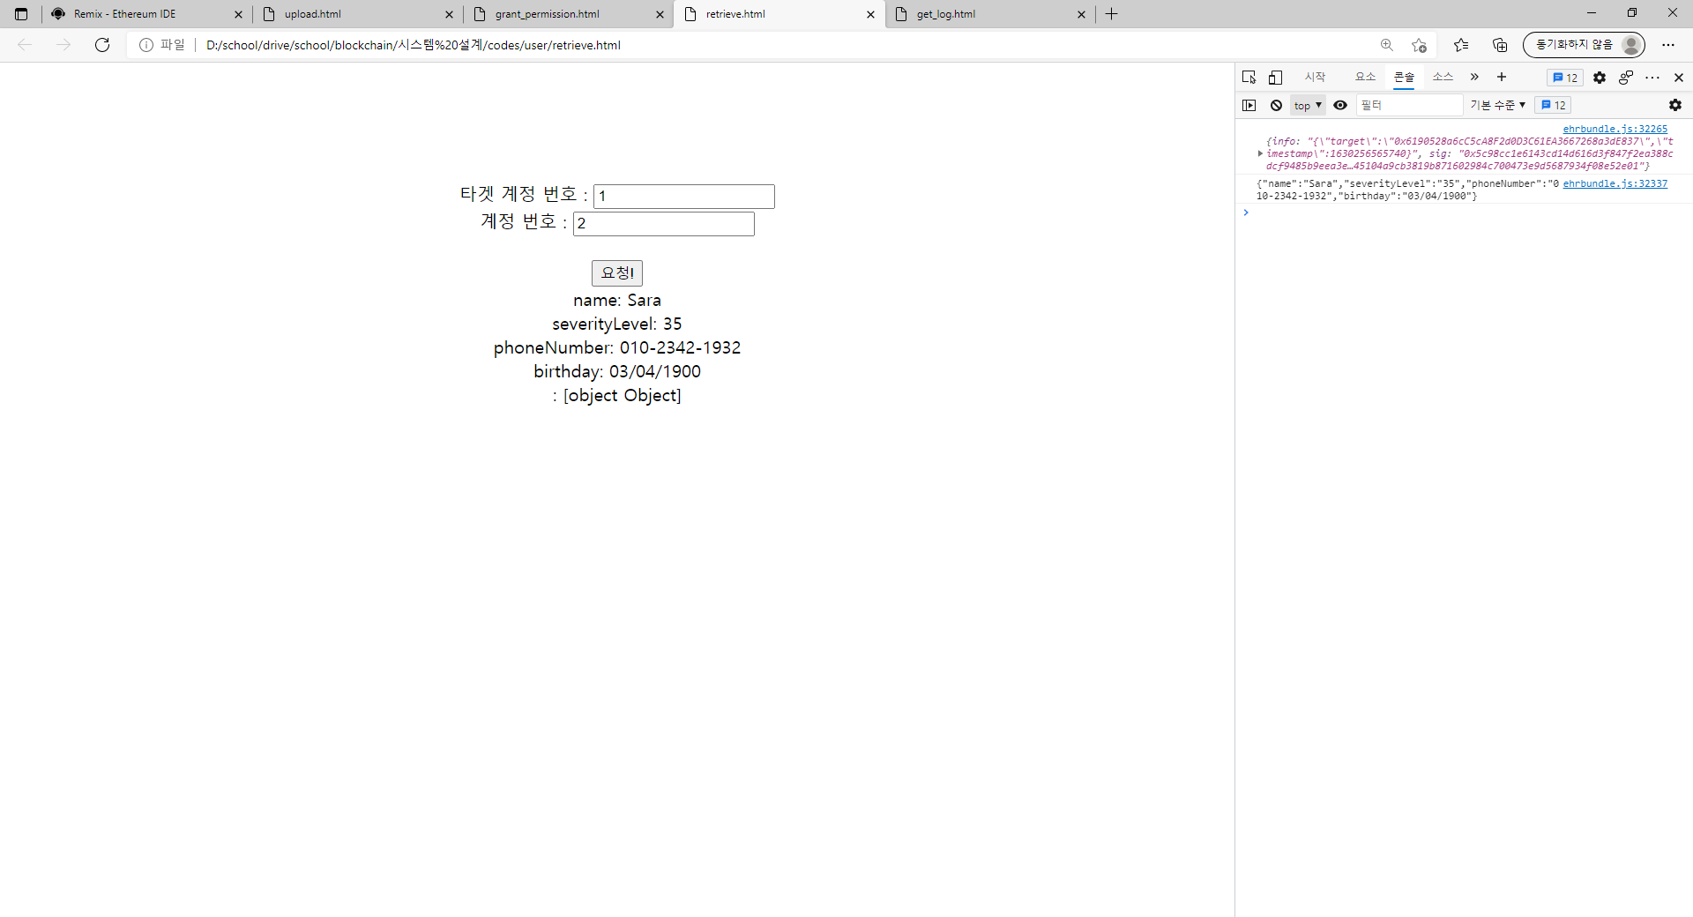

<log>

